

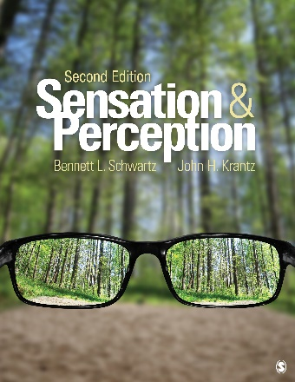
Sensation and Perception

SECOND EDITION

Bennett L. Schwartz – Florida International University

John H. Krantz – Hanover College

FORMATS & PRICING
- Print (9781506383910): $ 131 net price
Available: January 2018

NEW TO THE SECOND EDITION
- Anaglyph glasses now included with the text allow readers to see anaglyphic stereograms in a memorable way, making it easier to retain concepts.
- New Interactive Sensation Laboratory Exercises (ISLE) give students more opportunities to engage with the phenomena discussed in the book.
- Expanded coverage of perceptual development with developmental topics clearly identified in chapter headings gives students a more complete understanding of sensation and perception.
- Enhanced Learning Objectives take into account Bloom’s Taxonomy to more effectively help students learn the material.
- Additional Test Your Knowledge questions at the end of each major section give students more opportunities to assess their understanding and identify areas for improvement.
- Exploration sections and Application sections that replace the In Depth sections of the previous edition convey the exciting changes in the field through examinations of research topics and discussions their applications to sensation and perception.
- Ponder Further sections feature open-ended questions that encourage students to think critically about material in greater depth.
- SAGE coursepacks allows instructors to import high-quality content into their school’s learning management system (LMS) with no access codes.

ESTIMATED TOC COMPARISON AVAILABILITY DATE: January 19, 2018
If you have any questions, your sales representative is happy to help. You can utilize our Rep Locator to quickly find the contact information for your sales representative. http://www.sagepub.com/replocator.sp
KEY BUNDLES:
- Schwartz Sensation and Perception 2e + Interactive eBook: net $136 (IEB is $5 with book)

ANCILLARY RESOURCES

STUDENT STUDY SITE
SAGE edge for students enhances learning and is easy to use.

Learning objectives reinforce the most important material

Mobile-friendly eFlashcards strengthen understanding of key terms and concepts

Multimedia content includes audio and video resources that appeal to diverse learners

Exclusive access to influential SAGE journal content ties important research and scholarship to chapter concepts to strengthen learning

INSTRUCTOR RESOURCE SITE
Say NO to…
- required access codes
- learning a new system

Say YES to…
- using only the content you want and need
- high-quality assessment and multimedia exercises
SAGE coursepacks for instructors makes it easy to import our quality content into your school’s learning management system (LMS)*.
*For use in: Blackboard, Canvas, Brightspace by Desire2Learn (D2L), and Moodle
Don’t use an LMS platform? No problem, you can still access many of the online resources for your text via SAGE edge.
Instructors: The following online resources are included FREE with this text. For a brief demo, contact your sales representative today.
- Pedagogically robust assessment tools foster review, practice, and critical thinking, and offer a more complete way to measure student engagement
- Diagnostic chapter pre-tests and post-tests identify opportunities for improvement, track student progress, and ensure mastery of key learning objectives
  - Test banks built on Bloom’s Taxonomy provide a diverse range of test items with ExamView test generation
  - Activity and quiz options allow you to choose only the assignments and tests you want
  - Instructions show you how to use and integrate the comprehensive assessments and resources provided
- Chapter-specific discussion questions help launch engaging classroom interaction while reinforcing important content
- Multimedia content includes links to video, audio, web, and data that are tied to learning objectives and enhance exploration of key topics
- EXCLUSIVE, influential SAGE journal articles, built into course materials tie important research and scholarship to chapter concepts
- Editable, chapter-specific PowerPoint® slides offer flexibility when creating multimedia lectures so you don’t have to start from scratch and can customize to your exact needs
- Lecture notes summarize key concepts on a chapter-by-chapter basis to help you prepare for lectures and class discussions
- Integrated links to the interactive eBook make it easy for your students to maximize their study time with this mobile-friendly version of the text that offers access to more digital tools and resources
- Access all tables and figures from the textbook in one place

