Suggested Answers to Review Questions

Chapter 15: Narrative Inquiry and Case Study Research

15.1 What are the key characteristics of qualitative research?
One good summary list of the key characteristics is Patton’s list of the 12 major characteristics of qualitative research shown in Table 15.1.
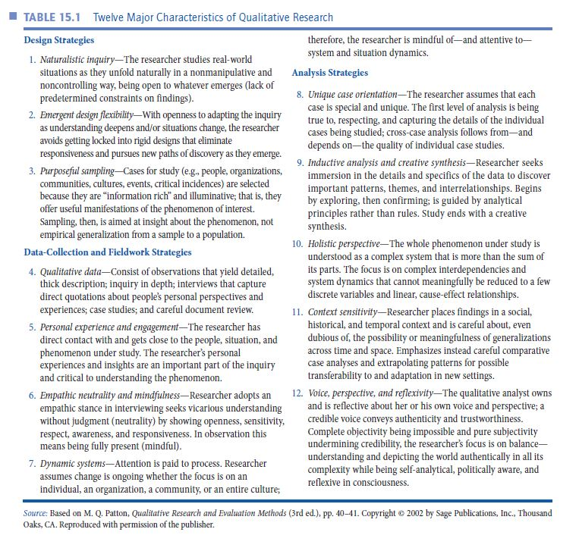

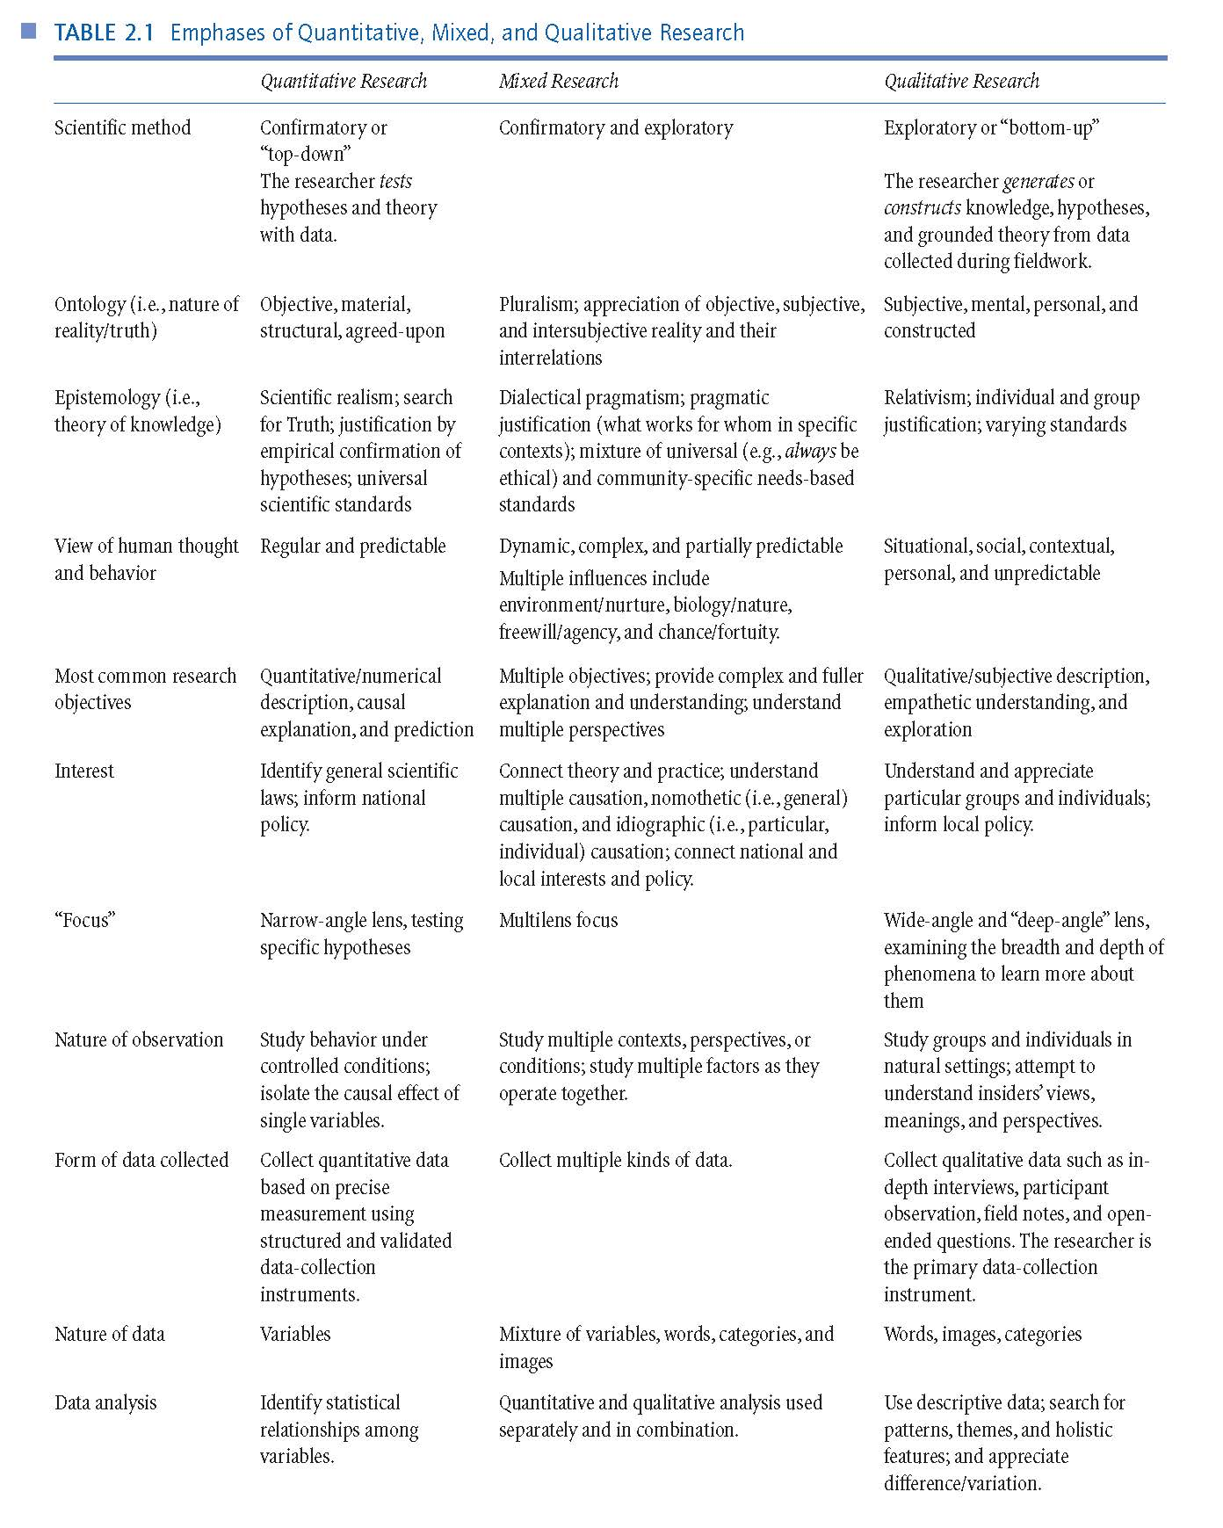
Another good summary that you should review now was shown in Chapter 2 in Table 2.1.
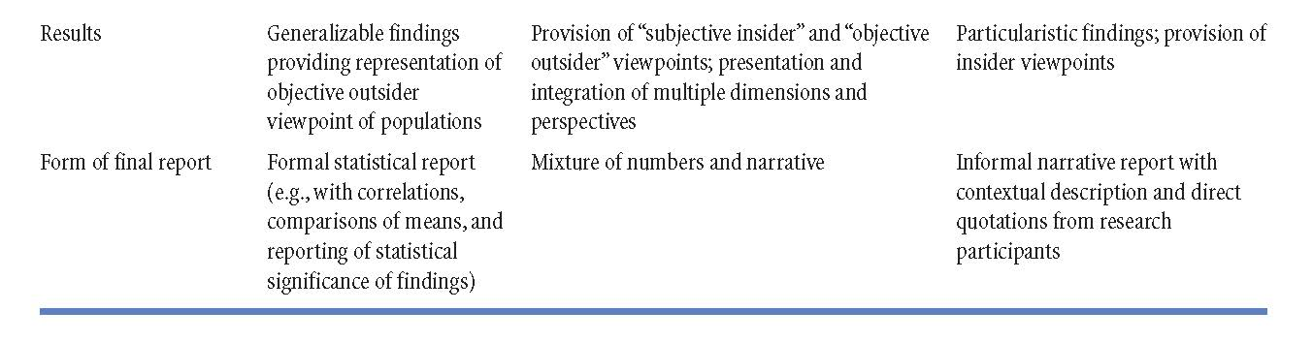

15.2 Why is it said that qualitative research does not follow a series of steps in a linear fashion?
One reason is because of the characteristic of qualitative research called emergent design flexibility (it is the second of the characteristics shown in Table 15.1). Another reason is because, unlike quantitative research, qualitative research opposes reducing research to a series of steps. Qualitative researchers tend to collect some data, analyze those data, and then continue this cycle until some closure is obtained. This is part of what is called extended fieldwork and interim analysis.
15.3 Why is qualitative research important for educational research?
If you look again at the two major scientific methods (exploratory and confirmatory) and the five major objectives of science (in Chapter 1) you will notice the importance of theory generation and exploration. Qualitative research is especially strong in describing and exploring phenomena and generating tentative explanations. Furthermore, qualitative research is very helpful in adding new dimensions of understanding (e.g., understanding groups from the insider’s perspective, understanding the importance of local context, studying complicated processes that occur over time, etc.).
15.4 What is poststructuralism, and what is postmodernism?
Poststructuralism is a historical intellectual movement that rejects universal truth and emphasizes differences, deconstruction, interpretation, and the power of ideas over peoples’ behavior. It rejects parts of but not all of the movement called structuralism. Postmodernism is a historical intellectual movement that constructs its self-image as in opposition to modernism; postmodernism emphasizes the primacy of individuality, difference, fragmentation, flux, constant change, lack of foundations for thought, and interpretation. Postmodernism fully rejects the movement they call modernism.

15.5 What are the key characteristics of narrative inquiry?
The key characteristics of narrative inquiry are the researcher and the participants using stories as lived and told to understand experience. In narrative inquiry, there is an understanding that the researcher and the participant both contribute to the developing narrative. Narrative inquiry begins with individuals telling stories as well as looking at people’s living stories. The process then becomes one of the researcher and participants jointly developing the narrative of the events. Narrative inquiries strive to answer research puzzles rather than research questions. Narrative inquiry encompasses time (the passing of time as well as the experience of time), social experiences (personal and social dimensions), and place (specific situations and geographical locations).

15.6 What are the key terms used in narrative inquiry?
Living stories: the experiences that individuals live out as stories.
Telling stories: the stories that individuals tell to others about their experiences.
Retelling stories: the results of researchers coming alongside participants and inquiring into lived and told stories.
Reliving stories: researchers and participants live differently and are changed through the process of retelling stories.
Personal justification: researchers’ reasons for conducting a narrative inquiry.
Practical justification: the ways that a narrative inquiry can impact practices.
Social and/or theoretical justification: the contribution of the research to theory and improving social justice.
Research puzzle: the process that guides narrative inquiry by focusing in on the experiences the researcher wants to understand more fully.
Being in the midst: attending to the temporal, place, and relational aspects of reality.
Field: the inquiry space created between researchers and participants during a narrative inquiry.
Filed texts: the data that emerge from a narrative inquiry.
Research texts: final representations of a narrative inquiry that is made public for a wider audience.
Interim research text: the evolving research report or text that is continually revised during the narrative inquiry.
Relational ethics: caring for and paying attention to participants’ experiences in responsible and responsive ways.

15.7 What are the key characteristics of case study research?
Here is the foundational question in case study research: What are the characteristics of this single case or of these comparison cases.
- Case study research is eclectic.
- It uses the conceptual organizer of “case” and “cases” in delineating the world.

15.8 What is a case?
A case is a “bounded system” of interrelated parts forming a whole.
- A case may be an object or entity, an event, an activity, or a process.

15.9 Define intrinsic case study, instrumental case study, and collective case study.
  - In an intrinsic case study, the researcher is interested in understanding the particulars of a specific case.
  - In an instrumental case study, the researcher is interested in understanding something more general than the particular case.
  - In a collective case study, the researcher is interested in comparing multiple cases in a single research study.

