SPSS APPENDIX
Social Statistics for a Diverse Society, 9th edition

We include in this appendix SPSS instructions for two standard procedures: selecting cases and computing a new variable. All screen shots are based upon GSS18SSDS-A, the GSS dataset that accompanies our text.

I. Selecting Cases

Suppose you are interested in examining the data only for the sample of women. The variable SEX has two categories: 1 – males and 2 – females.

In SPSS, go to Data – Select Cases. Select the box labeled, “If condition is satisfied” and click on “If”. You will see another window labeled “Select Cases: If”. In the variable listing, select the variable SEX and indicate that you would like to examine all cases where SEX = 2 (refer to Figure 1).

Figure 1.

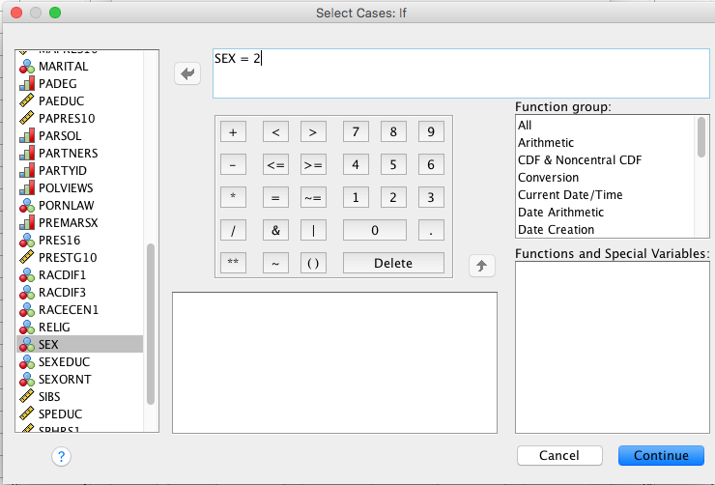

Click on “Continue” and you’ll return to the original Select Cases window.

Click “OK”.

In the data window, you’ll see slash marks in the first column of numbers (Figure 2). These slash marks indicate the cases where SEX = 1 (males). The unmarked rows indicate instances where SEX = 2 (females). You can proceed with your analyses from here.

Figure 2.

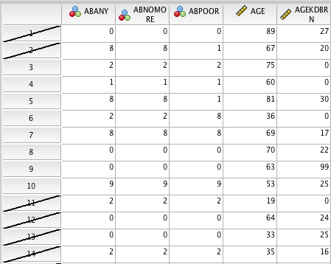

To allow analyses of all cases (men and women), return to the Select Cases box and select “All Cases”.

II. Recoding Variables

SPSS has two options for recoding variables. You may recode into the same variable- changing the values, but not the name of the variable OR you may recode into a different variable – changing the values and creating a new variable name. We recommend recoding into a different variable, allowing you to retain the original variable that your recode is based upon.

For our recoding example, let’s take a look at the interval measure of educational attainment, EDUC. The frequencies for EDUC are presented below in Figure 3.

Figure 3.

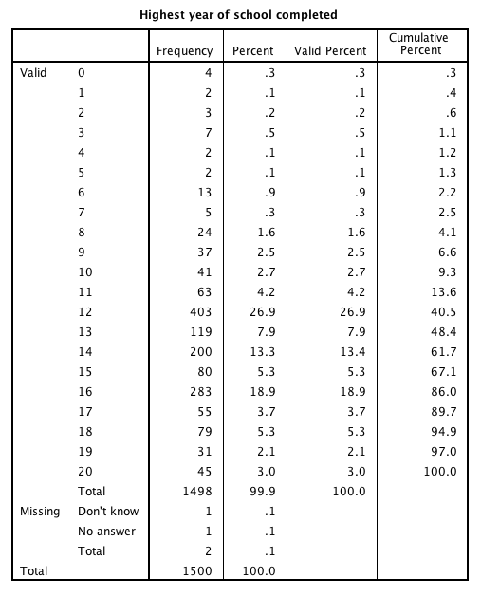

Let’s say we decided to recode EDUC into REDUC, on ordinal measure with the following categories:

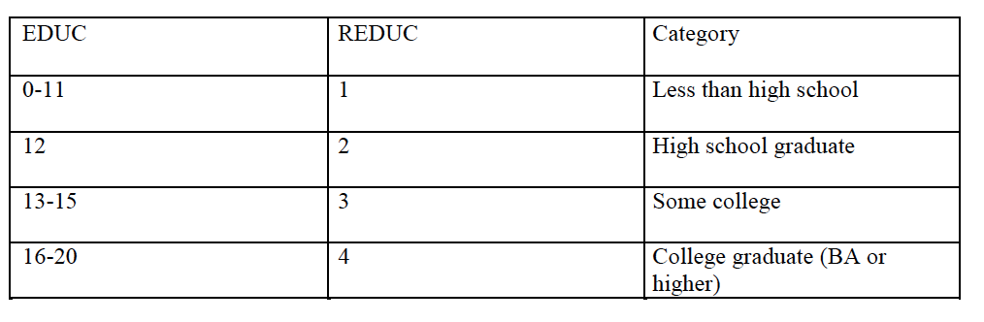

In SPSS, select Transform-Recode into Different Variables. Select EDUC as your input variable, and type REDUC (recoded education) as your output variable (click on “Change” to confirm the new variable name).

Select “Old and New Values”. A new window will appear. Here, you will select whichever old values (from 0 to 20) of the input variable (EDUC) you wish to condense or recode into the values (from 1 to 4) of the output variable (REDUC). Notice that you may select one value at a time or a range of values. Begin by selecting “range”. In the boxes below, enter 0 and 11, respectively. Now, on the right side of the box, under “new value”, select “value” and enter 1. Move your cursor down, and select “add”. Repeat until your figure resembles Figure 4.

Once you have created the four new categories, choose “all other values” and recode as “System-missing”, to ensure that the SPSS accounts for all possible cases.

Figure 4.

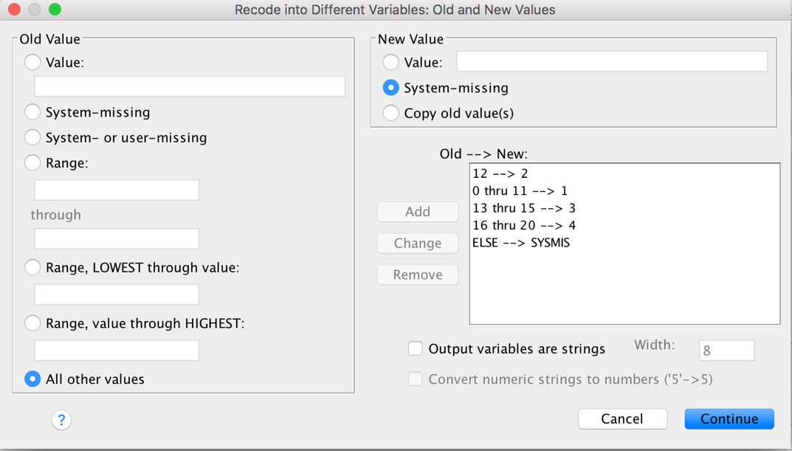

Click “Continue”. When you return to the Recode into Different Variables window, click “OK”.

In Data View, your new variable is placed in the last column (or maybe placed in alphabetical order, depending on your SPSS settings).

To confirm that your recode is correct, you may want to run a frequency of REDUC (Figure 5) and compare the results with the EDUC frequency.

Figure 5.
