Using and Promoting the Development of the Profession of Evaluation
Excerpt from Essentials of Utilization-Focused Evaluation (Sage, 2015)
pp. 26-27
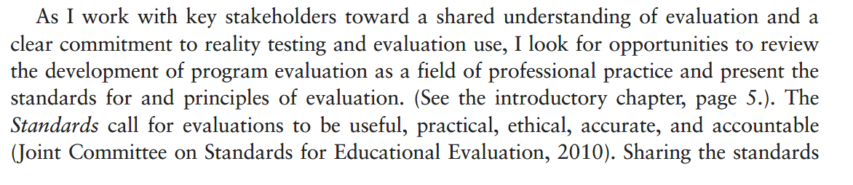
See below
