Applying the Concept Answers
Applying the Concept 7-1: Principles of Organization
Identify which organizational principle or principles are represented by each statement.
A. Unity of command and direction
B. Chain of command
C. Span of management
D. Division of labor
E. Coordination
F. Balanced responsibility and authority
G. Delegation
H. Flexibility
1. “Tom told me to use his computer to get some information for him. But when I got to the computer, it was turned off, and when it booted up, I didn’t have Tom’s password, so I couldn’t get the information.”
F. Balanced responsibility and authority. The employee was not given the password; therefore, the assignment was delegated without authority.
2. “Tonya handles all the accounts receivable transactions, and Ed does all the accounts payable transactions.”
D. Division of labor. They specialize by business accounting functions.
3. “I know it will be difficult to supervise 19 employees reporting to you, Brenda, but by cutting two managers, we all have to take on more employees.”
C. Span of management. The number of employees reporting to a manager is the span of management.
4. “He is a good customer, Helen, so make him happy and ignore the rule and give him a cash refund without the sales receipt.”
H. Flexibility. Being allowed to breaking rules is being flexible.
5. “To make your job more interesting, Sean, I’m going to assign a new task to you.”
G. Delegation. Assigning a new task is a delegation.
6. “My department manager, Rick, tells me to do one thing, but my project manager, Betty, tells me to do something else at the same time. Whom should I listen to?”
A. Unity of command and direction. Having two bosses violates the unity of command principle.
7. “I need Carlos to do some research for me, but as a middle manager, I can’t give an operative employee a direct order to do it. I have to have my supervisor, Chris, give Carolos the assignment for me.”
B. Chain of command. The manager is following the downward chain of command.
8. “The ambulance is on the way. Latina, call Dr. Rodriguez and have her get to emergency room A in 10 minutes. Arron, prepare emergency room A. Juan, get the paperwork ready.”
E. Coordination. The head nurse is coordinating the organization’s resources through ordering or instructing employees to do their jobs rather than truly delegating new tasks to them.
Applying the Concept 7-2: Authority
Identify the type of authority referred to in each statement.
A. Formal
B. Informal
C. Centralized
D. Decentralized
E. Line
F. Staff
9. “I like your creative idea for a new product. I’ll talk to the boss, and if Jamal likes it, he’ll let us present the idea to his boss Ginna.”
A. Formal. They are following the formal chain of command.
10. “When I recommend good sales rep job candidates to the marketing manager, I get angry when Sam does not hire them.”
F. Staff. This is a human resources staff person who is advising and assisting with hiring for the marketing department.
11. “Everyone throughout the organization is encouraged to share information and knowledge with everyone else to get the job done.”
B. Informal. Within the informal organization, people develop patterns of relationships and can communicate outside the chain of command.
12. “Hu, it’s time to o stop making pencils and start making pens.”
E. Line. This is a line manager giving production instructions to an employee.
13. “ Being a manager here is great because we have the autonomy to run the department the way we want to.”
D. Decentralized. Having autonomy to run the department is decentralization.
14. “Don’t forget. Don’t take any action until you check with me for my approval first.”
C. Centralized. The higher level manager is going to make the decision--micromanagement.
Applying the Concept 7-3: Departmentalization
Identify the type of departmentalization illustrated by each organization chart.
A. Functional
B. Product (service)
C. Customer
D. Territory (geographic)
E. Matrix
F. Divisional
Proctor & Gamble
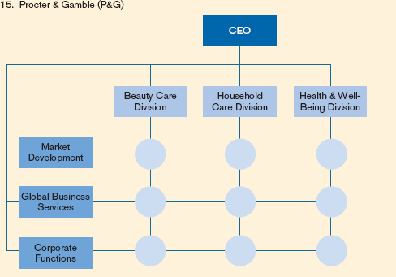
E. Matrix. Three left activities are provided for all three divisions making it a matrix.
Chicago CC
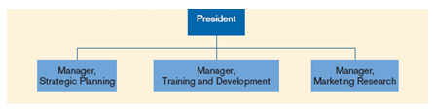
B. Product (service). The company is a consulting firm. These are services it offers to its clients. These are not internal functions.
Digital PC
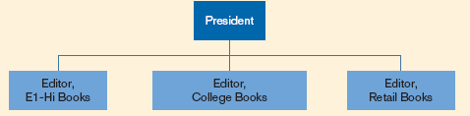
C. Customer. The customers have different needs. The books sold to each type of customer are different.
Worldwide Marriage Encounter–USA
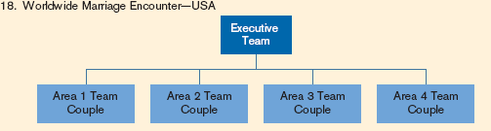
D. Territory. These are departmentalized by geographic areas.
Latino International
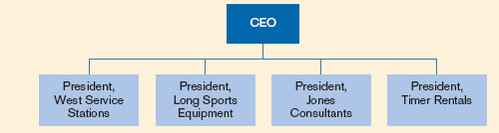
F. Divisional. These are business units in a conglomerate structure.
Toys For U Production Department
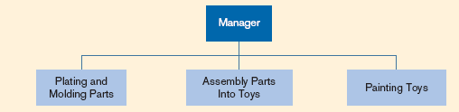
A. Functional. These are internal activities within a functional area of production stages.
Applying the Concept 7-4: Job Designs
Identify which job design technique is exemplified in each statement.
A. Job simplification
B. Job rotation
C. Job enlargement
D. Job enrichment/job characteristics model
E. Work teams
21. “Elan, I’d like you to learn how to run the monthly budget reports for Kramer while he is on vacation.”
B. Job rotation. The person will do his or her usual job, then rotate to budgeting, and rotate back to his or her usual job.
22. “ I’d like you to work together to come up with ways to improve how your jobs get done.”
E. Work teams. The manager is asking the department members to act as a team to redesign jobs
23. “Jamal, would you like me to delegate a new task to you to make your job more challenging?”
D. Job enrichment. Delegating challenging tasks is a simple way to enrich jobs.
24. “You will be given $50 per day for meals when you travel, so you no longer need to provide receipts.”
A. Job simplification. This is eliminating paper work.
25. “Waneta, I want your job to be less repetitive So you will be trained to add a couple new tasks to your job responsibility.”
C. Job enlargement. Adding new tasks to a job is enlarging it.

