Activity 1-1
- A; the answers would be centered around chance performance (5/10)
- B
- statistics, parameters, sampling error
- C
- B

X f OR X f
10 0 0 0
9 0 1 1
8 1 2 1
7 3 3 8
6 2 4 5
5 7 5 7
4 5 6 2
3 8 7 3
2 1 8 1
1 1 9 0
0 0 10 0

- C. N = 28 (add up the frequencies in the f column)
- B
- B. 22/28 = 78.57%
- B (Note that this study was not looking at the therapeutic value of actual physical touch)
- B
- 937
- 48
- 5.1%
- 14
- 1.5%
- 15.4%
- 41.9%
- 9
- 2
- 71.3%
- 15.9%
- C. 12 (years to complete high school) & D. 16 (Years to complete college)
- 12 years
- 27.4%
- 30% (100%-70%)
- 17%
- Slightly negative

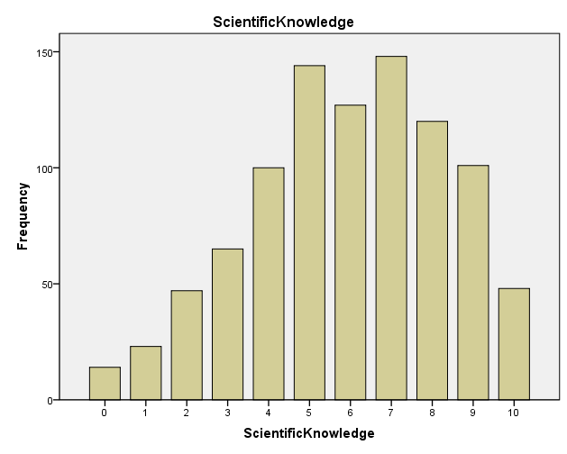

- Positively skewed
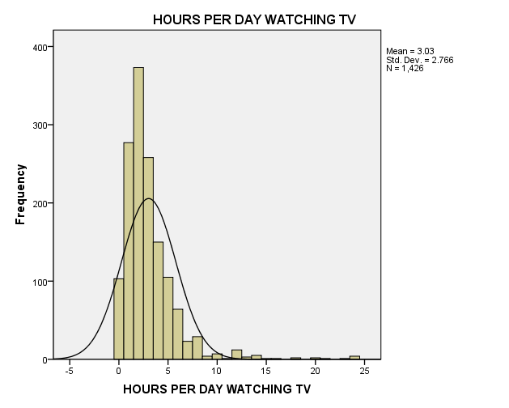

- Slight positive skew
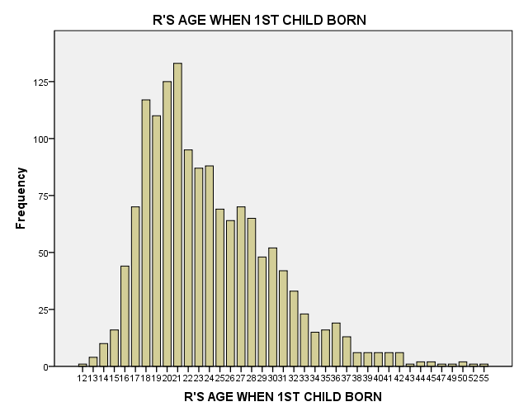

- Almost bell shaped (normal).
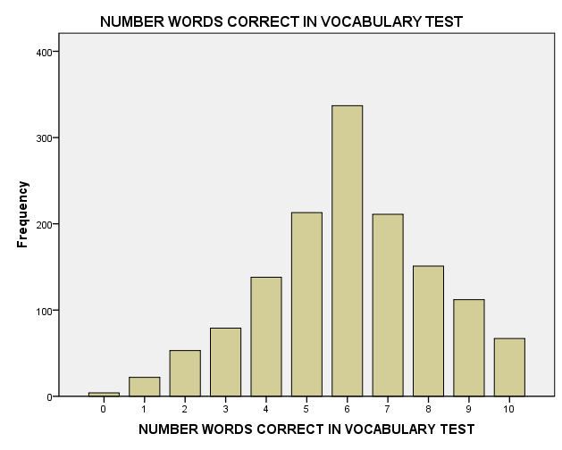

- Leptokurtic
- Negatively skewed
- Ordinal
- interval/ratio
- nominal
- interval/ratio
- nominal
- ordinal
- interval/ratio
- Discrete
- Discrete
- Continuous

Activity 2-1

Known Typos: the figure on page 56 has 2 12’s it should only have 1 12.

- X f
------------
5 1
4 3
3 3
2 2
1 1

- Frequency bar graph of the data.

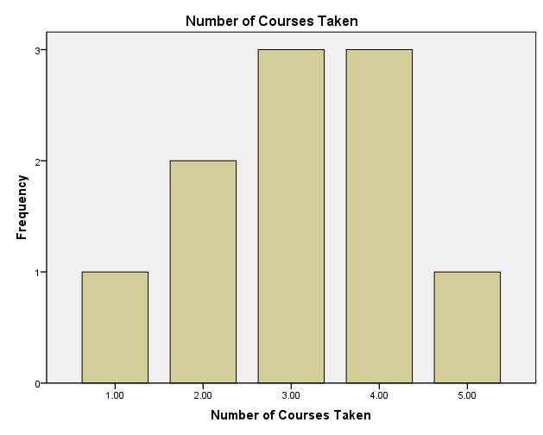
- 3.1; Answers are in the activity in the paragraph after question 3.
- 3; Answers are in the activity in the paragraph after question 3.
- Both 3 and 4
- Mean
- Mode
- Median
- Mean
- Median
- Median
- A
- C
- C. The mode is the only option because it is nominal data. It is fine as a measure of central tendency, but it misses the most important aspect of the data. Although 460 correctly disagreed with the false statement, “Do you agree that patients’ memories of past events are improved by hypnosis?”, 408 psychologists agreed with this false statement.
- A
- B
- B
- There are 16 scores total.
- 10 (answer is in the text)

Scores Below the Mean
Score | Deviation  (X-M)
8 | 8-10 = -2
8 | 8-10 = -2
9 | 9-10=-1
9 | 9-10=-1
9 | 9-10=-1
9 | 9-10=-1
∑(X-M) = -8
Scores At the Mean
Score | Deviation  (X-M)
10 | 10-10=0
10 | 10-10=0
10 | 10-10=0
∑(X-M) = 0
Scores Above the Mean
Score | Deviation  (X-M)
11 | 11-10 = 1
11 | 11-10 = 1
11 | 11-10 = 1
11 | 11-10 = 1
11 | 11-10 = 1
11 | 11-10 = 1
12 | 12-10 =2
∑(X-M) = 8

- The sum for all negative deviation scores = -8
The sum for all positive deviation scores = +8
- 0
- 5; Answer in text
- 2-5 = -3
3-5 = -2
3-5 = -2
4 – 5 = -1
4 – 5 = -1
4 – 5 = -1
4 – 5 = -1
4 – 5 = -1
4 – 5 = -1
- -13
- 6-5 = 1
6-5 = 1
6-5 = 1
7-5 = 2
7-5 = 2
8-5 = 3
8-5 = 3

- 13
- 0

- A

X f
2 0
3 2
4 5
5 1
6 1
7 0
8 1

- 4 and 6
- 4.5 (average of 4 and 5, the middle two numbers); 2, 3, 4, 4, 4, 5, 5, 6, 6, 6,
- M = 45/10 = 4.5

Score | Deviation Scores: (X − M)
2 | 2-4.5 = -2.5
3 | 3-4.5 = -1.5
4 | 4-4.5 = -.5
4 | 4-4.5 = -.5
4 | 4-4.5 = -.5
5 | 5-4.5 = .5
5 | 5-4.5 = .5
6 | 6-4.5 = 1.5
6 | 6-4.5 = 1.5
6 | 6-4.5 = 1.5

- 0
- C
- B

Activity 3-1
- A, B, C
- A, B, D
- B
- B
- B
- B
- C
- A
- B
- A
- B
- A
- B
- C
- B and C
- B
- C
- A
- A
- A has more variability because more of the scores are further from the mean.
- Same amount of variability.
- B has more variability (note the range of values on the x-axes for the two graphs).
- B
- A
- 68.75
- 68.75
- 4.79
- 4.15
- Don’t skip this! It will save you a lot of time if you figure out how to use the statistics mode on your calculator. If you don’t have a manual for your calculator, you can search on the internet for people explaining how to use your specific model of calculator.
- SD = 2.07, SS = 17.20
- σ = 2.04, SS = 20.81
- A

X | f
1 | 1
2 | 2
3 | 10
4 | 2
5 | 1

- σ = .87
- B
- SD = .89

Activity 4-1
Known Typos: Q15—the third row in the table, the word “lower” should be replaced with “higher”

- C
- A
- .1151
- .7734
- .7454
- .0495
- z = -.77, p = .7794 (Memory test)
- z = -3.37, p = .9996 (Object naming tests)
- z = -.38, p = .3520 (Stroop, attentional test) (lower time to complete the task means that people who did better than average had lower z-scores and so you should look at the tail)
- He should focus on the object naming tests and the memory test. Henry’s score was dramatically worse that the population on those tests (99.96% and 77.94% of people do better than him on the test). Henry scored better than average on the Stroop test (remember, lower numbers mean better performance).
- Be sure the values are located correctly on the graph. Use the raw score number line to place each X value.
- Most likely 98.0, 97.5, 96.9, 96.5 Least likely
- A and c

Temperature | 98ºF | 97.5ºF | 96.9ºF | 96.5 ºF
z-score | -.33 | -1.17 | -2.17 | -2.83
Probability of  z-score or a  more extreme z-score | .3707 | .1210 | .0150 | .0023

Temperature | 98.4ºF | 98.9ºF | 99.5ºF | 99.9 ºF
z-score | .33 | 1.17 | 2.17 | 2.83
Probability of  z-score or a  more extreme z-score | .3707 | .1210 | .0150 | .0023

- Should have drawn a vertical lines at +1.96 and -1.96.
- The section of the curve between the z-scores of +1.96 and -1.96 is “likely” and the tails of the distribution are “unlikely”.
- The temperature cutoff for the z of +1.96 = 99.376
The temperature cut off for the z of -1.96 = 97.024

19. 96.9, 96.5 99.5, 99.9

Activity 5-1
- B
- 64.5
- A
- A
- B
- B
- A
- A
- 5
- 2.24
- Population mean
- 5
- 1.58
- A
- 6, 7, 8
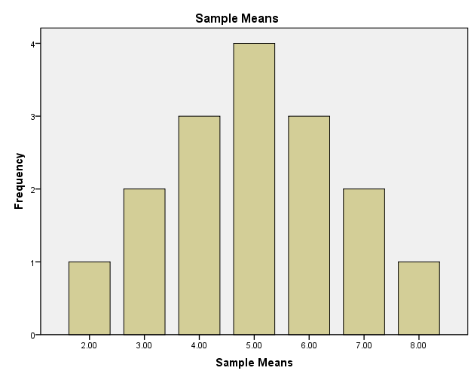

- A
- You are most likely to get sample means that are close to 5. When taking all random samples with N = 2, the sample means cluster around the population mean of 5.
- B and C
- A
- 5
- 1.58
- A
- C
- B
- A
- 16 and 5
- C
- 16
- 5/√5 = 2.24
- B
- A
- B
- B
- 16
- C
- A
- Mean is 16 and the standard deviation is 2.24
- A
- B
- A and D
- C. The standard error is a measure of sampling error. It tells us the amount of variability we would expect between the population mean and our sample means. We want this number to be low because we want our samples to accurately represent the population.
- SEM = 5/√25 = 1
- A
- A
- B
- Mean is 8.08 and the standard deviation is SEM = 6.22/√25 = 1.24
- B
- B
- Answers will vary
- Answers will vary. The mean will be the same as the mean in #49. The SEM will be the standard deviation divided by the square root of 25.
- B
- B
- Normal (bell-shaped), increases
- A

Activity 5-2
- Sampling error is the difference between a sample’s statistic and a population’s parameter.
- C & D
- B
- Body temperature with a sample of 9 people
µ = 98.2; σ = .6; N = 9

Raw scores—sample means
97.8 98.0 98.2 98.4 98.6
z-scores
-2 -1 0 1 2

- Body temperature with a sample of 36 people
µ = 98.2; σ = .6; N = 36
Raw scores
98.0 98.1 98.2 98.3 98.4
z-scores
-2 -1 0 1 2

- Body temperature with a sample of 100 people
µ = 98.2; σ = .6; N = 100

Raw scores
98.08 98.14 98.2 98.26 98.32
z-scores
-2 -1 0 1 2
- A
- A
- .6826
- a. 98.0 and 98.4; b. 98.1 and 98.3; c. 98.14 and 98.26
- A.
- z = (44-45) / (6/√27) = -1/1.15 = -.87; probability = .1922;
- The probability of the z score is greater than .05 in question 12, so this sample mean is likely to have come from a population of full term toddlers.
- z = (205-208) / (15/√100) = -3 / 1.5 = -2.0; probability = .0228 and so this sample mean is unlikely to have come from the target population
- z = (1004.5 – 1003) / (25/√105) = .61; probability = .2709 and so this sample mean is likely to have come from the target population
- Because the samples are not truly random.
- A. z = -1, 15.87%;
- A. z score for 62 inches z = -1, 15.87% of the population are less than 62 inches tall; z score for 68.5 inches z = 2.25, 1.22% of the population are greater than 68.5 inches tall, therefore the total percent of the US female population whose height is outside of the safest range is 17.09%
- B. z = -2.5, .62%
- B., z = 2.07, .0192
- A. top third, z = .44, x = 28.28; bottom third, z = -.44, x = 25.72
- Answers above

Activity 6-1
- C, D, A, B
- H₀ is d, H₁ is a
- H₀ is c, H₁ is b
- 1.65

- 61-50=11
- 20/√16 = 5
- 11/5=2.20
- .0139
- A
- A
- (61-50)/20 = .55
- Medium
- Science test scores were significantly higher in the sample that received the tutoring program (M = 61.00, SD = 21.00) than in the population (µ = 50.00, σ = 20.00), z (N = 16) = 2.20, p = .01, d = .55.
Note--you look up the exact p value for a z of 2.20 and report p = .0139.
- B
- D
- 50
- Sampling error--- sample statistics don’t perfectly represent population parameters.
- Standard error of the mean (SEM_{p}) = 20/√16 = 20/ 4 = 5.
- A
- This should be a normal distribution with a mean of 50 and a standard deviation of 5.
- See figure in activity below question 36 for an example.
- The line should be at 1.65. See figure in activity above question 36 for an example.
- D
- B
- A
- B
- A
- 50
- B. We can only expect a range of values if the research hypothesis is true, in this case we expect to get a z-score for the sample mean that is positive but we don’t know how far from zero it will be.
- A
- 61 (the sample mean)
- C
- B
- B
- B
- See graph in assignment below #37
- See graph in assignment below #37
- Type I error [rejecting a true null] = B
Type II error [failing to reject a false null] = C
Statistical Power [rejecting a false null] = D
Failing to reject a true null = A
- d = (61- 50)/ 20 = .55
- medium
- The sample mean for people who received the tutoring is .55 standard deviations above the population mean of people who did not receive the tutoring.
- b

Activity 6-2
- independence = c, measurement = d, normality = b, homogeneity of variance = a
- B is H₀, A is H₁
- A
- SEM = σ/√N = 9/√36 = 1.5
- A
- A
- C
- A
- B
- B
- C. (19.2 – 16)/1.5 = 2.13
- A
- B
- B
- C
- A
- A
- B
- B
- B
- B
- A
- B
- A

Activity 6-3
- Sample means are generally less variable than populations of individual scores. The central limit theorem makes this point.
- 50
- True
- 2
- True
- a
- b
- a
- a
- a
- a
- c
- a
- c
- b
- a
- b
- z = (52-50)/ (10/√25) = 2/2 = 1
- It would be located at 1 on the z score number line which is NOT in the critical region.
- b
- b
- The curve on the left is the null curve; the curve on the right is the research curve; The null curve is centered on the population mean because if the treatment does not work at all you would expect the sample mean to be the same as the population mean. The research curve centered on the actual sample mean from the study because that is our best guess at what the population mean would be if everyone in the population got the same treatment that the sample got.
- a
- b
- 52, z = 1
- b
- a
- b
- a
- Type II error = .740; Statistical Power = .260
- a
- a
- The new Statistical Power value = .912; The new Type II error rate = .088
- Increasing the treatment effect increases statistical power and decreases Type II error rate. Decreasing the treatment effect decreases statistical power and increases Type II error rate.
- The statistical power = .26 and Type II error = .74.
- z = (52-50)/ (10/√100) = 2/1 = 2
- a
- a
- b
- c
- When N = 25, power = .26 and Type II error rate = .74; When N = 100, power = .639 and Type II error rate = .361.
- Increasing sample size increases statistical power and decreases Type II error rates. Decreasing sample size decreases statistical power and increases Type II error rates.
- b
- b
- Increasing α to .05 will increase statistical power, make the Type I error rate 5%, and decrease Type II error. Decreasing α to .01 will decrease statistical power, make the Type I error rate 1%, and increase Type II error.
- Type II error rate = .74; Power = .26
- Type II error rate = .361; Power = .639
- If measurement error is decreased statistical power will increase and Type II error rate will decrease.
- The answer is A. If they made the sample size inappropriately large they would have so much statistical power that even a very small treatment effect could be found to be statistically significant. It is possible to have too much statistical power. If a treatment is only slightly better and a company used a very large sample so that the small difference would be statistically significant it may mislead people to think that the drug is more effective than it really is. This is why it is a good idea to compute an effect size when evaluating a how effective a treatment is.
- The answer is C. You could compute an effect size and show the doctors that the actual effect sizes of the two drugs are very similar and then point out that your drug costs less.
- The answer is A. The cost of saying the drug works when it does not is not that great because no alternative treatment is currently available. The relative cost of a Type II error is large however, saying the treatment does not work when it really does would prevent people from getting a treatment that could help them (remember no other treatment currently exists).
- The answer is B. No, we already have effective treatments for a cough. The higher risk of a Type I error is not worth it.
- The researchers who conducted study #3 rejected the null, used an appropriately large sample size of 210, and obtained a large effect size (d = 1.2). Clearly, these researchers have the most evidence for a successful treatment. It is not as clear which research is has the next best evidence. Researcher #2 has the next largest effect size (d = .92) and also rejected the null. However, their study used only 15 participants. A larger sample would be more convincing. Researcher #5 had the next largest effect size (d = .67) but had only 9 participants. Researcher #4 has a slightly lower effect size (d = .57) and did reject the null with a sample size of 430. Considering effect size, the results of the significance test and sample size Researcher #4 seems to have the next best program for the second grant.

Activity 6-4
- D
- A, C, E, H
- Independence = d, appropriate measurement = b, normality = c, homogeneity = a
- H₀ is D; H₁ is A
- H₀ is C; H₁ is A
- 1.65
- SEM = 10.9/√33 = 1.897; z = (76=74)/1.897 = 1.05
- D
- B
- (76-74)/10.9 = .18
- small
- A
- A
- B
- A
- D
- A
- B
- Independence =a, appropriate measurement = b, normality = d, homogeneity = c
- H₀ = C; H₁ = A
- 1.65
- $SEM= \frac{σ}{\sqrt{n}}= \frac{10.4}{\sqrt{33}}=1.81$ $z=\frac{M-μ}{SEM}= \frac{81-77}{1.81}=2.21$
- A
- B
- .38
- Small-medium
- B
- The analysis of Exam 2 scores suggests that the self-test strategy is beneficial. The current students who were trained to test themselves while studying for exams had higher scores (M = 81) than the previous students who did not receive the training (μ = 77, σ = 10.4), z (N = 33) = 2.21, p = .0136, d = .38.

You get the p value by looking up the z score in the unit normal table.

- A
- C
- D
- B
- B and C
- B
- B
- B
- C
- A and B
- A

Chapter 6 Practice Problems (Done)

- Reject the null
- Fail to reject the null
- Fail to reject the null
- Fail to reject the null
- Reject the null
- Fail to reject the null
- Fail to reject the null
- Reject the null
- A
- B
- B
- A
- B
- A
- A
- Type I
- Type II
- Increase Sample Size
- Decrease measurement error
- .05
- .05
- The sample size was too small to detect the effect
- If the treatment really has no effect (i.e., Type I error) it is very unlikely to repeatedly obtain sample means in the critical region.

Activity 7-1
- Independence = D; Appropriate measurement of IV and DV = B; Normality = C; Homogeneity of variance = A
- B
- A
- B
- B
- t = -2.412 = (874.17-1247)/535.56/√12)
- d = (874.17-1247)/535.56 = -.70
- medium-large
- B
- A. The students’ scores (M = 874.17, SD = 535.56) were significantly lower than the population (μ = 1247), t (11) = -2.41, p < .05 (two-tailed), d = -.70.
- A
- A (you use the p value rule instead of the critical region rule)
- A
- C
- A
- C, B, A, D
- B
- A
- C
- D
- B

- t = (1198-1247) / (654/√1150) = -2.541
- d = -49/654 =-.0749
- small effect
- The mean stress score for the 1150 students attending a women’s college (M = 1198, SD = 654) is significantly less than the college student population mean stress score (µ = 1247), t (1149) = -2.54, p < .05 (one-tailed), d = -.07. Although the effect was statistically significant, it was very small.
- D
- A
- A & C
- True
- A & C
- Single sample t
- z for a sample mean
- no # 33 in book
- Single sample t
- z for a sample mean
- single sample t
- z for a sample mean

Chapter 7 Practice Problems
Scenario 1
1. B
2. C
3. C
4. A
5. 9
6. A
7. (36.1 – 35) = 1.1
8. 5.587 / √10 = 1.767
9 t = 1.1 / 1.767 = .623
10 No
11. d = 1.1 / 5.587 = .197
12. small
13. A

Scenario 2
14. The difference between sample mean and the comparison group mean may have been caused by sampling error. A significance test is needed to determine if the difference between the means was likely or unlikely to have been created by sampling error.
15. Null: µ_{Ginko} ≤ 9; Ginko biloba will not improve memory scores.
Research: µ_{Ginko} > 9; Ginko biloba will improve memory scores.
16. df = 9 – 1 = 8; critical value of t = 1.8595
17. t = (10-9)/(2.12/√9) = 1/.707 = 1.41
18. Fail to reject.
19. d = (10-9)/2.12 = .47 (medium)
20. B. The mean memory score for those who took gingko biloba (M = 10.0, SD = 2.12) was not significantly higher than the mean memory score for the comparison group (µ =9.0), t (8) = 1.41, p > .05, d = .47. These results do not support the claim that gingko biloba improves memory performance of elderly people. However the fact that the null was not rejected even though the observed effect size was medium suggests that the sample size in this study (N = 9) was too small. Further research is needed to clarify the impact of gingko biloba on memory.
- statistical power; type II error

Scenario 3
- Null: µ_{elderly} = 9; the mean memory performance for the active elderly will be the same as the mean memory performance of the population of high school students; Research: µ_{elderly} ≠ 9; the mean memory performance for the active elderly will not be the same as the mean memory performance of the population of high school students.
- df = N – 1 = 20 – 1 = 19; critical value = 2.093
- t = (10.15 – 9.0) / ( 1.69/ √20) = 3.035
- A; reject the null
- d = 1.15 /1.69 = .68 ( medium-large)
- The memory performance of the active elderly (M = 10.2, SD = 1.7) was significantly better than the mean memory for performance of the high school students (µ = 9), t (19) = 3.04, p < .05(two-tailed), d = .68.

Scenario 4
- Null: µ_{Golfer} > 9; The golfer’s average number of putts is not less than 9
Research: µ_{Golfer} > 9; The golfer’s average number of putts is less than 9
- df = (N – 1) = 6, critical value = 1.9432 (with an alpha of .05)
- t = (5.85-9)/(1.35/√7) = -6.18
- d = (5.85-9)/1.35 = -2.33 (large)
- The golfer’s average number of putts (M = 5.85, SD = 1.35) was significantly less than 9, t (6) = -6.18, p < .05(one-tailed), d =-2.33.
- Use SPSS to confirm your results

Scenario 5
- Null: µ_{golfer} = 72; the mean score for the golfer is the same as par
Research: µ_{golfer} ≠ 72; the mean score for the golfer is not the same as par
- df = N – 1 = 17 – 1 = 16; critical value = 2.1199 (with an alpha of .05)
- t = (75.5 – 72) / ( 2.1/ √17) = 6.87
- d = (75.5 – 72) / 2.1 = 1.67 (large)
- The golfer’s mean score (M = 75.5) was significantly worse than par (72), t (16) = 6.87, p < .05 (two-tailed), d = 1.67
- Use SPSS to confirm your results.

Activity 8-1

- B
- B
- -2.0096 and + 2.0096
- 95% with N = 15; 2 tailed .05; -2.1448 and +2.1448
99% with N = 15: 2 tailed .01; -2.9768 and +2.9768
- 95% with N = 50: 2 tailed .05, -2.0096 and +2.0096
99% with N = 50: 2 tailed .01, -2.6800 and +2.6800
- C
- Population mean, sampling error, confidence interval
- 34.58
- A
- 59
- (4/√15)(2.1448) = 2.215
- UB = 59 + (4/√15)(2.1448) = 61.215
- LB = 59 - (4/√15)(2.1448) = 56.785
- C
- 59
- (4/√15)(2.9768) = 3.074
- UB = 59 + (4/√15)(2.9768) = 62.074
- LB = 59 - (4/√15)(2.9768) = 55.9256
- C
- 59
- (2/√15)(2.1448) = 1.108
- UB = 59 + (2/√15)(2.1448) = 60.108
- LB = 59 - (2/√15)(2.1448) = 57.892
- A
- B
- B
- wider, lower
- 50,000
- (500,000/√50)(2.0096) = 142100.18
- 50,000+142100.18 = 192100.18
- 50,000-142100.18 = -92100.18
- C
- Lowest = 1; Highest = 5
- C
- 3.40
- Sampling error
- B
- A
- B
- A
- A
- A
- B
- A is H₀, B is H₁
- B
- D
- B
- C
- C
- A
- B
- -.30, sampling error
- A
- C
- The average job satisfaction rating of the 35 employees was (M = _3.40_ , SD = _1.58_ ), 95% CI [_2.86_, _3.94_] was not significantly lower than the overall corporation mean of 3.7, t (_34_) = _-1.13_, p = _.134_, d = _-.19_, 95% CI [_-.84_ , _.24_].
- Did you try it? You really should.

Activity 9-1
- B, C, A
- A
- A; if treatment works to decrease cell phone use while driving Before should have a higher value than After, so subtracting Before – After should result in a positive difference score.
- B
- A
- A
- B
- A
- A
- H₀ is F, H₁ is C
- H₀ is C, H₁ is A
- df = N -1 = 15 – 1 = 14; t_{critical} = 1.7613
reject if t_{obt} exceeds t_{critical} (i.e., if it falls in the region of rejection t_{obt} > 1.7613)
- B
- M_{D} = .333
- SEM_{R} = .159
- C
- t = 2.09
- Reject H₀
- .333/.617 = .5397
- medium effect
- M = 4.87, SD = 1.30; M = 5.20, SD = 1.474; t(14) = 2.09, p <.05, d = .54
- A
- C
- t_{critical} = 2.2622 and -2.2622
- A
- -.2
- 0
- SEM_{r} = SD_{D}/√N = 1.476 / √10 = .467
- t = M_{D} /SEM_{R} = -.2/.467 = -.429
- B
- d = |M_{D}|/SD_{D} = .2/1.476 = .1355
- small
- B and C; M = 5.9, SD = .876; M = 5.70, SD = 1.059; t(9) = -.429, p>.05, d = .1355
- D
- A
- M = 5.20, SD = 1.474; M = 4.87, SD = 1.302
- .333
- .159
- t = 2.092
- p = .055
- B
- B
- Reject
- t = -.429
- .678; -.429; null
- A
- Both researchers rejected the null and found that the manipulations were effective. Similarly, both researchers obtained large effect sizes, though the effect size for the negative feedback manipulation was higher (d = .93) than the effect size for the movie clip (d = .83). The study assessing the video clip did have a larger sample size (N = 55) than the study assessing the math test (N = 19) and so I would have more confidence in the results of the study using the video clip. Statistically, the results are very similar for these two manipulations. In order to choose a manipulation, I would need to consider the practical implications. The movie clip takes just 10 minutes and does not involve deception (ethical standards are to avoid deception if possible) while the negative feedback manipulation takes 30 minutes and requires deception. Given these issues, I would use the movie clip.
- Single sample t test
- Related samples t test
- Single sample t test
- Related samples t test
- z for a sample mean

Activity 9-2
- a is CI, b is ES, c is CI, d is ST, e is ES, f is ST
- C
- A and B
- C
- A and B
- A
- C
- C
- B
- H₁ is A; H₀ is C
- 1.8331
- Mpre = 4.00, SDpre = 1.15, Mpost = 5.10, SDpost=1.29
M_{D} = 1.10 (or -1.10) depending on how you created the Ds, SD_{D} = .738, t = 4.714 (or -4.714) depending on how you created the Ds
- B
- B
- 1.10/.738 = 1.49
- C
- C
- C
- 2.2622
- A
- LB = 1.10-(2.2622)(.233) = .572; UB = 1.10 + (2.2622)(.233) = 1.627 (these values will be negative if you computed the mean of the difference scores as -1.10.
- A
- A
- Pre: LB = 4.0 - (2.2622)(1.155/√10) = 3.17; UB = 4.0 + (2.2622)(1.155/√10) = 4.83
Post: LB = 5.10 - (2.2622)(1.29/√10) = 4.18; UB = 5.10 + (2.2622)(1.29/√10) = 6.02
- The results of the pilot study indicated that approval ratings were significantly higher after watching the commercial (M = 5.10, SD = 1.29), 95% CI [4.18, 6.02] than before watching the commercial (M = 4.00, SD = 1.15), 95% CI [3.17, 4.83], t (9) = 4.71, p < .05, d = 1.49, 95% CI [.57, 1.63]. These results suggest that the commercial may be effective because the change in attitude was statistically significant and we can be 95% confident that the true value of the attitude change is between .57 and 1.63. This is a large effect. Although these results are promising, we should be cautious in interpreting them because the sample size is too small to draw firm conclusions.
- B
- 33
- Pre = 4.9394, post = 5.5152
- Pre LB = 4.67, UB = 5.20
- Post LB = 5.25, UB = 5.79
- A
- B
- A
- H₁ is B, H₀ is A
- t (32) = 5.899, p < .001
- A and C
- A
- C
- B
- d = .57576/.56071 = .1.027
- B
- E
- C
- .57576 (might be negative, depending on how you ran the analysis in SPSS)
- LB = .37694, UB = .77458 (if your answer to 43 was negative, these values will also be negative)
- The results of the study indicated that approval ratings were significantly higher after watching the commercial (M = 5.52, SD = .76), 95% CI [5.25, 5.78] than before watching the commercial (M = 4.94, SD = .75), 95% CI [4.67, 5.20], t (32) = 5.90, p < .001, d = 1.027, 95% CI [.38, .77]. These results suggest that the increase in approval ratings is statistically significant and we are 95% confident that mean amount of attitude increase in the population is likely to be between .38 and .77. This is a large effect. A larger sample size would still be preferable, but we are much more confident in these results than the results of the pilot study.
- B
- B
- A
- A and B
- B

Chapter 9 Practice Problems (Not done, need to add CI)
- A
- C
- B
- D
- df = N-1 = 7-1 = 6
- A
- If Ds computed as Time2 – Time1: 5, 1, 1, -4, 3, 2, 5
If Ds computed as Time 1-Time2: -5, -1, -1, 4, -3, -2, -5
- If Ds computed as Time2 – Time1: M_{D} = 1.86
If Ds computed as Time 1-Time2: M_{D} = -1.86
- 0
- SS_{D} = 81-(13²/7) = 56.86
- SD_{D} = √(56.86)/6 = 3.08
- SEM_{R} = 3.08/√7= 1.16
- If Ds computed at Time2-Time1: t = 1.86/1.16 = 1.60
If Ds computed at Time1-Time2: t = -1.86/1.16 = -1.60
- d = 1.86/3.08 = .60
- medium-large
- A
- Null: µ_{D} ≥ 0; When people are depressed their p11 levels will be the same or higher than when they are manic; Research: µ_{D} < 0; When people are depressed their p11 levels will be lower than when they are manic.
- df = N – 1 = 12 – 1 = 11; critical value = -1.7959
- t = (-6.75) / (3.793/ √12) = - 6.165
- A; reject the null
- d = -6.75 / 3.793 = 1.78; large
- a; When the patients were in a manic state (M = 110.17, SD = 5.01) their p11 levels in the nucleus accumbens were significantly higher than when they were in a depressed state (M = 103.42, SD = 4.58), t (11 ) = -6.17, p < .05 (one-tailed), d = 1.78. The results support the conclusion that p11 levels in the nucleus accumbens play a role in manic depression.
- Null: µ_{D}= 0; The caloric intake of rats will be the same when p11 levels are normal and when p11 levels are elevated; Research: µ_{D} ≠ 0; The caloric intake of rats will not be the same when p11 levels are normal and when p11 levels are elevated.
- df = N – 1 = 14 – 1 = 13; critical value = -2.1604 and + 2.1604
- t = ( -1.71) / (.726/√14) = -8.83
- B; reject the null
- d = -1.71 / .726 = -2.36; large
- The rats’ caloric intake was significantly higher when their p11 levels were elevated (M = 23.29, SD = 2.37) than when their p11 levels were normal (M = 21.57, SD = 2.62), t (14) = -8.83, p < .05, d = -2.36.

Activity 10-1

Known Typos: Q4 options d and f should include an equal sign

- B, D, A, C
- A
- A
- Null is option d -- µ_{drug} > µ_{placebo}. Research is option e-- µ_{drug} < µ_{placebo.}
- Null is option d. Research is option c.
- 0
- B
- the pooled variance ( ${SD}_{p}^{2}$ ) is 362; the standard error (SEM_{i}) = 4.832
- B
- See picture below

Mean diff -14.5 -9.7 -4.8 0 4.8 9.7 14.5
t-score -3 -2 -1 0 1 2 3

critical value -1.67
- A
- Obtained t = -1.86
- A
- d = -9/√362 = .473
- Medium
- C
- -9 the mean difference you found in the sample
- -1.86
- Picture in activity under question 19
- Type I = B; Type II = D; Statistical Power = C; Failing to reject true null = A
- B
- B; closer to left tail
- Type I = decrease; Type II = increase; Statistical Power = decrease
- Type I = precise value of alpha; Type II = estimate; Statistical Power = estimate
- B
- Central Limit Theorem, null, 0, 0, research, Type I error, Type II error, Statistical Power, critical value, research hypothesis, significance test, effect size
- B; The sample size (1.5 million) is huge, which would make the standard error (the denominator of the t-test) very small. It is possible that the mean difference is actually very small but statistically significant because of the very large sample size. This statistically significant difference might be so small that is it not meaningful.

- Pooled variance for study A: $\frac{{4.21}^{2}\left(249\right)+ {4.62}^{2}\left(249\right)}{498}=19.57;$
SEM for Study A =$\sqrt{\frac{19.57}{250}+\frac{19.57}{250}}= \sqrt{.078+.078}= \sqrt{.156}= .39$
Pooled variance for study B: $\frac{{2.89}^{2}\left(149\right)+ {2.94}^{2}\left(149\right)}{298}=8.498;$
SEM for Study B =$\sqrt{\frac{8.498}{150}+\frac{8.498}{150}}= \sqrt{.057+.057}= \sqrt{.114}= .34$
C; The study evaluating Drug A used a sample of 250 people. The study evaluating Drug B used a sample of 150 people. Both sample sizes are fairly large. In this case, the study with the smaller sample size actually has the smaller standard error of the mean (i.e., sampling error) because it had smaller SDs in each of its conditions. The morale of the story is once the sample size is fairly large, even larger samples don’t have that much of an impact on sampling error.
- B; The effect size for Drug A was .39 while the effect size for Drug B was .70. Drug B was more effective.
- C
- B; Drug A requires a 1 hour visit once a week to a local hospital. Drug B requires a 1.5 hour visit once a week to a hospital 45 minutes away.
- I would recommend Drug B. Although both drugs were shown to be effective and used an adequate sample size, the effect size for Drug B was much larger than for Drug A. Given that the migraines are debilitating, I would suggest that he try the treatment that is the most effective, despite the additional travel/treatment time for Drug B.

Note that we are looking for your rationale in answering this question. You may have come to a different conclusion based on different priorities. For example, if someone were in this situation and had to pay for childcare while he received treatment each week, he may opt for Drug A because of the travel limitations. One may make a decision to use a less effective treatment for any number of reasons. However, you must explain your rationale if that is your choice.

Activity 10-2

Known Typos: Q19 options e and f should include an equal sign

- B, D, A, C
- E = null hypothesis; F = research hypothesis
- 560.3135
- C
- the mean of each sample
- -1918.727
- B
- B, C
- B
- C
- C
- d = (3199.91-1281.18) / 1314.05 = 1.46; SD_{p}² = ((10)(497.22²)+ (10)(1790.60²))/20 = 1726727.40 (take square root to get the denominator of d)
- Those given the 800 anchor gave estimates that were significantly less (M = 1281.18, SD = 497.22) than those given the 3000 anchor (M = 3199.91, SD = 1790.60), t (11.5) = -3.42, p = .005, d = 1.46.
- A = research hypothesis; D = null hypothesis
- No
- A
- Yes. We would reject
- D, A, C, B
- D = research hypothesis; E = null hypothesis
- B
- A
- A
- E
- The two conditions produced means that were different by 1.2 pooled standard deviation. That is a large effect.
- C
- B

Activity 10-3
- Independent t test
- Repeated t test
- z for a sample mean
- single sample t test
- independent t test
- repeated t test
- z for a sample mean
- independent t test
- single sample t test
- repeated t test
- repeated t test
- repeated t test

Activity 10-4
- Standing should lead to a higher heart rate than sitting
- The repeated t test will typically have the smallest sampling error because the people in the it has less variance created by individual differences than the other designs. Additionally, if you collect data from every person twice you will have more data so you sampling error will be less for that reason as well.
- The repeated t test will typically have the smallest sampling error which leads to a larger obtained t.
- Repeated it is usually the best design to choose for all the reasons listed in questions 2 and 3.
- Have your instructor check your answers.

Activity 10-5

- b, c, d
- c, d
- a
- Null hypothesis: C; Research hypothesis: D
- B
- B
- B
- (8.375-7.875)/1.75 = .29
- Point estimate = .5; critical t is 2.1448; SEM is .87; UB = 2.3399; LB = -1.34
- Women: point estimate = 8.375, SD = 1.8468, N = 8, SEM = .652, LB = 6.83, UB = 9.92
Men: point estimate = 7.875, SD = 1.642, N = 8, SEM = .58; LB 6.50, UB = 9.25
- The mean anxiety level for women (M = 8.38, SD = 1.85), 95% CI [6.83, 9.92] was not significantly different from that for men (M = 7.88, SD = 1.64), CI [6.50, 9.25], t (14) = .57, p < .05, d = .29, CI [-1.37, 2.37]. These results suggest that the average severity of symptoms does not differ for men and women. The next step for this research should be to repeat the study with a larger sample size.
- B
- The participants who used a cell phone before bed did not sleep significantly less (M = 8.66, SD = .99), 95% CI [8.23, 9.08] than participants who did not use a cell phone before bed (M = 8.71, SD = .99), CI [8.27, 9.14], t (44) = .16, p = .44 (one-tailed), d = .05, CI [-.54, .64].

Note that you need to compute the effect size by hand. This is not provided in the SPSS output.
- B

- C, B, A

Activity 11-1
- B, A, D, C
- A
- B
- A
- B, C, and D
- B
- C
- B
- Answers in text
- SS_{error} = 46 + 40 + 46 = 132
- MS_{error} = 132/ 12 = 11
- A
- B
- A
- B and D
- C, A, B, D
- B
- A
- B, C, D
- E
- A
- A
- A
- A
- $2260-\frac{{82}^{2}}{3}=18.66$
- 18.666 (5) =93.33
- 93.333/ 2 = 46.6665
- 46.667/11= 4.242
- 4.242
- 3.89
- A
- B
- $3.77 \sqrt{\frac{11}{5}}=5.592$
- 40 Books – 0 Books: 30 – 24 = 6; 20 Books – 0 Books = 28-24 = 4
- A
- Mean diff = 4; ${SD}_{p}^{2}=\frac{(4){3.16}^{2}+(4){3.39}^{2}}{\left(4\right)+ (4)}=10.739$ ;d = $\frac{4}{\sqrt{10.739}}=1.22$
- A

Source of Variance | SS | df | MS | F | $$η_{p}^{2}$$
Between treatments | 93.33 | 2 | 46.667 | 4.242 | .414
Within treatments(Error) | 132.00 | 12 | 11.00
Total | 225.333 | 14

- Compare your answers to those provided by SPSS
- F (2, 12) = 4.24, p = .04, $η_{p}^{2}$ = .414.; Missing values in tables: 40 Books 30.00 (3.39); d = 1.22, p = .62

Activity 11-2
1. F ( 2, 300) = 10.45, p < .001, MSE = 54.21, $η_{p}^{2}$= .07
2. Yes
3. A, B
4.
40 vs. 0; Mean diff = 4.55; ${SD}_{p}^{2}=\frac{(100){6.41}^{2}+(100){7.86}^{2}}{\left(100\right)+ (100)}=51.433$ ;d = $\frac{4.55}{\sqrt{51.433}}=.634$
20 vs. 0; Mean diff = 3.43; ${SD}_{p}^{2}=\frac{(100){6.41}^{2}+(100){7.74}^{2}}{\left(100\right)+ (100)}=50.50$ ; d = $\frac{3.43}{\sqrt{50.50}}=.483$
- Have your instructor check your answer.

Activity 11-3

- E
- a. Null (H₀) b. Research (H₁)
- Freshmen M = 2.21, SD = .55
Sophomores M = 2.80, SD = .57
Juniors M = 2.68, SD = .73
Seniors M = 2.47, SD = .52

Source | SS | df | MS | F | p (sig) | η_{p}²
Between Treatments | _3.762 | __3__ | _1.254 | _3.516 | _.019_ | _.128_
Within Treatments | 25.675 | _72_ | _.357
Total | 29.437 | _75__
- A
- Freshmen and sophomores are significantly different;
- B
- .128
- A

 | Mean difference | SD₁ | SD₂ | Pooled variance | d
Sophomores vs. Seniors | .3246 | .5654 | .5249 | $$\frac{(18){.565}^{2}+(18){.525}^{2}}{\left(18\right)+ (18)}=.297$$ | $$\frac{.3246}{\sqrt{.297}}=.596$$
Juniors vs. Seniors | -.2018 | .7296 | .5249 | $$\frac{(18){.730}^{2}+(18){.525}^{2}}{\left(18\right)+ (18)}=.404$$ | $$\frac{-.2018}{\sqrt{.404}}=-.317$$
- B

Group | Mean(SD) | 95% CI
Freshmen | 2.21(.55) | 1.95, 2.47
Sophomores | 2.80(.57) | 2.53, 3.07
Juniors | 2.68(.73) | 2.32, 3.03
Seniors | 2.54(.63) | 2.22, 2.73

Comparison | Mean difference | 95% CI | p | d
Freshmen vs Sophomores | -.5877 | -1.10, -.08 | .02 | -1.06
Freshmen vs Juniors | -.4649 | -.97, .04 | .09 | -.72
Freshmen vs Seniors | -.2632 | -.77, .25 | .53 | -.49
Sophomores vs Juniors | .1228 | -.39, .63 | .92 | .19
Sophomores vs. Seniors | .3246 | -.19, .83 | .34 | .60
Juniors vs Seniors | -.2018 | -.31, .71 | .73 | -.32

- C and D
- C
- E
- E
- a. Null (H₀) b. Research (H₁)
- F = 1.74; η_{p}² = .068
- A
- B
- E
- A, D
- C
- E
- a. Null (H₀) b. Research (H₁)
- F = 3.88; Freshmen Mean(SD) = 1.47 (.59); Juniors vs Seniors .01, 1.00, .01
- B
- A
- D

Source | SS | df | MS | F | p (sig) | η_{p}²
Between Treatments | _120 | __3__ | 40.0_ | _6.40 | _<.05_ | _.255_
Within Treatments | 350 | _56_ | 6.25_
Total | 470 | _59__
- 4
- 60
- 2.77
- Reject the null
- You rejected the null and you had more than 2 groups (conditions).

Group | DV_Score
1 | 36
1 | 40
1 | 44
2 | 37
2 | 38
2 | 41
3 | 44
3 | 43
3 | 42

Activity 11-4

- A, C, and D
- B
- C and D
- B
- B
- B and C
- B
- B
- More procedural error leads to more within group variability (one researcher might have been less careful doing the study than the other).

Researcher 1 |  |  |  |  |  | Researcher 2
Source | SS | df | MS | F |  | Source | SS | df | MS | F
Between treatments | 98.0 | 2 | 49.0 | 12.25 |  | Between treatments | 98.0 | 2 | 49.0 | 1.96
Within treatments | 24.0 | 6 | 4.0 |  |  | Within treatments | 150.0 | 6 | 25.0
Total | 122.0 | 8 |  |  |  | Total | 248.0 | 8
- B
- C
- A
- SS_{within} / df_{within}
- B
- Critical F for Team 1 = 5.14; Critical F for Team 2 = 5.14
- The two studies have the same number of participants (n = 9) and the same number of conditions (g = 3) so they will have the same dfs and the same critical value.
- B
- C
- Team 2 had more error in their study than Team 1 had in their study.

Source | SS | df | MS | F |  |  | Source |  |  | SS |  | df | MS | F
Between treatments | 134.0 | 2 | 67.0 | 7.444 |  |  |  | Between treatments | 26.0 |  | 2 |  | 13.0 | 1.444
Within treatments | 54.0 | 6 | 9.0 |  |  |  | Within treatments |  | 54.0 |  | 6 |  | 9.0
Total | 188.0 | 8 |  |  |  |  | Total |  | 80.0 |  | 8
- B
- Treatment effect, Individual Differences, and Measurement error
- F_{critical} = 5.14
- A

Source | SS | df | MS | F | p (Sig) | $$η_{p}^{2}$$
Between treatments | 399.6 | 3 | 133.2 | 2.425 | p > .05 | 0.185
Within treatments | 1757.6 | 32 | 54.925
Total | 2157.2 | 35
- B
- C
- B
- B
- B
- C
- C
- C
- B
- A
- B
- C
- A
- A
- B
- A
- B
- A and C
- A and C
- C
- A
- A
- Answers will vary. Compare your answer to someone else’s and/or have your instructor read over your answer. Here is an acceptable answer.

An ANOVA compares the amount of variability created by the different treatment conditions to the amount of variability created by individual differences and measurement error. The numerator of the ANOVA has variability created by the treatment, individual differences and measurement error. The denominator of the ANOVA has variability created by individual differences and measurement error. If the size of the numerator is substantially more than the size of the denominator the different treatments are probably different in their effectiveness. Stated differently, if the numerator and the denominator are about the same size the treatments are probably equally effective. Of course, you must compare the obtained F-value and the critical F-value to determine whether or not to reject the null.

Activity 11-5
- F (3, 116) = 12.43, p < .001, MSE = 132.19, $η_{p}^{2}$ = .24.
- (and 3)
 |  |  | Confidence Intervals
 | Mean | Standard Deviation | Lower Bound | Upper Bound
- Studied the material twice | 50.83 | 12.74 | 46.08 | 55.59
- Closed book test with feedback | 65.33 | 11.44 | 61.06 | 69.61
- Closed book test without feedback | 55.33 | 10.25 | 51.51 | 59.16
- Open book test | 65.67 | 11.43 | 61.40 | 69.93
- The above CIs are for means, NOT mean differences.
- The closed book test with feedback and the open book test conditions were not different from each other but they both had higher performance than the study twice and closed book test without feedback conditions. So, 4 of the 6 possible comparisons were significantly different.

 |  | 95% Confidence Interval for Mean Difference
 | Mean Difference | Lower Bound | Upper Bound
Closed book test without feedback vs Study twice | -4.5 | -12.24 | 3.24
Closed book test with feedback vs Study twice | -14.5 | -22.24 | -6.76
Open book test vs Study twice | -14.83 | -22.57 | -7.10
Closed book test with feedback vs Closed book test without feedback | 10.00 | 2.26 | 17.74
Open book test vs Closed book test without feedback | 10.33 | 2.60 | 18.07
Open book test vs Closed book test with feedback | -.33 | -8.07 | 7.40
- A and B
- η_{p}² = .243
- A

 | Mean difference | SD₁ | SD₂ | Pooled variance ${SD}_{p}^{2})$ | d
Open book test vs Closed book test without feedback | 10.333 | 11.427 | 10.250 | $$\frac{(29){11.43}^{2}+{(29)}^{2}{10.25}^{2}}{\left(29\right)+ (29)}=117.85$$ | $$\frac{10.333}{\sqrt{117.85}}=.952$$
Open book test vs Closed book test with feedback | -.333 | 11.427 | 11.442 | $$\frac{(29){11.43}^{2}+{(29)}^{2}{11.44}^{2}}{\left(29\right)+ (29)}=130.76$$ | $$\frac{-.333}{\sqrt{130.76}}=.029$$
- Have your instructor check your results summary.

A oneway independent measures ANOVA revealed that studying method had a significant effect on test scores, F (3, 116) = 12.43, p < .001, MSE = 132.19, η_{p}² = .24. The means and confidence intervals for each condition are in Table 1. The mean differences, confidence intervals and effect size for each pairwise comparison are in Table 2. The results clearly support the conclusion that taking a test is more effective than studying twice. The results also suggest that feedback is an important component of performance because both conditions in which feedback was available had higher performance than those conditions in which no feedback was available.

Activity 11-6
- z for sample mean
- Repeated/related t
- Single sample t
- Independent ANOVA
- Independent t
- Independent ANOVA
- Independent t (assuming there are really only two work teams)
- Repeated/related t
- Single sample t
- Repeated/related t
- Independent ANOVA
Activity 12-1
- C, D, E, F, A, B

 | Drug A |  |  | Drug B |  |  | Gender Main Effect
Gender | n | M(SD) |  | n | M(SD) |  |  |  | M(SD)
Males | ___8___ | __19.63(2.33)__ |  | __8__ | __16.75(1.98)__ |  |  |  | _18.19(2.56)_
Females | ___8___ | __17.13(2.23)__ |  | __8___ | __19.88(2.23)__ |  |  |  | _18.50(2.58)_
Drug Main Effect |  | __18.38(2.55)__ |  |  | __18.31(2.60)__
- F ( 1, 28) = 13.11, p = .001, MSE = 4.83, ${}_{p}^{2}$ = .32.
- 19.63-16.75= 2.88
- A. Yes
- ${SD}_{p}= \sqrt{\frac{\left(7\right){2.33}^{2}+\left(7\right){1.98}^{2}}{\left(7\right)+ (7)}= }$2.162
- d = 2.88/ 2.162 = 1.332 (large)
- 17.13-19.88=-2.75
- A. Yes
- ${SD}_{p}= \sqrt{\frac{\left(7\right){2.23}^{2}+\left(7\right){2.23}^{2}}{\left(7\right)+ (7)}= }2.23$
d = -2.75/2.23 = -1.233 (large)
- B
- F ( 1, 28) = .16, p = .69, MSE = 4.83,${}_{p}^{2}$ = .01.
- Females (M = 18.50, SD = 2.58); Males (M = 18.19, SD = 2.56).
- B. No
- ${SD}_{p}= \sqrt{\frac{\left(15\right){2.56}^{2}+\left(15\right){2.58}^{2}}{\left(15\right)+ (15)}= }2.57$
d = (18.19-18.50)/ 2.57 = -.31/2.57 = -0.12
- C
- F ( 1, 28) = .01, p = .94, MSE = 4.83,${}_{p}^{2}$ < .01.
- Drug A (M = 18.38, SD = 2.55); Drug B (M = 18.31, SD = 2.60).
- B. No
- ${SD}_{p}= \sqrt{\frac{\left(15\right){2.55}^{2}+\left(15\right){2.60}^{2}}{\left(15\right)+ (15)}= }2.575$
d = (18.38-18.31)/ 2.575 = .07/2.575 = 0.027 (small)
- C

 | Drug A |  |  | Drug B |  |  | Gender Main Effect
Gender | n | M(SD) |  | n | M(SD) |  |  |  | M(SD)
Males | ___8___ | __19.63(2.33)__ |  | __8__ | __16.75(1.98)__ |  |  |  | _18.19(2.56)_
Females | ___8___ | __17.13(2.23)__ |  | __8___ | __19.88(2.23)__ |  |  |  | _18.50(2.58)_
Drug Main Effect |  | __18.38(2.55)__ |  |  | __18.31(2.60)__

higher; 1.33; 28; .69;4.83; -.12; .94;.03

 | Drug A |  |  | Drug B |  |  | Gender Main Effect
Gender | n | M(SD) |  | n | M(SD) |  |  |  | M(SD)
Males | ___8___ | __19.63(2.33)__ |  | __8__ | __15.75(1.98)__ |  |  |  | __17.69(2.89)__
Females | ___8___ | __20.38(1.92)__ |  | __8___ | __19.88(2.23)__ |  |  |  | __20.13(2.03)__
Drug Main Effect |  | __20.00(2.10)__ |  |  | __17.81(2.95)__

- F ( 1, 28) = 5.06, p = .03, ${}_{p}^{2}$ = .15, MSE = 4.50.
- 19.63-15.75=3.88
- A. Yes
- ${SD}_{p}= \sqrt{\frac{\left(7\right){2.33}^{2}+\left(7\right){1.98}^{2}}{\left(7\right)+ (7)}= }2.162$
d = 3.88/ 2.162 = 1.79 (large)
- 20.38-19.88=.5
- B. No
- ${SD}_{p}= \sqrt{\frac{\left(7\right){1.92}^{2}+\left(7\right){2.23}^{2}}{\left(7\right)+ (7)}= }2.081$
d = .5/ 2.081 = .24 (small)
- C
- F (1, 28) = 10.55, p = .003, MSE = 4.50, η_{p}²= .27.
- Females: 20.13(2.03); Males: 17.69 (2.89)
- B
- ${SD}_{p}= \sqrt{\frac{\left(15\right){2.89}^{2}+\left(15\right){2.03}^{2}}{\left(15\right)+ (15)}= }2.497$
d = (20.13-17.69)/2.497=2.44/2.497 = .977 (large)
- F (1, 28) = 8.50, p = .007, MSE = 4.50, η_{p}² = .23.
- Drug A: 20.0(2.10); Drug B: 17.81(2.95)
- A
- ${SD}_{p}= \sqrt{\frac{\left(15\right){2.10}^{2}+\left(15\right){2.95}^{2}}{\left(15\right)+ (15)}= }2.561$
d = (20.00-17.81)/2.561 = 2.19/2.561 = .855 (large)
- first paragraph: for elderly men, those who took Drug A had scores on the memory test that were HIGHER different than those who took Drug B
second paragraph: Need to add to the end: Overall, females had higher scores than males, d = .99.
third paragraph: Finally, the main effect of Drug was not significant,

 | Drug A |  |  | Drug B |  |  | Gender Main Effect
Gender | n | M(SD) |  | n | M(SD) |  |  |  | M(SD)
Males | ___8___ | __19.50(2.45)__ |  | __8__ | __15.38(1.69)__ |  |  |  | __17.44(2.94)__
Females | ___8___ | __20.38(1.92)__ |  | __8___ | __17.00(2.00)__ |  |  |  | __18.69(2.57)__
Drug Main Effect |  | __19.94(2.17)__ |  |  | __16.19(1.97)__

- F (1, 28) = .27, p = .61, MSE = 4.13, η_{p}²= .01.
- 19.50-15.38=4.12
- A. Yes
- ${SD}_{p}= \sqrt{\frac{\left(7\right){2.45}^{2}+\left(7\right){1.69}^{2}}{\left(7\right)+ (7)}= }2.105$
d = 4.12 / 2.105 = 1.958 (large)
- 20.38-17 = 3.38
- A. Yes
- ${SD}_{p}= \sqrt{\frac{\left(7\right){1.92}^{2}+\left(7\right){2.00}^{2}}{\left(7\right)+ (7)}= }1.960$
d = 3.38/1.96 = 1.72 (large)
- C
- F (1, 28) = 3.02, p = .09, MSE = 4.13, η_{p}² = .10.
- Females (M = 18.69, SD = 2.57); Males (M= 17.44, SD = 2.94)
- ${SD}_{p}= \sqrt{\frac{\left(15\right){2.94}^{2}+\left(15\right){2.57}^{2}}{\left(15\right)+ (15)}= }2.761$
d = 1.25/2.761 = .453 (medium)
- C
- F (1, 28) = 27.21, p < .001, MSE = 4.13, η_{p}² = .49.
- Drug A (M = 19.94, SD = 2.17); Drug B (M= 16.19, SD = 1.97)
- ${SD}_{p}= \sqrt{\frac{\left(15\right){2.17}^{2}+\left(15\right){1.97}^{2}}{\left(15\right)+ (15)}= }2.072$
d = 3.75/2.072 =1.809
- A

 | Drug A |  |  | Drug B |  |  | Gender Main Effect
Gender | n | M(SD) |  | n | M(SD) |  |  |  | M(SD)
Males | ___8___ | __19.50(2.45)__ |  | __8__ | __15.38(1.69)__ |  |  |  | __17.44(2.94)__
Females | ___8___ | __20.38(1.92)__ |  | __8___ | __17.00(2.00)__ |  |  |  | __18.69(2.57)__
Drug Main Effect |  | __19.94(2.17)__ |  |  | __16.19(1.97)__

The interaction between Gender and Drug Treatment was not significant, F (1, 28) = .27, p = .61, η_{p}² = .01, MSE = 4.13. Drug A improved the memory scores of males more than it improved the memory scores of females.

The main effect of Gender was not significant, F (1, 28) = 3.02, p = .09, η_{p}² = .10, MSE = 4.13. Overall, memory scores were not significantly different for males and females, d = ___.45___.

The main effect of Drug was significant, F (1, 28) = 27.21, p < .001, η_{p}²= .49, MSE = 4.13. Overall, Drug A was more effective than Drug B, d = 1.81.

Activity 12-2

- IV 1: Driving Condition; Level 1 = cell phone, Level 2 = alcohol.
IV 2: driver experience; Level 1 = high, Level 2 = low.
- a, b, c, d, e, f,
- You need to graph the cell means for Low Experience & Alcohol = 1.27; Low Experience & Cell Phone =1.20; High Experience & Alcohol = 1.00; High Experience and Cell Phone = 1.195; Have your instructor check this in class (really have me check it)
- Low experience: 1.27-1.20 = .07; High experience: 1.005-1.195 = -.19
- A
- A
- d = .41
- -1.08
- You need to graph the marginal means of Low = 1.235 and High = 1.10
- A
- d = .74
- You need to graph the marginal means of Alcohol = 1.1375 and Cell Phone = 1.1975
- B
- d = -.31
- Be sure to have your instructor check your write up.

Activity 12-3

- A and B
- C
- B
- C
- A
- c, d, e, f, a, b,

 | Meditation |  |  | No Meditation |  |  | Exercise Group Main Effect
 | n | M(SD) |  | n | M(SD) |  |  |  | M(SD)
Exercise | 10 | 6.90 (2.33) |  | 10 | 3.50 (1.58) |  |  |  | 5.20 (2.61)
No Exercise | 10 | 4.00 (1.41) |  | 10 | 3.10 (2.02) |  |  |  | 3.55 (1.76)
Meditation Group Main Effect |  | 5.45 (2.40) |  |  | 3.30 (1.78)

- Either of the graphs below is acceptable. You may have also graphed the same points using a bar graph.
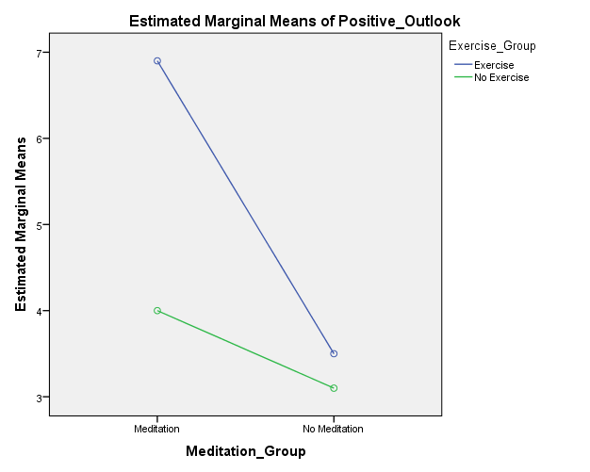
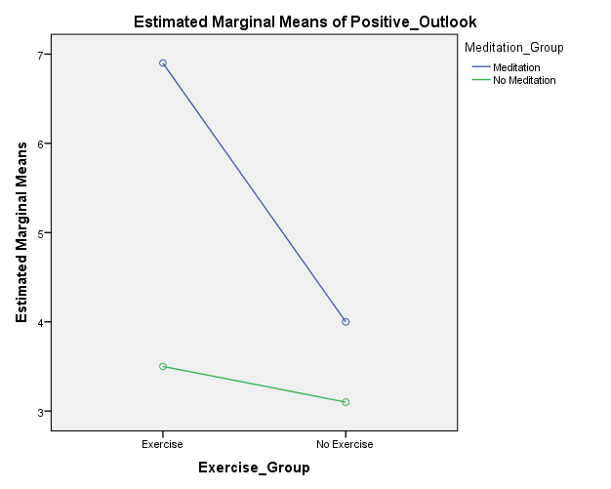

- F ( 1, 36) = 4.45, p = .042, MSE = 3.51 η_{p}²= .11.
- A. Yes
- Exercise: 6.90-3.50 = 3.40
- Yes
- ${SD}_{p}= \sqrt{\frac{\left(9\right){2.33}^{2}+\left(9\right){1.58}^{2}}{\left(9\right)+ (9)}= }1.991$
d = 3.40/1.991 = 1.708
- No Exercise 4.00-3.10 = .90
- B. No (p = .290)
- ${SD}_{p}= \sqrt{\frac{\left(9\right){1.41}^{2}+\left(9\right){2.03}^{2}}{\left(9\right)+ (9)}= }1.742$
d = .90/1.606 = .52
- A
- Bar graph with M = 5.20 (Exercise group) and M = 3.55 (No exercise group)
- F ( 1, 36) = 7.76, p = .008, MSE = 3.51, η_{p}² = .18.
- A. Yes
- ${SD}_{p}= \sqrt{\frac{\left(19\right){2.61}^{2}+\left(19\right){1.76}^{2}}{\left(19\right)+ (19)}= }2.226$
d = (5.20-3.55)/2.226 = .741
- A
- Bar graph with M = 5.45 (Mediation group and M = 3.30 (No meditation group)
- F ( 1, 36) = 13.18, p = .001, MSE = 3.51, η_{p}² = .27.
- A. Yes
- ${SD}_{p}= \sqrt{\frac{\left(19\right){2.40}^{2}+\left(19\right){1.78}^{2}}{\left(19\right)+ (19)}= }2.113$
d = (5.45-3.30) / 2.113 = 1.018
- A
- See question #7 for table numbers.
First paragraph: 36, .042, more, d=1.71
Second paragraph: 13.18
Third paragraph: significant, .18, more, .74
- B
- A
- B
- 6.92-4.00 = 2.92
- ${SD}_{p}= \sqrt{\frac{\left(11\right){2.23}^{2}+\left(11\right){2.34}^{2}}{\left(11\right)+ (11)}= }2.285$
d = 2.92/2.285 = 1.278
- 3.67-2.58 = 1.09
- ${SD}_{p}= \sqrt{\frac{(11){2.06}^{2}+\left(11\right){1.975}^{2}}{\left(11\right)+ (11)}= }2.018$
d = 1.09/2.018 =.540
- B
- A
- A
- A
- A
- Be sure to have your instructor check your answer.

Activity 12-4
- A
- A
- A
- E
- C
- B
- A
- A and C
- Republican vs Democrat d = (3.98-4.98)/.462 = -2.151 (very large)
Republican vs Independent d = (3.98-4.23)/.485 = -.508 (medium)
Democrat vs Independent d = (4.98-4.23)/ ..462 = 1.621 (very large)

- B
- Those from different political parties did differ in the degree to which they were disturbed by the income inequality in the United States, F (2, 75) = 31.61, p <.001, MSE = .22, η² = .46. Two of the three political party comparisons were significantly different. Democrats were more disturbed by the income inequality than Independents, p <.001, d = 1.63. They were also more disturbed by the income inequality than Republicans, p <.001, d = 2.15. Independents and Republications were not significantly different, p = .149 , d = -.52, though the large effect size suggests that the study should be replicated with a larger sample size.
- B
- A and E
- A
- E
- C
- C
- B

- A
- The effect of instructions while watching the video is the same, regardless of political party, F (2, 72) = .27, p = .76, MSE = .24, η² = .01. The instructions had the same effect on every political party.
- Political Party; F-ratio = 25.27; p < .001, MSE = .24, η_{p}²= .41
Instructions; F-ratio =21.40; p < .001, MSE = .24, η_{p}²= .23

Republican M = 3.79, SD = .58
Democrat M = 4.72, SD = .53
Independent M = 4.01, SD = .54
- B
- A and C
- Remember to use the pooled standard deviation as the denominator for each d.
Republican vs Democrat d = -1.661
Republican vs Independent d = -.384
Democrat vs Independent d = 1.333

- Choice Group: 3.9154 (.64340); Touch Group: 4.4318 (.61069)
- B
- B
- Choice vs. Touch d = -.823

 | Choice |  |  | Touch |  |  | Political Party Main Effect
 | n | M(SD) |  | n | M(SD) |  |  |  | M(SD)
Democrat | __13_ | _4.48_(.50)____ |  | _13_ | _4.96_(.47)_____ |  |  |  | _4.72_(.53)____
Republican | __13_ | _3.48_ (.375)___ |  | _13_ | _4.11_(.60)_____ |  |  |  | _3.79_(.58)____
Independent | __13_ | _3.78_(.59)_____ |  | _13_ | _4.23_(.38)_____ |  |  |  | _4.01 (.54)_____
Choice Main Effect |  | 3.92 (.64) |  |  | 4.43 (.61)

A two factor ANOVA was conducted with Political Party and Instructions as the independent variables and Perceptions of income inequality as the dependent variable. The interaction between Political Party and Instructions was not significant, F (2, 72) = .27, p = .76, MSE = .24, η_{p}² = .01. The instructions had different effects on every political party.

There was a significant main effect for Political Party F (2, 72) = 25.27, p < .001, MSE = .24, η_{p}² = .41. Overall, Democrats were more disturbed by income inequality than were Republicans, p <.001, d = 1.66 and Independents, p <.001, d = 1.33.

Finally, there was a significant main effect for Instructions F (2, 72) = 21.40, p < .001, MSE =.24, η_{p}² = .23. Overall, those who were attending to choices were significantly less disturbed by income inequality than those who attended to “touches”, p < .001, d = .82.

- Main effect of Party; F (1, 76) = 9.02, p = .04, MSE = .31, η_{p}² = .11
Main effect of Video; F (1, 76) = 0.23, p = .64, MSE = .31, η_{p}² = .003
Interaction of Party x Video; F (1 ,76) = 6.08, p = .02, MSE = .31, η_{p}² = .07
- B
- A, C
- B
- A
- C
- Table 1. Cell and Marginal Means and Standard Deviations
 | Watched Ad |  |  | Did Not Watch Ad |  |  | Political Party Main Effect
 | n | M(SD) |  | n | M(SD) |  |  |  | M(SD)
Democrat | 20 | _2.25 (.51)_ |  | _20_ | 2.50 (.73) |  |  |  | 2.38 (.64)
Independent | 20 | _2.93 (.49)_ |  | _20_ | _2.57 (.44)_ |  |  |  | _2.75 (.49)_
Video Main Effect |  | 2.59 (.60) |  |  | _2.53 (.60)_

A two factor ANOVA was conducted with Political Party and Video Condition as the independent variables and attitudes towards tax cuts as the dependent variable. There was a significant interaction between Political Party and Video Condition, F ( 1, 76) = 6.08, p = .02, MSE = .31, η_{p}² = .07. For Democrats, those who watched the video and those who did not had similar scores, suggesting that the video had little to no effect on attitude toward the proposed tax cut, p = .16, d = .40. However, the video was less more effective on Independents. Independents who watched the video were more favorable toward the proposed tax cut than Independents who did not watch the video, p = .04, d = .77.
There was a significant interaction Main Effect for Political Party F (1, 76) = 9.02, p = .004, MSE = .31, η_{p}² = .11. Overall, Democrats were more less supportive of the proposed tax cuts than Independents, d = .65.

Finally, there was not a significant main effect for Video Condition, F (1, 72) = .23 p = .64, MSE = .31, η_{p}² = .003. Overall, those who watched the video were not more supportive of tax cuts that those who did not watch the video, d = .10.

Activity 12-5
      - Related t
      - Oneway ANOVA
      - Twoway ANOVA
      - Independent t
      - Oneway ANOVA
      - Related t
      - Single t
      - z for a sample mean
      - independent t
      - Twoway ANOVA
      - Single sample t

Activity 13-1: Correlations
Part 1
- Try to get at least 10 in a row
- If the data points line up as a straight line the correlation is very strong. The more the data points deviate from a perfect straight line the weaker the correlation (i.e., the closer it will be to zero). If you draw a circle around all the data points if it is shaped like a circle it is a weak correlation if it is shaped like a line it is a strong correlation.
- If the general trend is for a line to run from the high left to the low right it is a negative correlation. If the general trend is for a line to run from the low left to the high right it is a positive correlation. If the two variables pair up as high-high or low-low it is a positive correlation. If the two variables pair up as high-low or low-high it is a negative correlation.
Part 2
- C
- A
- A
- B
- C

Part 3
- You should place a data point at Exam Score = 77 and Spacing Scale Score = 2.5
- A
- H₀: Higher Spacing scale scores will not be associated with higher Exam Scores
H₁: Higher Spacing scale scores will be associated with higher Exam Scores
- df = 8, critical value of r = .549; Reject H₀ if r > .549

$${SS}_{xy}= ∑XY-\frac{\left(∑X\right)\left(∑Y\right)}{n}= 2391-\frac{\left(760.5\right)\left(31\right)}{10}= 33.45$$

$${SS}_{X}= ∑X^{2}-\frac{(Σ{X)}^{2}}{n}= 58485.75-\frac{(760.5)^{2}}{10}= 649.725$$

$${SS}_{Y}= ∑Y^{2}-\frac{(Σ{Y)}^{2}}{n}= 113.5- \frac{(31)^{2}}{10}= 17.4$$

$r= \frac{{SS}_{XY}}{\sqrt{({SS}_{X}{)(SS}_{Y})}}= \frac{33.45}{\sqrt{(649.725{)(17.4)}_{}}}$ = .315

- r² = .099
- medium
- B; r (8) = .315, p < .05.
Data Table that does not have a number but should
∑Y = 49.5, ∑Y² = 253.75, ∑XY = 3770.75

- A
- df = 8, critical value of r = .632; reject null if obtained r is more extreme than .632

$${SS}_{xy}= ∑XY-\frac{\left(∑X\right)\left(∑Y\right)}{n}= 3770.75-\frac{\left(760.5\right)\left(49.5\right)}{10}= 6.275$$

$${SS}_{X}= ∑X^{2}-\frac{(Σ{X)}^{2}}{n}= 58485.75-\frac{(760.5)^{2}}{10}= 649.725$$

$${SS}_{Y}= ∑Y^{2}-\frac{(Σ{Y)}^{2}}{n}= 253.75- \frac{(49.5)^{2}}{10}= 8.725$$

$r= \frac{{SS}_{XY}}{\sqrt{({SS}_{X}{)(SS}_{Y})}}= \frac{6.275}{\sqrt{(649.725{)(8.725)}_{}}}$ = = .083

- r² = .007
- There was no significant correlation between the Re-reading Scale Scores and Exam scores of the students, r (8) = .08, p > .05.
- A
- A
- A
- No answer, just run the correlations as instructed.
- There are 6 unique correlations. Some are reported twice.
- Practice Retrieval and Exam score: r (100) = .264, p = .004.
Spacing and Exam score: r (100) = .255, p = .005.
Re-reading and Exam score: r (99) = .023, p = .411.
- Practice Retrieval and Exam score: .070
Spacing and Exam score: .065
Re-reading and Exam score: .001
- A; these results support the predictions Practice Retrieval and Spacing studying behaviors were both positively correlated with Exam Scores. Both had small-medium effect sizes. Re-reading was not correlated with Exam Scores and the effect size was essentially zero.
- Those who reported using Practice Retrieval as a studying strategy scored better on the Exam, r (100) = .264, p = .004. Additionally, those who reported Spacing out their studying scored better on the Exam, r (100) = .255, p = .005. However, Re-reading the chapters was not associated with Exam scores at all, r (99) = .023, p = .411. Based on these results the practice retrieval and spacing studying strategies seem to be moderately effective while re-reading the chapters does not seem to be effective at all.

Activity 13-2
- $Lower boundary =\left(z_{r}\right)- \left(z_{CI}\right)\left(\frac{1}{\sqrt{N-3}}\right)= .2661-1.96 \left(\frac{1}{\sqrt{102-3}}\right)$
$$Lower boundary =.2661-1.96 \left(\frac{1}{\sqrt{99}}\right)= .2661-1.96 \left(.1005\right)=.2661-.1970=.069$$
z to r conversion: z of .069 is equal to an r of .07 (from Appendix X)
- Spacing and Exam Score
$$Upper z boundary =.2661+1.96 \left(\frac{1}{\sqrt{99}}\right)= .2661+1.96 \left(.1005\right)=.2661+.1970=.4631$$
z to r conversion: z of .4631 is equal to an r of .43
$$Lower z boundary =.2661-1.96 \left(\frac{1}{\sqrt{99}}\right)= .2661-1.96 \left(.1005\right)=.2661-.1970=.069$$
z to r conversion: z of .069 is equal to an r of .07
- Re-reading and Exam Score
$$Upper z boundary =.0200+1.96 \left(\frac{1}{\sqrt{98}}\right)= .0200+1.96 \left(.1010\right)=.0200+.1980=.218$$
z to r conversion: z of .218 is equal to an r of .22
$$Lower z boundary =.0200-1.96 \left(\frac{1}{\sqrt{98}}\right)= .0200-1.96 \left(.1010\right)=.0200-.1980= -.178$$
z to r conversion: z of -.178 is equal to an r of -.18
- D
- B, C

Activity 13-3
- B
- A
- A
- A
- No answer, just compute the Spearman’s correlation using SPSS
- Mathematics readiness and income: r (78) = .79, p < .001 (two-tailed)
Mathematics readiness and education: r (78) = .90, p < .001 (two-tailed)
- A
- Overall, higher parental education was associated with higher mathematics readiness scores, r(78) = .90, p < .001 (two-tailed). Likewise, higher parental income was associated with higher mathematics readiness scores, r(78) = .79, p < .001 (two-tailed). Both effect sizes were large.

Activity 13-4

- SS_{xy} = 17.5; = .98
- Predict score on one variable when you know a score for another variable
- 3.07
- 37.14
- Ŷ=3.07X + 37.14
- 58.63
- 69.375

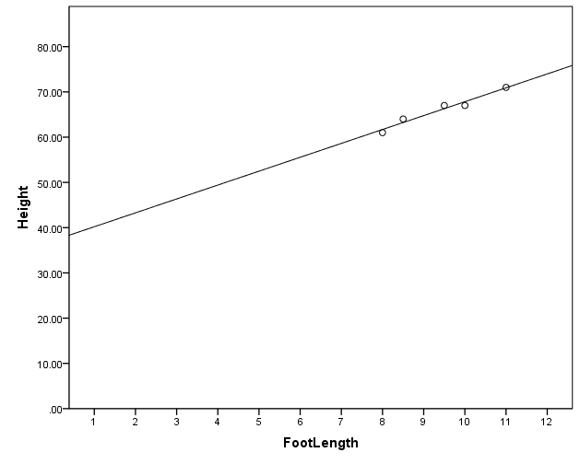

- .9604
- A
- 2.807
- 48.30
- Ŷ=2.807X + 48.30
- 63.74
- 69.359

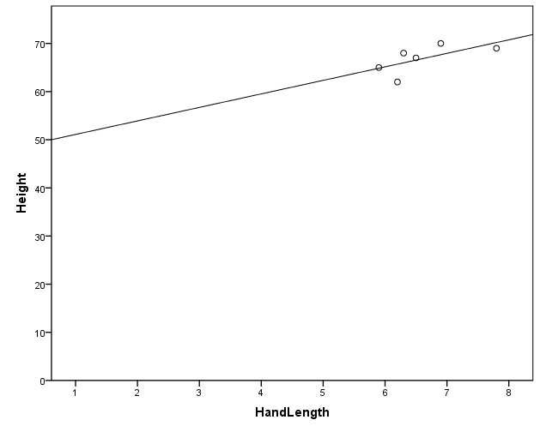
- .4199
- The closer the data points are to the regression line, the better the predictor.
- The closer r squared is to 1, the better the predictor
- Check your SPSS output against the output in the activity
- No, p = .164
- The sample size was probably too small
- B
- Ŷ=1.660X + 811.290
- 1757.49mm
- .124
- Yes
- Head circumference explained a significant proportion of the variance in height, R² = .124, F(1,173) = 24.47, p < .05.
- The n was much larger for head circumference than for hand length. The critical values get smaller as n gets larger.

Activity 13-5
- Spearman r
- Independent samples t
- Independent measures ANOVA
- Related samples t
- Independent measures ANOVA
- Two factor ANOVA
- Pearson r
- Related samples t
- Spearman r
- Two factor ANOVA
- Independent samples t
- Pearson r
- Single sample t

Activity 15-1: Goodness of fit chi-square and Independence Chi Square

- Goodness of fit; Chi-square for independence
- 5
- Expected frequency for approve = 970 * .5 = 485; Expected frequency for disapprove = 970 * .5 = 485
- A
- df = 1; critical value = 3.84
- χ² (1) = 31.21
- reject the null
- C
- B; Significantly more people disapprove of the health care overhaul than would be expected by chance, χ² (1) = 31.21, p < .05.
- Approve = 510.5; Disapprove = 510.5, No opinion = 0
- B
- I’d probably drop the no opinion people. I don’t have any rationale for changing my hypothesis. I want to know of the approval for the bank bill is greater than change approval.
- Approve = 993 * .5 = 496.5; Disapprove = 993 * .5 = 496.5
- df = 1; critical value = 3.84
- χ² (1) = 61.49
- reject the null
- Significantly more people approve of the increased regulation on financial institutions than would be expected by chance, χ² (1) = 61.49, p < .05.
- Expected freq for approve = 1021 * .475 = 484.975; disapprove = 1021* .475 = 484.975; no opinion = 1021 * .05 = 51.05.
- The expected frequencies for all three cells would be 980 * .333 = 326.34
- A
- df = 2; critical value = 5.99
- χ² (2) = 146.35
- reject the null
- More people favor extending the tax cuts to everyone or extending them to only those making less than 250K than would be expected by chance and fewer people favor allowing the tax cuts to expire than would be expected by chance, χ² (2) = 146.35, p < .05. The greatest discrepancy from the expected value was in the middle option in which more people favored the tax cuts for only those making less than 250K.
- The expected frequencies for each cell are list in the table below
 | Keep tax cuts for all | Keep tax cuts for only those making less than 250K | Do nothing and allow tax cuts to expire for all tax payers
Republican | 141.58 | 168.41 | 57.00
Independent | 104.16 | 123.90 | 41.94
Democrat | 134.25 | 159.69 | 54.05

- A
- df = 4; critical value = 9.49
- χ² (4) = 104.27
- reject the null
- B
- ${}^{ '} = \sqrt{\frac{χ^{2}}{n(df*)}}= \sqrt{\frac{104.88}{985 (2)}}$ = .231; df* = 2,
- therefore this is a medium effect size
- Political identification and opinion on extending the Bush tax cut were associated, χ² (4) = 104.88, p < .05. Republicans were much more likely to favor keeping the tax cuts for all tax payers. Independents were slightly more likely to favor keeping the tax cuts for only those making less than 250K a year. Democrats were much more likely to favor extending the tax cuts for only those making less than 250K a year.

Activity 15-2: Choose the correct statistic
      - H, Pearson correlation
      - J, chi square goodness of fit
      - B, z for a sample mean
      - B, z for a sample mean
      - D, independent samples t
      - C, single sample t
      - I, Spearman correlation
      - C, single sample t
      - E, related samples t
      - K, chi square test of independence
      - D, independent samples t
      - G, two factor ANOVA
      - G, two factor ANOVA
      - K, chi square test of independence
      - J, chi square goodness of fit
      - H, Pearson correlation
      - E, related samples t
      - F, oneway independent ANOVA
      - F, oneway independent ANOVA
      - G, two factor ANOVA

