Chapter 2 – Answers to Exercises (in-text)

1. a. Race is a nominal variable. Class is an ordinal variable, since the categories can be ordered from lower to higher status.

b. Frequency Table for Race
Race | Frequency (f)
White | 17
Nonwhite | 13
Total (N) | 30

Frequency Table for Class
Class | Frequency (f)
Lower | 3
Working | 15
Middle | 11
Upper | 1
Total (N) | 30

2.
 | Class | Percentage
 | Lower | 10.0%
 | Working | 50.0%
 | Middle | 36.7%
 | Upper | 3.3%
 | Total | 100%
a. The smallest perceived class is the upper class, composing only 3.3% of the survey.
b. Together, the working and middle class compose 86.7% of the survey.

3.

Number of traumas | Frequency (f)
0 | 15
1 | 11
2 | 4
Total (N) | 30

Trauma is an interval or ratio-level variable, since it has a real zero point and a meaningful numeric scale.
b. People in this survey are more likely to have experienced no traumas last year (50% of the group).
c. The proportion who experienced one or more traumas is calculated by first adding 36.7% and 13.3% = 50%. Then divide that number by 100 to obtain the proportion, 0.50, or half the group.

4.

5. Ranking them from highest to lowest level of support: Strong Democrats, Strong Republicans and Independents. Support does vary by group, however, the majority of strong Democrats (56.8%) and strong Republicans (50%) agree/strongly agree with the statement. The group with the lowest level of support is Independents with 42.3%.

6.

Email hours per week | Frequency | Cf | % | C%
0 | 19 | 19 | 19 | 19
1 | 20 | 39 | 20 | 39
2 | 13 | 52 | 13 | 52
3 | 5 | 57 | 5 | 57
4 | 2 | 59 | 2 | 59
5 | 6 | 65 | 6 | 65
6 | 5 | 70 | 5 | 70
7 | 2 | 72 | 2 | 72
8 | 3 | 75 | 3 | 75
9 | 1 | 76 | 1 | 76
10 or more | 23 | 99 | 23 | 99
Total | 99 |  | 99%

b. .575 (57/99) spent 3 hours or less on email per week.
c. This group includes 5+2+3+1+23= 34 respondents. The proportion is 34/99 or .343.
d. A histogram can be used to display frequency for an interval variable.

7. a.
For whites.
Education | f | % | C%
Less than high school | 72 | 12.3 | 12.3
High school graduate | 272 | 46.5 | 58.8
Junior college | 46 | 7.9 | 66.7
Bachelor | 118 | 20.2 | 86.9
Graduate | 77 | 13.2 | 100.1
TOTAL | 585

For blacks.

Education | f | % | C%
Less than high school | 26 | 22.0 | 22.0
High school graduate | 59 | 50 | 72.0
Junior college | 10 | 8.5 | 80.5
Bachelor | 16 | 13.6 | 94.1
Graduate | 7 | 5.9 | 100.0
TOTAL | 118

For males.

Education | f | % | C%
Less than high school | 46 | 14.0 | 14.0
High school graduate | 151 | 45.9 | 59.9
Junior college | 24 | 7.3 | 67.2
Bachelor | 65 | 19.8 | 87
Graduate | 43 | 13.1 | 100.1
TOTAL | 329

For females.

Education | f | % | C%
Less than high school | 67 | 15.0 | 15.0
High school graduate | 214 | 47.8 | 62.8
Junior college | 37 | 8.2 | 71.0
Bachelor | 81 | 18.1 | 89.1
Graduate | 49 | 10.9 | 100.0
TOTAL | 448

b. 40.2% of males attended school beyond high school. A lower percentage of females (37.2%) did the same.
c. 58.8% for whites and 72.0% for blacks.
d. Cumulative percentages are more similar for men and women than for white and blacks. Inequality appears to be larger between racial groups. A larger percentage of whites complete bachelor or graduate degrees than do blacks.

8. a. We can conclude the highest rate of uninsured is in the following categories: 18-44 years of age, 100-199% of the poverty level, American Indian or Alaska Native only, and South and West geographic regions.
b. Pie charts can be used to compare the demographic data. However, age and percent of poverty level are ordinal measures and can be presented in histograms.

9. The group with the largest increase in voting rates is blacks, from 53% in 1996 to 66.2% in 2012. Blacks are the only group that did not experience a decline in voting rates for the years presented. Hispanic voting rates exceeded the voting rates for Asians in 2000 and remained higher than Asians through 2012. Hispanics and Asians have the lowest voting rates for all groups. As noted in the exercise, in the 2012 presidential election, blacks had the highest voting rates for all groups, followed by non-Hispanic whites, Hispanics and Asians. White voting rates declined by 2% from 2008 to 2012. The highest voting rate for whites was in 2004 (67.2%), 2008 for Hispanics (49.9%) and for Asians (47.6%).

10.

b. The shapes of both histograms are similar, which indicates that both groups have roughly the same type of distribution of educational attainment. The highest percentage of blacks is in the 9-12 category, while the highest percentage of whites is in the next category, 13-16 years. Whites have higher educational attainment, 15.4% of whites vs. 9.3% of blacks completed 17-20 years of education.

11. a. Victimization rates are highest for those 12-17 years of age.
b. Victimization rates have been declining since 1994-1998. In the last time period, 2005-2010, all rates are below 5 per 1,000 females. Across the three time periods, victimization rates are highest for females age 12-17 (11.3 to 4.1). Second highest rates are among females age 18-34 year (7.0 to 3.7).

12. For sex and age: Women were more likely than men to indicate that same-sex marriage should be legal. There was an increase in both age groups for men and women. The highest increase was among men ages 18-49 years. For age: There is an increase in support across all three age groups. The largest increase was among those 18-34 years of age (70-54 = 16%). For political affiliation: There was an increase in the percent indicating support for the legalization of same-sex marriage among Democrats and Independents. No change among Republicans. For political views: There was an increase in support for same-sex marriage among all political affiliation categories. The percent increases can be ranked from high to low: moderates (9%), liberals (8%) and conservatives (3%).

13. The group with the highest level of support (favor) for stricter gun laws is graduate degree (84.4%), followed by the high school degree group (77.02%). The lowest level of support is reported for the junior college group (71.43%).

14. a. The variable PAYHLTH is an ordinal level measurement.
b. A higher percentage of women (63.2%) than men (55.7%) indicated that they strongly agree or agree to the statement. Based on these responses, women are more likely to be worried about receiving second-class health care than men.

Chapter 2 SPSS Solutions

1.

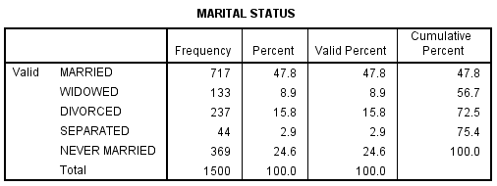

a. 15.8% of the sample is divorced.
b. 47.8% are married.
c. Currently single includes those in the following response categories: widowed, divorced, and never married: 8.9 + 15.8 + 24.6 = 49.3%

2.
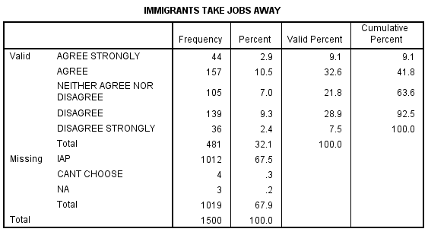
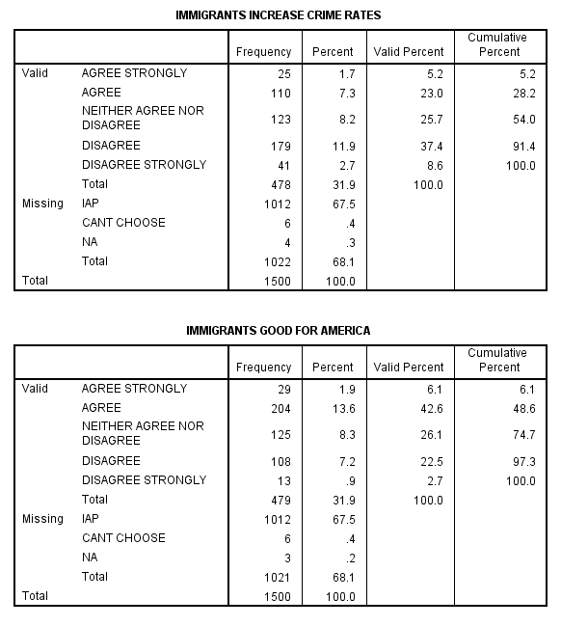
b. Each variable is an ordinal measurement. [Review the definitions of levels of measurement.] The higher value (5) indicates strong disagreement to the statement. Overall, respondents express positive attitudes toward immigrants. Most believe that immigrants are good for America (48.6% agree or strongly agree to the statement) and disagree that immigrants increase crime rates (46% disagree or strongly disagree). However, almost 41.7% agree or strongly agree that immigrants take away jobs.
3.
a. RACIDIMP is an ordinal measure (a four point scale).

b. RACIDIMP may vary by respondent’s racial identity (RACECEN1 and RACECEN2), whether the respondent lives in racially diverse neighborhood (RACLIVE) or the number of family generations in the household (FAMGEN).

4. Students are encouraged to determine on their own how to recode the variable. Students should consider how the years of education is related to degree attainment, for example: 12 years = high school graduate or 16 years = college graduate.

5. We recoded labor force participation rates into four categories: 1 – 25% and below, 2 – 25.01-50%, 3 – 50.01-75% and 4 – 75.01% and above. Our recoded variables are presented in the following tables.

From the data we can conclude that labor participation is higher for males than females. There were no countries where the male labor force participation rate was 50% or less. Out of the 70 countries, all the reported labor rate was 50.01% or higher. The largest category was 50.01-75 (75.7% of all cases). For women, the largest category was 50.01-75% (60% of all cases).

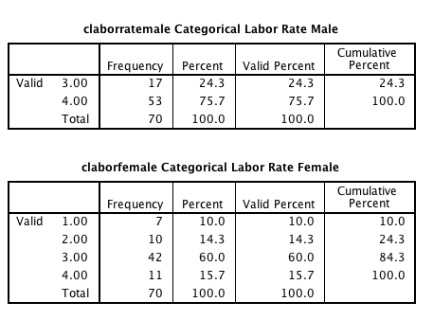

6. a. Bar graph for AGEGRPA

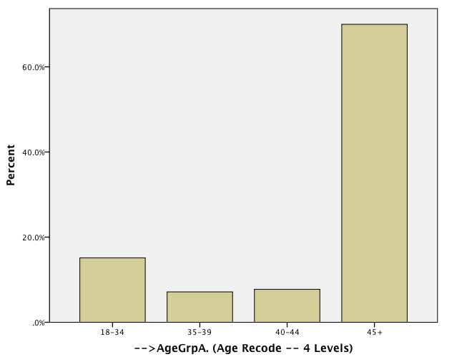

b. Bar graphs for males and females (% of cases reported)

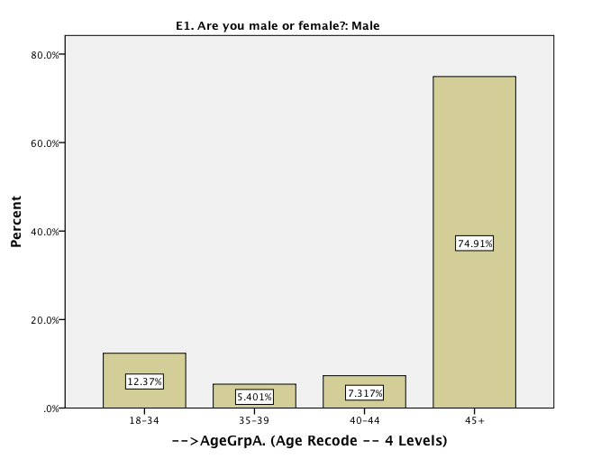

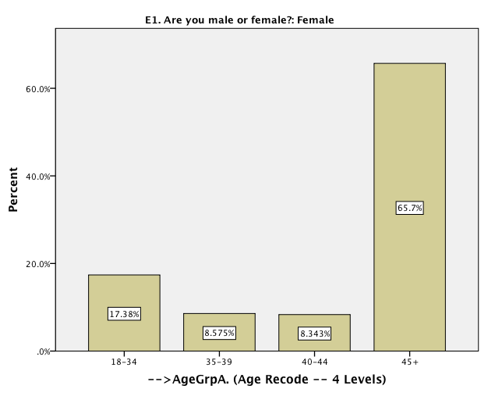

c. Overall, almost two third of the respondents are above 45. The largest age category for both male and female respondents is the oldest group, 45+. A slightly higher percent of males are 45 or older (74.91%) than the females (65.7%). The second largest age group is the youngest one, 18-34. 17.38% of the female respondents fall in this category as compared to their male counterparts of whom 12.37% are between 18 to 34 years of age.

7.

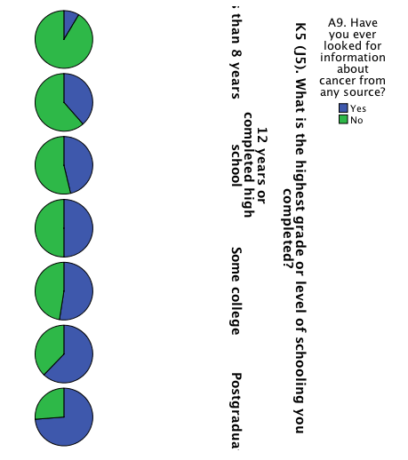

The amount of respondents who have ever looked for information about health or medical topics from any source increases as educational degree increases, from 44.4% among those with less than 8 years of education to 93.1% among those with a postgraduate degree. You can see the increase in this category by tracking how the blue section of the pie chart increases in size with each educational level.

8.

a. GeneralHealth (Bar Chart). Approximately the same percent of men and women report excellent, very good and good health. A slightly higher percentage of males report fair health (13.1 vs. 11.9%) than women and slightly more women report poor health (3.4 vs. 2.9%) than women.

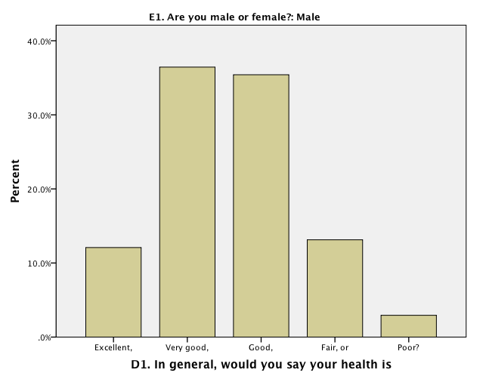
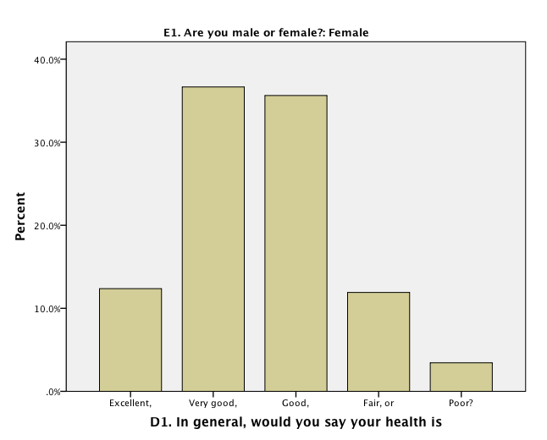
b. Occupation Status (Bar Chart). A higher percentage of males are employed than females (57.12% vs. 51.73% The largest difference between the two groups is in the “Homemaker” category in which 10.61% of the female respondents fall as compared to only 0.178% of their male counterparts.

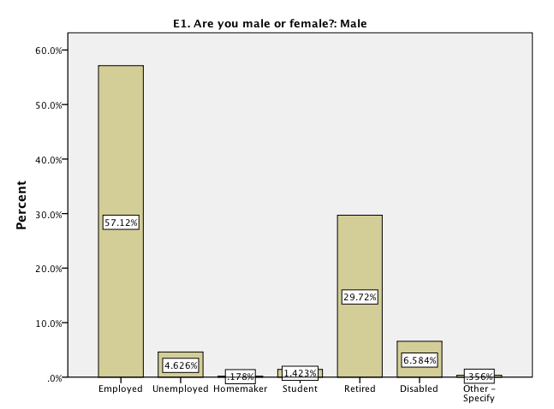

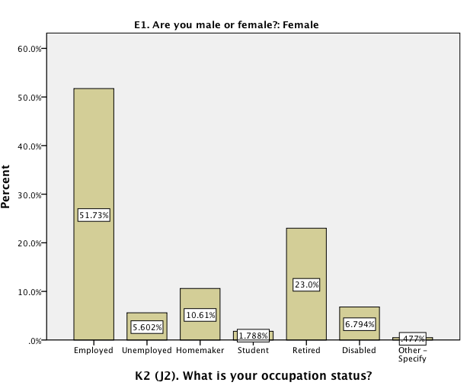

c. EverHadCancer (Pie Chart). A slightly higher percentage of men reported that they have been diagnosed as having cancer than women, 14.8% vs. 13.9%

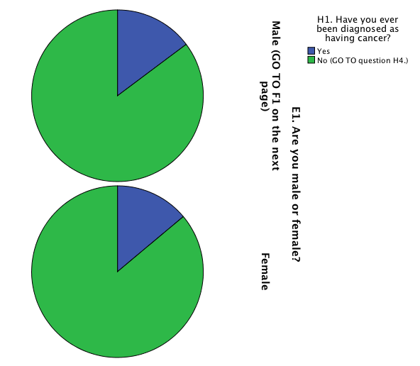

9. RentOrOwn: nominal
WhenDiagnosedCancer: interval
IncomeRanges- ordinal
QualityCare: ordinal

Interval data is best displayed in histograms, while ordinal and nominal data can be displayed in pie charts or bar graphs.

