Getting Started with Littlefield Labs
Introduction
Littlefield Laboratories is a highly automated, state-of-the-art service provider specializing in individual blood tests. Customers pay premium prices for shorter lead times and there are several competing companies offering similar services. Littlefield differentiates by guaranteeing lead times. Their guarantee offers rebates for all jobs shipping after a quoted time. These rebates are prorated until an order exceeds the maximum quoted time. Orders delivered after maximum quoted times are provided free of charge.
Blood samples arrive from hospitals and clinics as customer orders. Processing each sample requires a disposable test kit, which is fully consumed during the process. Fresh test kits come from a reliable supplier who delivers inventory into the laboratory’s Materials Buffer. Orders become jobs as each customer’s blood sample is matched with a test kit.
Littlefield has a four-step reentrant process carried out over three machine stations called the sample preparing, testing and centrifuging stations. A graphic representation of their laboratory flow appears below:
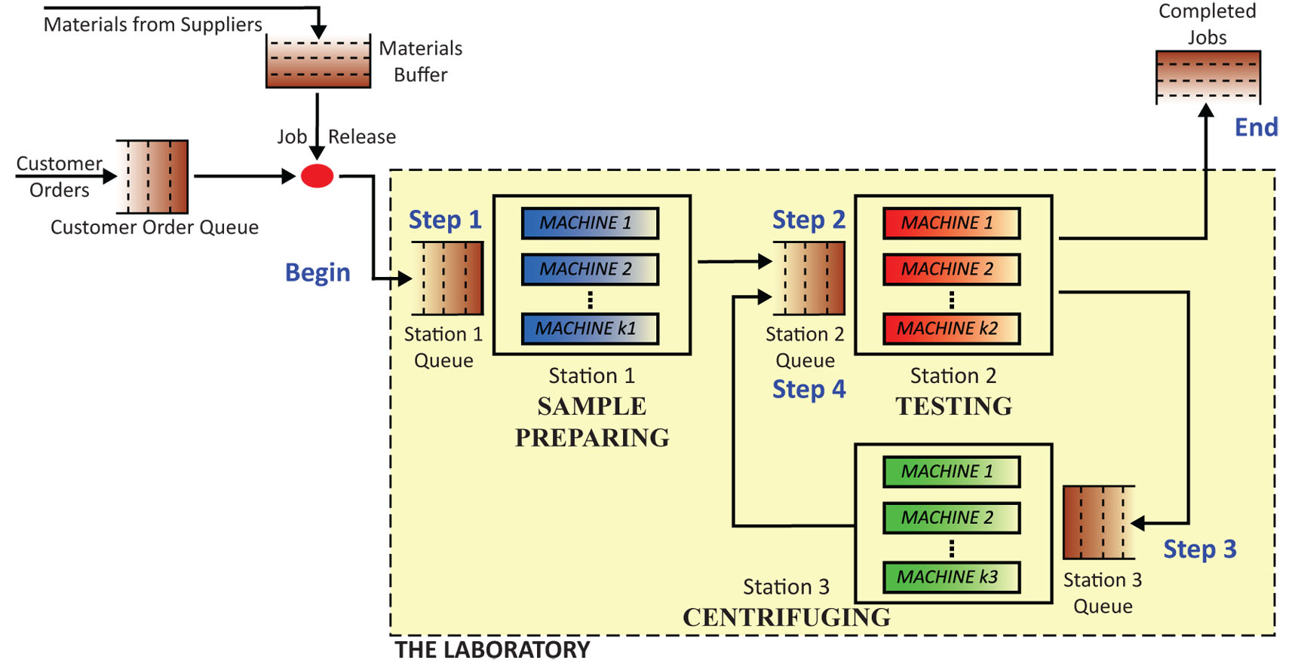
All stations consist of fully automated machines performing specific transformations. In step-one at Station 1, blood samples are transferred to test tubes containing reagents and prepared for testing. Preliminary tests are performed in step-two. In step-three, blood samples are centrifuged to separate plasma, white, and red blood cells at Station 3. In step-four, all jobs return to Station 2 for final testing and electronic transmittal of those results to the customer.
Your team will manage Littlefield’s Laboratory with the goal of maximizing profits. Specific details about Littlefield’s process are provided in your assignment document. Every team’s performance is measured against those of competing teams and a donothing team. Total cash in hand, at any given moment, determines team rank.
Registering your team
Students will need to register with a team before the simulation begins. Your instructor will provide a web address ending in /start.html, and a course code word. Each team must invent a unique yet memorable name and password consisting of only lower-case letters or numbers—please no caps, dots, dashes, spaces or other punctuation.
An image showing the registration page appears below:
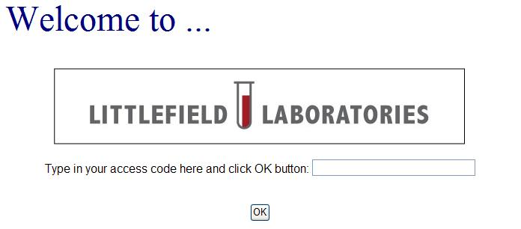
Enter your course code word and click the OK button. On the subsequent page, enter your team’s name and password. After the first student creates a team, other members will be able to join using an identical team name and password. You may use upper case letters and spaces to distinguish first and last names. If your instructor also provides a section ID for your team, please enter this number in the small field at the top of your page. Changes take effect after the submit button is clicked. Students may change their team’s name, password, or membership by logging into this registration page and editing the appropriate fields, and submitting those changes. To delete a team, erase all registered names and submit an empty team. You will not be able to reenter this page once the simulation has begun.
Accessing your laboratory
Your instructor will provide a web address ending /entry.html , from which you will play the game. Opening that URL will provide the login window illustrated on the following page:

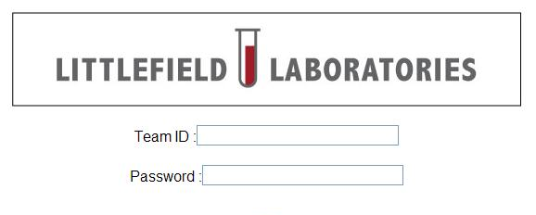
You can enter the laboratory using a registered team name and password. Data plots are displayed with the Java plugin. An option to toggle html5 plots is also provided. Please allow JavaScript and pop-ups while using this software.
Using the simulator
This web-based simulation runs continuously. Simulated time elapses at a fixed rate of simulated days per real day. You will have no control over the simulator’s clock and may need to wait for several simulated days to pass to see the effects of your actions. It will end automatically. Afterwards you may review the final status of your lab and download historic data, but the lab will no longer be active.
Clicking icons in the laboratory schematic, previously illustrated on page one, will reveal menus which control the lab’s performance and provide historic data. Specific information available from each icon is listed on the last page of this document.
Your lab status is automatically updated upon login. To update lab status thereafter, please click the update button found in the black control bar near the bottom of your laboratory schematic—or refresh your browser window.
We recommend that you download historic laboratory data, for in-depth spreadsheet analysis. Below each plot you will find a download button. Clicking that button will initiate a file download. It is in tab-delimited text format and contains the exact data points displayed on the plot. Save that file to a temporary location, and open with a spreadsheet application to display in columns and rows.
Most data points record the ending values for each simulated day. Littlefield’s inventory plot uses a slightly different time index which permits fractional days. New shipments of inventory can arrive at any point in time and stock outages could also happen at any time. When these events take place, beginning and ending inventories are indexed by the fraction of a day in which they occur.
You may notice some days where zero jobs exit the lab. On those days, daily average lead times and daily average revenues are meaningless, so a value of zero will appear in the plots.
Cash on hand at game’s end is the only winning condition, plan accordingly.

Icons on Littlefield Labs’ factory web page:
Order Queue:  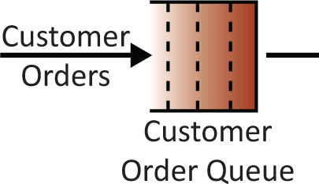 | • Number of new customer orders by day  • Average number of orders waiting for kits by day  • Contract offered for newly arriving orders  • Work in process (WIP) limit
Materials Buffer:  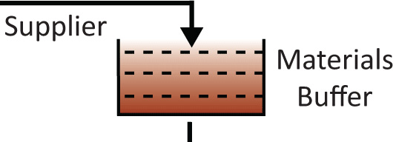 | • Total kit inventory at the end of each day, whenever inventory hits zero, and whenever a new shipment arrives.  • Inventory costs  • Reorder Point and Order Quantity  • Time remaining until next shipment arrives
Station Queues:  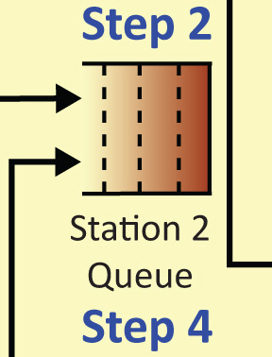 | • Average number of jobs waiting in queue while machines in that station are busy, by day
Stations:  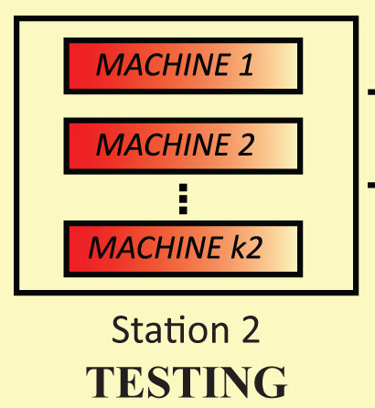 | • Number of machines at that station  • Scheduling policy used at the reentrant tester  • Historic utilization of that station by day  **Utilization is the average fraction of time all machines were busy at a station during that day
Completed Jobs:  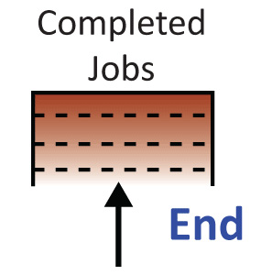 | • Actual number of orders completed by day (by pricing contract)  • Average order lead time by day sorted by contract  • Average revenue per order by day sorted by contract

Clicking on the above icons will permit changes to specific features of the laboratory. Your assignment handout will explain which features you may change.
Sources and uses of cash may be obtained by clicking the cash button on your lab’s control bar. Sources of cash are revenue, machine resales, and interest earned on cash held. Uses of cash are raw material inventories and machine purchases. Clicking the history button will reveal your team’s actions to date. Clicking the update button will refresh your screen. Clicking the quit button will exit the lab. Clicking the overall standing button will show your team’s relative rank.

Based on a document written by Sunil Kumar and Samuel C. Wood, Stanford University Graduate School of Business. Copyright 2009. No part of this document may be reproduced without permission from Responsive Learning Technologies, Inc. info@responsive.net

