Look Behind the Numbers

Questions about family from the General Social Survey

- Children are a financial burden on parents.

ALL RESPONSES

CHILDREN ARE FINANCIAL BURDEN ON PARENTS
 |  | Frequency | Percent | Valid Percent | Cumulative Percent
Valid | AGREE | 339 | 17.2 | 26.8 | 26.8
 | NEITHER AGREE OR DISAGREE | 198 | 10.0 | 15.6 | 42.4
 | DISAGREE | 729 | 36.9 | 57.6 | 100.0
 | Total | 1266 | 64.1 | 100.0
Missing | System | 708 | 35.9
Total |  | 1974 | 100.0

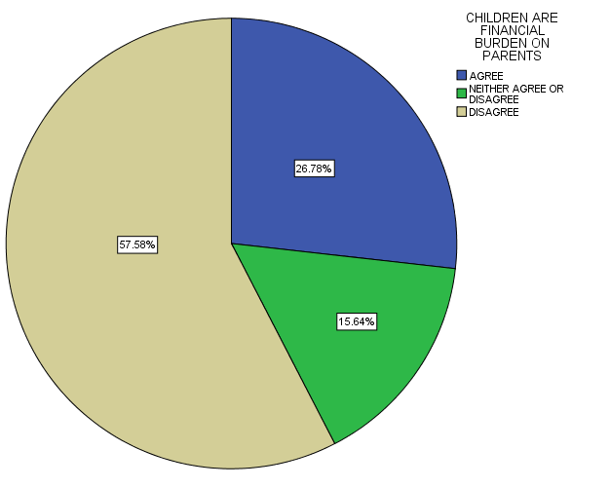

- Single parents can raise kids as well as two.

BY SEX

SINGLE PARENTS CAN RAISE KIDS AS WELL AS TWO * RESPONDENTS SEX Crosstabulation
 |  |  | RESPONDENTS SEX |  | Total
 |  |  | MALE | FEMALE
SINGLE PARENTS CAN RAISE KIDS AS WELL AS TWO | AGREE | Count | 212 | 408 | 620
 |  | % within RESPONDENTS SEX | 36.6% | 59.1% | 48.8%
 | NEITHER AGREE OR DISAGREE | Count | 52 | 68 | 120
 |  | % within RESPONDENTS SEX | 9.0% | 9.9% | 9.4%
 | DISAGREE | Count | 316 | 214 | 530
 |  | % within RESPONDENTS SEX | 54.5% | 31.0% | 41.7%
Total |  | Count | 580 | 690 | 1270
 |  | % within RESPONDENTS SEX | 100.0% | 100.0% | 100.0%

