Look Behind the Numbers

Questions about media from the General Social Survey
- What is your confidence level in television?

BY EDUCATION

CONFIDENCE IN TELEVISION * Education Crosstabulation
 |  |  | Education |  |  |  |  | Total
 |  |  | Some Elementary, Middle or High School | Graduated High School | Some College | Graduated College | Post Bachelors Schooling
CONFIDENCE IN TELEVISION | A GREAT DEAL | Count | 39 | 41 | 30 | 19 | 10 | 139
 |  | % within Education | 17.5% | 12.2% | 8.7% | 8.4% | 5.6% | 10.6%
 | ONLY SOME | Count | 115 | 153 | 191 | 98 | 73 | 630
 |  | % within Education | 51.6% | 45.5% | 55.5% | 43.2% | 40.8% | 48.1%
 | HARDLY ANY | Count | 69 | 142 | 123 | 110 | 96 | 540
 |  | % within Education | 30.9% | 42.3% | 35.8% | 48.5% | 53.6% | 41.3%
Total |  | Count | 223 | 336 | 344 | 227 | 179 | 1309
 |  | % within Education | 100.0% | 100.0% | 100.0% | 100.0% | 100.0% | 100.0%
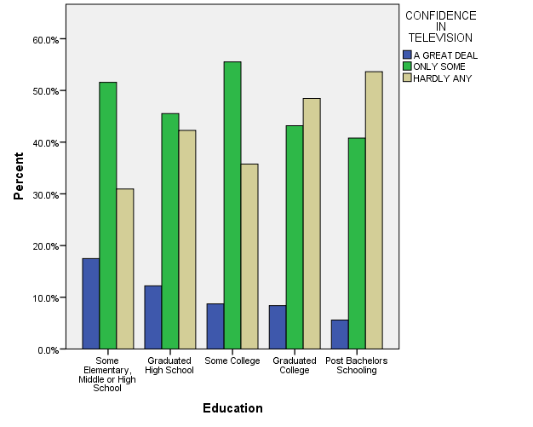

- What is your confidence level in the press?

BY EDUCATION
CONFIDENCE IN PRESS * Education Crosstabulation
 |  |  | Education |  |  |  |  | Total
 |  |  | Some Elementary, Middle or High School | Graduated High School | Some College | Graduated College | Post Bachelors Schooling
CONFIDENCE IN PRESS | A GREAT DEAL | Count | 25 | 28 | 27 | 26 | 13 | 119
 |  | % within Education | 11.5% | 8.3% | 7.9% | 11.4% | 7.1% | 9.1%
 | ONLY SOME | Count | 102 | 137 | 155 | 96 | 88 | 578
 |  | % within Education | 46.8% | 40.7% | 45.2% | 41.9% | 48.1% | 44.1%
 | HARDLY ANY | Count | 91 | 172 | 161 | 107 | 82 | 613
 |  | % within Education | 41.7% | 51.0% | 46.9% | 46.7% | 44.8% | 46.8%
Total |  | Count | 218 | 337 | 343 | 229 | 183 | 1310
 |  | % within Education | 100.0% | 100.0% | 100.0% | 100.0% | 100.0% | 100.0%

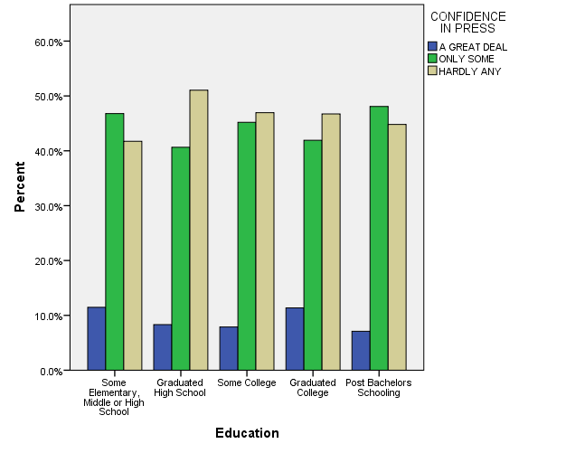

- What is your main source of information about events in the news?

BY SEX

MAIN SOURCE OF INFORMATION ABOUT EVENTS IN THE NEWS * RESPONDENTS SEX Crosstabulation
 |  |  | RESPONDENTS SEX |  | Total
 |  |  | MALE | FEMALE
MAIN SOURCE OF INFORMATION ABOUT EVENTS IN THE NEWS | NEWSPAPERS | Count | 60 | 61 | 121
 |  | % within RESPONDENTS SEX | 12.9% | 11.5% | 12.2%
 | THE INTERNET | Count | 149 | 150 | 299
 |  | % within RESPONDENTS SEX | 32.0% | 28.4% | 30.1%
 | TV | Count | 201 | 275 | 476
 |  | % within RESPONDENTS SEX | 43.2% | 52.0% | 47.9%
 | OTHER | Count | 55 | 43 | 98
 |  | % within RESPONDENTS SEX | 11.8% | 8.1% | 9.9%
Total |  | Count | 465 | 529 | 994
 |  | % within RESPONDENTS SEX | 100.0% | 100.0% | 100.0%

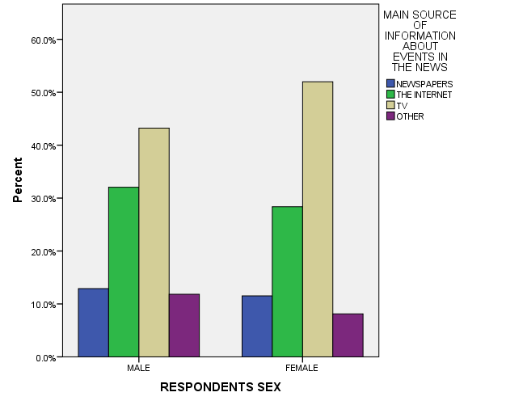

- What is your confidence level in the press?

ALL RESPONSES – CHANGE OVER TIME

