Look Behind the Numbers

Questions about education from the General Social Survey
- What is your confidence level in education?

BY INCOME

CONFIDENCE IN EDUCATION * Income Crosstabulation
 |  |  | Income |  |  | Total
 |  |  | $0-$14,999 | $15,000-$24,999 | $25,000 or Greater
CONFIDENCE IN EDUCATION | A GREAT DEAL | Count | 43 | 74 | 86 | 203
 |  | % within Income | 32.6% | 30.1% | 19.8% | 25.0%
 | ONLY SOME | Count | 73 | 138 | 274 | 485
 |  | % within Income | 55.3% | 56.1% | 63.1% | 59.7%
 | HARDLY ANY | Count | 16 | 34 | 74 | 124
 |  | % within Income | 12.1% | 13.8% | 17.1% | 15.3%
Total |  | Count | 132 | 246 | 434 | 812
 |  | % within Income | 100.0% | 100.0% | 100.0% | 100.0%

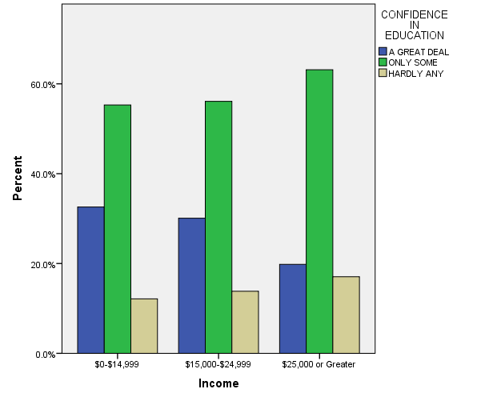

- What is your interest level in local school issues?

BY SEX
INTERESTED IN LOCAL SCHOOL ISSUES * RESPONDENTS SEX Crosstabulation
 |  |  | RESPONDENTS SEX |  | Total
 |  |  | MALE | FEMALE
INTERESTED IN LOCAL SCHOOL ISSUES | Very interested | Count | 211 | 330 | 541
 |  | % within RESPONDENTS SEX | 45.4% | 62.6% | 54.5%
 | Moderately interested | Count | 187 | 161 | 348
 |  | % within RESPONDENTS SEX | 40.2% | 30.6% | 35.1%
 | Not at all interested | Count | 67 | 36 | 103
 |  | % within RESPONDENTS SEX | 14.4% | 6.8% | 10.4%
Total |  | Count | 465 | 527 | 992
 |  | % within RESPONDENTS SEX | 100.0% | 100.0% | 100.0%

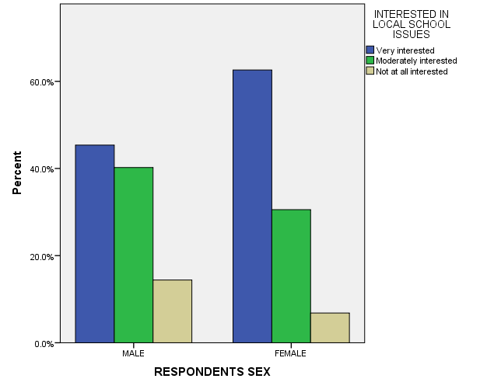

- What is your interest level in local school issues?

ALL REPONSES
INTERESTED IN LOCAL SCHOOL ISSUES
 |  | Frequency | Percent | Valid Percent | Cumulative Percent
Valid | Very interested | 541 | 27.4 | 54.5 | 54.5
 | Moderately interested | 348 | 17.6 | 35.1 | 89.6
 | Not at all interested | 103 | 5.2 | 10.4 | 100.0
 | Total | 992 | 50.3 | 100.0
Missing | IAP | 972 | 49.2
 | DONT KNOW | 5 | .3
 | NA | 5 | .3
 | Total | 982 | 49.7
Total |  | 1974 | 100.0

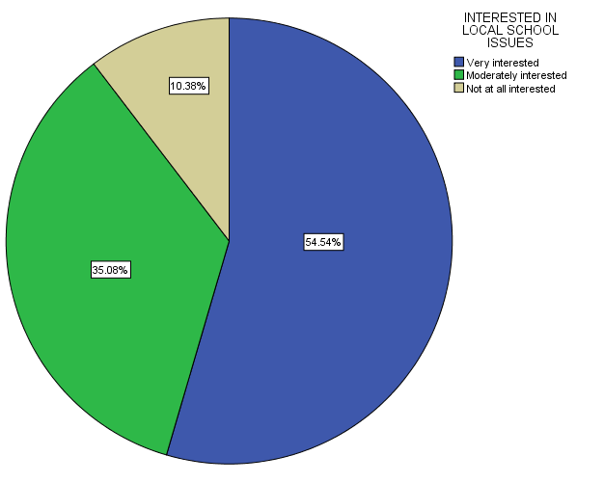
- What is your confidence level in education?

ALL RESPONSES
CONFIDENCE IN EDUCATION
 |  | Frequency | Percent | Valid Percent | Cumulative Percent
Valid | A GREAT DEAL | 342 | 17.3 | 25.8 | 25.8
 | ONLY SOME | 766 | 38.8 | 57.7 | 83.5
 | HARDLY ANY | 219 | 11.1 | 16.5 | 100.0
 | Total | 1327 | 67.2 | 100.0
Missing | IAP | 636 | 32.2
 | DK | 11 | .6
 | Total | 647 | 32.8
Total |  | 1974 | 100.0

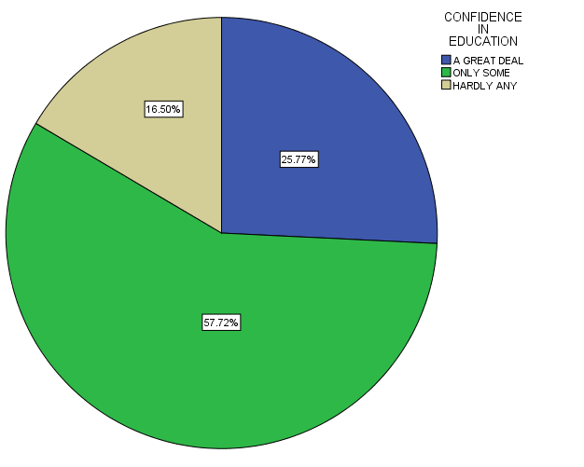
- In the United States, do you think we’re spending too much money on improving the nation’s education system, too little money, or about the right amount?

ALL REPONSES – CHANGE OVER TIME

