Look Behind the Numbers

Questions about Poverty from the General Social Survey.
- In the United States, do you think we’re spending too much money on assistance to the poor, too little money, or about the right amount?

ALL RESPONSES
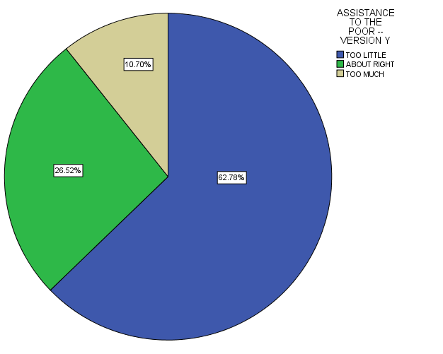

- Chart does not reflect the question sent by Lauren, due to previous edit. Please refer to email to Nick and Nathan on May 16 that addressed the error in the data involved in this question. Question should read, “More than 60% of respondents believe that we are spending too little money on assistance to the poor. What policy changes could that mean for the future? “

- Should government reduce income difference?
BY EDUCATION

SHOULD GOV REDUCE INCOME DIFFERENCES RECODED * Education Crosstabulation
 |  |  | Education |  |  |  |  | Total
 |  |  | Some Elementary, Middle or High School | Graduated High School | Some College | Graduated College | Post Bachelors Schooling
SHOULD GOV REDUCE INCOME DIFFERENCES RECODED | GOVERNMENT ACTION | Count | 125 | 172 | 170 | 86 | 97 | 650
 |  | % within Education | 74.0% | 62.1% | 59.4% | 44.3% | 61.4% | 60.0%
 | NO GOVERNMENT ACTION | Count | 44 | 105 | 116 | 108 | 61 | 434
 |  | % within Education | 26.0% | 37.9% | 40.6% | 55.7% | 38.6% | 40.0%
Total |  | Count | 169 | 277 | 286 | 194 | 158 | 1084
 |  | % within Education | 100.0% | 100.0% | 100.0% | 100.0% | 100.0% | 100.0%

