Look Behind the Numbers

Questions about war and terrorism from the General Social Survey

- What is your confidence level in Congress?

ALL RESPONSES

CONFIDENCE IN CONGRESS
 |  | Frequency | Percent | Valid Percent | Cumulative Percent
Valid | A GREAT DEAL | 87 | 4.4 | 6.7 | 6.7
 | ONLY SOME | 569 | 28.8 | 43.9 | 50.7
 | HARDLY ANY | 639 | 32.4 | 49.3 | 100.0
 | Total | 1295 | 65.6 | 100.0
Missing | IAP | 636 | 32.2
 | DK | 39 | 2.0
 | NA | 4 | .2
 | Total | 679 | 34.4
Total |  | 1974 | 100.0

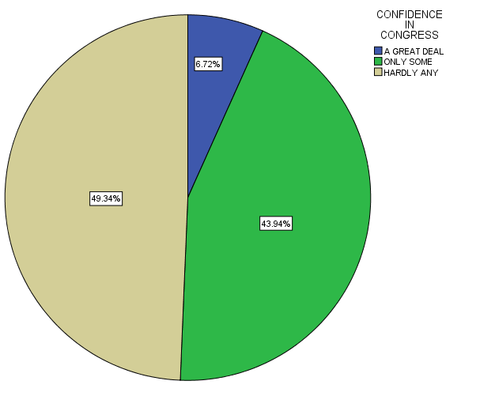

- Do you expect the United States to be in a world war in the next 10 years?

BY EDUCATION

EXPECT U.S. IN WORLD WAR IN 10 YEARS * Education Crosstabulation
 |  |  | Education |  |  |  |  | Total
 |  |  | Some Elementary, Middle or High School | Graduated High School | Some College | Graduated College | Post Bachelors Schooling
EXPECT U.S. IN WORLD WAR IN 10 YEARS | YES | Count | 46 | 111 | 89 | 28 | 33 | 307
 |  | % within Education | 61.3% | 61.0% | 53.3% | 36.4% | 33.7% | 51.3%
 | NO | Count | 29 | 71 | 78 | 49 | 65 | 292
 |  | % within Education | 38.7% | 39.0% | 46.7% | 63.6% | 66.3% | 48.7%
Total |  | Count | 75 | 182 | 167 | 77 | 98 | 599
 |  | % within Education | 100.0% | 100.0% | 100.0% | 100.0% | 100.0% | 100.0%

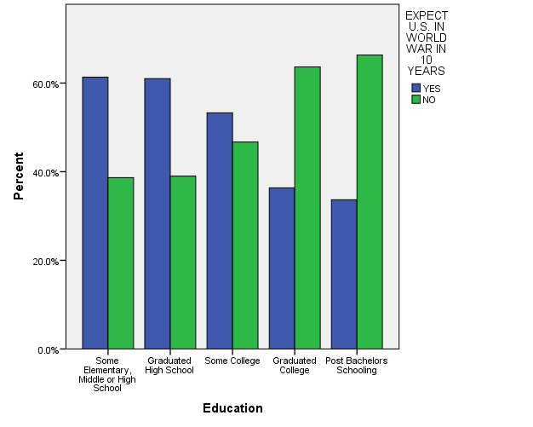

- In the United States, do you think we’re spending too much money on military, armaments, and defense, too little money, or about the right amount?

ALL RESPONSES

MILITARY, ARMAMENTS, AND DEFENSE
 |  | Frequency | Percent | Valid Percent | Cumulative Percent
Valid | TOO LITTLE | 243 | 12.3 | 25.2 | 25.2
 | ABOUT RIGHT | 401 | 20.3 | 41.6 | 66.7
 | TOO MUCH | 321 | 16.3 | 33.3 | 100.0
 | Total | 965 | 48.9 | 100.0
Missing | IAP | 976 | 49.4
 | DK | 31 | 1.6
 | NA | 2 | .1
 | Total | 1009 | 51.1
Total |  | 1974 | 100.0

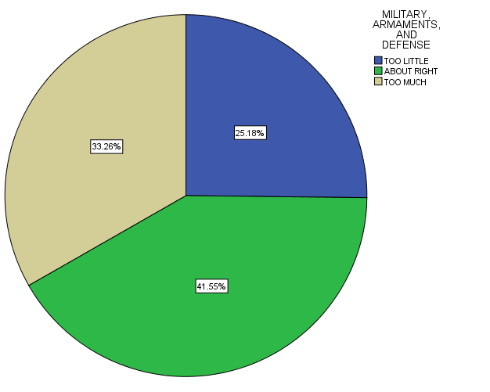

- In the United States, do you think we’re spending too much money on military, armaments, and defense, too little money, or about the right amount?

ALL RESPONSES – CHANGE OVER TIME

