Look Behind the Numbers

Questions about environment from the General Social Survey

- What is your interest level in environmental issues?

BY AGE

INTERESTED IN ENVIRONMENTAL ISSUES * Age Crosstabulation
 |  |  | Age |  |  |  |  |  |  |  |  | Total
 |  |  | 18-24 | 25-32 | 33-40 | 41-48 | 49-56 | 57-64 | 65-72 | 73-80 | 81 and older
INTERESTED IN ENVIRONMENTAL ISSUES | Very interested | Count | 28 | 66 | 61 | 63 | 81 | 69 | 50 | 23 | 26 | 467
 |  | % within Age | 38.4% | 46.5% | 46.6% | 48.5% | 51.9% | 47.3% | 50.5% | 41.1% | 44.8% | 47.1%
 | Moderately interested | Count | 37 | 64 | 57 | 52 | 69 | 60 | 40 | 28 | 23 | 430
 |  | % within Age | 50.7% | 45.1% | 43.5% | 40.0% | 44.2% | 41.1% | 40.4% | 50.0% | 39.7% | 43.4%
 | Not at all interested | Count | 8 | 12 | 13 | 15 | 6 | 17 | 9 | 5 | 9 | 94
 |  | % within Age | 11.0% | 8.5% | 9.9% | 11.5% | 3.8% | 11.6% | 9.1% | 8.9% | 15.5% | 9.5%
Total |  | Count | 73 | 142 | 131 | 130 | 156 | 146 | 99 | 56 | 58 | 991
 |  | % within Age | 100.0% | 100.0% | 100.0% | 100.0% | 100.0% | 100.0% | 100.0% | 100.0% | 100.0% | 100.0%

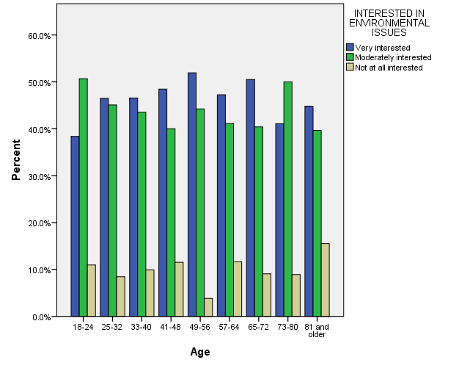

BY SEX

INTERESTED IN ENVIRONMENTAL ISSUES * RESPONDENTS SEX Crosstabulation
 |  |  | RESPONDENTS SEX |  | Total
 |  |  | MALE | FEMALE
INTERESTED IN ENVIRONMENTAL ISSUES | Very interested | Count | 225 | 242 | 467
 |  | % within RESPONDENTS SEX | 48.4% | 46.0% | 47.1%
 | Moderately interested | Count | 193 | 237 | 430
 |  | % within RESPONDENTS SEX | 41.5% | 45.1% | 43.4%
 | Not at all interested | Count | 47 | 47 | 94
 |  | % within RESPONDENTS SEX | 10.1% | 8.9% | 9.5%
Total |  | Count | 465 | 526 | 991
 |  | % within RESPONDENTS SEX | 100.0% | 100.0% | 100.0%

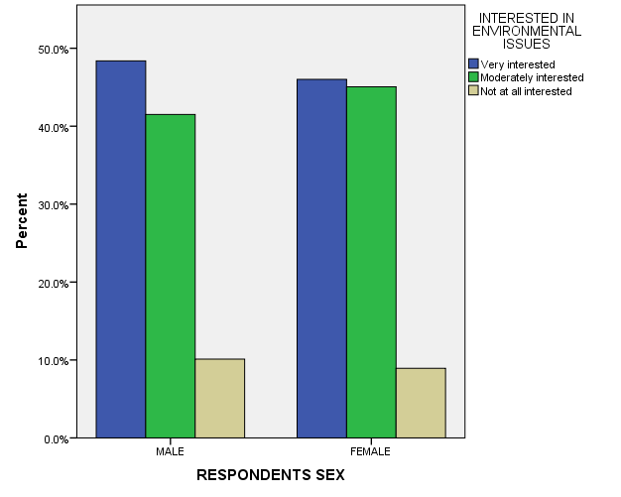

BY RACE

INTERESTED IN ENVIRONMENTAL ISSUES * RACE OF RESPONDENT Crosstabulation
 |  |  | RACE OF RESPONDENT |  |  | Total
 |  |  | WHITE | BLACK | OTHER
INTERESTED IN ENVIRONMENTAL ISSUES | Very interested | Count | 326 | 81 | 60 | 467
 |  | % within RACE OF RESPONDENT | 44.5% | 54.4% | 54.5% | 47.1%
 | Moderately interested | Count | 336 | 53 | 41 | 430
 |  | % within RACE OF RESPONDENT | 45.9% | 35.6% | 37.3% | 43.4%
 | Not at all interested | Count | 70 | 15 | 9 | 94
 |  | % within RACE OF RESPONDENT | 9.6% | 10.1% | 8.2% | 9.5%
Total |  | Count | 732 | 149 | 110 | 991
 |  | % within RACE OF RESPONDENT | 100.0% | 100.0% | 100.0% | 100.0%

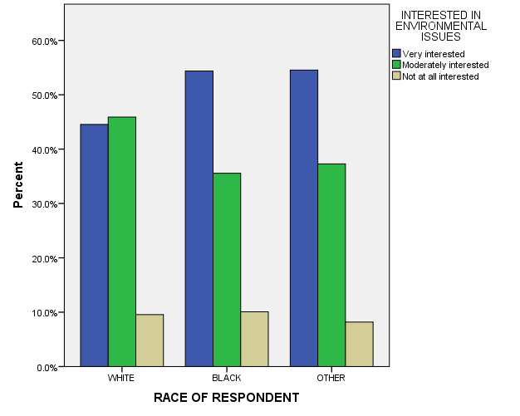

BY INCOME

INTERESTED IN ENVIRONMENTAL ISSUES * Income Crosstabulation
 |  |  | Income |  |  | Total
 |  |  | $0-$14,999 | $15,000-$24,999 | $25,000 or Greater
INTERESTED IN ENVIRONMENTAL ISSUES | Very interested | Count | 44 | 84 | 147 | 275
 |  | % within Income | 47.8% | 46.7% | 45.5% | 46.2%
 | Moderately interested | Count | 36 | 73 | 157 | 266
 |  | % within Income | 39.1% | 40.6% | 48.6% | 44.7%
 | Not at all interested | Count | 12 | 23 | 19 | 54
 |  | % within Income | 13.0% | 12.8% | 5.9% | 9.1%
Total |  | Count | 92 | 180 | 323 | 595
 |  | % within Income | 100.0% | 100.0% | 100.0% | 100.0%

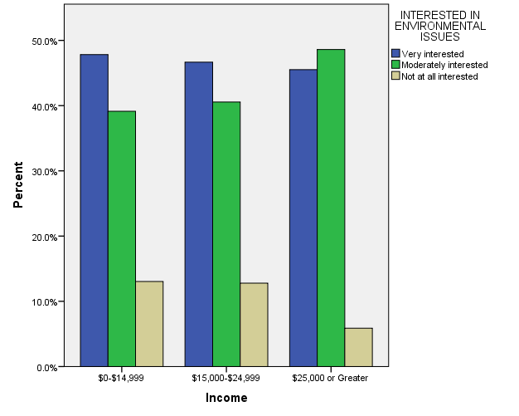

BY EDUCATION

INTERESTED IN ENVIRONMENTAL ISSUES * Education Crosstabulation
 |  |  | Education |  |  |  |  | Total
 |  |  | Some Elementary, Middle or High School | Graduated High School | Some College | Graduated College | Post Bachelors Schooling
INTERESTED IN ENVIRONMENTAL ISSUES | Very interested | Count | 69 | 114 | 131 | 78 | 75 | 467
 |  | % within Education | 41.6% | 42.4% | 50.8% | 45.9% | 58.6% | 47.1%
 | Moderately interested | Count | 75 | 120 | 107 | 78 | 50 | 430
 |  | % within Education | 45.2% | 44.6% | 41.5% | 45.9% | 39.1% | 43.4%
 | Not at all interested | Count | 22 | 35 | 20 | 14 | 3 | 94
 |  | % within Education | 13.3% | 13.0% | 7.8% | 8.2% | 2.3% | 9.5%
Total |  | Count | 166 | 269 | 258 | 170 | 128 | 991
 |  | % within Education | 100.0% | 100.0% | 100.0% | 100.0% | 100.0% | 100.0%

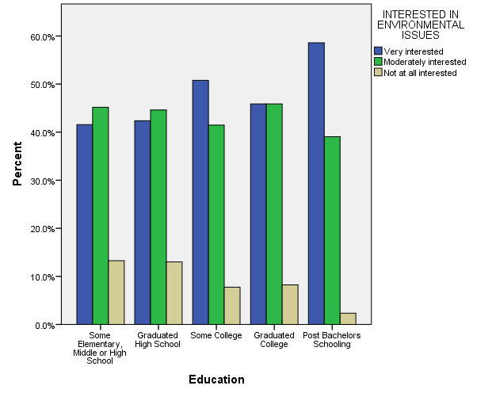

- In the United States, do you think we’re spending too much money on improving and protecting the environment, too little money or about the right amount?

BY AGE

IMPROVING & PROTECTING ENVIRONMENT * Age Crosstabulation
 |  |  | Age |  |  |  |  |  |  |  |  | Total
 |  |  | 18-24 | 25-32 | 33-40 | 41-48 | 49-56 | 57-64 | 65-72 | 73-80 | 81 and older
IMPROVING & PROTECTING ENVIRONMENT | TOO LITTLE | Count | 71 | 101 | 80 | 86 | 69 | 62 | 46 | 29 | 15 | 559
 |  | % within Age | 69.6% | 63.1% | 56.3% | 54.8% | 57.0% | 55.9% | 51.7% | 49.2% | 50.0% | 57.6%
 | ABOUT RIGHT | Count | 27 | 51 | 49 | 50 | 36 | 29 | 32 | 21 | 11 | 306
 |  | % within Age | 26.5% | 31.9% | 34.5% | 31.8% | 29.8% | 26.1% | 36.0% | 35.6% | 36.7% | 31.5%
 | TOO MUCH | Count | 4 | 8 | 13 | 21 | 16 | 20 | 11 | 9 | 4 | 106
 |  | % within Age | 3.9% | 5.0% | 9.2% | 13.4% | 13.2% | 18.0% | 12.4% | 15.3% | 13.3% | 10.9%
Total |  | Count | 102 | 160 | 142 | 157 | 121 | 111 | 89 | 59 | 30 | 971
 |  | % within Age | 100.0% | 100.0% | 100.0% | 100.0% | 100.0% | 100.0% | 100.0% | 100.0% | 100.0% | 100.0%

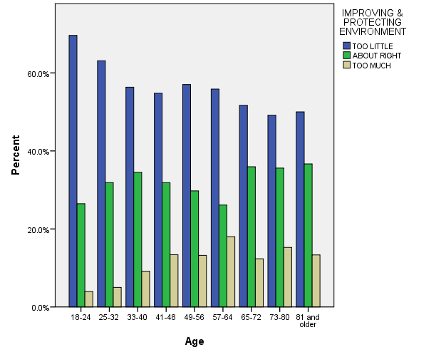

- In the United States, do you think we’re willing to spend too much money on the environment, too little money or about the right amount?

BY AGE

THE ENVIRONMENT -- VERSION Y * Age Crosstabulation
 |  |  | Age |  |  |  |  |  |  |  |  | Total
 |  |  | 18-24 | 25-32 | 33-40 | 41-48 | 49-56 | 57-64 | 65-72 | 73-80 | 81 and older
THE ENVIRONMENT -- VERSION Y | TOO LITTLE | Count | 46 | 71 | 75 | 76 | 96 | 65 | 41 | 25 | 14 | 509
 |  | % within Age | 70.8% | 59.2% | 54.3% | 63.9% | 59.6% | 51.6% | 45.6% | 45.5% | 27.5% | 55.0%
 | ABOUT RIGHT | Count | 13 | 42 | 48 | 34 | 44 | 40 | 32 | 17 | 25 | 295
 |  | % within Age | 20.0% | 35.0% | 34.8% | 28.6% | 27.3% | 31.7% | 35.6% | 30.9% | 49.0% | 31.9%
 | TOO MUCH | Count | 6 | 7 | 15 | 9 | 21 | 21 | 17 | 13 | 12 | 121
 |  | % within Age | 9.2% | 5.8% | 10.9% | 7.6% | 13.0% | 16.7% | 18.9% | 23.6% | 23.5% | 13.1%
Total |  | Count | 65 | 120 | 138 | 119 | 161 | 126 | 90 | 55 | 51 | 925
 |  | % within Age | 100.0% | 100.0% | 100.0% | 100.0% | 100.0% | 100.0% | 100.0% | 100.0% | 100.0% | 100.0%

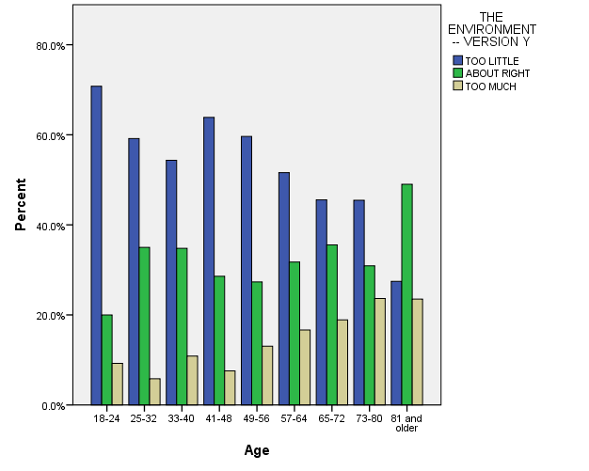

- What is your interest level in farm issues?

ALL RESPONSES – CHANGE OVER TIME

INTERESTED IN FARM ISSUES * GSS YEAR Crosstabulation
 |  |  | GSS YEAR |  |  | Total
 |  |  | 2008 | 2010 | 2012
INTERESTED IN FARM ISSUES | Very interested | Count | 369 | 182 | 236 | 787
 |  | % within GSS YEAR | 24.6% | 25.9% | 23.8% | 24.7%
 | Moderately interested | Count | 770 | 389 | 493 | 1652
 |  | % within GSS YEAR | 51.4% | 55.4% | 49.7% | 51.8%
 | Not at all interested | Count | 359 | 131 | 262 | 752
 |  | % within GSS YEAR | 24.0% | 18.7% | 26.4% | 23.6%
Total |  | Count | 1498 | 702 | 991 | 3191
 |  | % within GSS YEAR | 100.0% | 100.0% | 100.0% | 100.0%

