Look Behind the Numbers

Questions about health from the General Social Survey

- What is your interest level in medical discoveries?

BY AGE

INTERESTED IN MEDICAL DISCOVERIES * Age Crosstabulation
 |  |  | Age |  |  |  |  |  |  |  |  | Total
 |  |  | 18-24 | 25-32 | 33-40 | 41-48 | 49-56 | 57-64 | 65-72 | 73-80 | 81 and older
INTERESTED IN MEDICAL DISCOVERIES | Very interested | Count | 41 | 82 | 74 | 74 | 97 | 82 | 76 | 34 | 39 | 599
 |  | % within Age | 56.2% | 57.7% | 56.1% | 56.9% | 62.2% | 56.2% | 76.8% | 59.6% | 67.2% | 60.3%
 | Moderately interested | Count | 28 | 51 | 49 | 46 | 54 | 58 | 23 | 20 | 17 | 346
 |  | % within Age | 38.4% | 35.9% | 37.1% | 35.4% | 34.6% | 39.7% | 23.2% | 35.1% | 29.3% | 34.8%
 | Not at all interested | Count | 4 | 9 | 9 | 10 | 5 | 6 | 0 | 3 | 2 | 48
 |  | % within Age | 5.5% | 6.3% | 6.8% | 7.7% | 3.2% | 4.1% | 0.0% | 5.3% | 3.4% | 4.8%
Total |  | Count | 73 | 142 | 132 | 130 | 156 | 146 | 99 | 57 | 58 | 993
 |  | % within Age | 100.0% | 100.0% | 100.0% | 100.0% | 100.0% | 100.0% | 100.0% | 100.0% | 100.0% | 100.0%
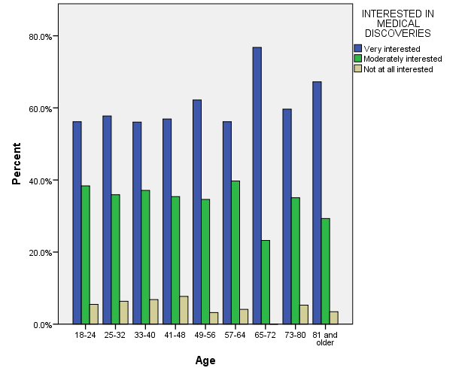

- Do you think that the government should help pay for medical care?

BY RACE

SHOULD GOVT HELP PAY FOR MEDICAL CARE * RACE OF RESPONDENT Crosstabulation
 |  |  | RACE OF RESPONDENT |  |  | Total
 |  |  | WHITE | BLACK | OTHER
SHOULD GOVT HELP PAY FOR MEDICAL CARE | GOVT SHOULD HELP | Count | 423 | 121 | 68 | 612
 |  | % within RACE OF RESPONDENT | 63.8% | 90.3% | 75.6% | 69.0%
 | PEOPLE HELF SELVES | Count | 240 | 13 | 22 | 275
 |  | % within RACE OF RESPONDENT | 36.2% | 9.7% | 24.4% | 31.0%
Total |  | Count | 663 | 134 | 90 | 887
 |  | % within RACE OF RESPONDENT | 100.0% | 100.0% | 100.0% | 100.0%
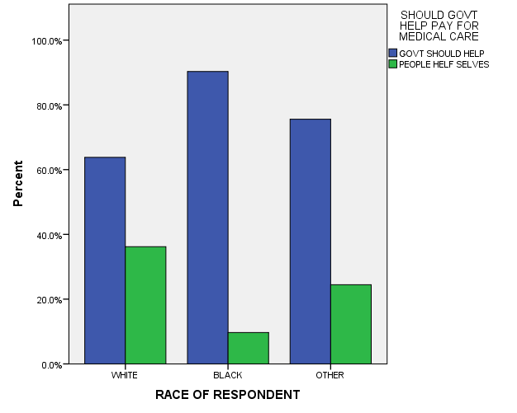

- What is your confidence level in medicine?

ALL RESPONSES – CHANGE OVER TIME

