Look Behind the Numbers

Questions about alcohol and other drugs from the General Social Survey

- Should marijuana be made legal?

BY SEX

SHOULD MARIJUANA BE MADE LEGAL * RESPONDENTS SEX Crosstabulation
 |  |  | RESPONDENTS SEX |  | Total
 |  |  | MALE | FEMALE
SHOULD MARIJUANA BE MADE LEGAL | LEGAL | Count | 295 | 291 | 586
 |  | % within RESPONDENTS SEX | 53.2% | 42.8% | 47.5%
 | NOT LEGAL | Count | 259 | 389 | 648
 |  | % within RESPONDENTS SEX | 46.8% | 57.2% | 52.5%
Total |  | Count | 554 | 680 | 1234
 |  | % within RESPONDENTS SEX | 100.0% | 100.0% | 100.0%

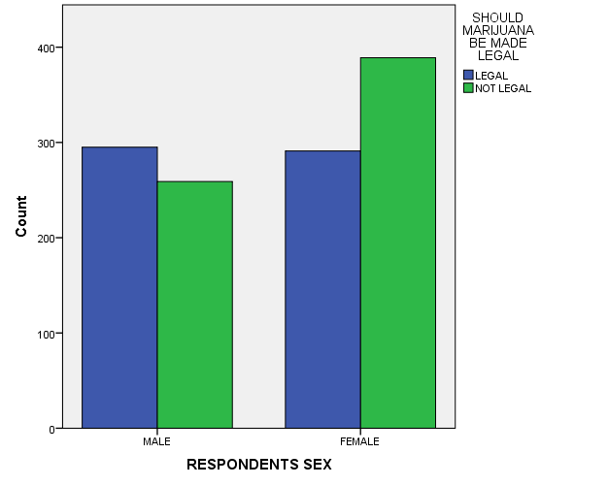

- In the United States, do you think we’re spending too much money on dealing with drug addiction, too little money, or about the right amount?

ALL RESPONSES

DEALING WITH DRUG ADDICTION
 |  | Frequency | Percent | Valid Percent | Cumulative Percent
Valid | TOO LITTLE | 544 | 27.6 | 57.6 | 57.6
 | ABOUT RIGHT | 290 | 14.7 | 30.7 | 88.3
 | TOO MUCH | 110 | 5.6 | 11.7 | 100.0
 | Total | 944 | 47.8 | 100.0
Missing | IAP | 976 | 49.4
 | DK | 52 | 2.6
 | NA | 2 | .1
 | Total | 1030 | 52.2
Total |  | 1974 | 100.0

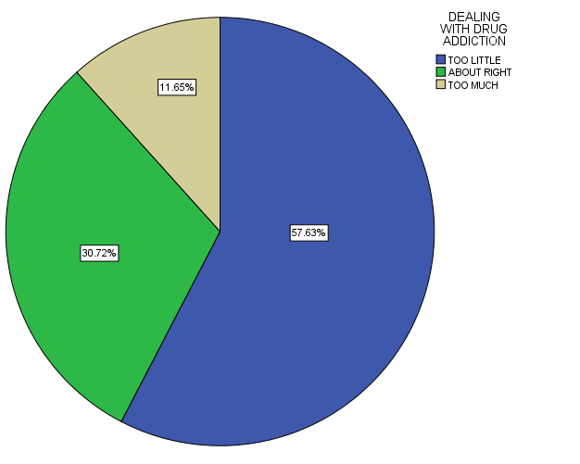

- In the United States, do you think we’re spending too much money on dealing with drug rehabilitation, too little money, or about the right amount?

ALL RESPONSES

DRUG REHABILITATION
 |  | Frequency | Percent | Valid Percent | Cumulative Percent
Valid | TOO LITTLE | 404 | 20.5 | 45.6 | 45.6
 | ABOUT RIGHT | 326 | 16.5 | 36.8 | 82.5
 | TOO MUCH | 155 | 7.9 | 17.5 | 100.0
 | Total | 885 | 44.8 | 100.0
Missing | IAP | 998 | 50.6
 | DK | 89 | 4.5
 | NA | 2 | .1
 | Total | 1089 | 55.2
Total |  | 1974 | 100.0

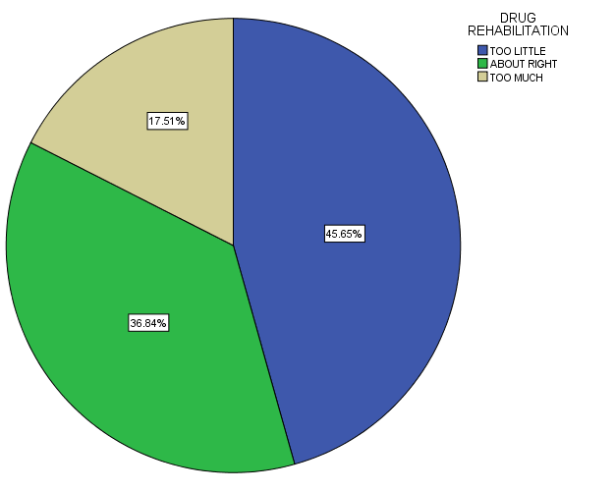

- Should marijuana be made legal?

ALL RESPONSES – CHANGE OVER TIME

