Look Behind the Numbers

Questions about Crime from the General Social Survey.
- Do you favor or oppose the death penalty for persons convicted of murder?

ALL RESPONSES-CHANGE OVER TIME

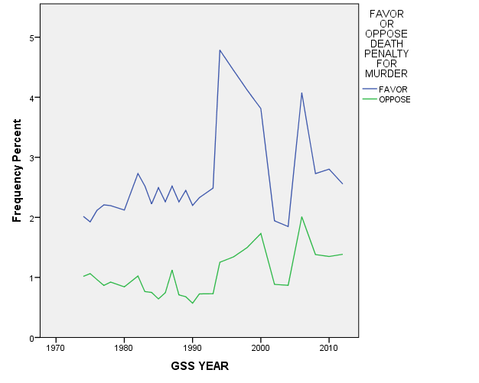
BY SEX

FAVOR OR OPPOSE DEATH PENALTY FOR MURDER * RESPONDENTS SEX Crosstabulation
 |  |  | RESPONDENTS SEX |  | Total
 |  |  | MALE | FEMALE
FAVOR OR OPPOSE DEATH PENALTY FOR MURDER | FAVOR | Count | 574 | 609 | 1183
 |  | % within RESPONDENTS SEX | 69.2% | 61.3% | 64.9%
 | OPPOSE | Count | 256 | 385 | 641
 |  | % within RESPONDENTS SEX | 30.8% | 38.7% | 35.1%
Total |  | Count | 830 | 994 | 1824
 |  | % within RESPONDENTS SEX | 100.0% | 100.0% | 100.0%

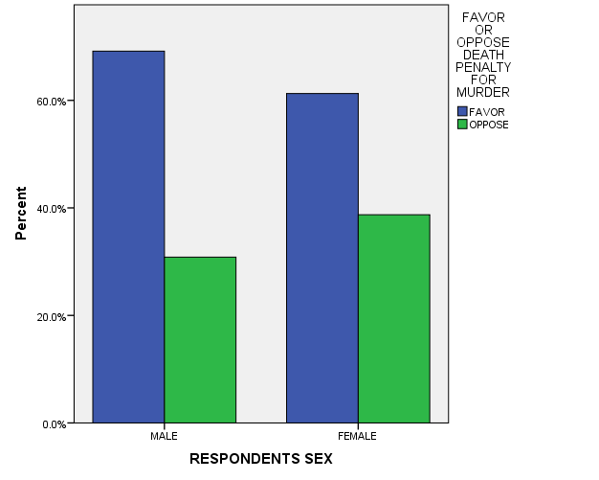

BY AGE

FAVOR OR OPPOSE DEATH PENALTY FOR MURDER * age recoded Crosstabulation
 |  |  | age recoded |  |  |  |  |  |  |  |  | Total
 |  |  | 18-24 | 25-32 | 33-40 | 41-48 | 49-56 | 57-64 | 65-72 | 73-80 | 9.00
FAVOR OR OPPOSE DEATH PENALTY FOR MURDER | FAVOR | Count | 101 | 163 | 170 | 183 | 182 | 155 | 113 | 68 | 48 | 1183
 |  | % within age recoded | 63.1% | 61.3% | 63.7% | 69.3% | 65.0% | 66.8% | 66.9% | 66.0% | 57.8% | 64.9%
 | OPPOSE | Count | 59 | 103 | 97 | 81 | 98 | 77 | 56 | 35 | 35 | 641
 |  | % within age recoded | 36.9% | 38.7% | 36.3% | 30.7% | 35.0% | 33.2% | 33.1% | 34.0% | 42.2% | 35.1%
Total |  | Count | 160 | 266 | 267 | 264 | 280 | 232 | 169 | 103 | 83 | 1824
 |  | % within age recoded | 100.0% | 100.0% | 100.0% | 100.0% | 100.0% | 100.0% | 100.0% | 100.0% | 100.0% | 100.0%

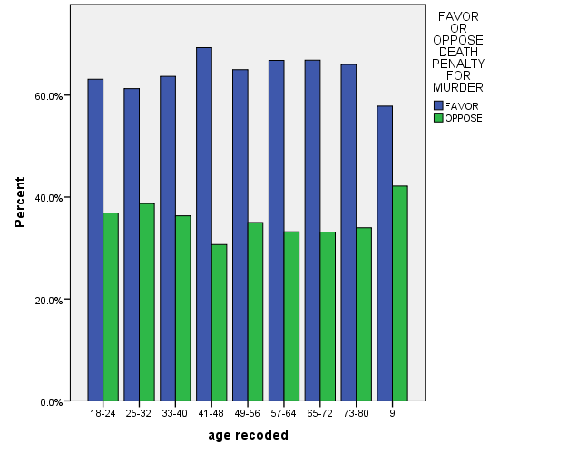

BY INCOME

FAVOR OR OPPOSE DEATH PENALTY FOR MURDER * Income Crosstabulation
 |  |  | Income |  |  | Total
 |  |  | $0-$14,999 | $15,000-$24,999 | $25,000 or Greater
FAVOR OR OPPOSE DEATH PENALTY FOR MURDER | FAVOR | Count | 116 | 218 | 418 | 752
 |  | % within Income | 61.7% | 61.1% | 69.7% | 65.7%
 | OPPOSE | Count | 72 | 139 | 182 | 393
 |  | % within Income | 38.3% | 38.9% | 30.3% | 34.3%
Total |  | Count | 188 | 357 | 600 | 1145
 |  | % within Income | 100.0% | 100.0% | 100.0% | 100.0%

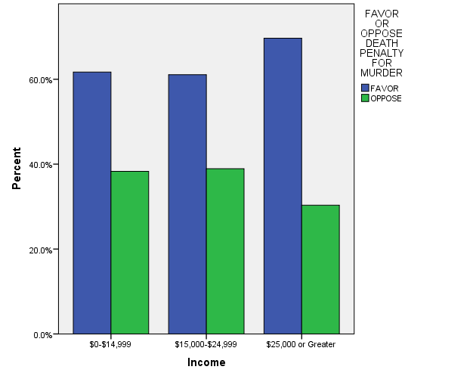

BY EDUCATION

FAVOR OR OPPOSE DEATH PENALTY FOR MURDER * Education Crosstabulation
 |  |  | Education |  |  |  |  | Total
 |  |  | Some Elementary, Middle or High School | Graduated High School | Some College | Graduated College | Post Bachelors Schooling
FAVOR OR OPPOSE DEATH PENALTY FOR MURDER | FAVOR | Count | 165 | 365 | 327 | 186 | 140 | 1183
 |  | % within Education | 58.5% | 71.4% | 68.1% | 66.4% | 51.7% | 64.9%
 | OPPOSE | Count | 117 | 146 | 153 | 94 | 131 | 641
 |  | % within Education | 41.5% | 28.6% | 31.9% | 33.6% | 48.3% | 35.1%
Total |  | Count | 282 | 511 | 480 | 280 | 271 | 1824
 |  | % within Education | 100.0% | 100.0% | 100.0% | 100.0% | 100.0% | 100.0%

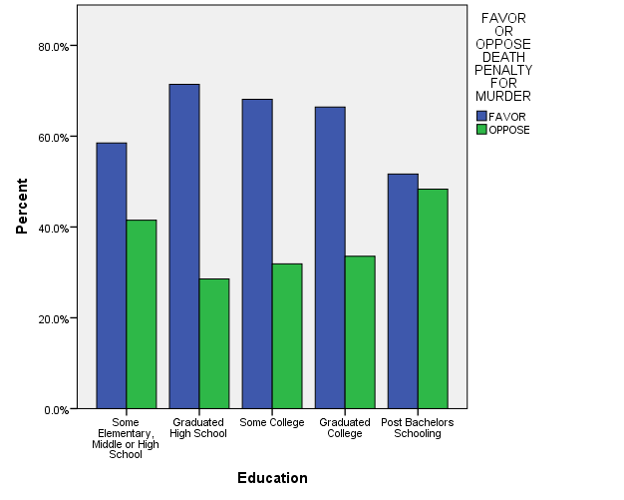

BY RACE: BLACK, WHITE & OTHER

FAVOR OR OPPOSE DEATH PENALTY FOR MURDER * RACE OF RESPONDENT Crosstabulation
 |  |  | RACE OF RESPONDENT |  |  | Total
 |  |  | WHITE | BLACK | OTHER
FAVOR OR OPPOSE DEATH PENALTY FOR MURDER | FAVOR | Count | 952 | 129 | 102 | 1183
 |  | % within RACE OF RESPONDENT | 69.6% | 48.1% | 54.0% | 64.9%
 | OPPOSE | Count | 415 | 139 | 87 | 641
 |  | % within RACE OF RESPONDENT | 30.4% | 51.9% | 46.0% | 35.1%
Total |  | Count | 1367 | 268 | 189 | 1824
 |  | % within RACE OF RESPONDENT | 100.0% | 100.0% | 100.0% | 100.0%

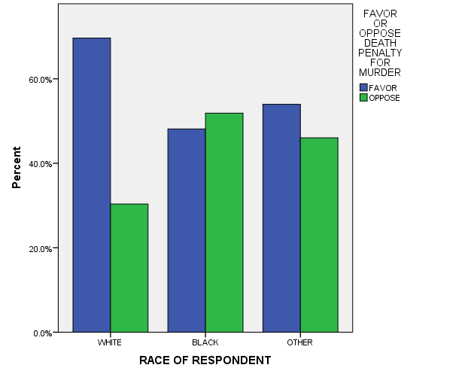

BY RACE: WHITE AND NON-WHITE

FAVOR OR OPPOSE DEATH PENALTY FOR MURDER * RACE OF RESPONDENT Crosstabulation
 |  |  | RACE OF RESPONDENT |  | Total
 |  |  | WHITE | NON-WHITE
FAVOR OR OPPOSE DEATH PENALTY FOR MURDER | FAVOR | Count | 952 | 231 | 1183
 |  | % within RACE OF RESPONDENT | 69.6% | 50.5% | 64.9%
 | OPPOSE | Count | 415 | 226 | 641
 |  | % within RACE OF RESPONDENT | 30.4% | 49.5% | 35.1%
Total |  | Count | 1367 | 457 | 1824
 |  | % within RACE OF RESPONDENT | 100.0% | 100.0% | 100.0%

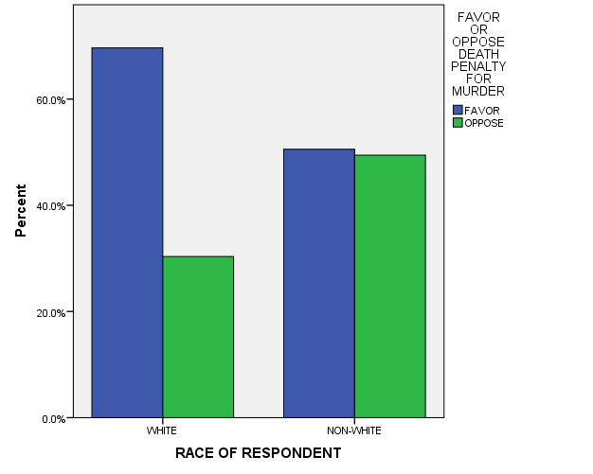

- In general, do you think the courts in this area deal too harshly or not harshly enough with criminals?

ALL RESPONSES – CHANGE OVER TIME
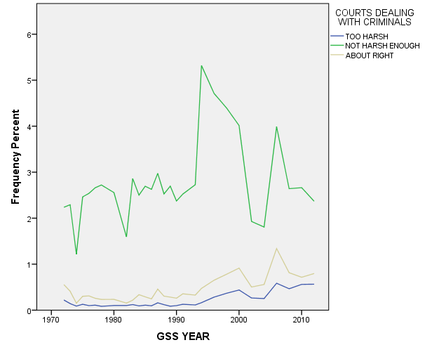

BY RACE: WHITE AND NON-WHITE

COURTS DEALING WITH CRIMINALS * RACE OF RESPONDENT Crosstabulation
 |  |  | RACE OF RESPONDENT |  | Total
 |  |  | WHITE | NON-WHITE
COURTS DEALING WITH CRIMINALS | TOO HARSH | Count | 165 | 104 | 269
 |  | % within RACE OF RESPONDENT | 12.4% | 23.3% | 15.1%
 | NOT HARSH ENOUGH | Count | 865 | 263 | 1128
 |  | % within RACE OF RESPONDENT | 65.0% | 59.0% | 63.5%
 | ABOUT RIGHT | Count | 301 | 79 | 380
 |  | % within RACE OF RESPONDENT | 22.6% | 17.7% | 21.4%
Total |  | Count | 1331 | 446 | 1777
 |  | % within RACE OF RESPONDENT | 100.0% | 100.0% | 100.0%

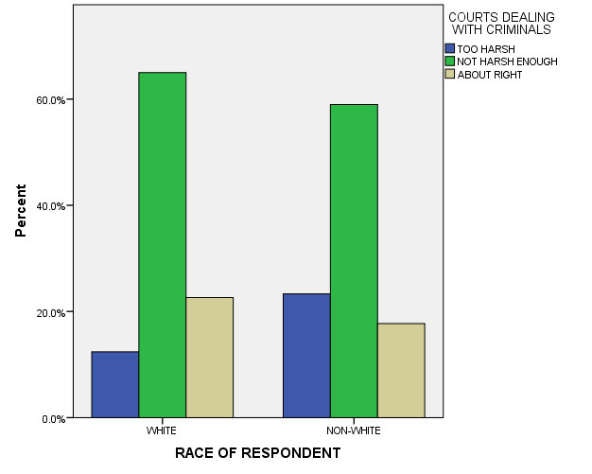

BY RACE: WHITE, BLACK & OTHER

COURTS DEALING WITH CRIMINALS * RACE OF RESPONDENT Crosstabulation
 |  |  | RACE OF RESPONDENT |  |  | Total
 |  |  | WHITE | BLACK | OTHER
COURTS DEALING WITH CRIMINALS | TOO HARSH | Count | 165 | 65 | 39 | 269
 |  | % within RACE OF RESPONDENT | 12.4% | 23.9% | 22.4% | 15.1%
 | NOT HARSH ENOUGH | Count | 865 | 163 | 100 | 1128
 |  | % within RACE OF RESPONDENT | 65.0% | 59.9% | 57.5% | 63.5%
 | ABOUT RIGHT | Count | 301 | 44 | 35 | 380
 |  | % within RACE OF RESPONDENT | 22.6% | 16.2% | 20.1% | 21.4%
Total |  | Count | 1331 | 272 | 174 | 1777
 |  | % within RACE OF RESPONDENT | 100.0% | 100.0% | 100.0% | 100.0%

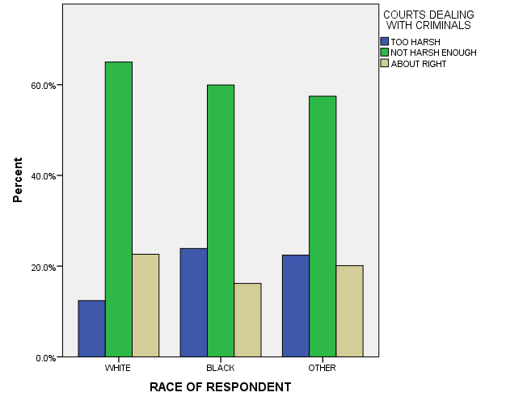

- Would you favor or oppose a law which would require a person to obtain a police permit before he or she could buy a gun?

ALL RESPONSES – CHANGE OVER TIME

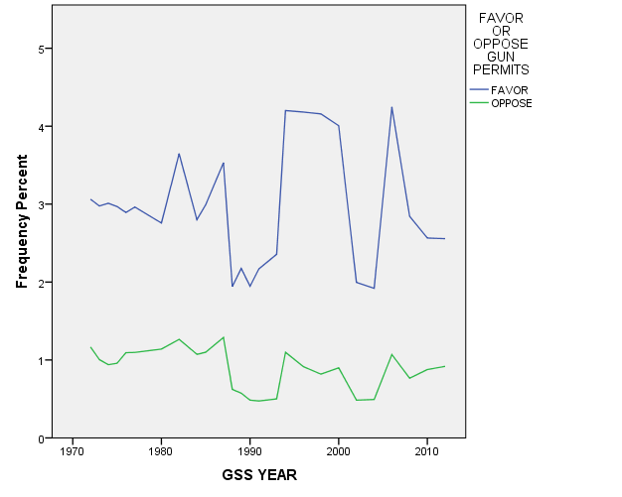

BY RACE: WHITE AND NONWHITE

FAVOR OR OPPOSE GUN PERMITS * RACE OF RESPONDENT Crosstabulation
 |  |  | RACE OF RESPONDENT |  | Total
 |  |  | WHITE | NON-WHITE
FAVOR OR OPPOSE GUN PERMITS | FAVOR | Count | 682 | 262 | 944
 |  | % within RACE OF RESPONDENT | 71.0% | 81.1% | 73.6%
 | OPPOSE | Count | 278 | 61 | 339
 |  | % within RACE OF RESPONDENT | 29.0% | 18.9% | 26.4%
Total |  | Count | 960 | 323 | 1283
 |  | % within RACE OF RESPONDENT | 100.0% | 100.0% | 100.0%

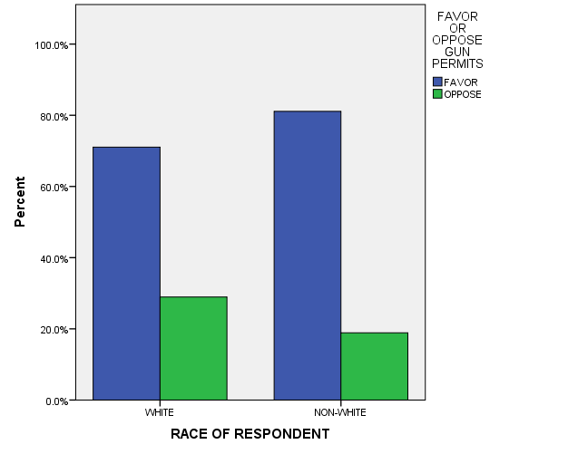

BY RACE: WHITE, BLACK, & OTHER

FAVOR OR OPPOSE GUN PERMITS * RACE OF RESPONDENT Crosstabulation
 |  |  | RACE OF RESPONDENT |  |  | Total
 |  |  | WHITE | BLACK | OTHER
FAVOR OR OPPOSE GUN PERMITS | FAVOR | Count | 682 | 162 | 100 | 944
 |  | % within RACE OF RESPONDENT | 71.0% | 83.5% | 77.5% | 73.6%
 | OPPOSE | Count | 278 | 32 | 29 | 339
 |  | % within RACE OF RESPONDENT | 29.0% | 16.5% | 22.5% | 26.4%
Total |  | Count | 960 | 194 | 129 | 1283
 |  | % within RACE OF RESPONDENT | 100.0% | 100.0% | 100.0% | 100.0%

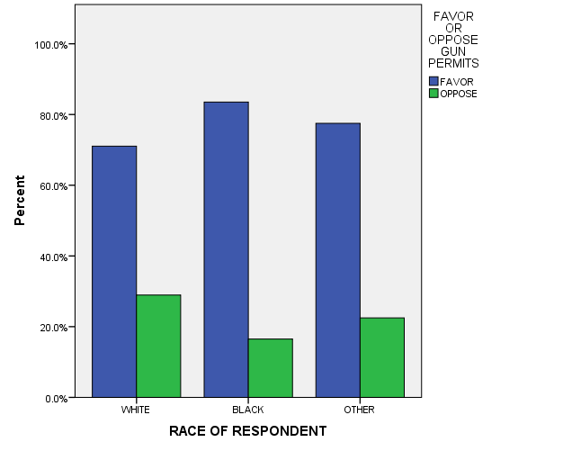

- In the United States, do you think we're spending too much money on law enforcement, too little money, or about the right amount?

ALL RESPONSES – CHANGE OVER TIME

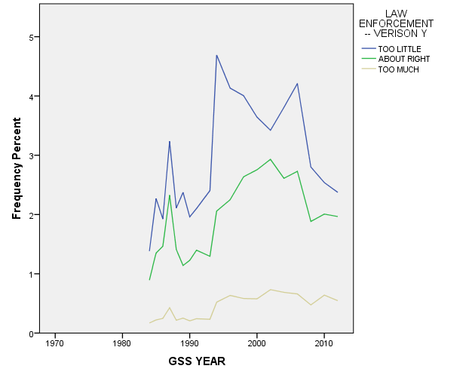

BY RACE: WHITE AND NON-WHITE

LAW ENFORCEMENT -- VERISON Y * RACE OF RESPONDENT Crosstabulation
 |  |  | RACE OF RESPONDENT |  | Total
 |  |  | WHITE | NON-WHITE
LAW ENFORCEMENT -- VERISON Y | TOO LITTLE | Count | 346 | 114 | 460
 |  | % within RACE OF RESPONDENT | 48.7% | 48.3% | 48.6%
 | ABOUT RIGHT | Count | 289 | 92 | 381
 |  | % within RACE OF RESPONDENT | 40.6% | 39.0% | 40.2%
 | TOO MUCH | Count | 76 | 30 | 106
 |  | % within RACE OF RESPONDENT | 10.7% | 12.7% | 11.2%
Total |  | Count | 711 | 236 | 947
 |  | % within RACE OF RESPONDENT | 100.0% | 100.0% | 100.0%

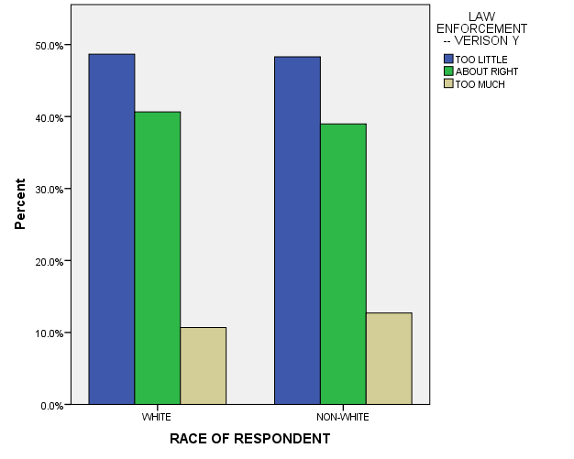

BY RACE: WHITE, BLACK, OTHER

LAW ENFORCEMENT -- VERISON Y * RACE OF RESPONDENT Crosstabulation
 |  |  | RACE OF RESPONDENT |  |  | Total
 |  |  | WHITE | BLACK | OTHER
LAW ENFORCEMENT -- VERISON Y | TOO LITTLE | Count | 346 | 80 | 34 | 460
 |  | % within RACE OF RESPONDENT | 48.7% | 54.8% | 37.8% | 48.6%
 | ABOUT RIGHT | Count | 289 | 48 | 44 | 381
 |  | % within RACE OF RESPONDENT | 40.6% | 32.9% | 48.9% | 40.2%
 | TOO MUCH | Count | 76 | 18 | 12 | 106
 |  | % within RACE OF RESPONDENT | 10.7% | 12.3% | 13.3% | 11.2%
Total |  | Count | 711 | 146 | 90 | 947
 |  | % within RACE OF RESPONDENT | 100.0% | 100.0% | 100.0% | 100.0%

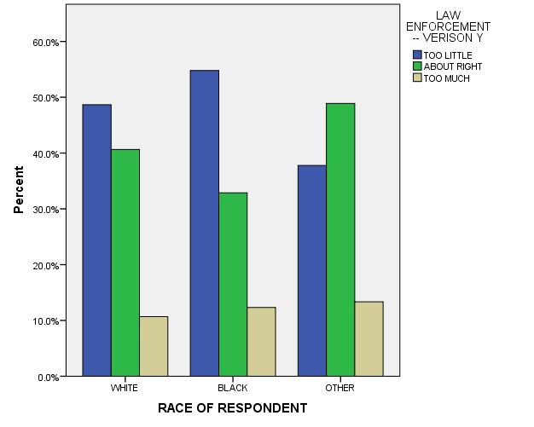

- Are there any situations you can imagine in which you would approve of a policeman striking an adult male citizen?

ALL RESPONSES – CHANGE OVER TIME
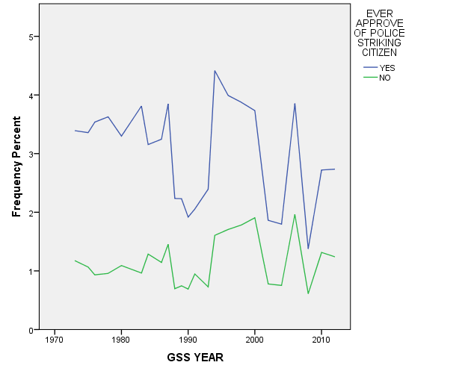

BY RACE: WHITE AND NON-WHITE

EVER APPROVE OF POLICE STRIKING CITIZEN * RACE OF RESPONDENT Crosstabulation
 |  |  | RACE OF RESPONDENT |  | Total
 |  |  | WHITE | NON-WHITE
EVER APPROVE OF POLICE STRIKING CITIZEN | YES | Count | 717 | 163 | 880
 |  | % within RACE OF RESPONDENT | 74.7% | 51.1% | 68.8%
 | NO | Count | 243 | 156 | 399
 |  | % within RACE OF RESPONDENT | 25.3% | 48.9% | 31.2%
Total |  | Count | 960 | 319 | 1279
 |  | % within RACE OF RESPONDENT | 100.0% | 100.0% | 100.0%

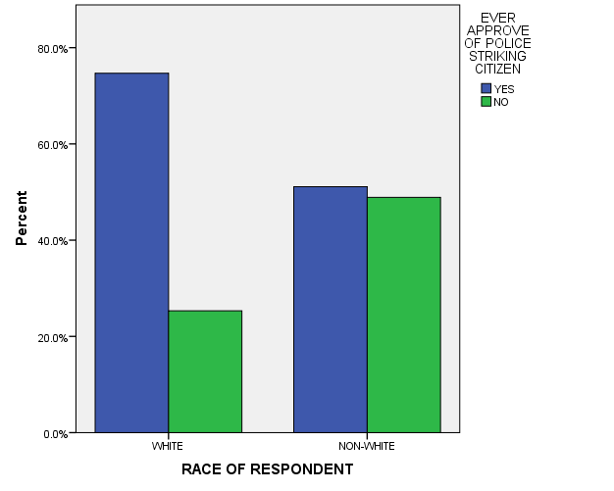

BY RACE: BLACK, WHITE, & OTHER

EVER APPROVE OF POLICE STRIKING CITIZEN * RACE OF RESPONDENT Crosstabulation
 |  |  | RACE OF RESPONDENT |  |  | Total
 |  |  | WHITE | BLACK | OTHER
EVER APPROVE OF POLICE STRIKING CITIZEN | YES | Count | 717 | 104 | 59 | 880
 |  | % within RACE OF RESPONDENT | 74.7% | 55.0% | 45.4% | 68.8%
 | NO | Count | 243 | 85 | 71 | 399
 |  | % within RACE OF RESPONDENT | 25.3% | 45.0% | 54.6% | 31.2%
Total |  | Count | 960 | 189 | 130 | 1279
 |  | % within RACE OF RESPONDENT | 100.0% | 100.0% | 100.0% | 100.0%

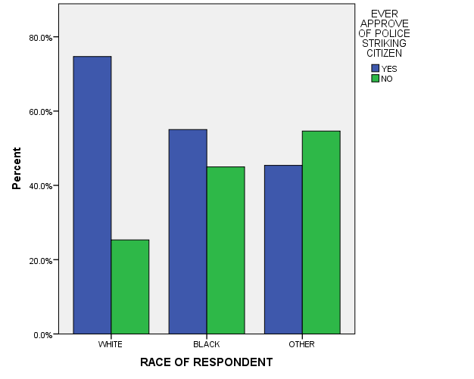

- Are you ever afraid to walk at night in your neighborhood?

ALL RESPONSES – CHANGE OVER TIME
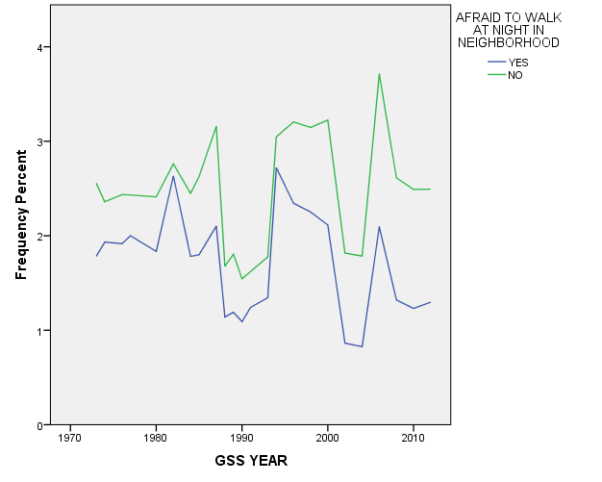

BY RACE: WHITE, BLACK, & OTHER

AFRAID TO WALK AT NIGHT IN NEIGHBORHOOD * RACE OF RESPONDENT Crosstabulation
 |  |  | RACE OF RESPONDENT |  |  | Total
 |  |  | WHITE | BLACK | OTHER
AFRAID TO WALK AT NIGHT IN NEIGHBORHOOD | YES | Count | 314 | 79 | 52 | 445
 |  | % within RACE OF RESPONDENT | 32.3% | 40.5% | 39.1% | 34.2%
 | NO | Count | 658 | 116 | 81 | 855
 |  | % within RACE OF RESPONDENT | 67.7% | 59.5% | 60.9% | 65.8%
Total |  | Count | 972 | 195 | 133 | 1300
 |  | % within RACE OF RESPONDENT | 100.0% | 100.0% | 100.0% | 100.0%

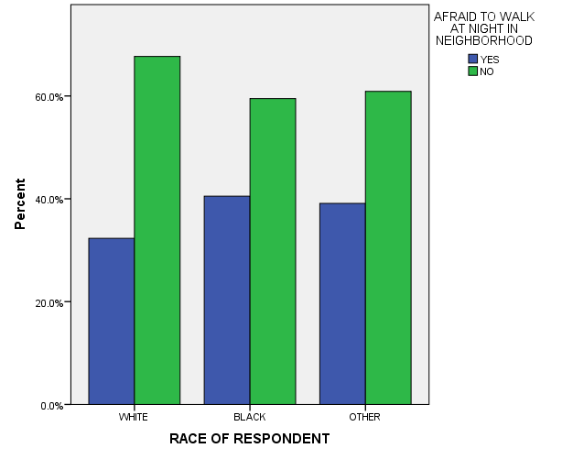

BY RACE: WHITE AND NON-WHITE

AFRAID TO WALK AT NIGHT IN NEIGHBORHOOD * RACE OF RESPONDENT Crosstabulation
 |  |  | RACE OF RESPONDENT |  | Total
 |  |  | WHITE | NON-WHITE
AFRAID TO WALK AT NIGHT IN NEIGHBORHOOD | YES | Count | 314 | 131 | 445
 |  | % within RACE OF RESPONDENT | 32.3% | 39.9% | 34.2%
 | NO | Count | 658 | 197 | 855
 |  | % within RACE OF RESPONDENT | 67.7% | 60.1% | 65.8%
Total |  | Count | 972 | 328 | 1300
 |  | % within RACE OF RESPONDENT | 100.0% | 100.0% | 100.0%

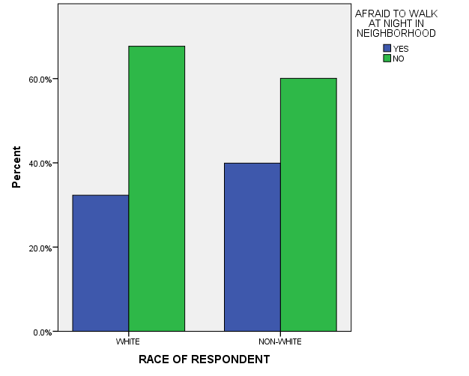

BY SEX

AFRAID TO WALK AT NIGHT IN NEIGHBORHOOD * RESPONDENTS SEX Crosstabulation
 |  |  | RESPONDENTS SEX |  | Total
 |  |  | MALE | FEMALE
AFRAID TO WALK AT NIGHT IN NEIGHBORHOOD | YES | Count | 121 | 324 | 445
 |  | % within RESPONDENTS SEX | 20.9% | 44.9% | 34.2%
 | NO | Count | 457 | 398 | 855
 |  | % within RESPONDENTS SEX | 79.1% | 55.1% | 65.8%
Total |  | Count | 578 | 722 | 1300
 |  | % within RESPONDENTS SEX | 100.0% | 100.0% | 100.0%

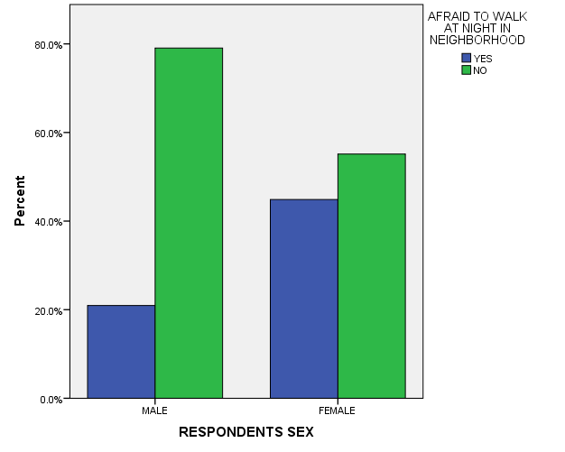

BY INCOME

AFRAID TO WALK AT NIGHT IN NEIGHBORHOOD * Income Crosstabulation
 |  |  | Income |  |  | Total
 |  |  | $0-$14,999 | $15,000-$24,999 | $25,000 or Greater
AFRAID TO WALK AT NIGHT IN NEIGHBORHOOD | YES | Count | 50 | 89 | 128 | 267
 |  | % within Income | 36.2% | 35.0% | 30.0% | 32.6%
 | NO | Count | 88 | 165 | 298 | 551
 |  | % within Income | 63.8% | 65.0% | 70.0% | 67.4%
Total |  | Count | 138 | 254 | 426 | 818
 |  | % within Income | 100.0% | 100.0% | 100.0% | 100.0%

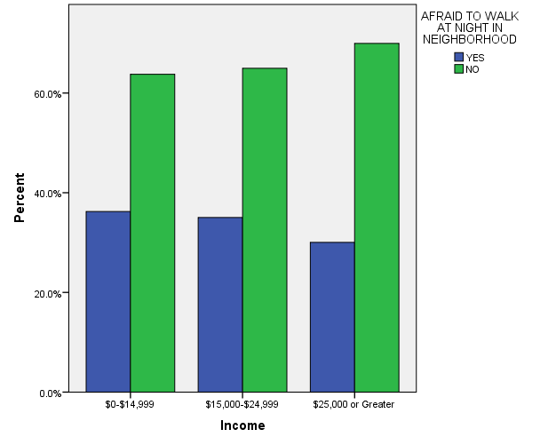

BY AGE

AFRAID TO WALK AT NIGHT IN NEIGHBORHOOD * Age Crosstabulation
 |  |  | Age |  |  |  |  |  |  |  |  | Total
 |  |  | 18-24 | 25-32 | 33-40 | 41-48 | 49-56 | 57-64 | 65-72 | 73-80 | 9.00
AFRAID TO WALK AT NIGHT IN NEIGHBORHOOD | YES | Count | 43 | 73 | 50 | 60 | 70 | 58 | 40 | 25 | 26 | 445
 |  | % within Age | 40.6% | 37.2% | 27.3% | 31.1% | 34.8% | 34.9% | 32.8% | 33.8% | 44.1% | 34.2%
 | NO | Count | 63 | 123 | 133 | 133 | 131 | 108 | 82 | 49 | 33 | 855
 |  | % within Age | 59.4% | 62.8% | 72.7% | 68.9% | 65.2% | 65.1% | 67.2% | 66.2% | 55.9% | 65.8%
Total |  | Count | 106 | 196 | 183 | 193 | 201 | 166 | 122 | 74 | 59 | 1300
 |  | % within Age | 100.0% | 100.0% | 100.0% | 100.0% | 100.0% | 100.0% | 100.0% | 100.0% | 100.0% | 100.0%

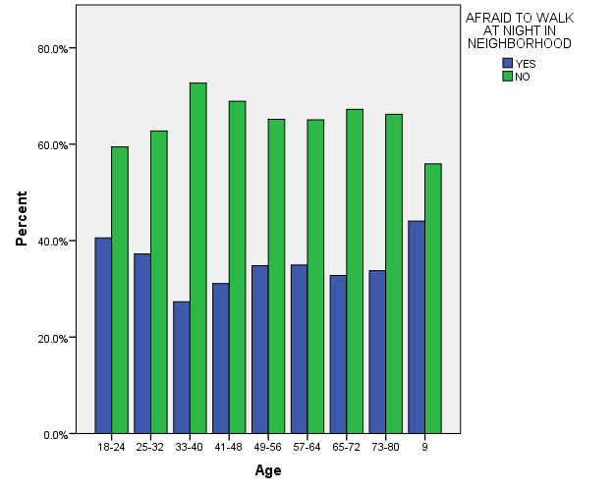

BY EDUCATION

AFRAID TO WALK AT NIGHT IN NEIGHBORHOOD * Education Crosstabulation
 |  |  | Education |  |  |  |  | Total
 |  |  | Some Elementary, Middle or High School | Graduated High School | Some College | Graduated College | Post Bachelors Schooling
AFRAID TO WALK AT NIGHT IN NEIGHBORHOOD | YES | Count | 75 | 118 | 133 | 58 | 61 | 445
 |  | % within Education | 37.9% | 32.0% | 38.6% | 29.4% | 31.9% | 34.2%
 | NO | Count | 123 | 251 | 212 | 139 | 130 | 855
 |  | % within Education | 62.1% | 68.0% | 61.4% | 70.6% | 68.1% | 65.8%
Total |  | Count | 198 | 369 | 345 | 197 | 191 | 1300
 |  | % within Education | 100.0% | 100.0% | 100.0% | 100.0% | 100.0% | 100.0%

