Look Behind the Numbers

Questions about work and the economy from the General Social Survey

- If you were to become rich, would you continue to work or stop working?

BY SEX

IF RICH, CONTINUE OR STOP WORKING * RESPONDENTS SEX Crosstabulation
 |  |  | RESPONDENTS SEX |  | Total
 |  |  | MALE | FEMALE
IF RICH, CONTINUE OR STOP WORKING | CONTINUE WORKING | Count | 290 | 290 | 580
 |  | % within RESPONDENTS SEX | 69.4% | 70.6% | 70.0%
 | STOP WORKING | Count | 128 | 121 | 249
 |  | % within RESPONDENTS SEX | 30.6% | 29.4% | 30.0%
Total |  | Count | 418 | 411 | 829
 |  | % within RESPONDENTS SEX | 100.0% | 100.0% | 100.0%
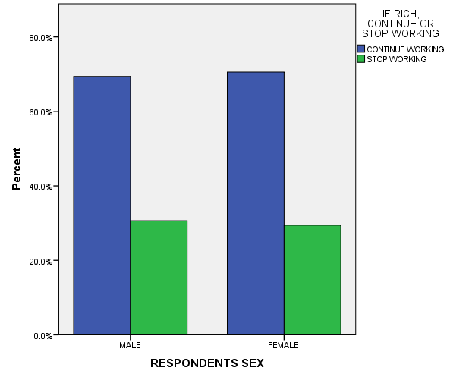

- What is your interest level in economic issues?

BY RACE

INTERESTED IN ECONOMIC ISSUES * RACE OF RESPONDENT Crosstabulation
 |  |  | RACE OF RESPONDENT |  |  | Total
 |  |  | WHITE | BLACK | OTHER
INTERESTED IN ECONOMIC ISSUES | Very interested | Count | 367 | 82 | 59 | 508
 |  | % within RACE OF RESPONDENT | 50.3% | 55.4% | 54.1% | 51.5%
 | Moderately interested | Count | 286 | 53 | 37 | 376
 |  | % within RACE OF RESPONDENT | 39.2% | 35.8% | 33.9% | 38.1%
 | Not at all interested | Count | 77 | 13 | 13 | 103
 |  | % within RACE OF RESPONDENT | 10.5% | 8.8% | 11.9% | 10.4%
Total |  | Count | 730 | 148 | 109 | 987
 |  | % within RACE OF RESPONDENT | 100.0% | 100.0% | 100.0% | 100.0%

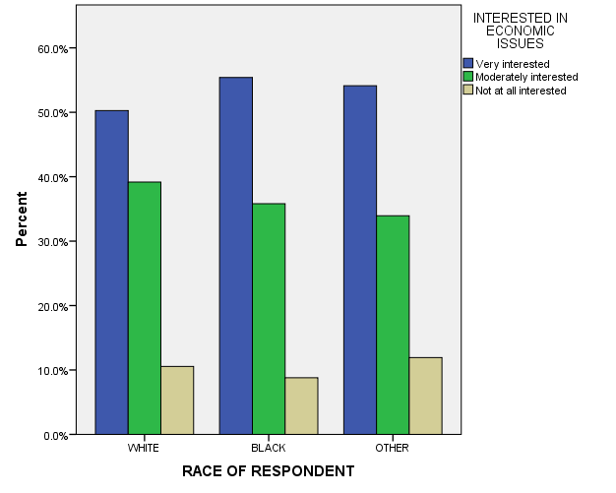

- Do you think work is most important to feel accomplished?

ALL RESPONSES

WORK IMPORTANT AND FEEL ACCOMPLISHMENT
 |  | Frequency | Percent | Valid Percent | Cumulative Percent
Valid | MOST IMPORTANT | 435 | 22.0 | 45.8 | 45.8
 | NOT THE MOST IMPORTANT | 515 | 26.1 | 54.2 | 100.0
 | Total | 950 | 48.1 | 100.0
Missing | System | 1024 | 51.9
Total |  | 1974 | 100.0

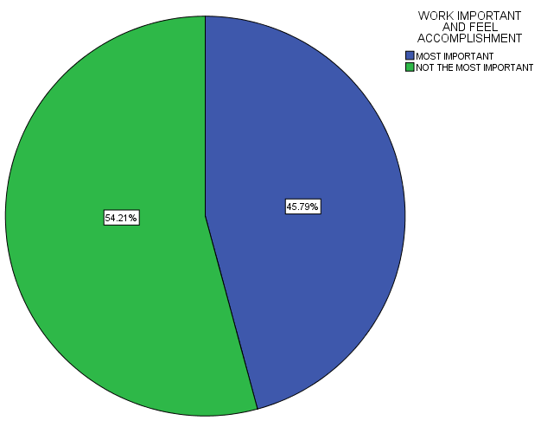

- What is your confidence level in banks and financial institutions?

ALL RESPONSES – CHANGE OVER TIME

