Look Behind the Numbers

Questions about Social Problems from the General Social Survey.

1. People need not overly worry about others.
ALL RESPONSES

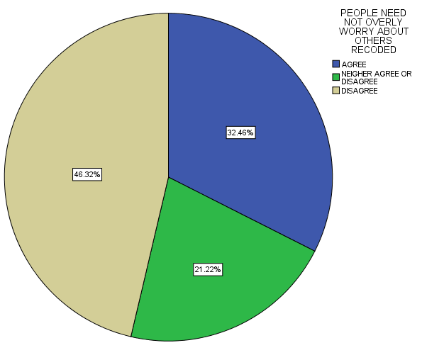

PEOPLE NEED NOT OVERLY WORRY ABOUT OTHERS RECODED
 |  | Frequency | Percent | Valid Percent | Cumulative Percent
Valid | AGREE | 419 | 21.2 | 32.5 | 32.5
 | NEIGHER AGREE OR DISAGREE | 274 | 13.9 | 21.2 | 53.7
 | DISAGREE | 598 | 30.3 | 46.3 | 100.0
 | Total | 1291 | 65.4 | 100.0
Missing | System | 683 | 34.6
Total |  | 1974 | 100.0

2. People need not overly worry about others.

BY AGE

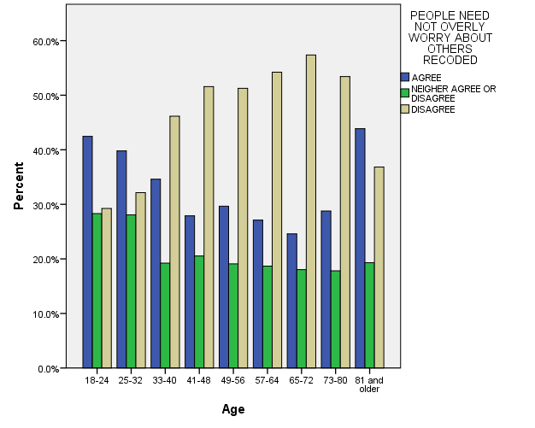

PEOPLE NEED NOT OVERLY WORRY ABOUT OTHERS RECODED * Age Crosstabulation
 |  |  | Age |  |  |  |  |  |  |  |  | Total
 |  |  | 18-24 | 25-32 | 33-40 | 41-48 | 49-56 | 57-64 | 65-72 | 73-80 | 81 and older
PEOPLE NEED NOT OVERLY WORRY ABOUT OTHERS RECODED | AGREE | Count | 45 | 78 | 63 | 53 | 59 | 45 | 30 | 21 | 25 | 419
 |  | % within Age | 42.5% | 39.8% | 34.6% | 27.9% | 29.6% | 27.1% | 24.6% | 28.8% | 43.9% | 32.5%
 | NEIGHER AGREE OR DISAGREE | Count | 30 | 55 | 35 | 39 | 38 | 31 | 22 | 13 | 11 | 274
 |  | % within Age | 28.3% | 28.1% | 19.2% | 20.5% | 19.1% | 18.7% | 18.0% | 17.8% | 19.3% | 21.2%
 | DISAGREE | Count | 31 | 63 | 84 | 98 | 102 | 90 | 70 | 39 | 21 | 598
 |  | % within Age | 29.2% | 32.1% | 46.2% | 51.6% | 51.3% | 54.2% | 57.4% | 53.4% | 36.8% | 46.3%
Total |  | Count | 106 | 196 | 182 | 190 | 199 | 166 | 122 | 73 | 57 | 1291
 |  | % within Age | 100.0% | 100.0% | 100.0% | 100.0% | 100.0% | 100.0% | 100.0% | 100.0% | 100.0% | 100.0%

BY AGE

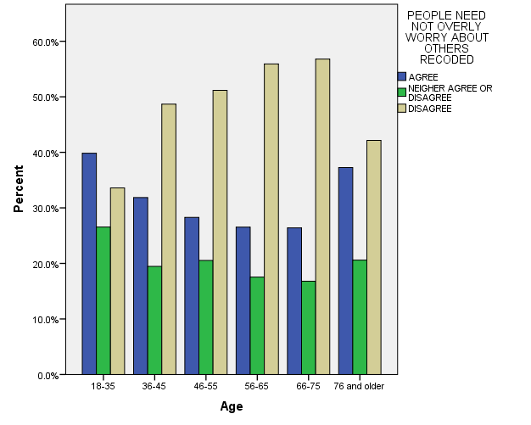

PEOPLE NEED NOT OVERLY WORRY ABOUT OTHERS RECODED * Age Crosstabulation
 |  |  | Age |  |  |  |  |  | Total
 |  |  | 18-35 | 36-45 | 46-55 | 56-65 | 66-75 | 76 and older
PEOPLE NEED NOT OVERLY WORRY ABOUT OTHERS RECODED | AGREE | Count | 147 | 72 | 73 | 56 | 33 | 38 | 419
 |  | % within Age | 39.8% | 31.9% | 28.3% | 26.5% | 26.4% | 37.3% | 32.5%
 | NEIGHER AGREE OR DISAGREE | Count | 98 | 44 | 53 | 37 | 21 | 21 | 274
 |  | % within Age | 26.6% | 19.5% | 20.5% | 17.5% | 16.8% | 20.6% | 21.2%
 | DISAGREE | Count | 124 | 110 | 132 | 118 | 71 | 43 | 598
 |  | % within Age | 33.6% | 48.7% | 51.2% | 55.9% | 56.8% | 42.2% | 46.3%
Total |  | Count | 369 | 226 | 258 | 211 | 125 | 102 | 1291
 |  | % within Age | 100.0% | 100.0% | 100.0% | 100.0% | 100.0% | 100.0% | 100.0%

BY EDUCATION

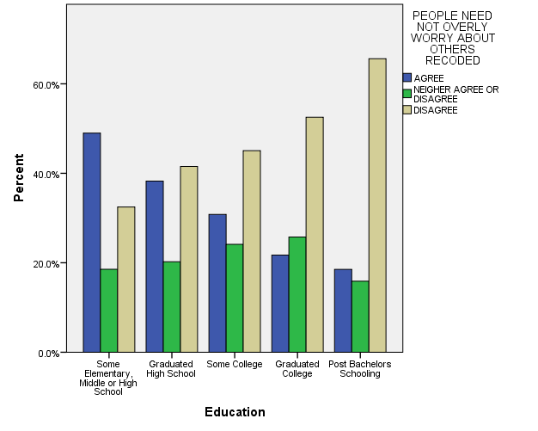

PEOPLE NEED NOT OVERLY WORRY ABOUT OTHERS RECODED * Education Crosstabulation
 |  |  | Education |  |  |  |  | Total
 |  |  | Some Elementary, Middle or High School | Graduated High School | Some College | Graduated College | Post Bachelors Schooling
PEOPLE NEED NOT OVERLY WORRY ABOUT OTHERS RECODED | AGREE | Count | 95 | 140 | 106 | 43 | 35 | 419
 |  | % within Education | 49.0% | 38.3% | 30.8% | 21.7% | 18.5% | 32.5%
 | NEIGHER AGREE OR DISAGREE | Count | 36 | 74 | 83 | 51 | 30 | 274
 |  | % within Education | 18.6% | 20.2% | 24.1% | 25.8% | 15.9% | 21.2%
 | DISAGREE | Count | 63 | 152 | 155 | 104 | 124 | 598
 |  | % within Education | 32.5% | 41.5% | 45.1% | 52.5% | 65.6% | 46.3%
Total |  | Count | 194 | 366 | 344 | 198 | 189 | 1291
 |  | % within Education | 100.0% | 100.0% | 100.0% | 100.0% | 100.0% | 100.0%

BY INCOME

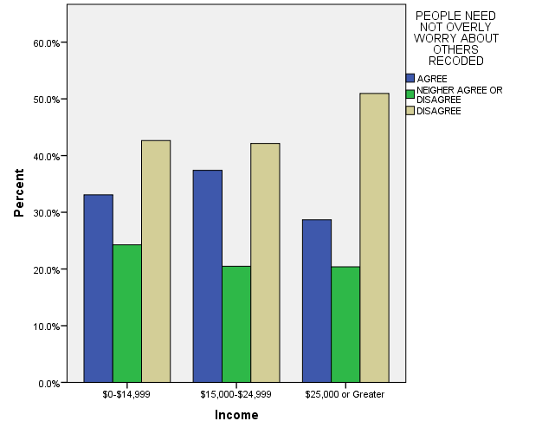

PEOPLE NEED NOT OVERLY WORRY ABOUT OTHERS RECODED * Income Crosstabulation
 |  |  | Income |  |  | Total
 |  |  | $0-$14,999 | $15,000-$24,999 | $25,000 or Greater
PEOPLE NEED NOT OVERLY WORRY ABOUT OTHERS RECODED | AGREE | Count | 45 | 95 | 121 | 261
 |  | % within Income | 33.1% | 37.4% | 28.7% | 32.1%
 | NEIGHER AGREE OR DISAGREE | Count | 33 | 52 | 86 | 171
 |  | % within Income | 24.3% | 20.5% | 20.4% | 21.1%
 | DISAGREE | Count | 58 | 107 | 215 | 380
 |  | % within Income | 42.6% | 42.1% | 50.9% | 46.8%
Total |  | Count | 136 | 254 | 422 | 812
 |  | % within Income | 100.0% | 100.0% | 100.0% | 100.0%

BY SEX

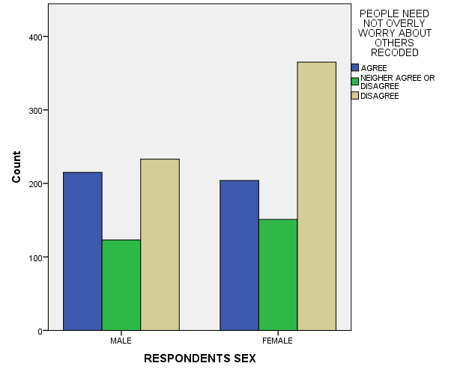

PEOPLE NEED NOT OVERLY WORRY ABOUT OTHERS RECODED * RESPONDENTS SEX Crosstabulation
 |  |  | RESPONDENTS SEX |  | Total
 |  |  | MALE | FEMALE
PEOPLE NEED NOT OVERLY WORRY ABOUT OTHERS RECODED | AGREE | Count | 215 | 204 | 419
 |  | % within RESPONDENTS SEX | 37.7% | 28.3% | 32.5%
 | NEIGHER AGREE OR DISAGREE | Count | 123 | 151 | 274
 |  | % within RESPONDENTS SEX | 21.5% | 21.0% | 21.2%
 | DISAGREE | Count | 233 | 365 | 598
 |  | % within RESPONDENTS SEX | 40.8% | 50.7% | 46.3%
Total |  | Count | 571 | 720 | 1291
 |  | % within RESPONDENTS SEX | 100.0% | 100.0% | 100.0%

BY RACE

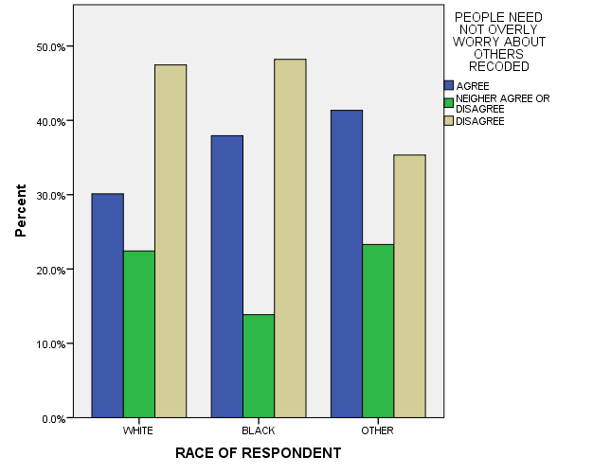

PEOPLE NEED NOT OVERLY WORRY ABOUT OTHERS RECODED * RACE OF RESPONDENT Crosstabulation
 |  |  | RACE OF RESPONDENT |  |  | Total
 |  |  | WHITE | BLACK | OTHER
PEOPLE NEED NOT OVERLY WORRY ABOUT OTHERS RECODED | AGREE | Count | 290 | 74 | 55 | 419
 |  | % within RACE OF RESPONDENT | 30.1% | 37.9% | 41.4% | 32.5%
 | NEIGHER AGREE OR DISAGREE | Count | 216 | 27 | 31 | 274
 |  | % within RACE OF RESPONDENT | 22.4% | 13.8% | 23.3% | 21.2%
 | DISAGREE | Count | 457 | 94 | 47 | 598
 |  | % within RACE OF RESPONDENT | 47.5% | 48.2% | 35.3% | 46.3%
Total |  | Count | 963 | 195 | 133 | 1291
 |  | % within RACE OF RESPONDENT | 100.0% | 100.0% | 100.0% | 100.0%

2. Are people helpful or looking out for themselves?

ALL RESPONES
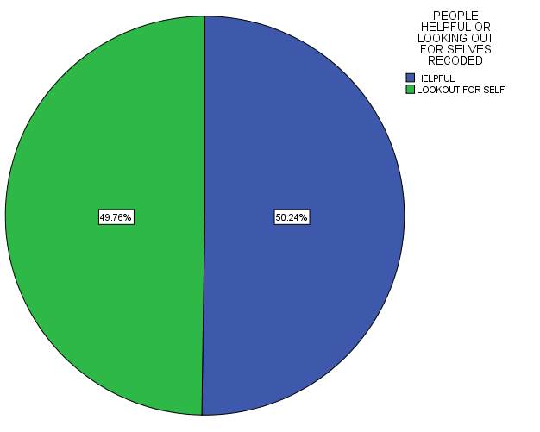

PEOPLE HELPFUL OR LOOKING OUT FOR SELVES RECODED
 |  | Frequency | Percent | Valid Percent | Cumulative Percent
Valid | HELPFUL | 618 | 31.3 | 50.2 | 50.2
 | LOOKOUT FOR SELF | 612 | 31.0 | 49.8 | 100.0
 | Total | 1230 | 62.3 | 100.0
Missing | System | 744 | 37.7
Total |  | 1974 | 100.0

BY INCOME

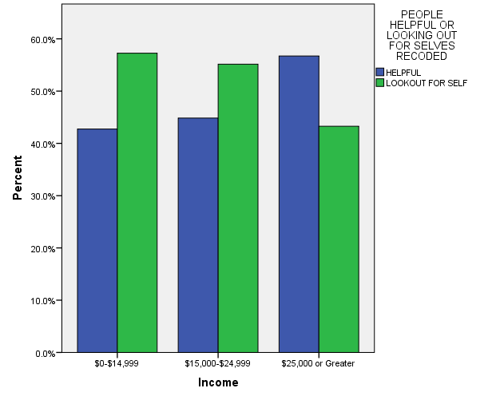

PEOPLE HELPFUL OR LOOKING OUT FOR SELVES RECODED * Income Crosstabulation
 |  |  | Income |  |  | Total
 |  |  | $0-$14,999 | $15,000-$24,999 | $25,000 or Greater
PEOPLE HELPFUL OR LOOKING OUT FOR SELVES RECODED | HELPFUL | Count | 53 | 100 | 232 | 385
 |  | % within Income | 42.7% | 44.8% | 56.7% | 50.9%
 | LOOKOUT FOR SELF | Count | 71 | 123 | 177 | 371
 |  | % within Income | 57.3% | 55.2% | 43.3% | 49.1%
Total |  | Count | 124 | 223 | 409 | 756
 |  | % within Income | 100.0% | 100.0% | 100.0% | 100.0%

BY EDUCATION

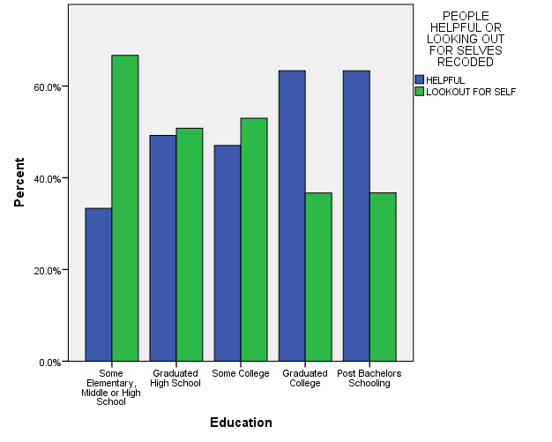

PEOPLE HELPFUL OR LOOKING OUT FOR SELVES RECODED * Education Crosstabulation
 |  |  | Education |  |  |  |  | Total
 |  |  | Some Elementary, Middle or High School | Graduated High School | Some College | Graduated College | Post Bachelors Schooling
PEOPLE HELPFUL OR LOOKING OUT FOR SELVES RECODED | HELPFUL | Count | 71 | 156 | 151 | 133 | 107 | 618
 |  | % within Education | 33.3% | 49.2% | 47.0% | 63.3% | 63.3% | 50.2%
 | LOOKOUT FOR SELF | Count | 142 | 161 | 170 | 77 | 62 | 612
 |  | % within Education | 66.7% | 50.8% | 53.0% | 36.7% | 36.7% | 49.8%
Total |  | Count | 213 | 317 | 321 | 210 | 169 | 1230
 |  | % within Education | 100.0% | 100.0% | 100.0% | 100.0% | 100.0% | 100.0%

BY SEX

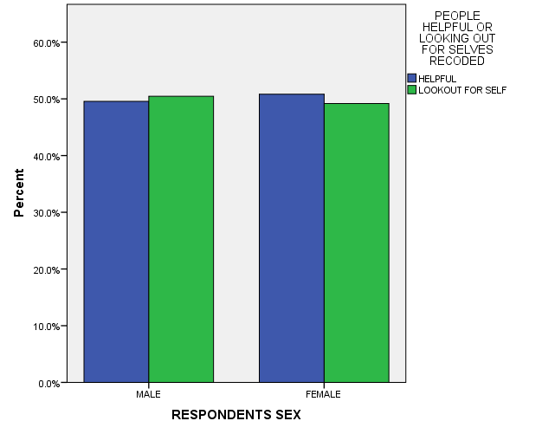

PEOPLE HELPFUL OR LOOKING OUT FOR SELVES RECODED * RESPONDENTS SEX Crosstabulation
 |  |  | RESPONDENTS SEX |  | Total
 |  |  | MALE | FEMALE
PEOPLE HELPFUL OR LOOKING OUT FOR SELVES RECODED | HELPFUL | Count | 275 | 343 | 618
 |  | % within RESPONDENTS SEX | 49.5% | 50.8% | 50.2%
 | LOOKOUT FOR SELF | Count | 280 | 332 | 612
 |  | % within RESPONDENTS SEX | 50.5% | 49.2% | 49.8%
Total |  | Count | 555 | 675 | 1230
 |  | % within RESPONDENTS SEX | 100.0% | 100.0% | 100.0%

BY RACE

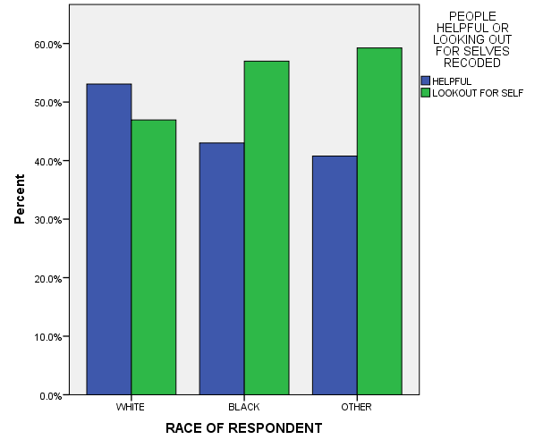

PEOPLE HELPFUL OR LOOKING OUT FOR SELVES RECODED * RACE OF RESPONDENT Crosstabulation
 |  |  | RACE OF RESPONDENT |  |  | Total
 |  |  | WHITE | BLACK | OTHER
PEOPLE HELPFUL OR LOOKING OUT FOR SELVES RECODED | HELPFUL | Count | 485 | 80 | 53 | 618
 |  | % within RACE OF RESPONDENT | 53.1% | 43.0% | 40.8% | 50.2%
 | LOOKOUT FOR SELF | Count | 429 | 106 | 77 | 612
 |  | % within RACE OF RESPONDENT | 46.9% | 57.0% | 59.2% | 49.8%
Total |  | Count | 914 | 186 | 130 | 1230
 |  | % within RACE OF RESPONDENT | 100.0% | 100.0% | 100.0% | 100.0%

BY AGE

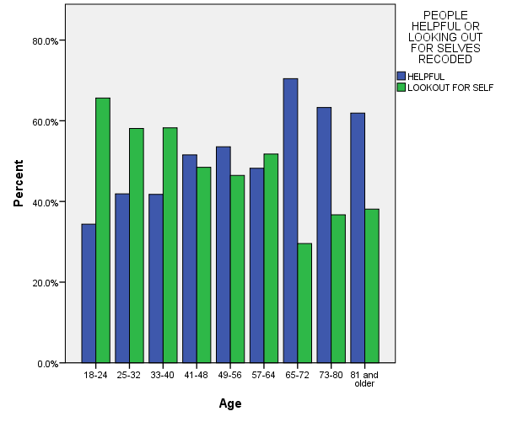

PEOPLE HELPFUL OR LOOKING OUT FOR SELVES RECODED * Age Crosstabulation
 |  |  | Age |  |  |  |  |  |  |  |  | Total
 |  |  | 18-24 | 25-32 | 33-40 | 41-48 | 49-56 | 57-64 | 65-72 | 73-80 | 81 and older
PEOPLE HELPFUL OR LOOKING OUT FOR SELVES RECODED | HELPFUL | Count | 33 | 75 | 76 | 84 | 98 | 82 | 81 | 50 | 39 | 618
 |  | % within Age | 34.4% | 41.9% | 41.8% | 51.5% | 53.6% | 48.2% | 70.4% | 63.3% | 61.9% | 50.2%
 | LOOKOUT FOR SELF | Count | 63 | 104 | 106 | 79 | 85 | 88 | 34 | 29 | 24 | 612
 |  | % within Age | 65.6% | 58.1% | 58.2% | 48.5% | 46.4% | 51.8% | 29.6% | 36.7% | 38.1% | 49.8%
Total |  | Count | 96 | 179 | 182 | 163 | 183 | 170 | 115 | 79 | 63 | 1230
 |  | % within Age | 100.0% | 100.0% | 100.0% | 100.0% | 100.0% | 100.0% | 100.0% | 100.0% | 100.0% | 100.0%

4. Can people be trusted?

ALL RESPONSES – CHANGES OVER TIME

