Path Analysis: SPSS

A researcher is interested in predicting the number relapses that occur after participation in an intensive inpatient substance abuse program. The researcher has data from 120 women who are at least five years beyond their initial admission to the program. At entry into the treatment program, the women were evaluated with respect to their psychological state and, in particular, on:

- Stress (score range from 1 to 10)
- Perception of the Quality of their Social Support (PQSS) (scores range from 10 to 30)
- Propensity for Substance Abuse (PSA) (scores range from 5 to 25)
- Depression (scores range from 60 to 160)

In addition there are records that indicate the number of relapses that each woman has had in the first five years after entry into the treatment program.
The hypothesized model is presented in Figure 1.

Figure 1: Proposed model of substance abuse relapses.

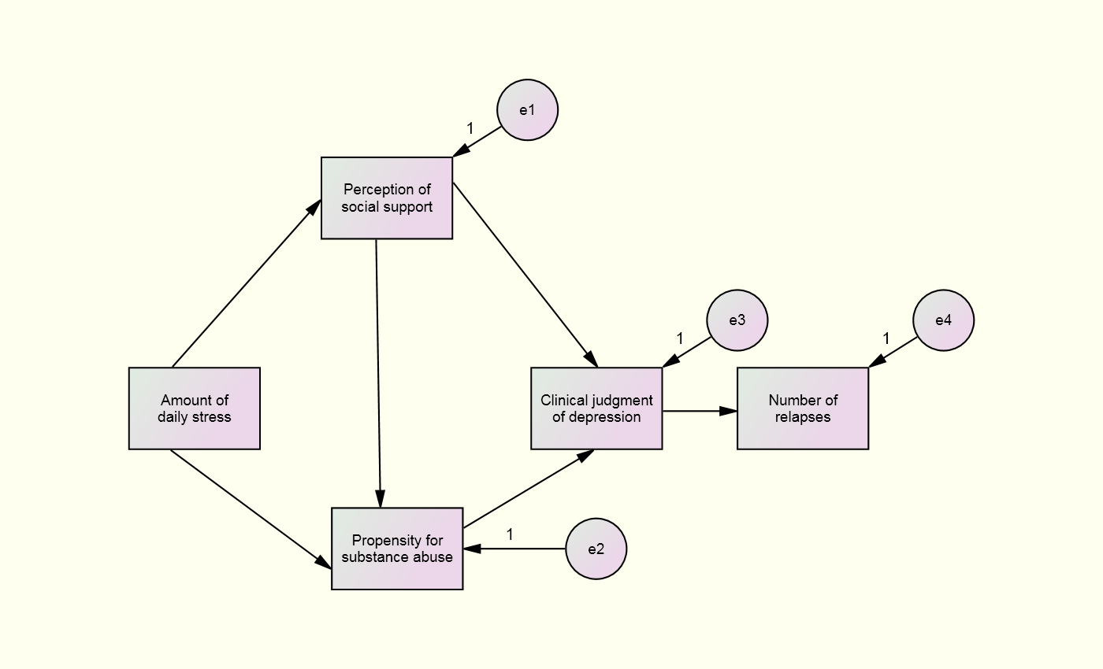

Questions

- Identify the EXOGENOUS Variable(s).

- Identify the ENDOGENOUS Variables.

- How many Simultaneous Regression Analyses will have to be calculated?

- How many of the Paths were Significant?

- What paths would you consider to delete?
Answers

- Identify the EXOGENOUS Variable(s).
Amount of daily stress

- Identify the ENDOGENOUS Variables.
Perception of the Quality of their Social Support (PQSS), Propensity for Substance Abuse (PSA), Depression, and relapses

- How many Simultaneous Regression Analyses will have to be calculated?
FOUR, one for each exogenous variable

- How many of the Paths were Significant?
Three, (a) propensity to depression, (b) stress to propensity, (c) stress to social support

- What paths would you consider to delete?
Social support to propensity and social support to depression

