Path Analysis: AMOS

A researcher is interested in predicting the number relapses that occur after participation in an intensive inpatient substance abuse program. The researcher has data from 120 women who are at least five years beyond their initial admission to the program. At entry into the treatment program, the women were evaluated with respect to their psychological state and, in particular, on:

- Stress (score range from 1 to 10)
- Perception of the Quality of their Social Support (PQSS) (scores range from 10 to 30)
- Propensity for Substance Abuse (PSA) (scores range from 5 to 25)
- Depression (scores range from 60 to 160)

In addition there are records that indicate the number of relapses that each woman has had in the first five years after entry into the treatment program.
The hypothesized model is presented in Figure 1.

Figure 1: Proposed model of substance abuse relapses.

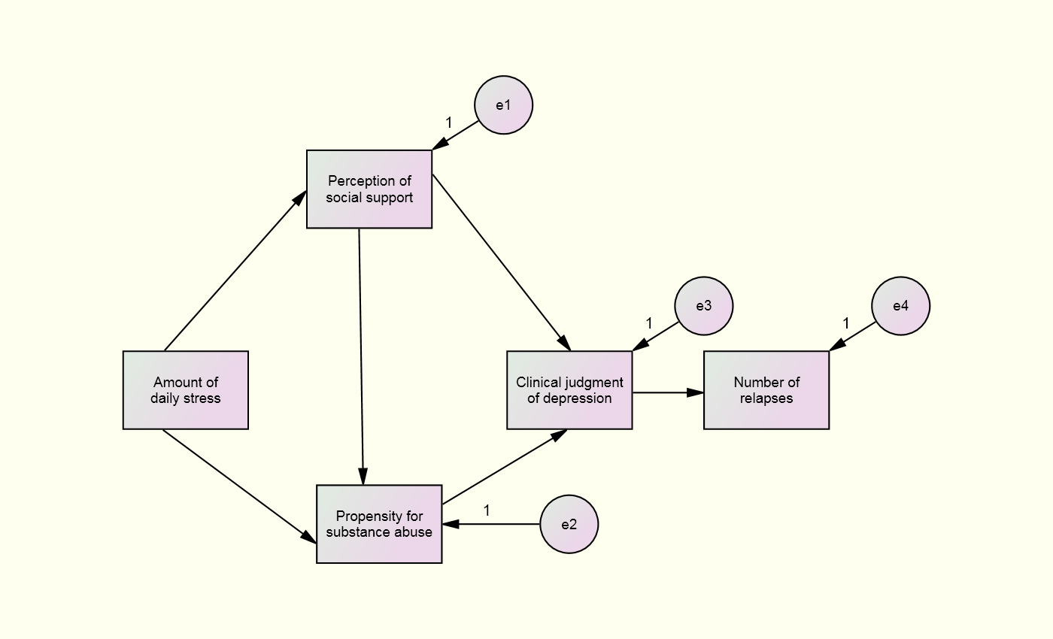

QUESTIONS:

- Was the model identified?

- Did the Model achieve acceptable fit measures?

- The Modification Indices identified which two error terms could be correlated?

- The Modification Indices identified which paths could be added?

- How many of the Paths were Significant?

- Overall, would a researcher consider this a “good” model? Explain your answer.
ANSWERS:

- Was the model identified?
YES: There was 4 degrees of freedom. In other words, there was more information (15) than parameters to be estimated (11) leaving 4 df.

- Did the Model achieve acceptable fit measures?
NO! All were less than the minimum acceptable level and the RMSEA as greater than 0.1.

- The Modification Indices identified which two error terms could be correlated?
Errors 1 & 4 and Errors 2 & 4.
 |  |  | M.I. | Par Change
e4 | <--> | e1 | 28.017 | 4.786
e4 | <--> | e2 | 6.814 | 2.428

- The Modification Indices identified which paths could be added?
Stress to depression
Stress to relapse
Perceived quality of social support to relapse
Propensity for substance abuse to relapse

 |  |  | M.I. | Par Change
depression | <--- | stress | 4.437 | 1.853
relapses | <--- | stress | 15.201 | .559
relapses | <--- | pqss | 39.254 | .913
relapses | <--- | psa | 13.611 | .526

- How many of the Paths were Significant?
Only three, (a) stress to perceived quality of social support, (b) stress to propensity for substance abuse, and (c) propensity for substance abuse to depression.

 |  |  | Estimate | S.E. | C.R. | P | Label
pqss | <--- | stress | .316 | .085 | 3.702 | ***
psa | <--- | stress | .303 | .093 | 3.263 | .001
psa | <--- | pqss | .004 | .094 | .047 | .962
depression | <--- | pqss | .534 | .899 | .594 | .552
depression | <--- | psa | -3.111 | .879 | -3.538 | ***
relapses | <--- | depression | .013 | .014 | .932 | .351

- Overall, would a researcher consider this a “good” model? Explain your answer.
This is a poor model because the fit measures failed to achieve acceptable levels as well as half the proposed paths failed to achieve neither statistical nor practical significance.
