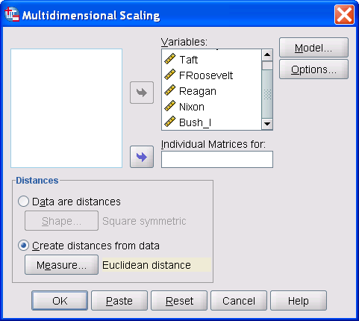

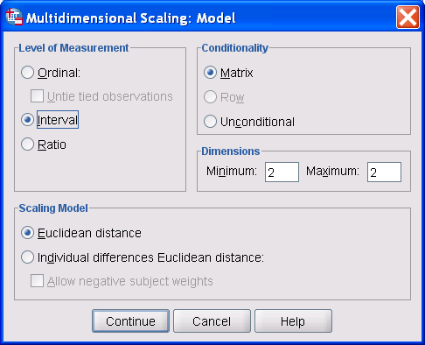

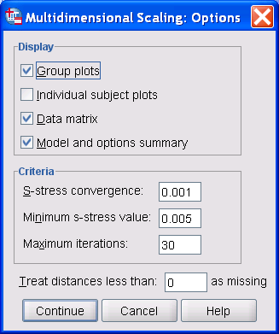

Proximities

Case Processing Summaryª
Cases
Valid |  | Missing |  | Total
N | Percent | N | Percent | N | Percent
300 | 100.0% | 0 | .0% | 300 | 100.0%
a. Euclidean Distance used

ALSCAL
/MATRIX=IN('C:\DOCUME~1\ajg40\LOCALS~1\Temp\spss2324\spssalsc.tmp')
/LEVEL=INTERVAL
/CONDITION=MATRIX
/MODEL=EUCLID
/CRITERIA=CONVERGE(0.001) STRESSMIN(0.005) ITER(30) CUTOFF(0) DIMENS(2,2)
/PLOT=DEFAULT
/PRINT=DATA HEADER.

Alscal

Alscal Procedure Options

Data Options-

Number of Rows (Observations/Matrix). 6
Number of Columns (Variables) . . . 6
Number of Matrices . . . . . . 1
Measurement Level . . . . . . . Interval
Data Matrix Shape . . . . . . . Symmetric
Type . . . . . . . . . . . Dissimilarity
Approach to Ties . . . . . . . Leave Tied
Conditionality . . . . . . . . Matrix
Data Cutoff at . . . . . . . . .000000

Model Options-

Model . . . . . . . . . . . Euclid
Maximum Dimensionality . . . . . 2
Minimum Dimensionality . . . . . 2
Negative Weights . . . . . . . Not Permitted

Output Options-

Job Option Header . . . . . . . Printed
Data Matrices . . . . . . . . Printed
Configurations and Transformations . Plotted
Output Dataset . . . . . . . . Not Created
Initial Stimulus Coordinates . . . Computed

Algorithmic Options-

Maximum Iterations . . . . . . 30
Convergence Criterion . . . . . .00100
Minimum S-stress . . . . . . . .00500
Missing Data Estimated by . . . . Ulbounds

Raw (unscaled) Data for Subject 1

1 2 3 4 5 6

1 .000
2 15.548 .000
3 5.659 16.326 .000
4 16.489 5.300 16.951 .000
5 6.358 15.327 7.861 16.456 .000
6 15.727 6.722 16.709 8.011 15.118 .000

Iteration history for the 2 dimensional solution (in squared distances)

Young's S-stress formula 1 is used.

Iteration S-stress Improvement

1 .00661
2 .00611 .00050

Iterations stopped because
S-stress improvement is less than .001000

Stress and squared correlation (RSQ) in distances

RSQ values are the proportion of variance of the scaled data (disparities)
in the partition (row, matrix, or entire data) which
is accounted for by their corresponding distances.
Stress values are Kruskal's stress formula 1.

For matrix
Stress = .01315 RSQ = .99937

Configuration derived in 2 dimensions

Stimulus Coordinates

Dimension

Stimulus Stimulus 1 2
Number Name

1 Kennedy 1.3512 .0427
2 Taft -1.3106 .0836
3 FRooseve 1.4976 .3922
4 Reagan -1.4928 .3958
5 Nixon 1.2512 -.4306
6 Bush_I -1.2966 -.4837

Optimally scaled data (disparities) for subject 1

1 2 3 4 5 6

1 .000
2 2.655 .000
3 .348 2.837 .000
4 2.875 .264 2.982 .000
5 .511 2.604 .862 2.867 .000
6 2.697 .596 2.926 .897 2.555 .000

