Chapter 9 Excel Output

1b. See earlier chapter outputs on how to create cross tabulations in Excel.



2b.



2c.



5b.



5ci.



5cii1.

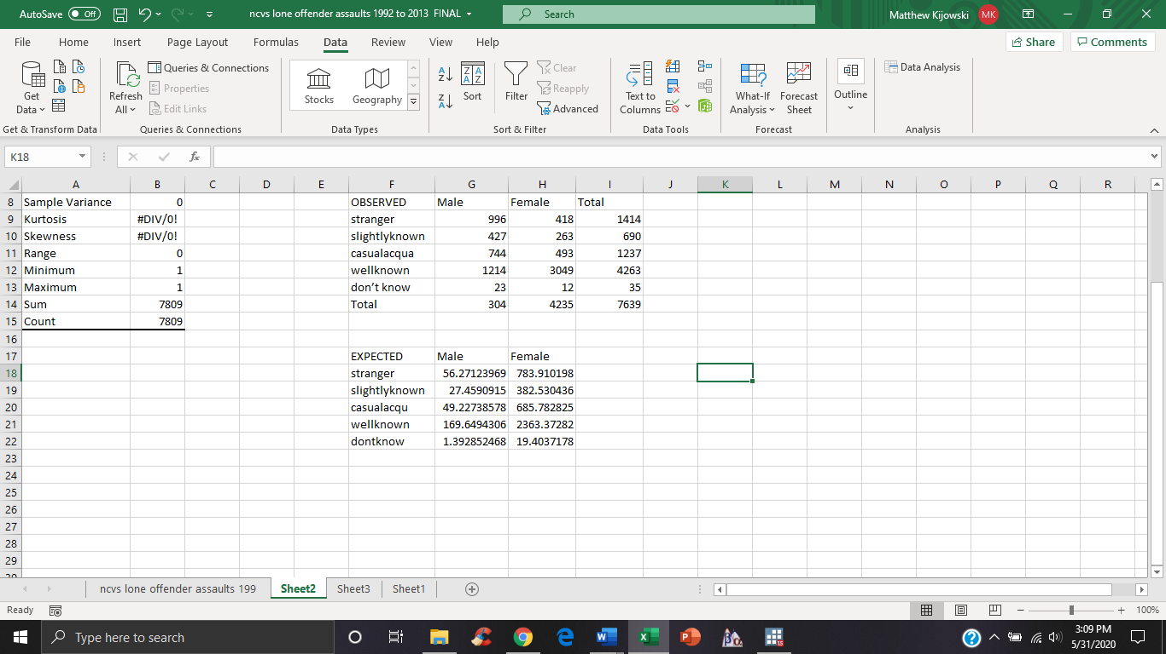

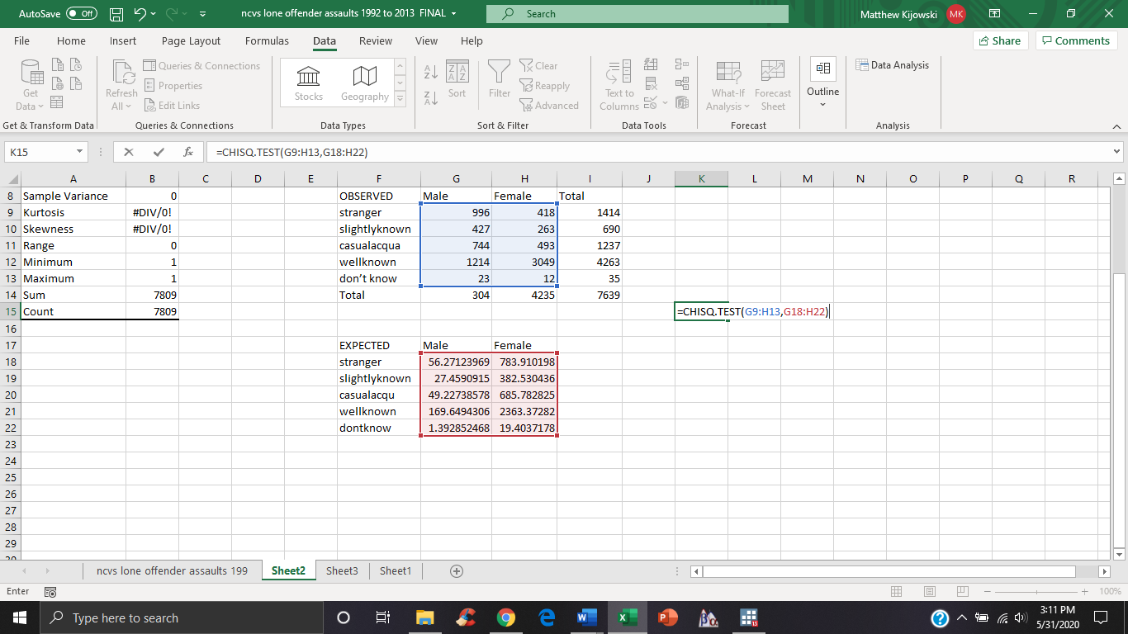

5ciii.

Lambda and Cramer’s V can be calculated by hand with the data available in Excel.