Chapter 8 Excel Output

3d. Copy and paste the column of interest over into a new sheet. Next to the first two respondents, simply place a “0” next to each and nothing else.

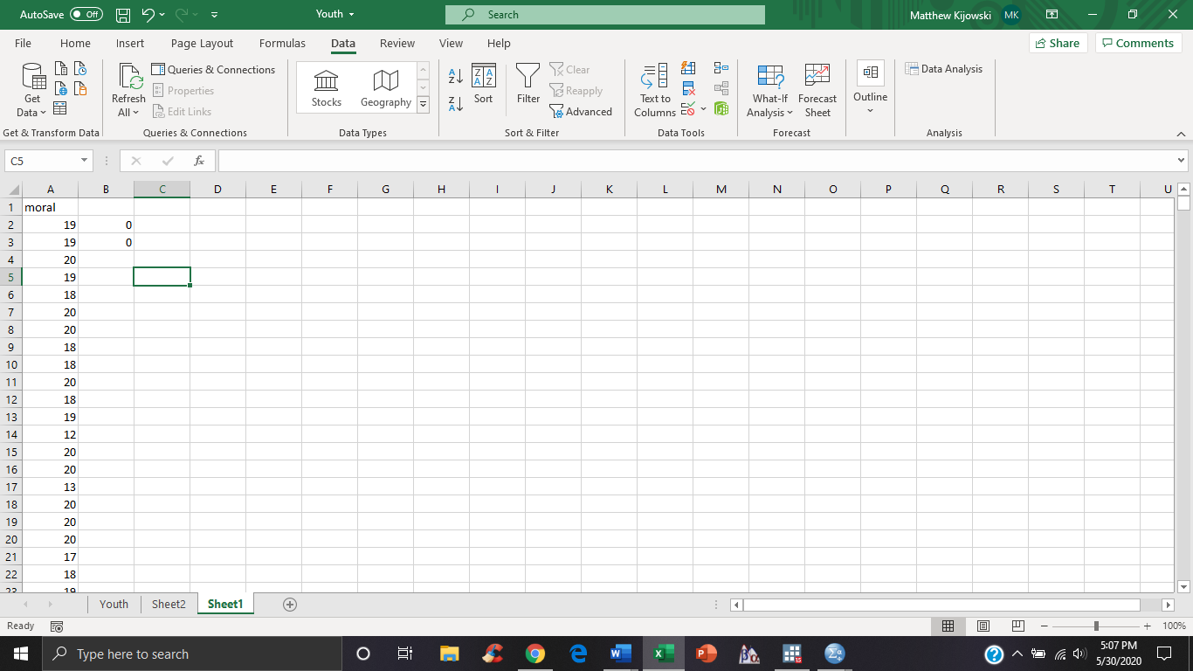

Click the “Data” tab and the “Data Analysis” button we introduced you to in the last chapter. Then click the option “t-Test: Two Sample Assuming Unequal Variances”. For variable 1 range, enter the column range of the variable of interest, and for variable two simply enter the range for the two “0” we put in. For “Hypothesized Mean Difference” enter 15.2 and click ok. You may delete the extra column in the output.



4c.



5e. Use the steps from 3d to answer this question on the truncated sample of parnt2.

