Chapter 7 Excel Output

2. To this point, we believe that you have gained enough experience using the formula commands to compute means, standard deviations, and other descriptive statistics individually. There is a much easier and faster way to get these statistics through an add-in. Click “File”, “Options” at the bottom, “Add-ins” and then “Analysis Toolpak”. Now you will have a “Data Analysis button on your “Data” tab. Click it and then click “Descriptive Statistics”, enter the range of the variable of interest, and click “Summary Statistics”. The output looks like:



Doing everything by hand one at a time, however, makes you appreciate this programs capabilities without the luxury of an add-in. Doing everything by hand and formula also helps you think like Excel and better understand its programming. As convenient as this is, it is often easier simply to type in “=AVERAGE” to get the mean without all the extra information. However, if you want all of the statistics, this is the way to go. The “Data Analysis” tab will be imperative in upcoming chapters.

3.

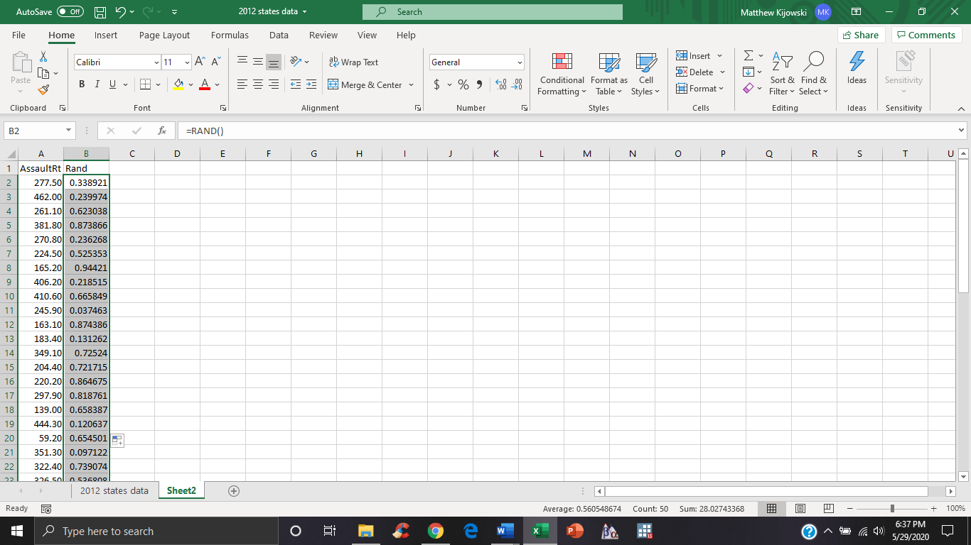



4a.



4b.





4c.



4d.



4e.









5a.



5b.

