Chapter 6 SPSS Output
1.

Statistics
Variable indicating the assailant's relationship to the victim
N | Valid | 23300
 | Missing | 669

Variable indicating the assailant's relationship to the victim
 |  | Frequency | Percent | Valid Percent | Cumulative Percent
Valid | stranger | 6547 | 27.3 | 28.1 | 28.1
 | slightly known | 2950 | 12.3 | 12.7 | 40.8
 | casual acquiant | 4576 | 19.1 | 19.6 | 60.4
 | well known | 9227 | 38.5 | 39.6 | 100.0
 | Total | 23300 | 97.2 | 100.0
Missing | Don't know | 126 | .5
 | System | 543 | 2.3
 | Total | 669 | 2.8
Total |  | 23969 | 100.0

2.
Case Processing Summary
 | Cases
 | Valid |  | Missing |  | Total
 | N | Percent | N | Percent | N | Percent
SEX (ALLOCATED) * Variable indicating the assailant's relationship to the victim | 23300 | 97.2% | 669 | 2.8% | 23969 | 100.0%

SEX (ALLOCATED) * Variable indicating the assailant's relationship to the victim Crosstabulation
Count
 |  | Variable indicating the assailant's relationship to the victim |  |  |  | Total
 |  | stranger | slightly known | casual acquiant | well known
SEX (ALLOCATED) | Male | 4614 | 1760 | 2609 | 3157 | 12140
 | Female | 1933 | 1190 | 1967 | 6070 | 11160
Total |  | 6547 | 2950 | 4576 | 9227 | 23300

3d.
Binomial Test
 |  | Category | N | Observed Prop. | Test Prop. | Exact Sig. (2-tailed)
Male offender =1, 0=female offender | Group 1 | female | 4798 | .20 | .50 | .000
 | Group 2 | male | 19171 | .80
 | Total |  | 23969 | 1.00

4d.

Binomial Test
 |  | Category | N | Observed Prop. | Test Prop. | Exact Sig. (1-tailed)
Victim Reported to Police Themselves | Group 1 | Victim Did Not Report Themselves | 17707 | .739857 | .447000 | .000
 | Group 2 | Victim Reported Themselves | 6226 | .260143
 | Total |  | 23933 | 1.000000

5a.
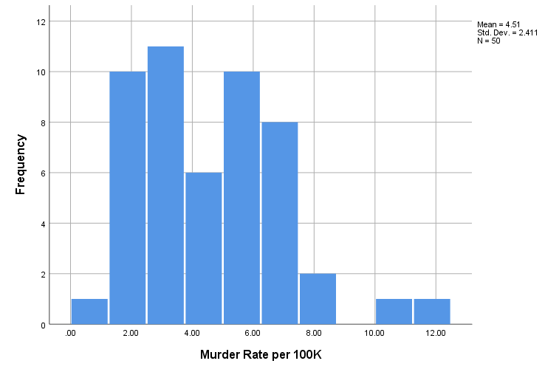
5b.

Statistics
Murder Rate per 100K
N | Valid | 50
 | Missing | 0
Std. Deviation |  | 2.41069

6.

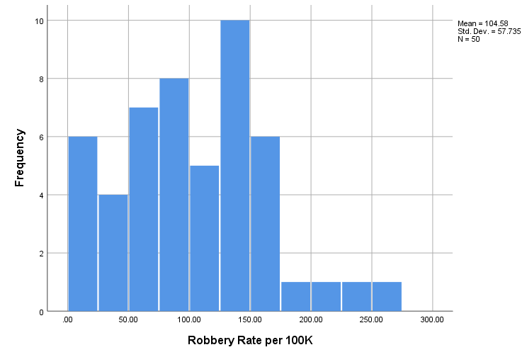

Statistics
Robbery Rate per 100K
N | Valid | 50
 | Missing | 0
Std. Deviation |  | 57.73535

8a.
Statistics
Murder Rate per 100K
N | Valid | 50
 | Missing | 0
Std. Error of Mean |  | .34092
8b.

Statistics
Burglary Rate per 100K
N | Valid | 50
 | Missing | 0
Std. Error of Mean |  | 36.11832

