Chapter 6 Excel Output

1.



2.



3d. Binomial hypothesis tests in Excel are based upon the “=BINOM.DIST” command. One needs to know the smallest group and record its number of respondents (for our example of male offenders, the smallest group is 4798), the total number in the sample (here it is 23969), and finally the probability you are testing (here it is 0.50). Once you enter “=BINOM.DIST”, Excel asks for these values in this order and also for “cumulative” which you can put “TRUE”.

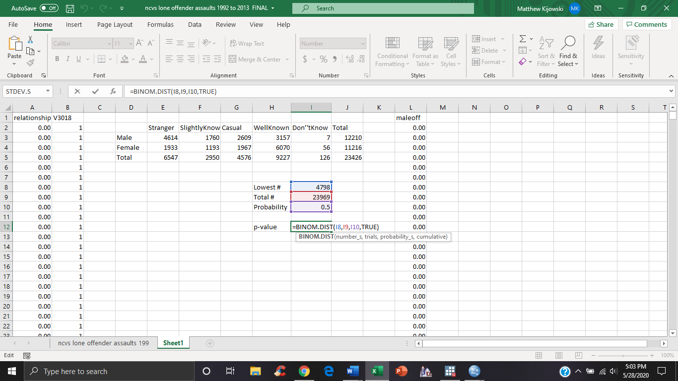

Click enter. Now, because the binomial in Excel is one-sided, you must multiply the resulting value by 2 to make it two-sided which is still zero.

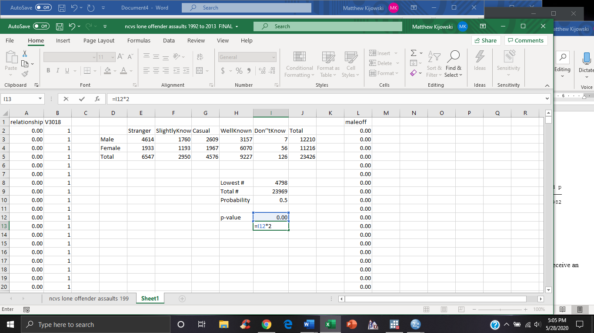

4d. Doing the same process as the 3d will lead to the following. The results are highly significant and essentially 0.



5a.

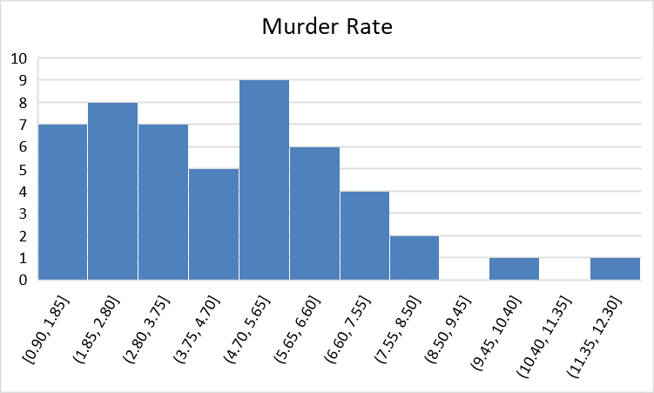

5b. Using “=STDEV.S” command introduced in the last chapter:



6.

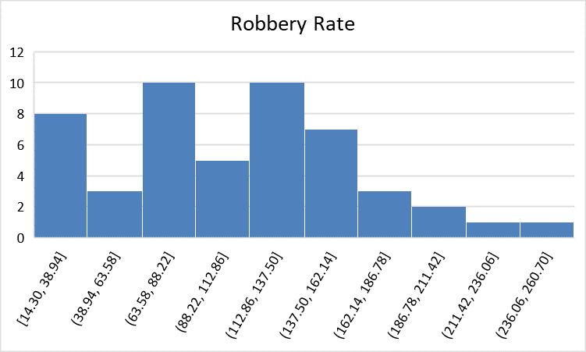



7. To obtain standardized variables in Excel, one must calculate that variables mean and standard deviation. Luckily for you we have already learned how to do that in Excel with the “=AVERAGE” and “STDEV.S” commands. To set this up, find three empty cells on top of one another and label the Mean, SD, and Standardize in that order. Calculate the mean and standard deviation in the first two cells. Now all you must do is enter “=STANDARDIZE” in the third cell, and then highlight the column of data for the variable of interest and enter a comma, then click on the cell containing the mean and entering another comma, and finally clicking on the cell containing the standard deviation and click enter. The result is a new column of data containing the standardized values of that variable. You can copy and past it to a desired place.

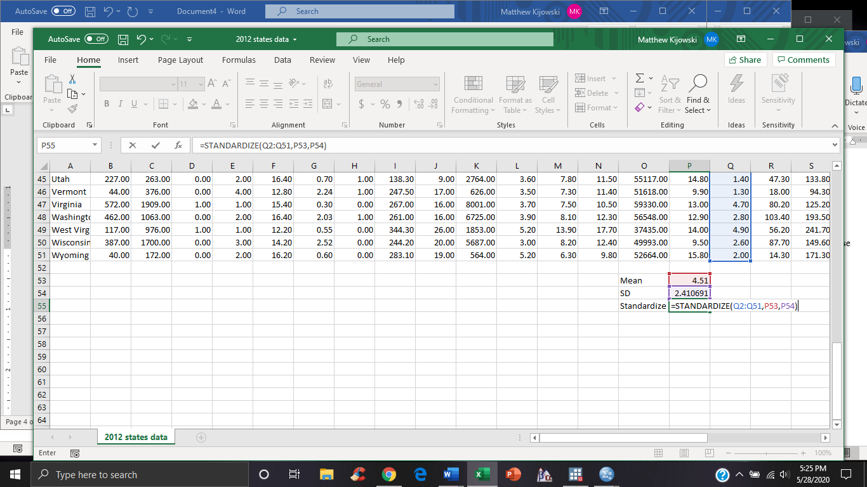

8a. Because the standard error of the mean is simply the standard deviation divided by the square root of the total number for the variable, one can easily impute this command into Excel.

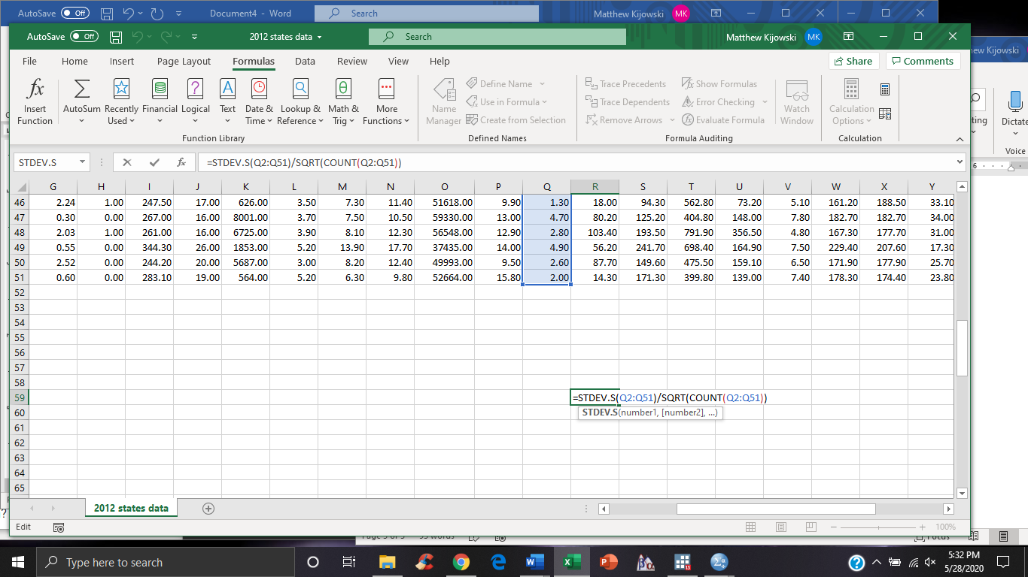



8b. Do the same command for burglary rate to get:

