Chapter 5 SPSS Output
1a.
how wrong do friends think it is to steal
 |  | Frequency | Percent | Valid Percent | Cumulative Percent
Valid | always wrong | 724 | 56.9 | 56.9 | 56.9
 | usually wrong | 297 | 23.3 | 23.3 | 80.3
 | sometimes wrong | 161 | 12.7 | 12.7 | 92.9
 | seldom wrong | 65 | 5.1 | 5.1 | 98.0
 | never wrong | 25 | 2.0 | 2.0 | 100.0
 | Total | 1272 | 100.0 | 100.0

1b.
how wrong do friends think it is to drink
 |  | Frequency | Percent | Valid Percent | Cumulative Percent
Valid | always wrong | 271 | 21.3 | 21.3 | 21.3
 | usually wrong | 218 | 17.1 | 17.1 | 38.4
 | sometimes wrong | 286 | 22.5 | 22.5 | 60.9
 | seldom wrong | 253 | 19.9 | 19.9 | 80.8
 | never wrong | 244 | 19.2 | 19.2 | 100.0
 | Total | 1272 | 100.0 | 100.0

2a.

Statistics
time 1 delinquency scale
N | Valid | 1272
 | Missing | 0
Range |  | 118

2b.
Statistics
how wrong do friends think it is to drink
N | Valid | 1272
 | Missing | 0
Range |  | 4

3.
Statistics
parental supervision scale
N | Valid | 1272
 | Missing | 0
Mean |  | 6.23
Std. Deviation |  | 1.383
Variance |  | 1.912

4.
Statistics
categorical recode for if crime is morally wrong
N | Valid | 1272
 | Missing | 0
Std. Deviation |  | .62281
Variance |  | .388

5a-c. You can get the frequencies for multiple variables at once by putting all of the variables of interest into the box to be estimated.

Statistics
 |  | friends opinion | time 1 delinquency scale | certainty of punishment
N | Valid | 1272 | 1272 | 1272
 | Missing | 0 | 0 | 0
Std. Deviation |  | 6.409 | 39.266 | 3.442
Variance |  | 41.070 | 1541.801 | 11.847
Range |  | 32 | 118 | 16
Minimum |  | 8 | 0 | 4
Maximum |  | 40 | 118 | 20

6ai-iii.
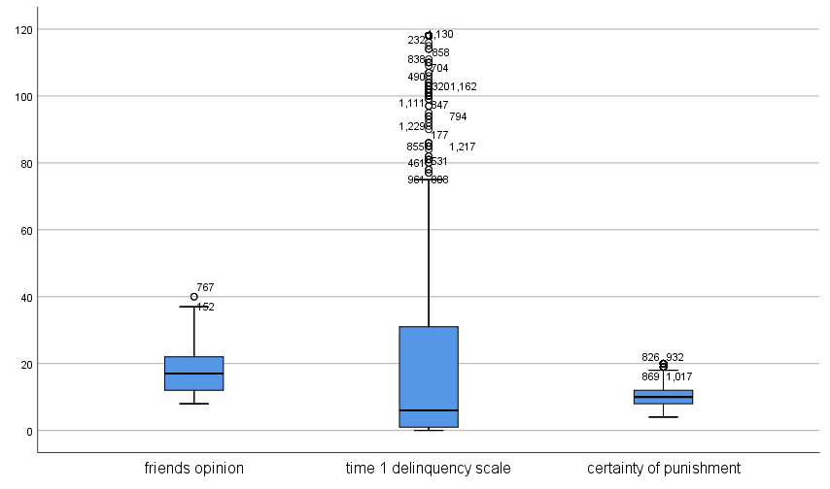

7c-d. For this question, I used 75 as my cutoff.

Statistics
time 1 delinquency scale
N | Valid | 1071
 | Missing | 0
Std. Deviation |  | 15.296

