Chapter 5 Excel Output

1. See chapter 2 on how to create a frequency table in Excel.

1a.



1b.



2a.

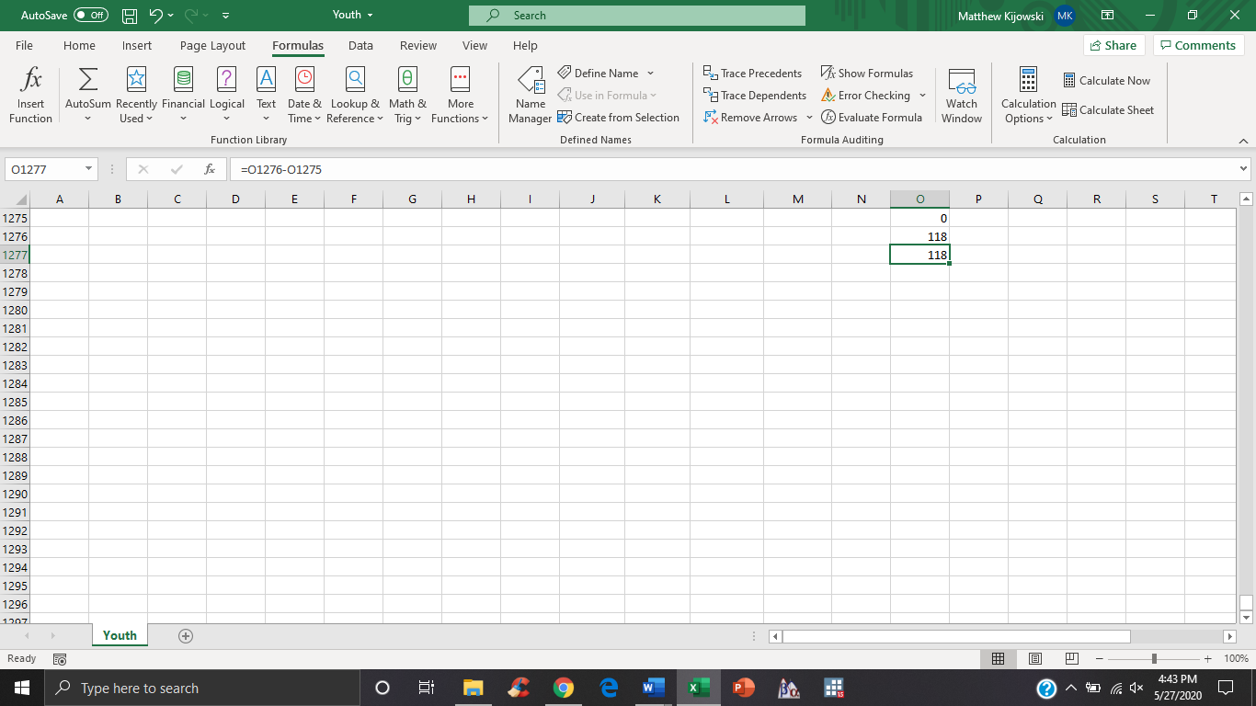

2b.



3.

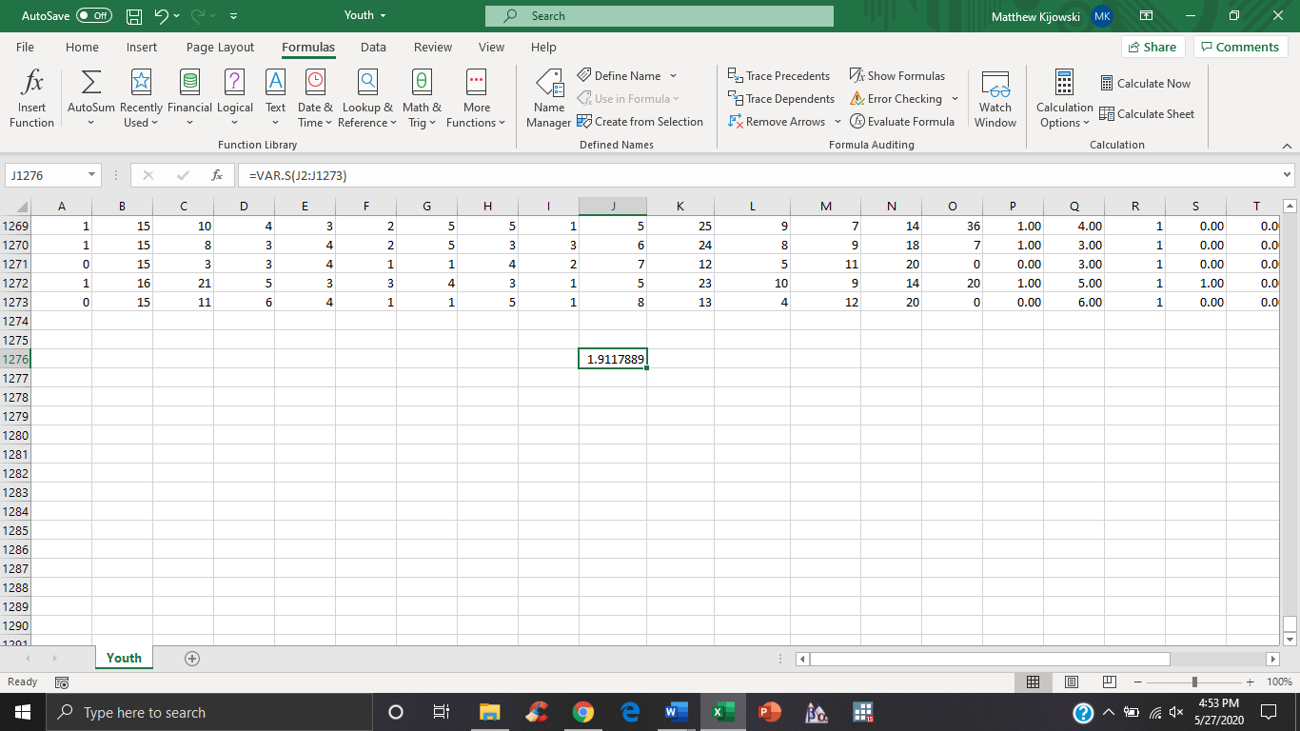





4.



5a-c.



6.

6ai.

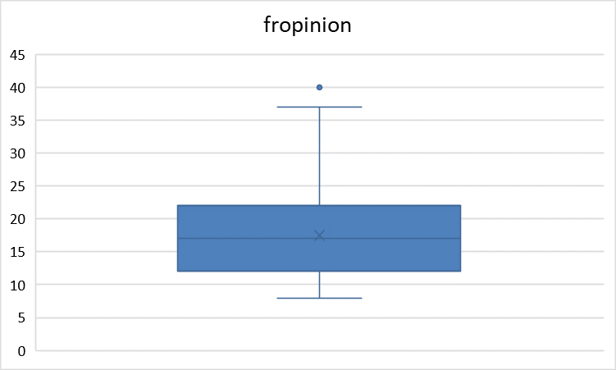

6aii.

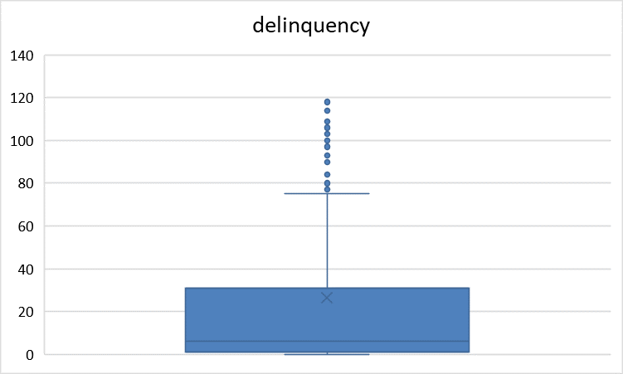

6aiii.

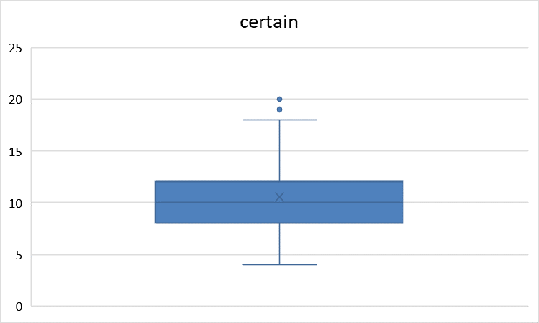

7d.

