Chapter 4: SPSS Output
1.
parental supervision scale
 |  | Frequency | Percent | Valid Percent | Cumulative Percent
Valid | 2 | 6 | .5 | .5 | .5
 | 3 | 16 | 1.3 | 1.3 | 1.7
 | 4 | 163 | 12.8 | 12.8 | 14.5
 | 5 | 139 | 10.9 | 10.9 | 25.5
 | 6 | 440 | 34.6 | 34.6 | 60.1
 | 7 | 189 | 14.9 | 14.9 | 74.9
 | 8 | 319 | 25.1 | 25.1 | 100.0
 | Total | 1272 | 100.0 | 100.0

2i.
Statistics
how wrong do friends think it is to steal
N | Valid | 1272
 | Missing | 0
Mean |  | 1.72
Median |  | 1.00
Mode |  | 1

how wrong do friends think it is to steal
 |  | Frequency | Percent | Valid Percent | Cumulative Percent
Valid | always wrong | 724 | 56.9 | 56.9 | 56.9
 | usually wrong | 297 | 23.3 | 23.3 | 80.3
 | sometimes wrong | 161 | 12.7 | 12.7 | 92.9
 | seldom wrong | 65 | 5.1 | 5.1 | 98.0
 | never wrong | 25 | 2.0 | 2.0 | 100.0
 | Total | 1272 | 100.0 | 100.0

2ii.
Statistics
how wrong do friends think it is to drink
N | Valid | 1272
 | Missing | 0
Mean |  | 2.99
Median |  | 3.00
Mode |  | 3

how wrong do friends think it is to drink
 |  | Frequency | Percent | Valid Percent | Cumulative Percent
Valid | always wrong | 271 | 21.3 | 21.3 | 21.3
 | usually wrong | 218 | 17.1 | 17.1 | 38.4
 | sometimes wrong | 286 | 22.5 | 22.5 | 60.9
 | seldom wrong | 253 | 19.9 | 19.9 | 80.8
 | never wrong | 244 | 19.2 | 19.2 | 100.0
 | Total | 1272 | 100.0 | 100.0

2iii.

Statistics
certainty of punishment
N | Valid | 1272
 | Missing | 0
Mean |  | 10.54
Median |  | 10.00
Mode |  | 12

certainty of punishment
 |  | Frequency | Percent | Valid Percent | Cumulative Percent
Valid | 4 | 49 | 3.9 | 3.9 | 3.9
 | 5 | 29 | 2.3 | 2.3 | 6.1
 | 6 | 70 | 5.5 | 5.5 | 11.6
 | 7 | 76 | 6.0 | 6.0 | 17.6
 | 8 | 148 | 11.6 | 11.6 | 29.2
 | 9 | 134 | 10.5 | 10.5 | 39.8
 | 10 | 167 | 13.1 | 13.1 | 52.9
 | 11 | 108 | 8.5 | 8.5 | 61.4
 | 12 | 175 | 13.8 | 13.8 | 75.2
 | 13 | 86 | 6.8 | 6.8 | 81.9
 | 14 | 72 | 5.7 | 5.7 | 87.6
 | 15 | 45 | 3.5 | 3.5 | 91.1
 | 16 | 56 | 4.4 | 4.4 | 95.5
 | 17 | 12 | .9 | .9 | 96.5
 | 18 | 11 | .9 | .9 | 97.3
 | 19 | 8 | .6 | .6 | 98.0
 | 20 | 26 | 2.0 | 2.0 | 100.0
 | Total | 1272 | 100.0 | 100.0

2iv.

Statistics
Gender of respondent
N | Valid | 1272
 | Missing | 0
Mean |  | .47
Median |  | .00
Mode |  | 0

Gender of respondent
 |  | Frequency | Percent | Valid Percent | Cumulative Percent
Valid | female | 680 | 53.5 | 53.5 | 53.5
 | male | 592 | 46.5 | 46.5 | 100.0
 | Total | 1272 | 100.0 | 100.0

3.
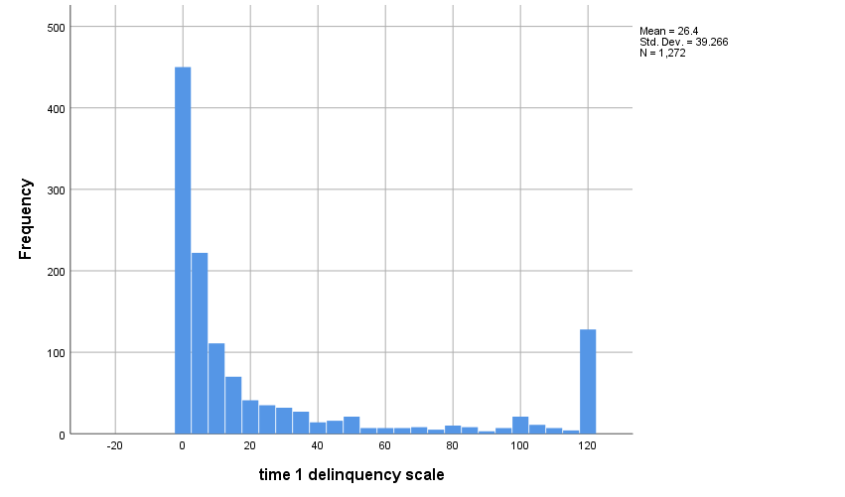
4a.

Gender of respondent
 |  | Frequency | Percent | Valid Percent | Cumulative Percent
Valid | female | 680 | 53.5 | 53.5 | 53.5
 | male | 592 | 46.5 | 46.5 | 100.0
 | Total | 1272 | 100.0 | 100.0

