Chapter 4: Excel Output

1. See chapter 2 Excel output for instructions on creating a frequency table.



2i. To get the mean for variable v77, highlight all of the cells in the column for that variable (cells F2-F1273). Then click the “Formulas” tab. Then click the arrow below “Auto Sum” and then “Average”. Alternatively, you can click “More Functions” tab, “Statistical” and then “AVERAGE”. Probably the easiest way is to do the command by hand. First, find an empty cell and type the following: “=AVERAGE(F2:F1273)” and click enter. In Excel, all equations can be done following the “=” sign.

Computing the Median can be done through the “More Functions” tab, then “Statistical” and finally “MEDIAN”. Alternatively, and easier, just type into an empty cell “=MEDIAN(F2:F1273)”.

The Mode is computed the same way. However, there are two model options. For our purposes, you must use the “MODE.SNGL”.

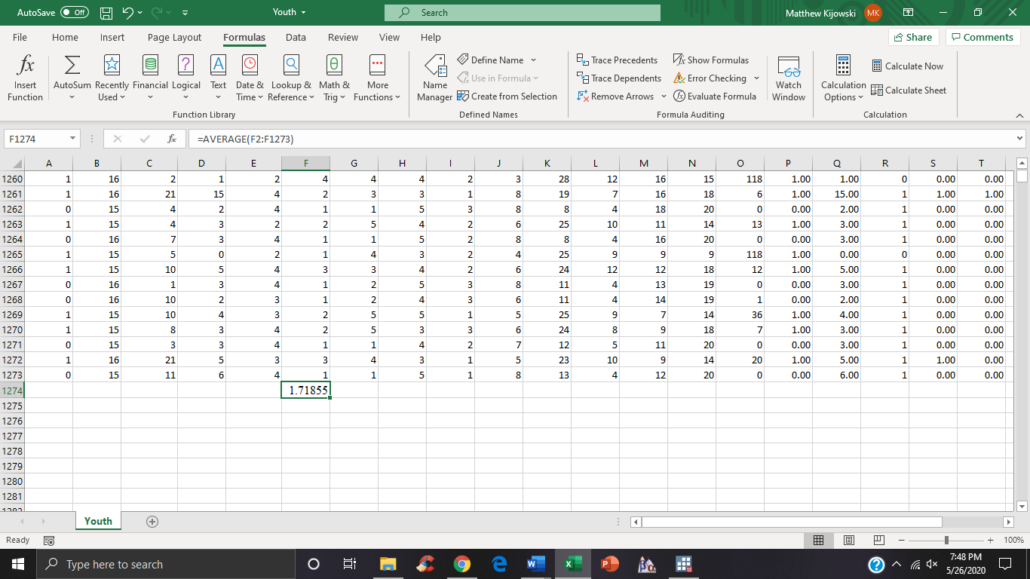

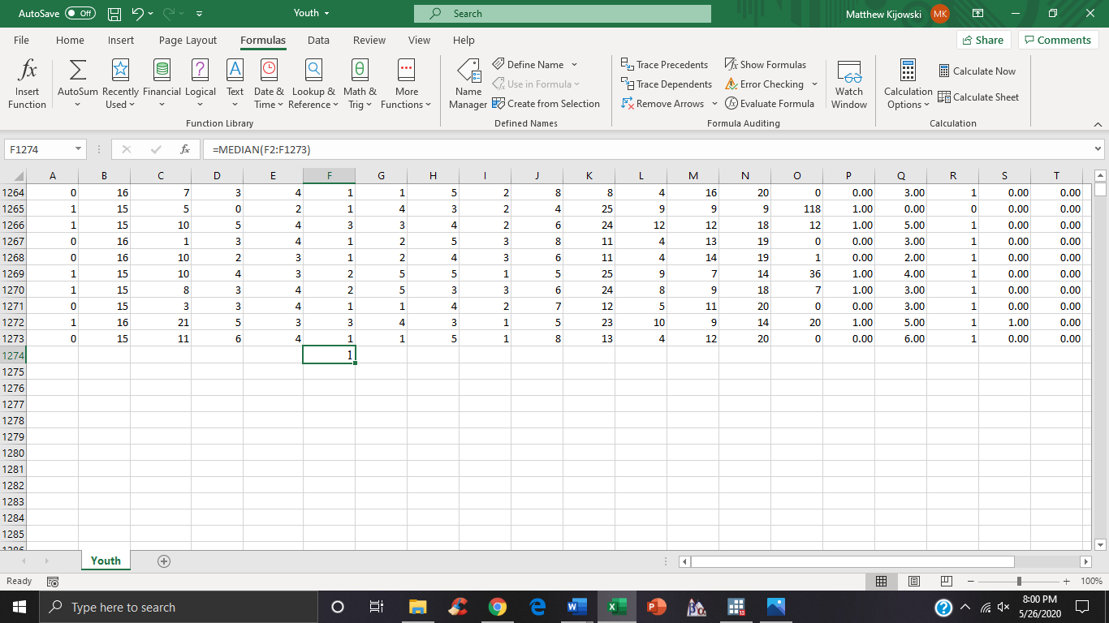

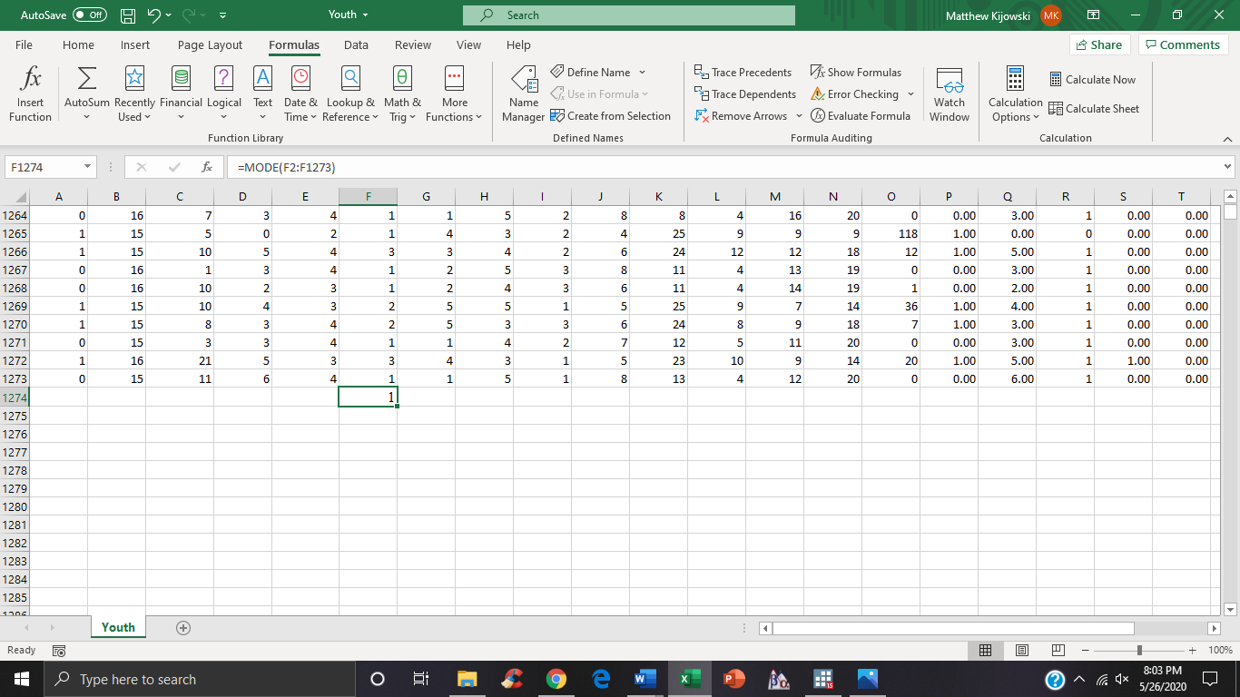

2ii. You can do any one of the aforementioned instructions for this variable too. Alternatively, copy the cell containing the command (cell F1274 in the above picture). And then paste it into a new cell and simply change all “F”’s into “G”.

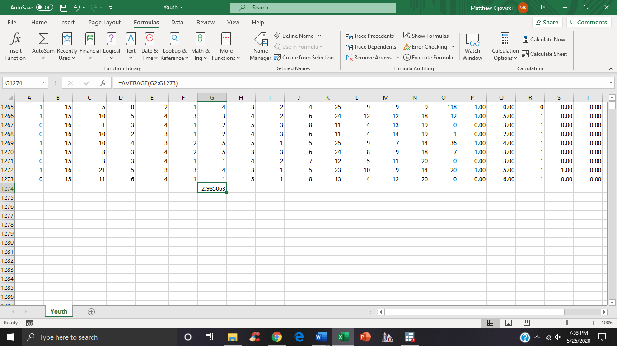

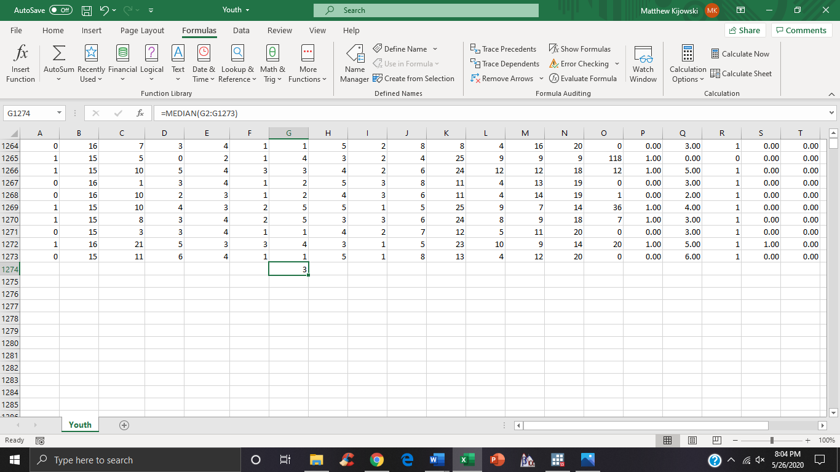

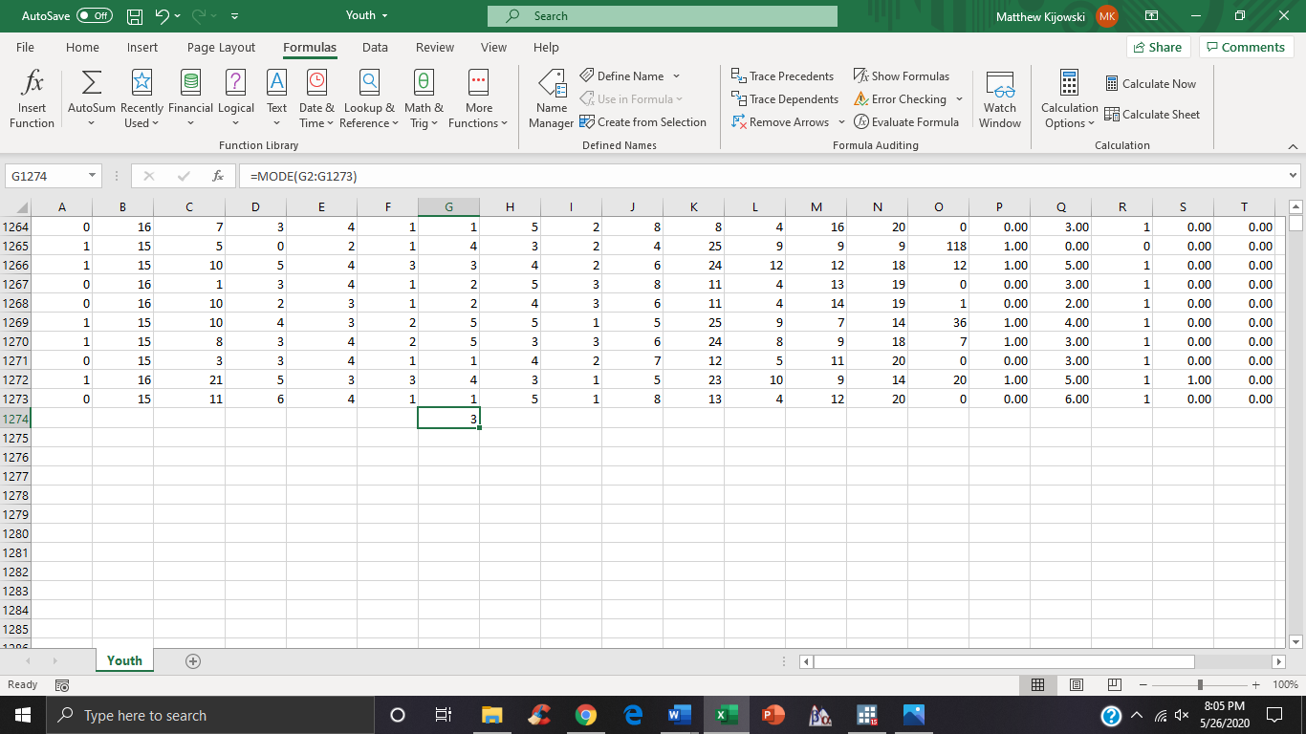

2iii.

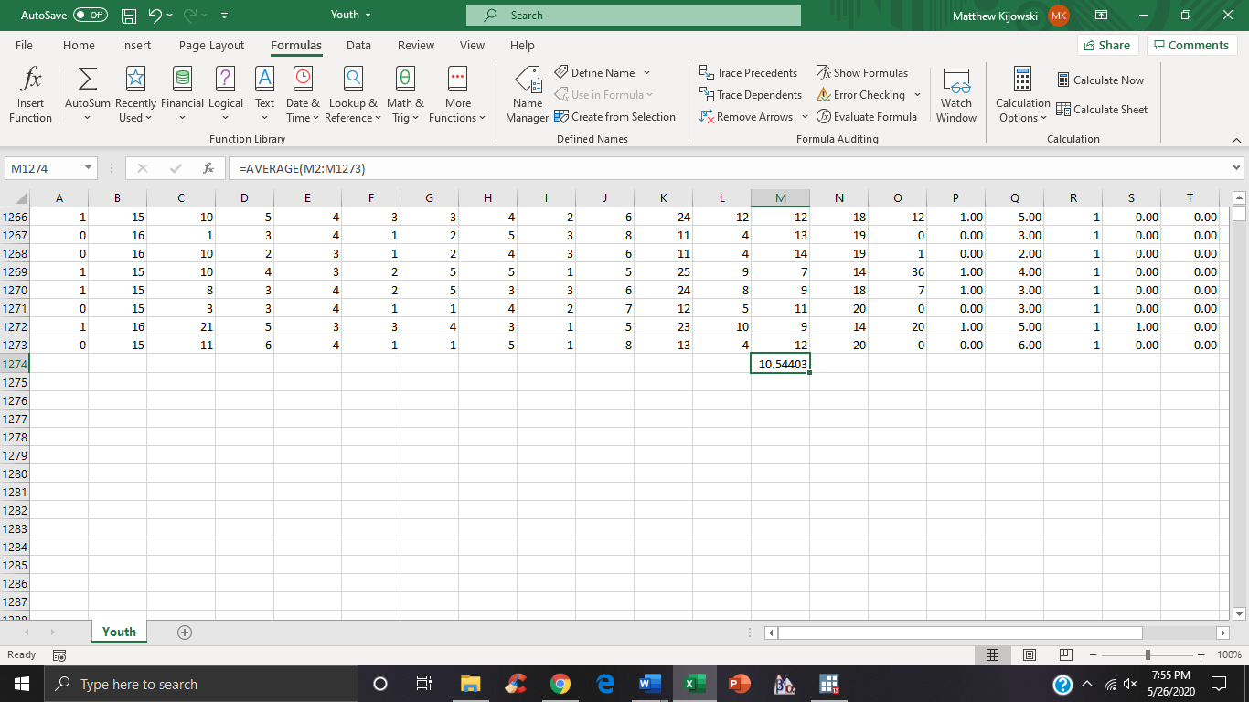

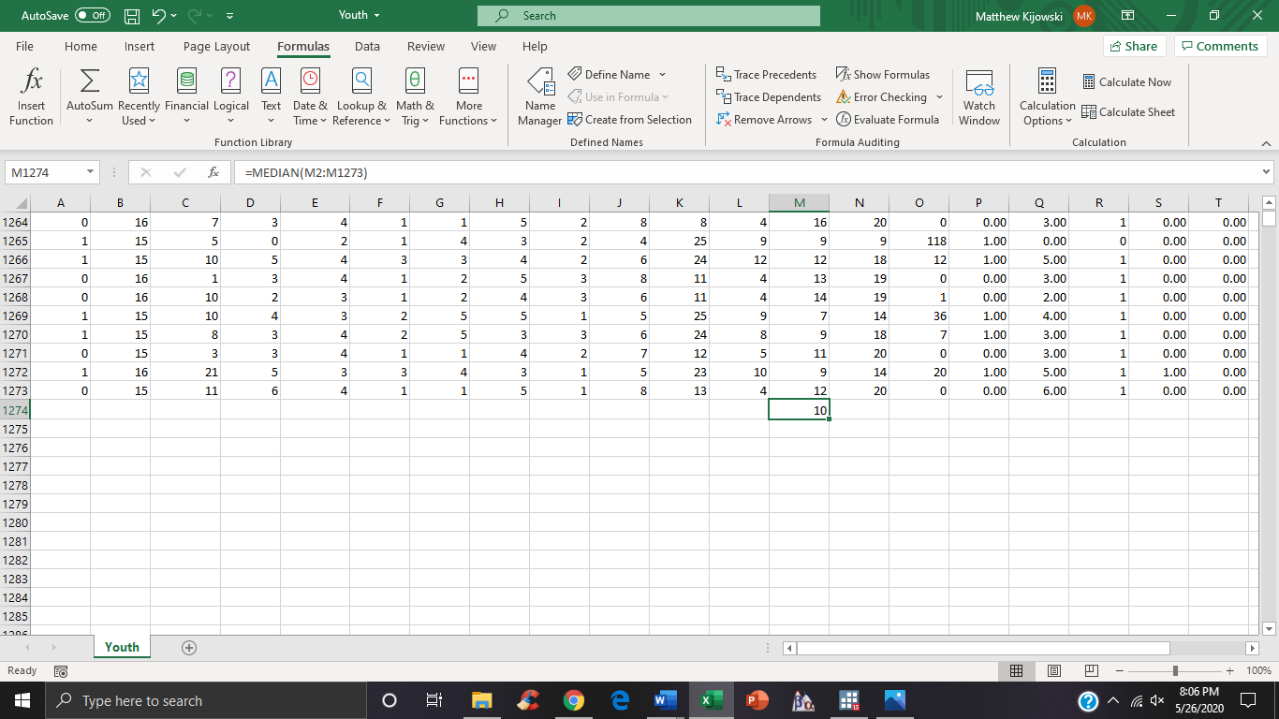

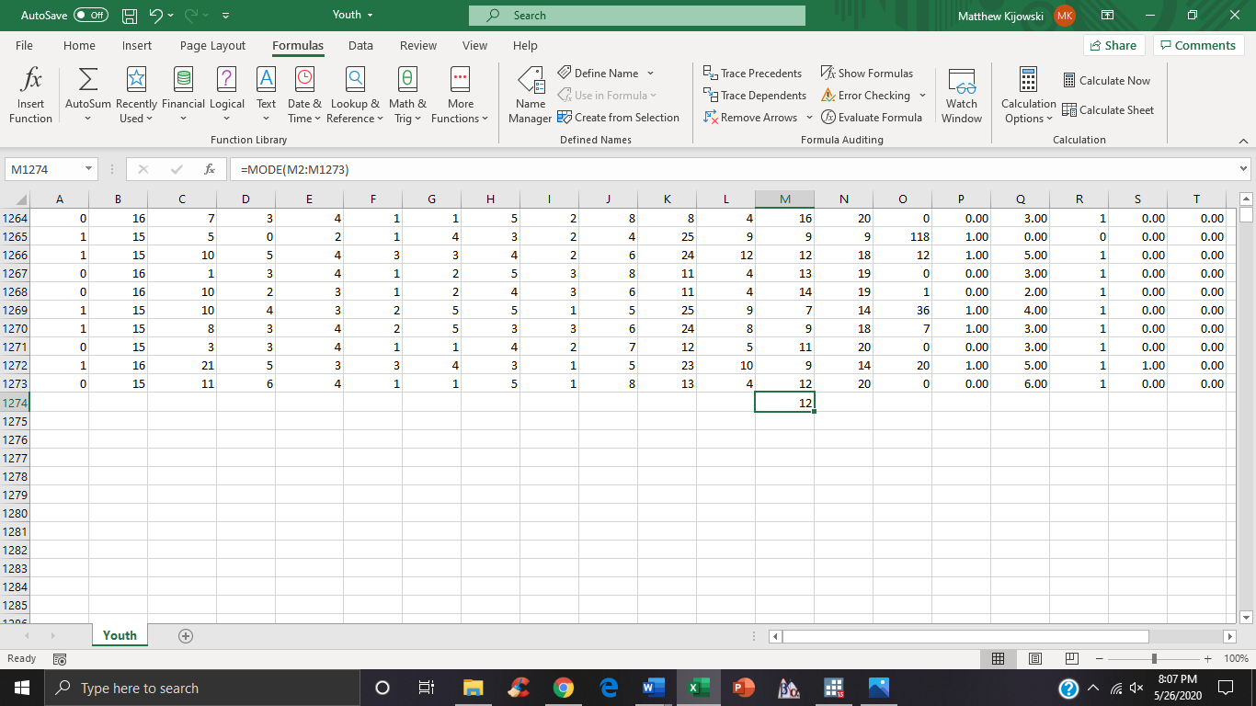

2iv.

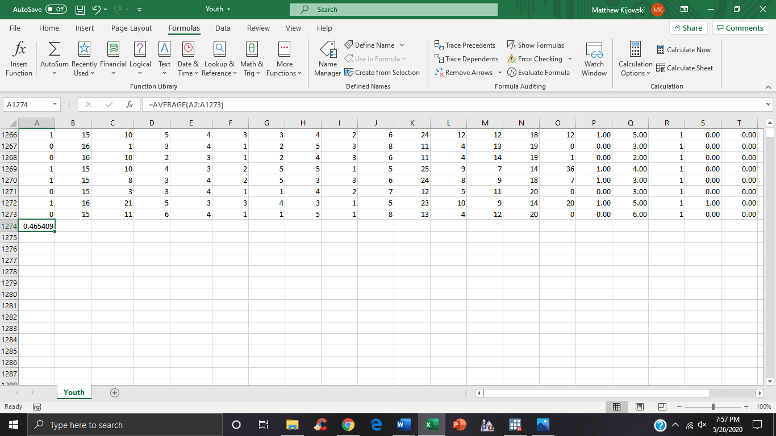

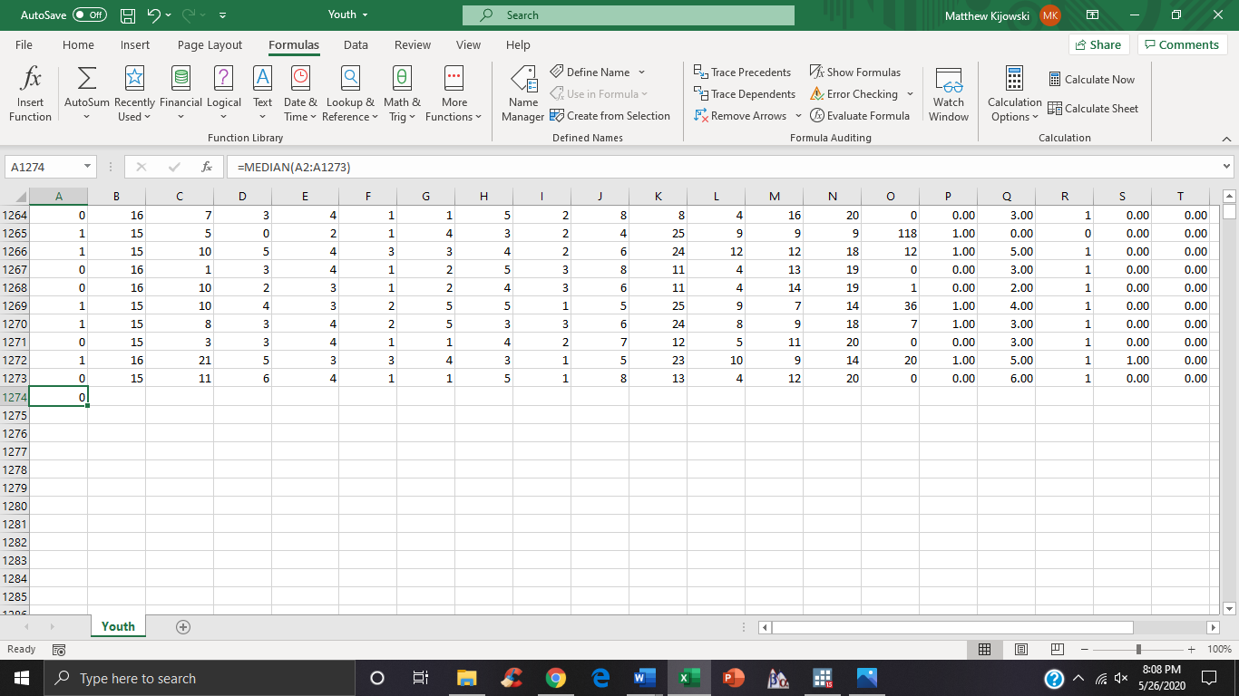

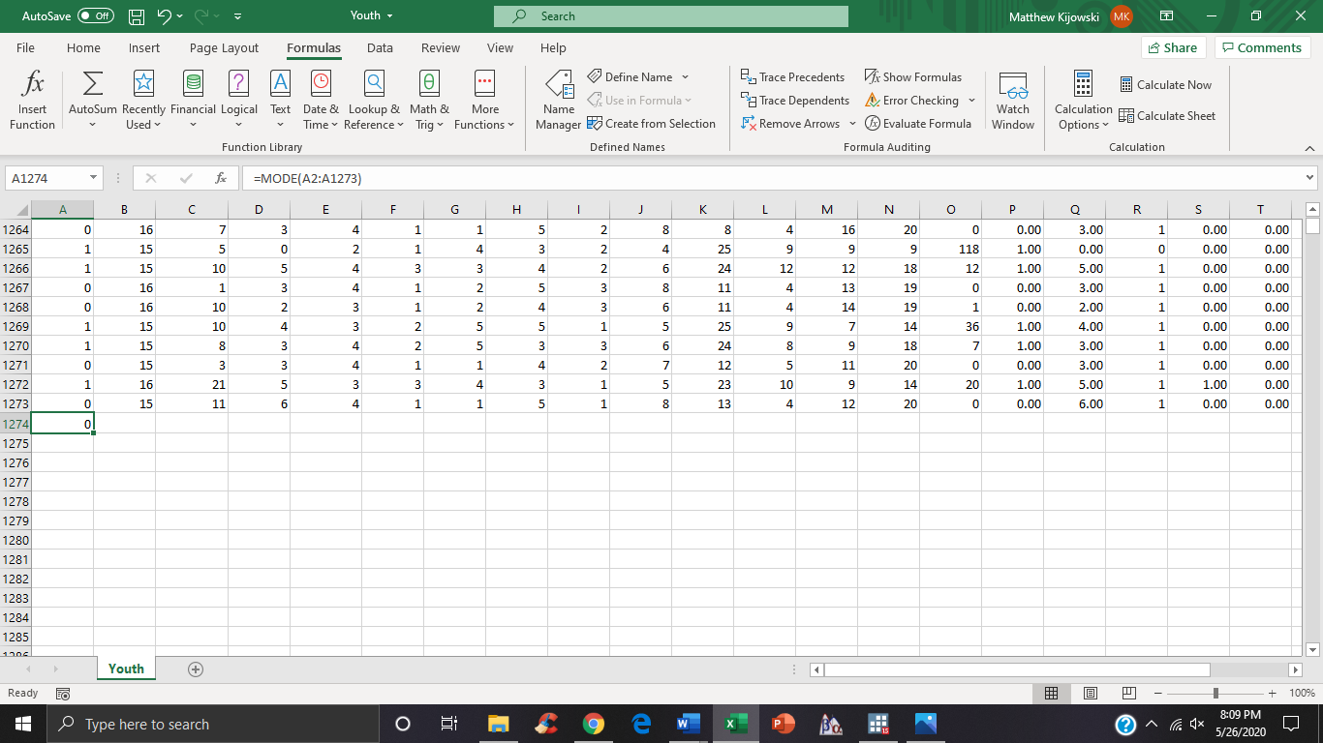

2c. One can obtain skew and kurtosis statistic in Excel in two ways. First, by highlighting the column of interest cells, then clicking “Formulas”, “More Functions”, “Statistical”, and either “SKEW” or “KURT”. Alternatively, find an empty cell and type “=SKEW(F2:F1273)” or whichever range your variable of interest is in. Do the same thing for kurtosis but change “SKEW” to “KURT”.

3.

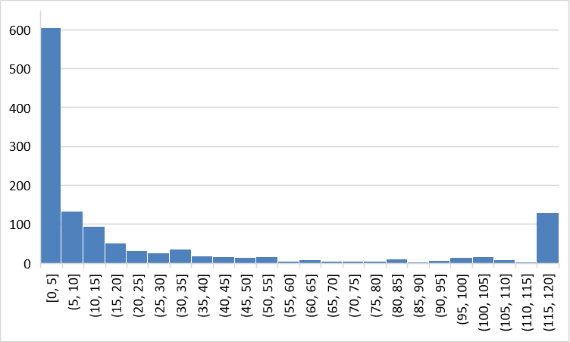

4a.

