1.
1a. Because injured is a binary nominal variable, one should use either a pie or bar chart.

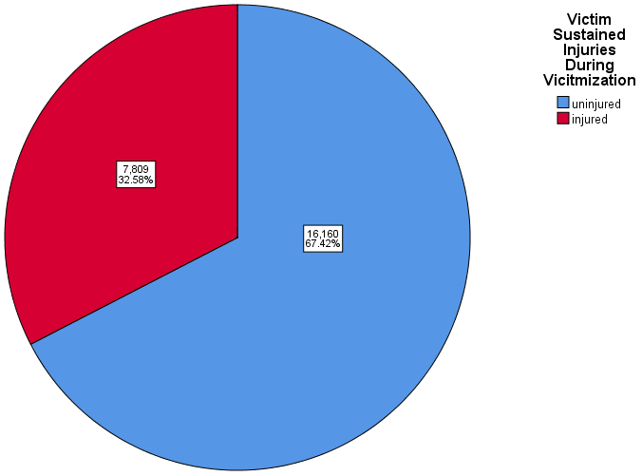
One may add labels and percentages into the pie chart by double clicking the pie chart output, clicking the button “show data labels”. When the “properties” box appears, click “Percent” and the up arrow button, and then “Apply.”

One may add labels and percentages to the forthcoming bar graph in a similar manner.
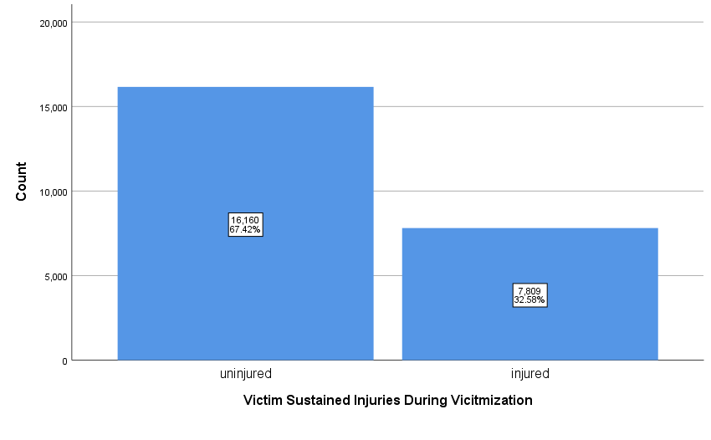
1b. Because maleoff is a binary nominal variable, we should use either the pie of bar chart.

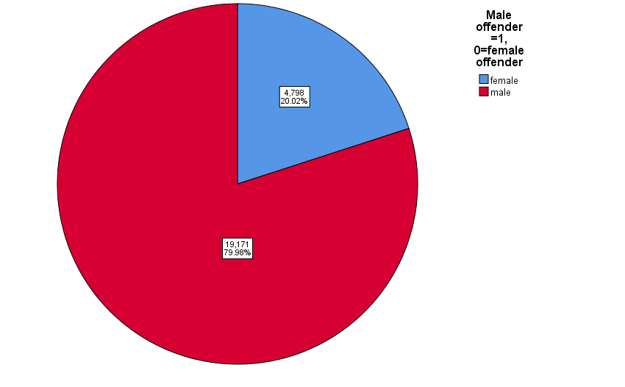
NOTE: You must remove the previous variable you entered into the graph or SPSS will simply rerun the previous variable.
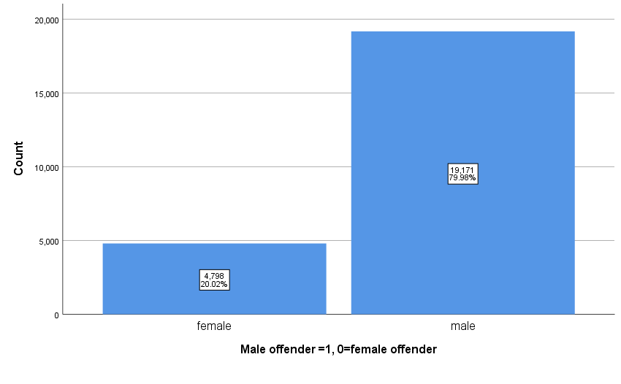
1c. Because age is an interval/ratio variable, the desired chart is a histogram.

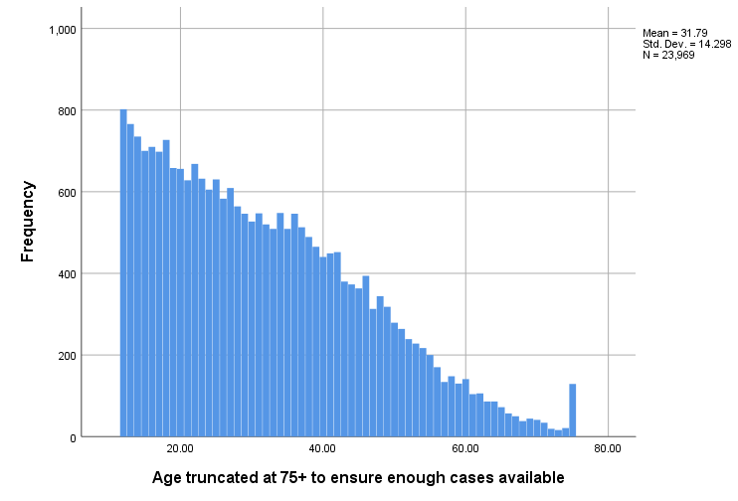

1ci. Beyond visual inspection, you may also click on “Analyze”, then “Descriptives”, click over the variable of interest, click “Options…”, “Skewness”, “Continue” and then “Okay”.
1d. Because V2129 is categorical nominal, a pie or bar chart is desired.
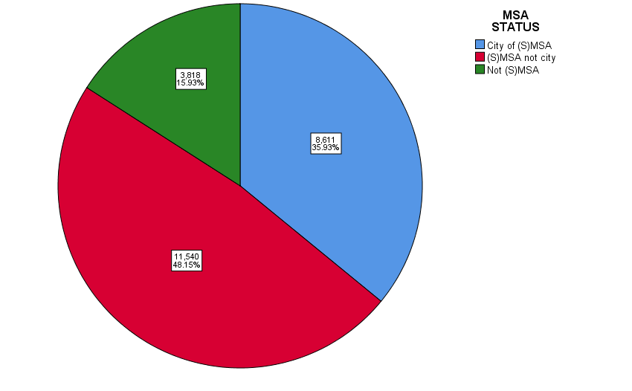

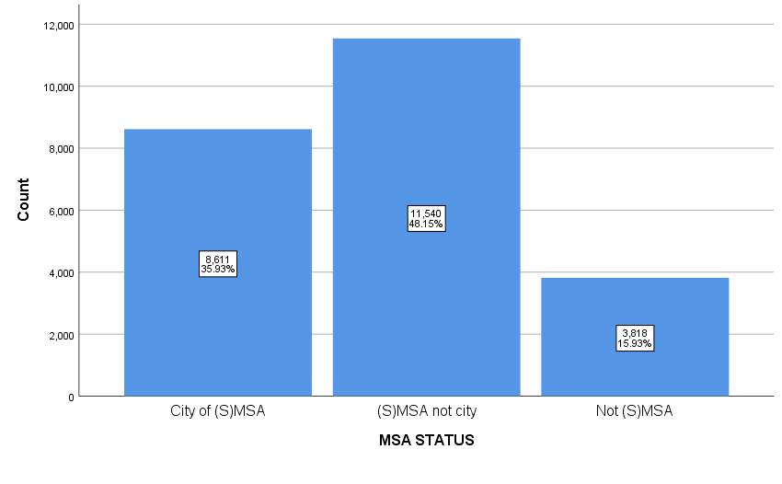
3.

Age truncated at 75+ to ensure enough cases available
 |  | Frequency | Percent | Valid Percent | Cumulative Percent
Valid | 12.00 | 802 | 3.3 | 3.3 | 3.3
 | 13.00 | 766 | 3.2 | 3.2 | 6.5
 | 14.00 | 735 | 3.1 | 3.1 | 9.6
 | 15.00 | 700 | 2.9 | 2.9 | 12.5
 | 16.00 | 710 | 3.0 | 3.0 | 15.5
 | 17.00 | 698 | 2.9 | 2.9 | 18.4
 | 18.00 | 727 | 3.0 | 3.0 | 21.4
 | 19.00 | 658 | 2.7 | 2.7 | 24.2
 | 20.00 | 656 | 2.7 | 2.7 | 26.9
 | 21.00 | 628 | 2.6 | 2.6 | 29.5
 | 22.00 | 668 | 2.8 | 2.8 | 32.3
 | 23.00 | 632 | 2.6 | 2.6 | 35.0
 | 24.00 | 605 | 2.5 | 2.5 | 37.5
 | 25.00 | 630 | 2.6 | 2.6 | 40.1
 | 26.00 | 583 | 2.4 | 2.4 | 42.5
 | 27.00 | 609 | 2.5 | 2.5 | 45.1
 | 28.00 | 564 | 2.4 | 2.4 | 47.4
 | 29.00 | 546 | 2.3 | 2.3 | 49.7
 | 30.00 | 527 | 2.2 | 2.2 | 51.9
 | 31.00 | 547 | 2.3 | 2.3 | 54.2
 | 32.00 | 520 | 2.2 | 2.2 | 56.4
 | 33.00 | 509 | 2.1 | 2.1 | 58.5
 | 34.00 | 548 | 2.3 | 2.3 | 60.8
 | 35.00 | 509 | 2.1 | 2.1 | 62.9
 | 36.00 | 546 | 2.3 | 2.3 | 65.2
 | 37.00 | 513 | 2.1 | 2.1 | 67.3
 | 38.00 | 489 | 2.0 | 2.0 | 69.4
 | 39.00 | 465 | 1.9 | 1.9 | 71.3
 | 40.00 | 440 | 1.8 | 1.8 | 73.1
 | 41.00 | 449 | 1.9 | 1.9 | 75.0
 | 42.00 | 452 | 1.9 | 1.9 | 76.9
 | 43.00 | 380 | 1.6 | 1.6 | 78.5
 | 44.00 | 373 | 1.6 | 1.6 | 80.0
 | 45.00 | 363 | 1.5 | 1.5 | 81.6
 | 46.00 | 394 | 1.6 | 1.6 | 83.2
 | 47.00 | 313 | 1.3 | 1.3 | 84.5
 | 48.00 | 344 | 1.4 | 1.4 | 85.9
 | 49.00 | 318 | 1.3 | 1.3 | 87.3
 | 50.00 | 279 | 1.2 | 1.2 | 88.4
 | 51.00 | 264 | 1.1 | 1.1 | 89.5
 | 52.00 | 239 | 1.0 | 1.0 | 90.5
 | 53.00 | 228 | 1.0 | 1.0 | 91.5
 | 54.00 | 217 | .9 | .9 | 92.4
 | 55.00 | 200 | .8 | .8 | 93.2
 | 56.00 | 170 | .7 | .7 | 93.9
 | 57.00 | 134 | .6 | .6 | 94.5
 | 58.00 | 148 | .6 | .6 | 95.1
 | 59.00 | 130 | .5 | .5 | 95.6
 | 60.00 | 141 | .6 | .6 | 96.2
 | 61.00 | 104 | .4 | .4 | 96.7
 | 62.00 | 106 | .4 | .4 | 97.1
 | 63.00 | 86 | .4 | .4 | 97.5
 | 64.00 | 86 | .4 | .4 | 97.8
 | 65.00 | 72 | .3 | .3 | 98.1
 | 66.00 | 57 | .2 | .2 | 98.4
 | 67.00 | 50 | .2 | .2 | 98.6
 | 68.00 | 38 | .2 | .2 | 98.7
 | 69.00 | 44 | .2 | .2 | 98.9
 | 70.00 | 41 | .2 | .2 | 99.1
 | 71.00 | 34 | .1 | .1 | 99.2
 | 72.00 | 19 | .1 | .1 | 99.3
 | 73.00 | 16 | .1 | .1 | 99.4
 | 74.00 | 21 | .1 | .1 | 99.5
 | 75.00 | 129 | .5 | .5 | 100.0
 | Total | 23969 | 100.0 | 100.0

4g.
Binary age of victimization 0=less than 18 1=18 or older
 |  | Frequency | Percent | Valid Percent | Cumulative Percent
Valid | less than 18 | 4411 | 18.4 | 18.4 | 18.4
 | 18 or older | 19558 | 81.6 | 81.6 | 100.0
 | Total | 23969 | 100.0 | 100.0

