Chapter 3 Excel Output:
1a. For a pie chart, one must first create a frequency of “injured’ similar to how a frequency table was done in the last chapter. After this is done, highlight the column you wish to graph, click the “Insert” tab, “Insert Pie or Donut Chart” and choose one of the options (the first one works fine). Excel offers numerous options to insert values and percentages with its boxes on the right side of the graph that appear once you click the graph.

1b.

1c.
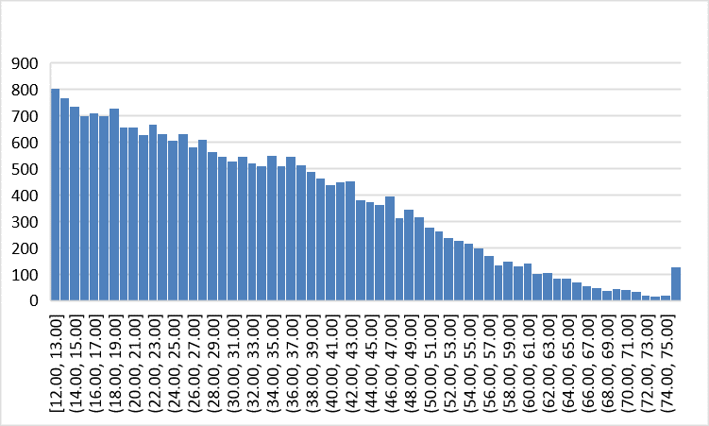
1d.

4a.

4c.

