Chapter 2 Excel Output:
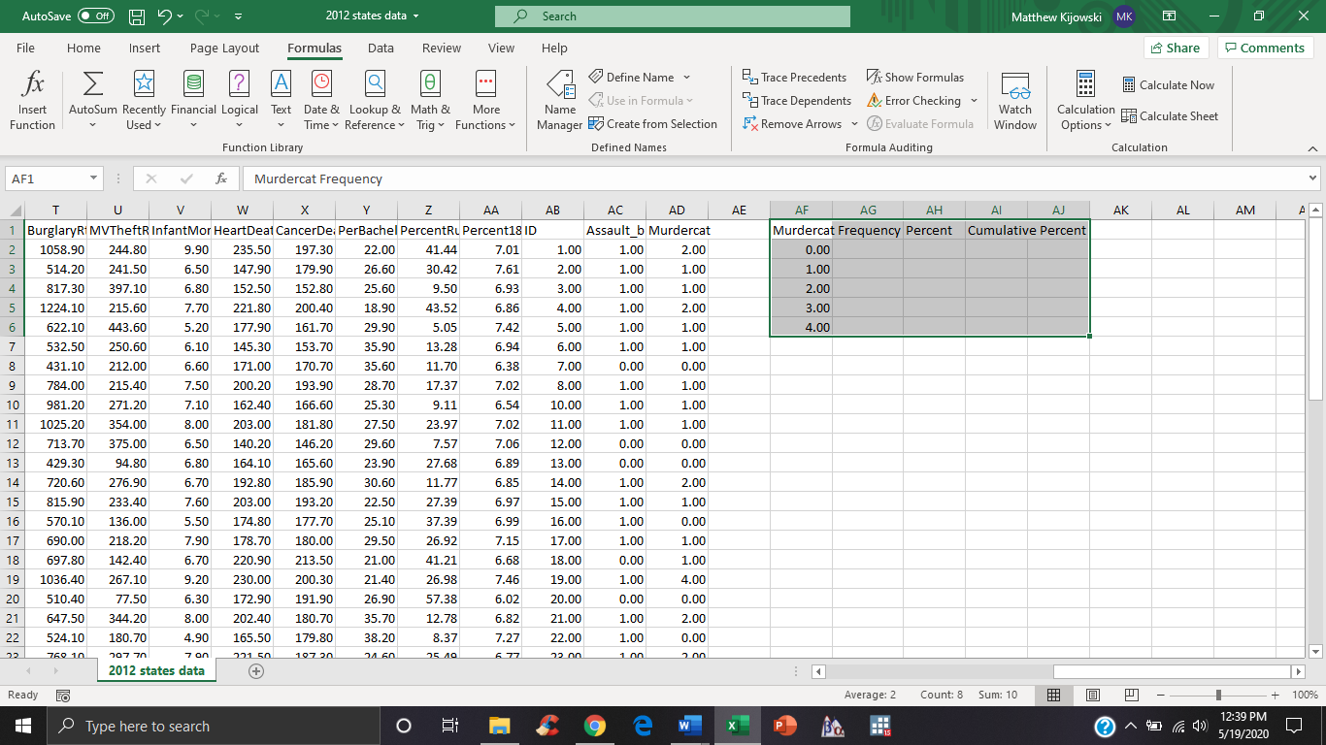

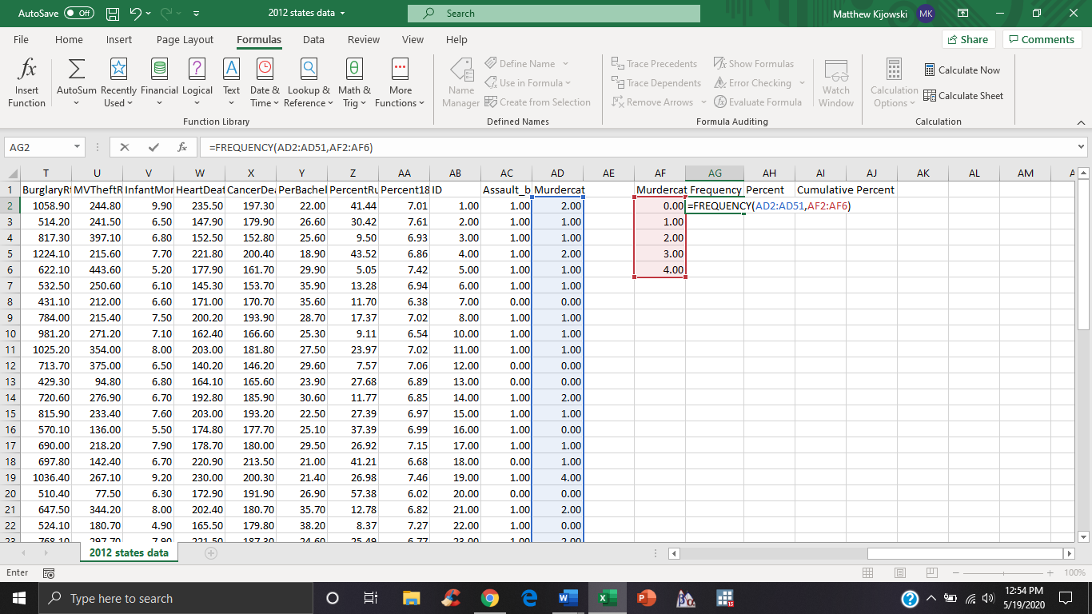
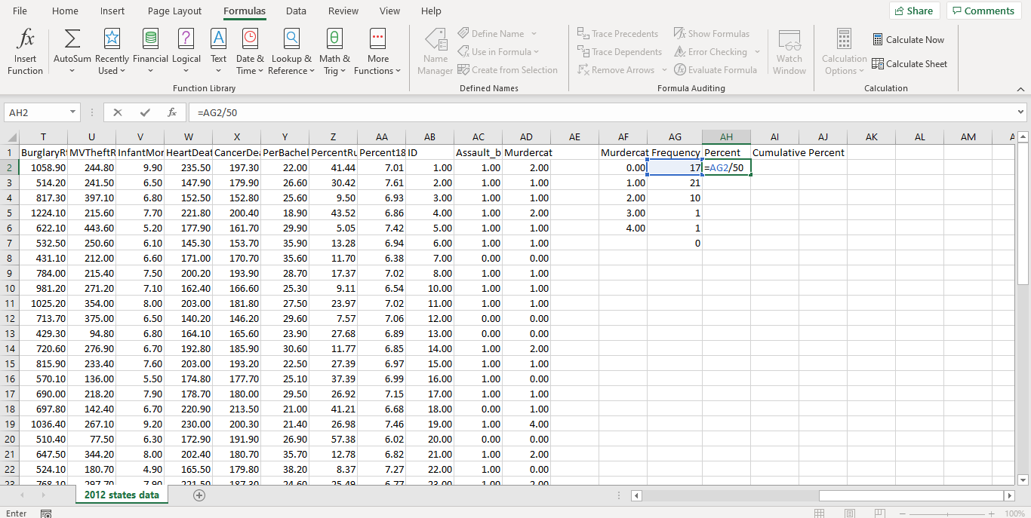
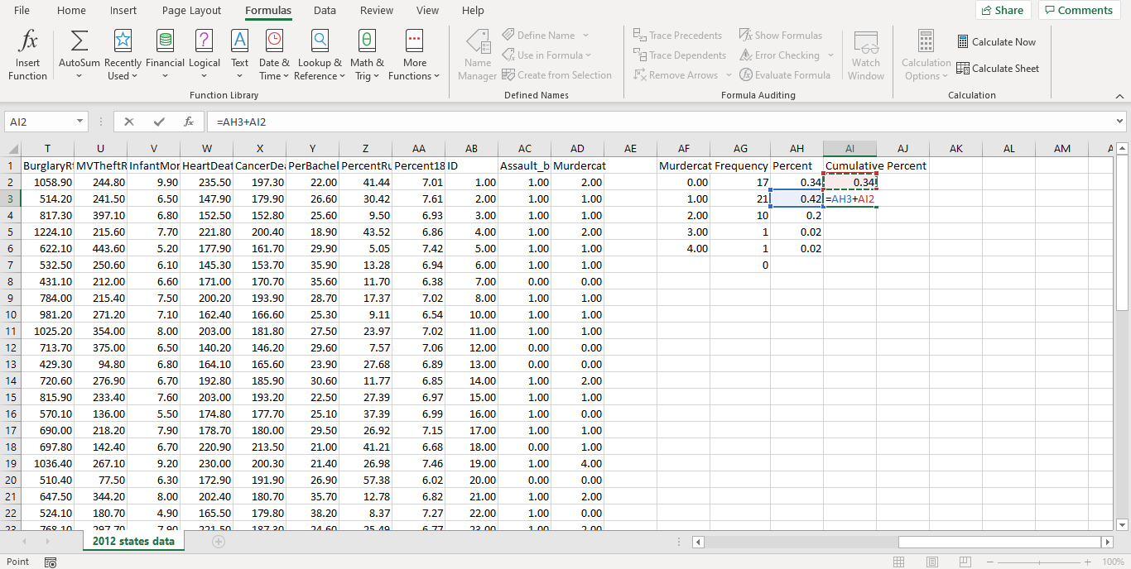

Murdercat Frequency |  | Percent | Cumulative Percent
0.00 | 17 | 0.34 | 0.34
1.00 | 21 | 0.42 | 0.76
2.00 | 10 | 0.2 | 0.96
3.00 | 1 | 0.02 | 0.98
4.00 | 1 | 0.02 | 1

