Chapter 12 SPSS Output
1a.
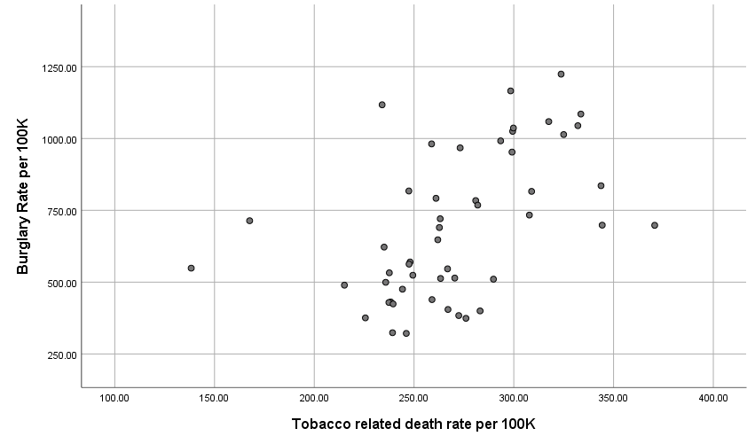

1bi.

Correlations
 |  | Tobacco related death rate per 100K | Burglary Rate per 100K
Tobacco related death rate per 100K | Pearson Correlation | 1 | .500**
 | Sig. (2-tailed) |  | .000
 | N | 50 | 50
Burglary Rate per 100K | Pearson Correlation | .500** | 1
 | Sig. (2-tailed) | .000
 | N | 50 | 50
**. Correlation is significant at the 0.01 level (2-tailed).

1c.

Variables Entered/Removedª
Model | Variables Entered | Variables Removed | Method
1 | Tobacco related death rate per 100K^{b} | . | Enter
a. Dependent Variable: Burglary Rate per 100K
b. All requested variables entered.

Model Summary
Model | R | R Square | Adjusted R Square | Std. Error of the Estimate
1 | .500ª | .250 | .234 | 223.45552
a. Predictors: (Constant), Tobacco related death rate per 100K

ANOVAª
Model |  | Sum of Squares | df | Mean Square | F | Sig.
1 | Regression | 799352.773 | 1 | 799352.773 | 16.009 | .000^{b}
 | Residual | 2396753.724 | 48 | 49932.369
 | Total | 3196106.497 | 49
a. Dependent Variable: Burglary Rate per 100K
b. Predictors: (Constant), Tobacco related death rate per 100K

Coefficientsª
Model |  | Unstandardized Coefficients |  | Standardized Coefficients | t | Sig.
 |  | B | Std. Error | Beta
1 | (Constant) | -113.055 | 203.649 |  | -.555 | .581
 | Tobacco related death rate per 100K | 2.978 | .744 | .500 | 4.001 | .000
a. Dependent Variable: Burglary Rate per 100K

2a.
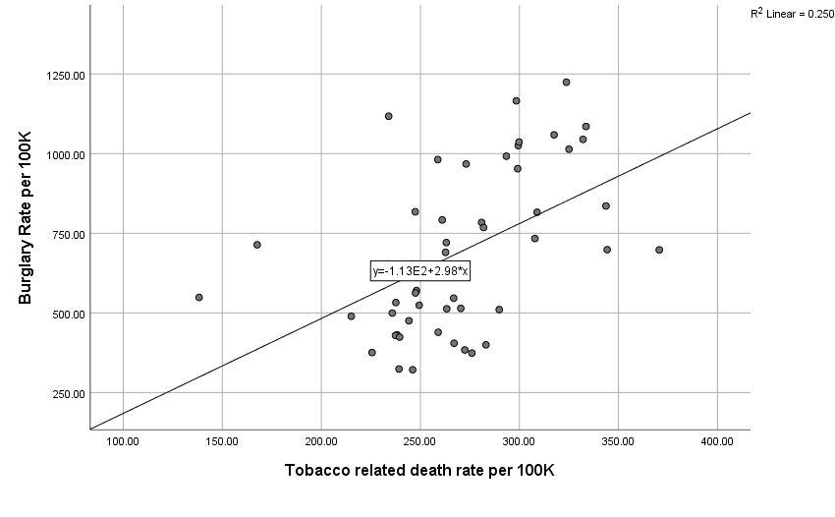

4a.
Variables Entered/Removedª
Model | Variables Entered | Variables Removed | Method
1 | Percent Individuals below poverty^{b} | . | Enter
a. Dependent Variable: Burglary Rate per 100K
b. All requested variables entered.

Model Summary
Model | R | R Square | Adjusted R Square | Std. Error of the Estimate
1 | .710ª | .505 | .494 | 181.62009
a. Predictors: (Constant), Percent Individuals below poverty

ANOVAª
Model |  | Sum of Squares | df | Mean Square | F | Sig.
1 | Regression | 1612785.397 | 1 | 1612785.397 | 48.893 | .000^{b}
 | Residual | 1583321.100 | 48 | 32985.856
 | Total | 3196106.497 | 49
a. Dependent Variable: Burglary Rate per 100K
b. Predictors: (Constant), Percent Individuals below poverty

Coefficientsª
Model |  | Unstandardized Coefficients |  | Standardized Coefficients | t | Sig.
 |  | B | Std. Error | Beta
1 | (Constant) | -120.707 | 119.017 |  | -1.014 | .316
 | Percent Individuals below poverty | 59.038 | 8.443 | .710 | 6.992 | .000
a. Dependent Variable: Burglary Rate per 100K

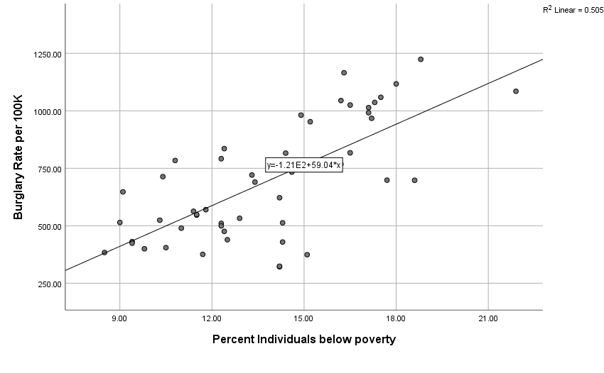
6b.
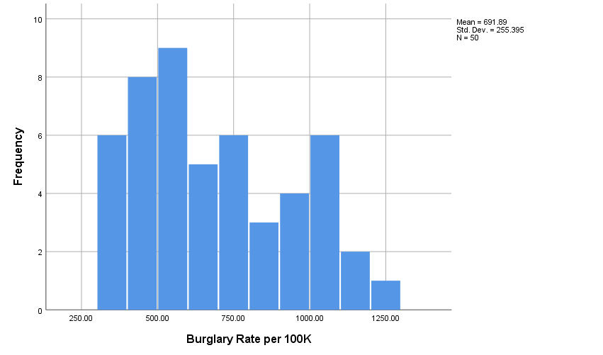

6d.
