Chapter 11 Excel Output

1c.

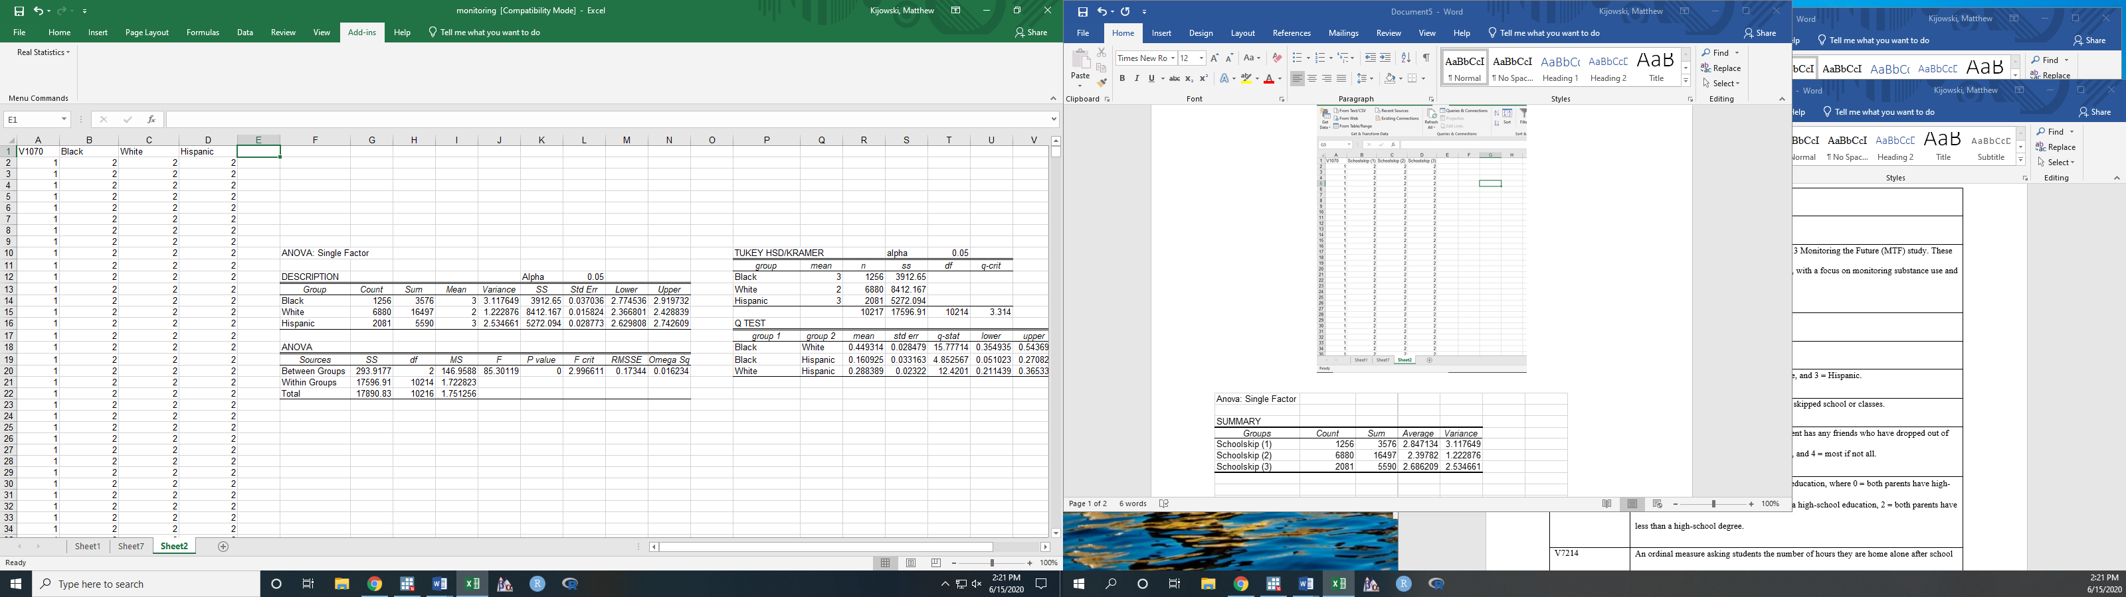



2a.





3.





4.





5.





6.















