CHAPTER 13: CONTROLLING FOR A THIRD VARIABLE:
MULTIPLE OLS REGRESSION
SOLUTIONS
1. Here are some data on four variables:
- Country
- The Crime Rate of the Country per 100,000
- The amount of Welfare Spending per capita in the country
- A Democracy Score that measures how democratic the country is where a high score means more democracy in the country.
Crime Welfare Democracy
Country Rate Spending Score
Poland 678.00 145.00 3
US 345.00 244.00 10
UK 644.00 422.00 8
France 823.00 480.00 8
Italy 456.00 465.00 6
Japan 756.00 220.00 5
Russia 333.00 755.00 2
China 567.00 300.00 0
Germany 345.00 657.00 8
Spain 567.00 622.00 5
Sweeden 158.00 688.00 10
Ireland 834.00 155.00 6
Norway 432.00 595.00 9
Belgium 226.00 836.00 8
Portugal 532.00 328.00 4

With this data, answer the following questions.

- What is the level of analysis or unit of observation?
The country is the level of analysis.

- Graph the relationship between a country’s crime rate and its amount of welfare expenditures and its democracy score. Does it look like there is a linear relationship?
The scatterplots or graphs:
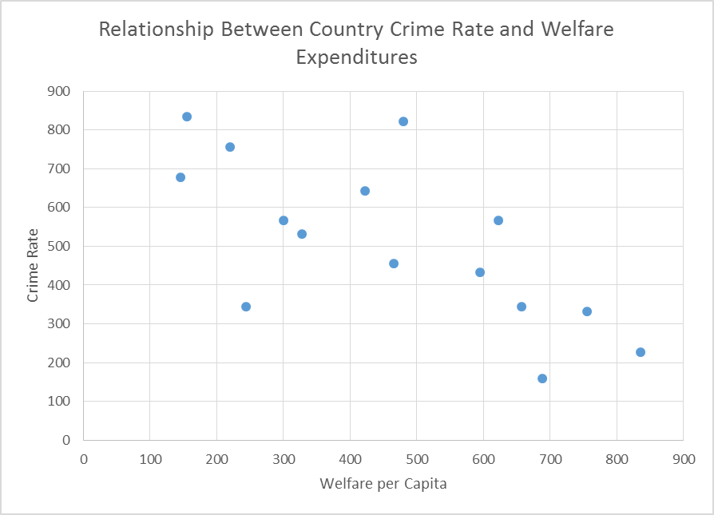

It does look like there is a strong negative linear relationship.

It does look like there is a weak negative relationship.

- What is the correlation between the crime rate in a country and its welfare expenditures? Interpret this value.
The correlation between crime and welfare expenditures is -.697, which means there is a strong inverse relationship between the welfare expenditures in a country and its crime rate. As the amount of spending on welfare increases the crime rate decreases.

- What is the correlation between the crime rate in a country and its democracy score? Interpret this value.
The correlation between crime and a country’s democracy score is -.32, a moderate negative relationship which means that more democratic countries have lower crime rates.

e. Estimate a regression equation with crime rate as the dependent variable and welfare expenditures as the independent variable. Interpret the y intercept, the slope coefficient, the t-test for the slope, and the amount of variance explained.
The regression results are: Interpret the y intercept, the slope coefficient, the t-test for the slope, and the amount of variance explained.

Coefficientsª
Model |  | Unstandardized Coefficients |  | Standardized Coefficients | t | Sig.
 |  | B | Std. Error | Beta
1 | (Constant) | 813.289 | 94.638 |  | 8.59 | .000
 | Welfarepercapita | -.652 | .186 | -.697 | -3.51 | .004
a. Dependent Variable: CrimeRate
R² = .49
The y intercept is 813.289 which means that in a country with no welfare expenditures the predicted crime rate would be 813.289 crimes per 100,000.

The slope is -.652 which means that for each unit increase in welfare spending the crime rate declines by .652.

The slope coefficient is statistically significant meaning that there is a relationship in the population and we would reject the null hypothesis that the slope coefficient is equal to 0.

Forty-nine percent of the variance in crime rates is explained by a country’s welfare expenditures.

f. Estimate a regression equation with crime rate as the dependent variable and the country’s democracy score as the independent variable. Interpret the y intercept, the slope coefficient, the t-test for the slope, and the amount of variance explained.
Coefficientsª
Model |  | Unstandardized Coefficients |  | Standardized Coefficients | t | Sig.
 |  | B | Std. Error | Beta
1 | (Constant) | 651.718 | 125.526 |  | 5.19 | .000
 | DemocracyScore | -22.606 | 18.535 | -.320 | -1.22 | .244
a. Dependent Variable: CrimeRate
R² = .10

The y intercept is 651.718 which means that in a country with a democracy score of 0 the predicted crime rate would be 651.718 crimes per 100,000.

The slope is -22.606 which means that for each unit increase in a country’s democracy score the crime rate declines by about 22 per 100,000.

The slope coefficient is not statistically significant meaning that there is no relationship in the population and we would fail to reject the null hypothesis that the slope coefficient is equal to 0.

Ten percent of the variance in crime rates is explained by a country’s welfare expenditures.

g. Here are the results of the multivariate regression equation when both welfare expenditures and democracy score are in the regression equation. Provide a full interpretation of the results.
Coefficientsª
Model |  | Unstandardized Coefficients |  | Standardized Coefficients | t | Sig.
 |  | B | Std. Error | Beta
1 | (Constant) | 855.325 | 117.272 |  | 7.29 | .000
 | DemocracyScore | -9.520 | 14.966 | -.135 | -.64 | .537
 | Welfarepercapita | -.616 | .198 | -.659 | -3.11 | .009
a. Dependent Variable: CrimeRate
R² = .50

The y intercept is 855.325 which means that in a country with no welfare expenditures and a democracy score of 0 the predicted crime rate could be 855 crimes per 100,000.

The slope coefficient for the Democracy Score is -9.520 which means that each unit increase in this score decreases the crime rate by about 9.5 crimes per 100,000 after controlling for welfare expenditures. The slope coefficient is not statistically significant meaning that there is no relationship in the population and we would fail to reject the null hypothesis that the slope coefficient is equal to 0.

The slope coefficient for Welfare Expenditures -.616 which means that each unit increase in welfare expenditures decreases the crime rate by about .616 crimes per 100,000, after controlling for the level of country’s democracy. The slope coefficient is statistically significant meaning that there is relationship in the population and we would reject the null hypothesis that the slope coefficient is equal to 0.
The absolute value of the standardized Beta for welfare expenditures is greater than that for democracy score (as is the t-statistic) telling us that welfare expenditure is more important than democracy score in explaining a countries crime rate.

Together the two variables explain 50% of the variance in a country’s crime rate.

