Look Behind the Numbers

Questions about Aging from the General Social Survey

- Who should pay for help for the elderly?

BY EDUCATION

WHO SHOULD PAY FOR HELP FOR ELDERLY * Education Crosstabulation
 |  |  | Education |  |  |  |  | Total
 |  |  | Some Elementary, Middle or High School | Graduated High School | Some College | Graduated College | Post Bachelors Schooling
WHO SHOULD PAY FOR HELP FOR ELDERLY | The elderly people themselves or their family | Count | 59 | 156 | 142 | 106 | 104 | 567
 |  | % within Education | 34.7% | 50.6% | 50.9% | 72.1% | 71.7% | 54.1%
 | The government/public funds | Count | 111 | 152 | 137 | 41 | 41 | 482
 |  | % within Education | 65.3% | 49.4% | 49.1% | 27.9% | 28.3% | 45.9%
Total |  | Count | 170 | 308 | 279 | 147 | 145 | 1049
 |  | % within Education | 100.0% | 100.0% | 100.0% | 100.0% | 100.0% | 100.0%

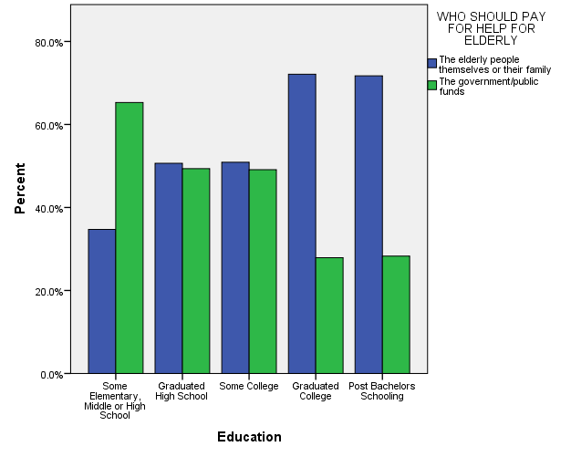

- Should the aged live with their parents?

BY AGE

SHOULD AGED LIVE WITH THEIR CHILDREN * Age Crosstabulation
 |  |  | Age |  |  |  |  |  |  |  |  | Total
 |  |  | 18-24 | 25-32 | 33-40 | 41-48 | 49-56 | 57-64 | 65-72 | 73-80 | 81 and older
SHOULD AGED LIVE WITH THEIR CHILDREN | A GOOD IDEA | Count | 59 | 109 | 109 | 101 | 124 | 83 | 48 | 28 | 23 | 684
 |  | % within Age | 64.1% | 66.1% | 65.7% | 66.9% | 70.5% | 56.5% | 49.5% | 43.8% | 45.1% | 61.7%
 | A BAD IDEA | Count | 33 | 56 | 57 | 50 | 52 | 64 | 49 | 36 | 28 | 425
 |  | % within Age | 35.9% | 33.9% | 34.3% | 33.1% | 29.5% | 43.5% | 50.5% | 56.3% | 54.9% | 38.3%
Total |  | Count | 92 | 165 | 166 | 151 | 176 | 147 | 97 | 64 | 51 | 1109
 |  | % within Age | 100.0% | 100.0% | 100.0% | 100.0% | 100.0% | 100.0% | 100.0% | 100.0% | 100.0% | 100.0%

