Look Behind the Numbers

Questions about Sexuality from the General Social Survey

- Should homosexual books be allowed in the library?

BY EDUCATION

ALLOW HOMOSEXUALS BOOK IN LIBRARY * Education Crosstabulation
 |  |  | Education |  |  |  |  | Total
 |  |  | Some Elementary, Middle or High School | Graduated High School | Some College | Graduated College | Post Bachelors Schooling
ALLOW HOMOSEXUALS BOOK IN LIBRARY | REMOVE | Count | 74 | 101 | 56 | 24 | 16 | 271
 |  | % within Education | 40.0% | 27.8% | 16.3% | 12.2% | 8.4% | 21.2%
 | NOT REMOVE | Count | 111 | 262 | 287 | 172 | 175 | 1007
 |  | % within Education | 60.0% | 72.2% | 83.7% | 87.8% | 91.6% | 78.8%
Total |  | Count | 185 | 363 | 343 | 196 | 191 | 1278
 |  | % within Education | 100.0% | 100.0% | 100.0% | 100.0% | 100.0% | 100.0%

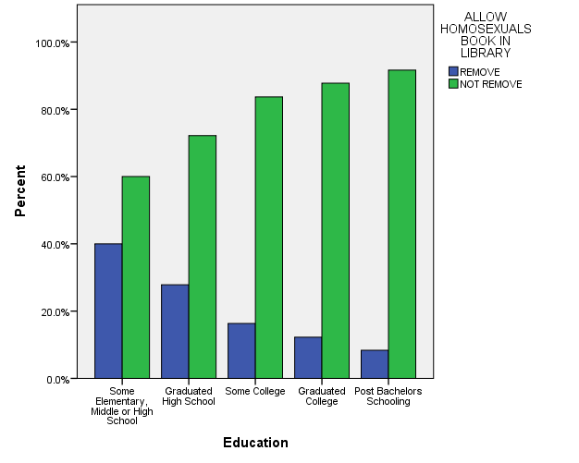

- Married people are happier than unmarried people.

BY SEX

MARRIED PEOPLE HAPPIER THAN UNMARRIED * RESPONDENTS SEX Crosstabulation
 |  |  | RESPONDENTS SEX |  | Total
 |  |  | MALE | FEMALE
MARRIED PEOPLE HAPPIER THAN UNMARRIED | AGREE | Count | 250 | 198 | 448
 |  | % within RESPONDENTS SEX | 45.1% | 29.9% | 36.8%
 | NEITHER AGREE OR DISAGREE | Count | 159 | 224 | 383
 |  | % within RESPONDENTS SEX | 28.7% | 33.8% | 31.5%
 | DISAGREE | Count | 145 | 241 | 386
 |  | % within RESPONDENTS SEX | 26.2% | 36.3% | 31.7%
Total |  | Count | 554 | 663 | 1217
 |  | % within RESPONDENTS SEX | 100.0% | 100.0% | 100.0%

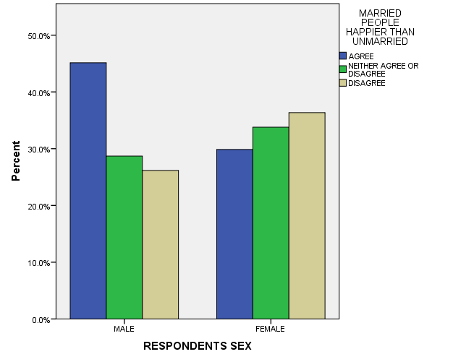

- What is your opinion of birth control to teens between 14 and 16 years of age?

BY SEX

BIRTH CONTROL TO TEENAGERS 14-16 * RESPONDENTS SEX Crosstabulation
 |  |  | RESPONDENTS SEX |  | Total
 |  |  | MALE | FEMALE
BIRTH CONTROL TO TEENAGERS 14-16 | AGREE | Count | 305 | 416 | 721
 |  | % within RESPONDENTS SEX | 52.9% | 60.1% | 56.8%
 | DISAGREE | Count | 272 | 276 | 548
 |  | % within RESPONDENTS SEX | 47.1% | 39.9% | 43.2%
Total |  | Count | 577 | 692 | 1269
 |  | % within RESPONDENTS SEX | 100.0% | 100.0% | 100.0%

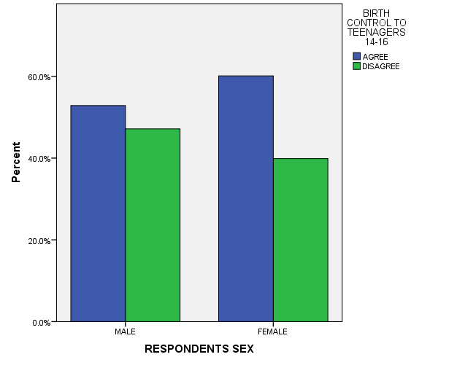

BY INCOME

BIRTH CONTROL TO TEENAGERS 14-16 * Income Crosstabulation
 |  |  | Income |  |  | Total
 |  |  | $0-$14,999 | $15,000-$24,999 | $25,000 or Greater
BIRTH CONTROL TO TEENAGERS 14-16 | AGREE | Count | 78 | 166 | 243 | 487
 |  | % within Income | 61.9% | 65.9% | 57.7% | 61.0%
 | DISAGREE | Count | 48 | 86 | 178 | 312
 |  | % within Income | 38.1% | 34.1% | 42.3% | 39.0%
Total |  | Count | 126 | 252 | 421 | 799
 |  | % within Income | 100.0% | 100.0% | 100.0% | 100.0%

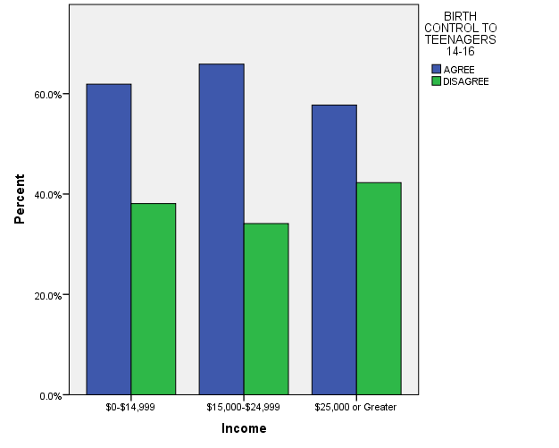

BY EDUCATION

BIRTH CONTROL TO TEENAGERS 14-16 * Education Crosstabulation
 |  |  | Education |  |  |  |  | Total
 |  |  | Some Elementary, Middle or High School | Graduated High School | Some College | Graduated College | Post Bachelors Schooling
BIRTH CONTROL TO TEENAGERS 14-16 | AGREE | Count | 122 | 195 | 191 | 102 | 111 | 721
 |  | % within Education | 61.3% | 55.1% | 55.8% | 55.4% | 58.4% | 56.8%
 | DISAGREE | Count | 77 | 159 | 151 | 82 | 79 | 548
 |  | % within Education | 38.7% | 44.9% | 44.2% | 44.6% | 41.6% | 43.2%
Total |  | Count | 199 | 354 | 342 | 184 | 190 | 1269
 |  | % within Education | 100.0% | 100.0% | 100.0% | 100.0% | 100.0% | 100.0%

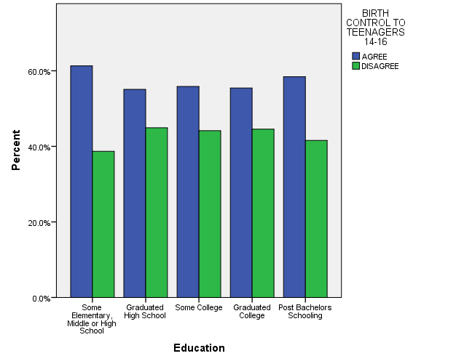

- What is your level of happiness with your partner?

BY SEX

HAPPINESS OF RELT WITH PARTNER * RESPONDENTS SEX Crosstabulation
 |  |  | RESPONDENTS SEX |  | Total
 |  |  | MALE | FEMALE
HAPPINESS OF RELT WITH PARTNER | Very happy | Count | 44 | 59 | 103
 |  | % within RESPONDENTS SEX | 62.9% | 60.2% | 61.3%
 | Pretty happy | Count | 25 | 37 | 62
 |  | % within RESPONDENTS SEX | 35.7% | 37.8% | 36.9%
 | Not too happy | Count | 1 | 2 | 3
 |  | % within RESPONDENTS SEX | 1.4% | 2.0% | 1.8%
Total |  | Count | 70 | 98 | 168
 |  | % within RESPONDENTS SEX | 100.0% | 100.0% | 100.0%

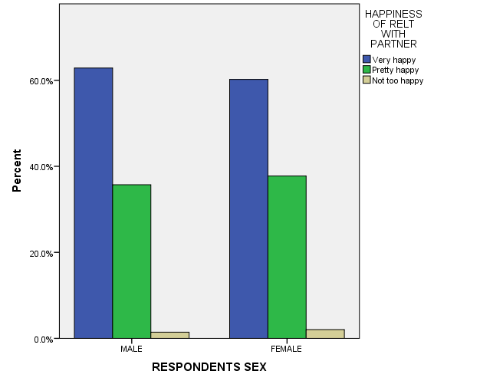

BY EDUCATION

HAPPINESS OF RELT WITH PARTNER * Education Crosstabulation
 |  |  | Education |  |  |  |  | Total
 |  |  | Some Elementary, Middle or High School | Graduated High School | Some College | Graduated College | Post Bachelors Schooling
HAPPINESS OF RELT WITH PARTNER | Very happy | Count | 20 | 30 | 30 | 15 | 8 | 103
 |  | % within Education | 52.6% | 62.5% | 68.2% | 62.5% | 57.1% | 61.3%
 | Pretty happy | Count | 16 | 17 | 14 | 9 | 6 | 62
 |  | % within Education | 42.1% | 35.4% | 31.8% | 37.5% | 42.9% | 36.9%
 | Not too happy | Count | 2 | 1 | 0 | 0 | 0 | 3
 |  | % within Education | 5.3% | 2.1% | 0.0% | 0.0% | 0.0% | 1.8%
Total |  | Count | 38 | 48 | 44 | 24 | 14 | 168
 |  | % within Education | 100.0% | 100.0% | 100.0% | 100.0% | 100.0% | 100.0%

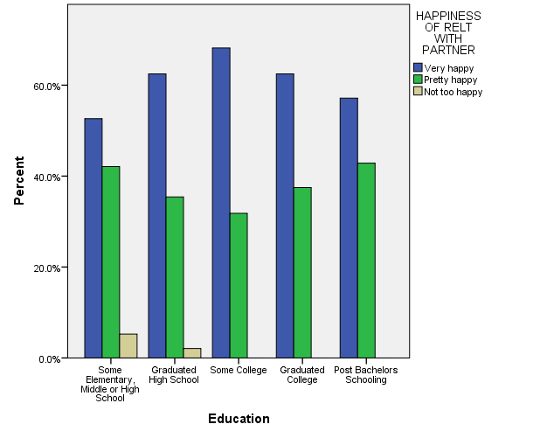

BY INCOME

HAPPINESS OF RELT WITH PARTNER * Income Crosstabulation
 |  |  | Income |  |  | Total
 |  |  | $0-$14,999 | $15,000-$24,999 | $25,000 or Greater
HAPPINESS OF RELT WITH PARTNER | Very happy | Count | 16 | 25 | 31 | 72
 |  | % within Income | 64.0% | 53.2% | 67.4% | 61.0%
 | Pretty happy | Count | 8 | 22 | 15 | 45
 |  | % within Income | 32.0% | 46.8% | 32.6% | 38.1%
 | Not too happy | Count | 1 | 0 | 0 | 1
 |  | % within Income | 4.0% | 0.0% | 0.0% | 0.8%
Total |  | Count | 25 | 47 | 46 | 118
 |  | % within Income | 100.0% | 100.0% | 100.0% | 100.0%

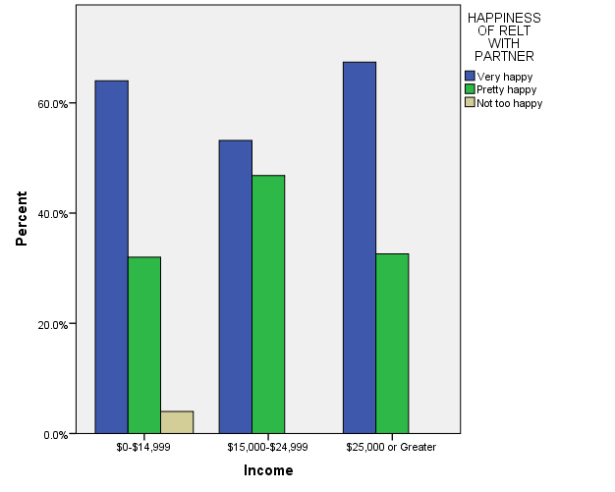

BY RACE

HAPPINESS OF RELT WITH PARTNER * RACE OF RESPONDENT Crosstabulation
 |  |  | RACE OF RESPONDENT |  |  | Total
 |  |  | WHITE | BLACK | OTHER
HAPPINESS OF RELT WITH PARTNER | Very happy | Count | 81 | 9 | 13 | 103
 |  | % within RACE OF RESPONDENT | 64.3% | 40.9% | 65.0% | 61.3%
 | Pretty happy | Count | 42 | 13 | 7 | 62
 |  | % within RACE OF RESPONDENT | 33.3% | 59.1% | 35.0% | 36.9%
 | Not too happy | Count | 3 | 0 | 0 | 3
 |  | % within RACE OF RESPONDENT | 2.4% | 0.0% | 0.0% | 1.8%
Total |  | Count | 126 | 22 | 20 | 168
 |  | % within RACE OF RESPONDENT | 100.0% | 100.0% | 100.0% | 100.0%

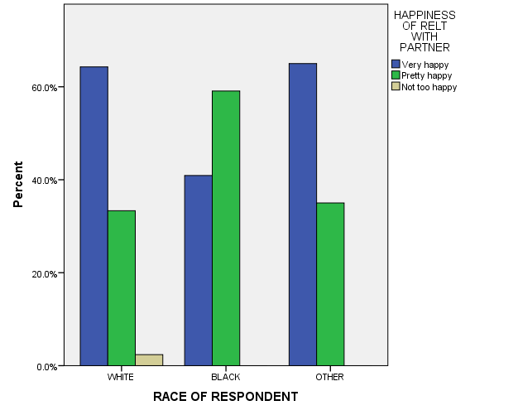

- What is your belief on having sex before marriage?

BY AGE

SEX BEFORE MARRIAGE * Age Crosstabulation
 |  |  | Age |  |  |  |  |  |  |  |  | Total
 |  |  | 18-24 | 25-32 | 33-40 | 41-48 | 49-56 | 57-64 | 65-72 | 73-80 | 81 and older
SEX BEFORE MARRIAGE | WRONG | Count | 44 | 69 | 79 | 73 | 68 | 64 | 61 | 53 | 40 | 551
 |  | % within Age | 36.1% | 37.7% | 39.5% | 39.9% | 38.2% | 44.8% | 53.0% | 68.8% | 74.1% | 43.9%
 | NOT WRONG | Count | 78 | 114 | 121 | 110 | 110 | 79 | 54 | 24 | 14 | 704
 |  | % within Age | 63.9% | 62.3% | 60.5% | 60.1% | 61.8% | 55.2% | 47.0% | 31.2% | 25.9% | 56.1%
Total |  | Count | 122 | 183 | 200 | 183 | 178 | 143 | 115 | 77 | 54 | 1255
 |  | % within Age | 100.0% | 100.0% | 100.0% | 100.0% | 100.0% | 100.0% | 100.0% | 100.0% | 100.0% | 100.0%

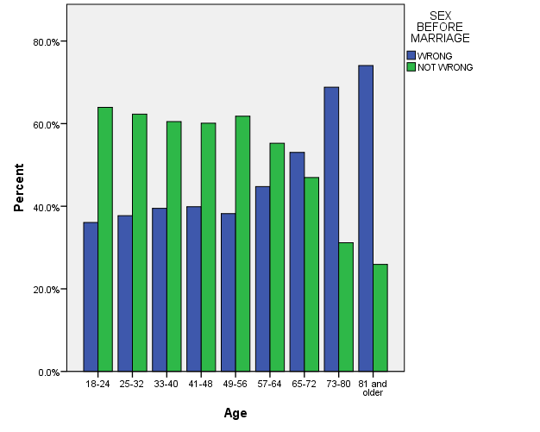

- Do you believe that homosexuals should have the right to marry?

BY AGE

HOMOSEXUALS SHOULD HAVE THE RIGHT TO MARRY * Age Crosstabulation
 |  |  | Age |  |  |  |  |  |  |  |  | Total
 |  |  | 18-24 | 25-32 | 33-40 | 41-48 | 49-56 | 57-64 | 65-72 | 73-80 | 81 and older
HOMOSEXUALS SHOULD HAVE THE RIGHT TO MARRY | AGREE | Count | 71 | 124 | 106 | 105 | 85 | 60 | 49 | 22 | 16 | 638
 |  | % within Age | 67.0% | 63.9% | 58.9% | 55.6% | 42.5% | 36.4% | 40.5% | 29.3% | 28.1% | 49.6%
 | NEITHER AGREE OR DISAGREE | Count | 14 | 24 | 19 | 18 | 31 | 21 | 12 | 2 | 11 | 152
 |  | % within Age | 13.2% | 12.4% | 10.6% | 9.5% | 15.5% | 12.7% | 9.9% | 2.7% | 19.3% | 11.8%
 | DISAGREE | Count | 21 | 46 | 55 | 66 | 84 | 84 | 60 | 51 | 30 | 497
 |  | % within Age | 19.8% | 23.7% | 30.6% | 34.9% | 42.0% | 50.9% | 49.6% | 68.0% | 52.6% | 38.6%
Total |  | Count | 106 | 194 | 180 | 189 | 200 | 165 | 121 | 75 | 57 | 1287
 |  | % within Age | 100.0% | 100.0% | 100.0% | 100.0% | 100.0% | 100.0% | 100.0% | 100.0% | 100.0% | 100.0%

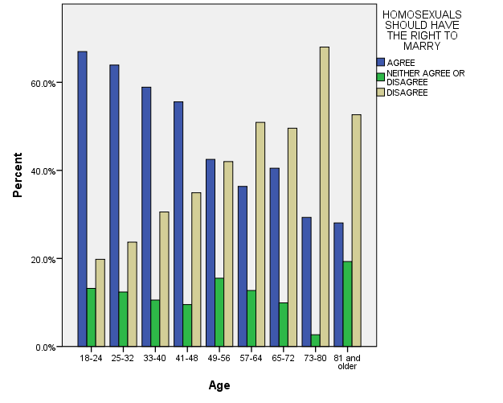

- What is your option on homosexual relations?

ALL RESPONSES – CHANGE OVER TIME

