Look Behind the Numbers

Questions about Race and Ethnicity from the General Social Survey.
- Should the number of immigrants to America be increased, remain the same, or be decreased?

BY RACE

NUMBER OF IMMIGRANTS TO AMERICA NOWADAYS SHOULD BE * RACE OF RESPONDENT Crosstabulation
 |  |  | RACE OF RESPONDENT |  | Total
 |  |  | WHITE | NONWHITE
NUMBER OF IMMIGRANTS TO AMERICA NOWADAYS SHOULD BE | INCREASED | Count | 120 | 55 | 175
 |  | % within RACE OF RESPONDENT | 12.6% | 17.9% | 13.9%
 | REMAIN THE SAME | Count | 377 | 128 | 505
 |  | % within RACE OF RESPONDENT | 39.5% | 41.7% | 40.0%
 | REDUCED | Count | 458 | 124 | 582
 |  | % within RACE OF RESPONDENT | 48.0% | 40.4% | 46.1%
Total |  | Count | 955 | 307 | 1262
 |  | % within RACE OF RESPONDENT | 100.0% | 100.0% | 100.0%

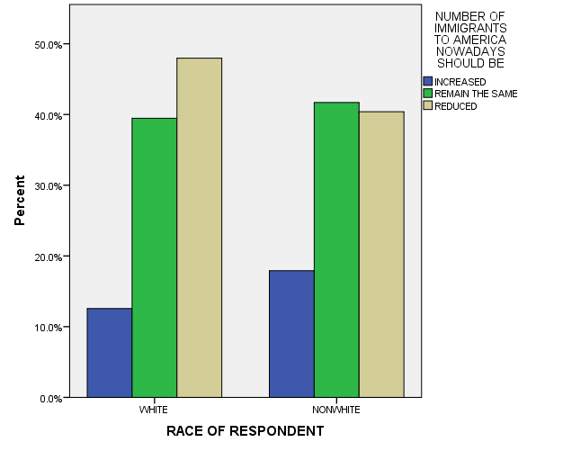

- Should a homeowner be able to decide who they sell their house to based on race?
BY SEX

VOTE ON OPEN HOUSING LAW * RESPONDENTS SEX Crosstabulation
 |  |  | RESPONDENTS SEX |  | Total
 |  |  | MALE | FEMALE
VOTE ON OPEN HOUSING LAW | OWNER DECIDED | Count | 175 | 159 | 334
 |  | % within RESPONDENTS SEX | 31.3% | 22.6% | 26.4%
 | CAN'T DISCRIMINATE | Count | 385 | 545 | 930
 |  | % within RESPONDENTS SEX | 68.8% | 77.4% | 73.6%
Total |  | Count | 560 | 704 | 1264
 |  | % within RESPONDENTS SEX | 100.0% | 100.0% | 100.0%

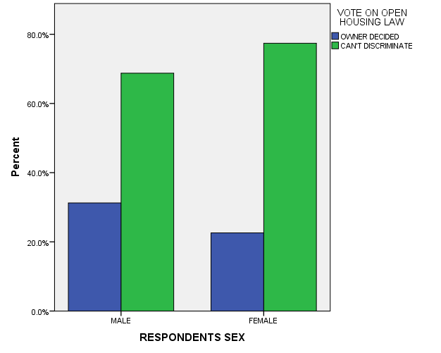

- What is the racial makeup of your workplace?

ALL RESPONSES

RACIAL MAKEUP OF WORKPLACE
 |  | Frequency | Percent | Valid Percent | Cumulative Percent
Valid | ALL WHITE | 167 | 8.5 | 22.6 | 22.6
 | MOSTLY WHITE | 333 | 16.9 | 45.1 | 67.7
 | HALF WHITE-BLACK | 192 | 9.7 | 26.0 | 93.6
 | MOSTLY BLACK | 42 | 2.1 | 5.7 | 99.3
 | ALL BLACK | 5 | .3 | .7 | 100.0
 | Total | 739 | 37.4 | 100.0
Missing | IAP | 1196 | 60.6
 | DON'T KNOW | 22 | 1.1
 | NA | 17 | .9
 | Total | 1235 | 62.6
Total |  | 1974 | 100.0

