Look Behind the Numbers

Questions about urbanization from the General Social Survey

- In the United States, do you think we’re spending too much money on assistance to big cities, too little money, or about the right amount?

BY RACE

ASSISTANCE TO BIG CITIES -- VERSION Y * RACE OF RESPONDENT Crosstabulation
 |  |  | RACE OF RESPONDENT |  |  | Total
 |  |  | WHITE | BLACK | OTHER
ASSISTANCE TO BIG CITIES -- VERSION Y | TOO LITTLE | Count | 88 | 38 | 14 | 140
 |  | % within RACE OF RESPONDENT | 14.7% | 29.5% | 18.9% | 17.4%
 | ABOUT RIGHT | Count | 244 | 57 | 40 | 341
 |  | % within RACE OF RESPONDENT | 40.7% | 44.2% | 54.1% | 42.5%
 | TOO MUCH | Count | 268 | 34 | 20 | 322
 |  | % within RACE OF RESPONDENT | 44.7% | 26.4% | 27.0% | 40.1%
Total |  | Count | 600 | 129 | 74 | 803
 |  | % within RACE OF RESPONDENT | 100.0% | 100.0% | 100.0% | 100.0%

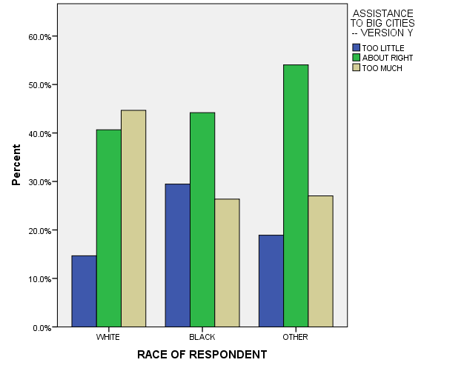

- In the United States, do you think we’re spending too much money on solving problems of big cities, too little money, or about the right amount?

BY RACE

SOLVING PROBLEMS OF BIG CITIES * RACE OF RESPONDENT Crosstabulation
 |  |  | RACE OF RESPONDENT |  |  | Total
 |  |  | WHITE | BLACK | OTHER
SOLVING PROBLEMS OF BIG CITIES | TOO LITTLE | Count | 258 | 88 | 39 | 385
 |  | % within RACE OF RESPONDENT | 40.5% | 59.5% | 40.6% | 43.7%
 | ABOUT RIGHT | Count | 256 | 41 | 42 | 339
 |  | % within RACE OF RESPONDENT | 40.2% | 27.7% | 43.8% | 38.5%
 | TOO MUCH | Count | 123 | 19 | 15 | 157
 |  | % within RACE OF RESPONDENT | 19.3% | 12.8% | 15.6% | 17.8%
Total |  | Count | 637 | 148 | 96 | 881
 |  | % within RACE OF RESPONDENT | 100.0% | 100.0% | 100.0% | 100.0%
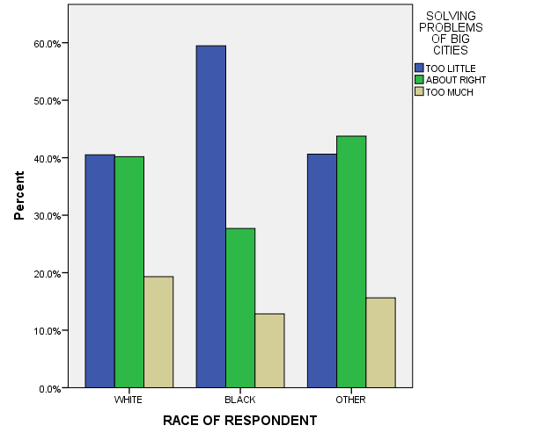

- In the United States, do you think we’re spending too much money on solving problems of big cities, too little money, or about the right amount?

ALL RESPONSES – CHANGE OVER TIME

