Look Behind the Numbers

Questions about science and technology from the General Social Survey

- What is your interest level in scientific discoveries?

BY EDUCATION

INTERESTED IN NEW SCIENTIFIC DISCOVERIES * Education Crosstabulation
 |  |  | Education |  |  |  |  | Total
 |  |  | Some Elementary, Middle or High School | Graduated High School | Some College | Graduated College | Post Bachelors Schooling
INTERESTED IN NEW SCIENTIFIC DISCOVERIES | Very interested | Count | 52 | 80 | 121 | 80 | 76 | 409
 |  | % within Education | 31.3% | 29.9% | 47.1% | 47.3% | 59.4% | 41.4%
 | Moderately interested | Count | 73 | 128 | 108 | 75 | 47 | 431
 |  | % within Education | 44.0% | 47.8% | 42.0% | 44.4% | 36.7% | 43.6%
 | Not at all interested | Count | 41 | 60 | 28 | 14 | 5 | 148
 |  | % within Education | 24.7% | 22.4% | 10.9% | 8.3% | 3.9% | 15.0%
Total |  | Count | 166 | 268 | 257 | 169 | 128 | 988
 |  | % within Education | 100.0% | 100.0% | 100.0% | 100.0% | 100.0% | 100.0%

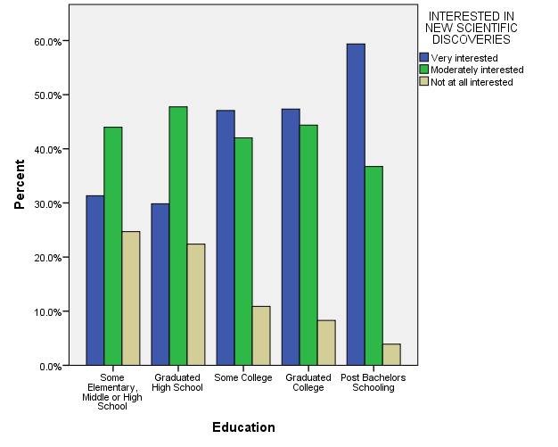

- What is your interest level in technologies?

BY EDUCAITON

INTERESTED IN TECHNOLOGIES * Education Crosstabulation
 |  |  | Education |  |  |  |  | Total
 |  |  | Some Elementary, Middle or High School | Graduated High School | Some College | Graduated College | Post Bachelors Schooling
INTERESTED IN TECHNOLOGIES | Very interested | Count | 54 | 95 | 131 | 68 | 72 | 420
 |  | % within Education | 33.1% | 35.2% | 51.2% | 40.0% | 56.3% | 42.6%
 | Moderately interested | Count | 74 | 133 | 106 | 92 | 49 | 454
 |  | % within Education | 45.4% | 49.3% | 41.4% | 54.1% | 38.3% | 46.0%
 | Not at all interested | Count | 35 | 42 | 19 | 10 | 7 | 113
 |  | % within Education | 21.5% | 15.6% | 7.4% | 5.9% | 5.5% | 11.4%
Total |  | Count | 163 | 270 | 256 | 170 | 128 | 987
 |  | % within Education | 100.0% | 100.0% | 100.0% | 100.0% | 100.0% | 100.0%

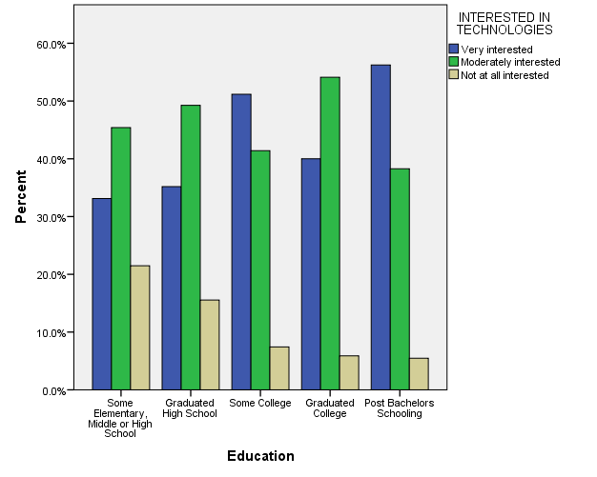

- Do you use the home internet through a mobile device?

ALL RESPONSES

R USES HOME INTERNET THROUGH MOBILE DEVICE
 |  | Frequency | Percent | Valid Percent | Cumulative Percent
Valid | Yes | 59 | 3.0 | 23.4 | 23.4
 | No | 193 | 9.8 | 76.6 | 100.0
 | Total | 252 | 12.8 | 100.0
Missing | IAP | 1718 | 87.0
 | DON'T KNOW | 1 | .1
 | No answer | 3 | .2
 | Total | 1722 | 87.2
Total |  | 1974 | 100.0
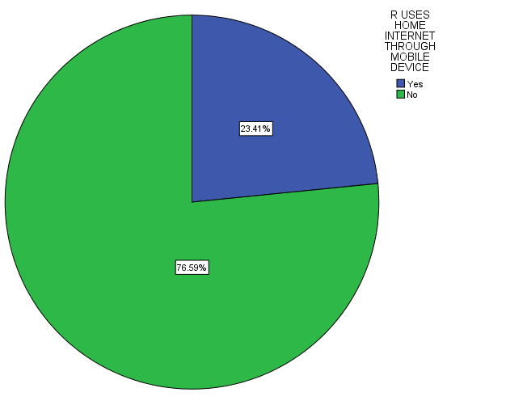

- Do the benefits of scientific research outweigh harmful results?

BY SEX

BENEFITS OF SCIENTIFIC RESEARCH OUTWEIGHT HARMFUL RESULTS * RESPONDENTS SEX Crosstabulation
 |  |  | RESPONDENTS SEX |  | Total
 |  |  | MALE | FEMALE
BENEFITS OF SCIENTIFIC RESEARCH OUTWEIGHT HARMFUL RESULTS | BENEFITS GREATER | Count | 343 | 366 | 709
 |  | % within RESPONDENTS SEX | 90.0% | 88.2% | 89.1%
 | HARMFUL RESULTS GREATER | Count | 38 | 49 | 87
 |  | % within RESPONDENTS SEX | 10.0% | 11.8% | 10.9%
Total |  | Count | 381 | 415 | 796
 |  | % within RESPONDENTS SEX | 100.0% | 100.0% | 100.0%

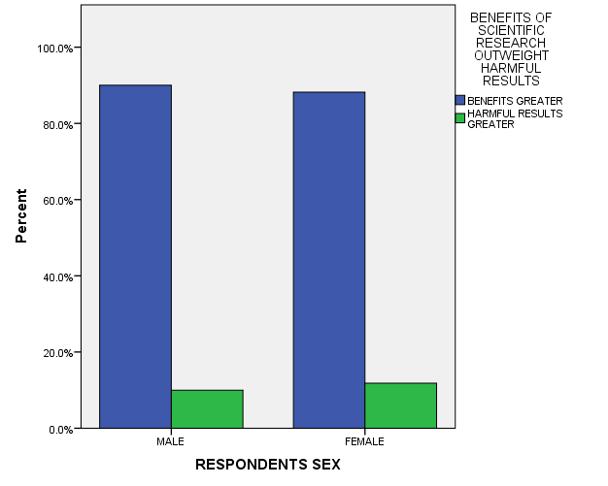

- What is your confidence level in the scientific community?

ALL RESPONES – CHANGE OVER TIME

