Sample Business Plan

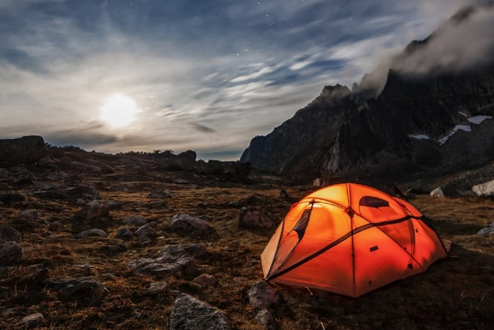

Altitude Tents

“Taking Indoor Comfort Outside”

Kipper Marsh

December 2018

Table of Contents

I. Executive Summary
A. Mission Statement p. 4
B. Company Information p. 4
C. Market Opportunity pp. 4–5
D. Financial Data p. 5

II. Description of Your Company and Industry
A. Company Background and History pp. 6–7
B. The Industry pp. 7–8

III. Description of the Product or Service
A. Description of the Product or Service p. 9
B. Competitive Advantages pp. 9–10

IV. Market Research and Evaluation
A. Markets pp. 11–13
B. Market Trends p. 13
C. Competition pp. 13–15
D. Market Share p. 15

V. Marketing Plan
A. Market Strategy p. 16
B. Product pp. 16–17
C. Pricing p. 17
D. Promotion pp. 17–18
E. Place p. 18
F. Service Policies p. 19

VI. Manufacturing and Operations Plan
A. Production pp. 20–21
B. Geographic Location p. 21
C. Facilities p. 22
D. Make or Buy Policy p. 23
E. Control Systems pp. 23–24
F. Labor Force p. 24
G. Training pp. 24–25
H. Staffing Plan pp. 25–26

VII. The Management Team
A. Identification of Key People pp. 27–28
B. Succession Plan p. 28
C. Management Philosophy pp. 28–29
D. Business/Organizational Structure p. 29
E. Identification of Firms Assisting the Company p. 29

VIII. Timeline
A. Key Events p. 30

IX. Critical Risks and Assumptions
A. Risk Management Strategies pp. 31–32

X. Benefits to Community
A. Economic Development p. 33
B. Community Development p. 33
C. Human Development p. 33

XI. Exit Strategy p. 34

XII. Financial Plan
A. Sources and Uses of Funds p. 35
B. Financial Practices p. 35
C. Cash Flow Statement pp. 35–36
D. Cash Budget p. 37
E. Profit and Loss Statement p. 38
F. Breakeven Analysis p. 39
G. Financial Ratios p. 40
H. Intangibles-Intellectual Property p. 40

Appendices pp. 41–42

I. Executive Summary:
A. Mission Statement:
We strive to make sleeping in a tent comfortable for the long-distance backpacking enthusiast to the weekend warrior with sustainable manufacturing while keeping consumer’s interest and environmentally conscious efforts at the forefront of our operations.

B. Company Information:

  - The objective of Altitude Tents (AT) is to gain a commanding demand of our tent from all consumer preferences. This will create a competitive advantage by not leaving out consumer segments, since there are many different reasons as to why an individual purchases a tent. We plan to initially keep our distribution bound in North America and then enter more international markets once we gather enough recognition to feasibly export our product internationally.

  - The history of this product idea stemmed when I was on a 3-day biking trip riding the Kokopelli Trail and had the worst three nights of sleep I had ever experienced due to constantly rolling off my sleeping pad in the middle of the night. If you have ever camped, you quickly learn that no matter how flat a surface you pitch you tent up seems, it is never truly flat. In addition to that, nearly no one sleeps within the confines of a 3-ft wide area for an entire night; people, like myself, move in the night. Then the solution came to me . . . “what if the entire tent floor was comprised of a sleeping pad?” and so the process of this company began to grow.

  - My management team, as of this point, consists of myself and my family. I am an entrepreneurship major at Colorado Mesa University and will be graduating in May 2019, then continuing my educational endeavors at law school beginning fall of 2019. I have a strong passion for the outdoors but also enjoy the comforts of home.

Much like myself, my family who is my support group and management team in this endeavor have a long history of commercial real estate and development that is tied to our family-owned business. All of them are key to the success of AT because of their extensive knowledge of entrepreneurial endeavors, problem-solving skills, and business experience.

C. Market Opportunity
According to Business Wire, “An estimated 13 million U.S. households plan to camp more in 2017 than they did in 2016, and more than 1 million new households have started camping each year since 2014.” Much of this growth is due to millennials’ interest in camping. The same source stated that “Millennials now account for 38 percent of the 75 million active camper households in the U.S., up from 34 percent in 2016, and 51 percent say they plan to increase their camping this year.”
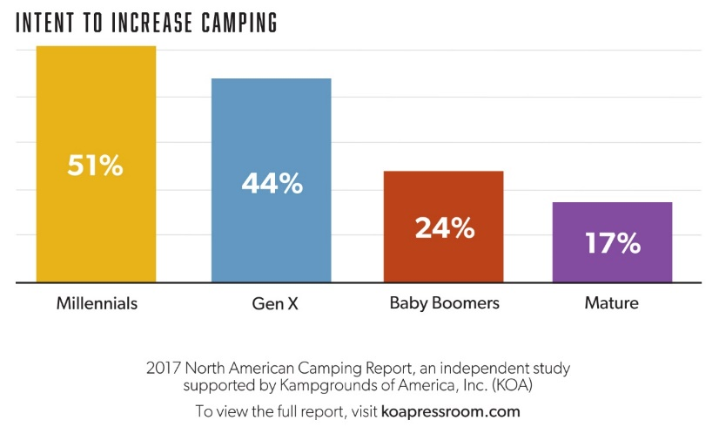
There has also been a growing trend for generation Xers of 6% in the last 2 years. These trends are relevant to investors because the fact that younger generations are more interested in camping than older generations shows that people still resonate with the psychological benefits of getting outdoors to camp. This new influx of young campers allows for a market expansion opportunity, like AT, to meet the demands of how these younger generations experience the outdoors when they live comfortable lifestyle in their daily lives.

D. Financial Data:
  - Altitude Tents (AT) is seeking $660,000 from investors to fund material costs, manufacturing facilities, and marketing.
  - AT plans to take out $122,160 in bank loans on top of investor funds. We are seeking five investors to put up $132,000 each.
  - Bank Loan: 15 years at 4.88%--Investor Loan: Either a 3-year, $44,000 per year plan at a 2.44% interest rate with a 12-year payback period or all $132,000 at a 1.22% interest rate with a 10-year payback period.
  - Investors will receive a $4 royalty on every unit sold, then a jump to an $8 royalty on every unit sold for 5 years after positive cash flow is generated, then steady off back at $5 as long as the company is functioning under current ownership.

II. Description of Company and Industry
A. History of Operation
- Altitude Tents (AT) began with one goal in mind. Provide the best quality night sleep in a tent for the consumer. We plan to run as an LLC until we expand past the credentials for such legal form and ultimately become an S-corporation. This will help save money on taxes. The existence of our company is due in part to the desire to reinvent a commonly used product aimed toward comfort while maintaining a degree of packability and lightweight. Also, according to The Coleman Company 2017 American Camper Report, a tent is the most essential camping item.

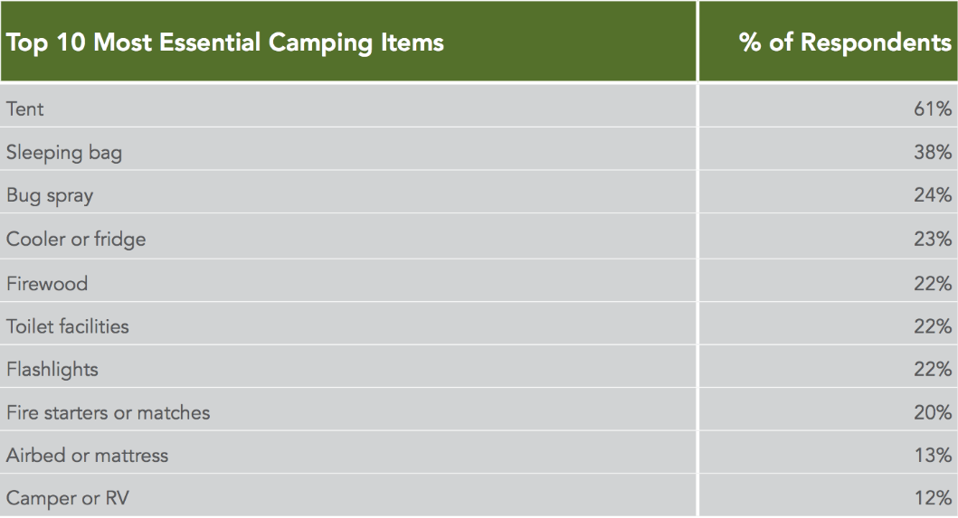

- AT functions to produce a “smart” tent. This involved the hopeful patent of our signature inflatable tent, removable floor, and an integrated device charging built into the lining of the tent itself for easy deceive organization and charging. These innovations will be combined with multiple other options such as shoe stash pockets, integrated entry mats, and outdoor vicinity lighting. All of these options will be combined with different models varying in sleeping pad thickness and material element capabilities, which causes variance in price and overall product weight.

- We chose the multi-option approach to allow customers of all types to find the product that fits their camping needs best.

- The toughest issue that we have faced is finding the materials to use for the tent canvas itself and sleeping pad. The issue is finding an environmentally friendly material that provides the same lightness and durability as competing brands. There has been no significant success to date.

- No significant financial or operational events to highlight to date.

- Intangible Assets include Made in the USA, environmental consciousness, customer service, we stand behind our product, strong credit ratings.

B. The Industry

- The nature of the industry is that camping is among one of the biggest pastimes as a method of gathering friends and family to unplug from reality and enjoy the outdoors. Whether you are an avid backcountry, multiday hiker, weekend warrior, or camp once a year, there is a key component needed for comfort, a tent. The outdoor camping industry is growing as well, as stated in the Market Opportunity section of our Executive Summary. There is also little seasonal fluctuation since camping can be done year-round due to the variety of outdoor activities it encompasses, as seen below. The chart was created by The Coleman Company 2017 American Camper Report.
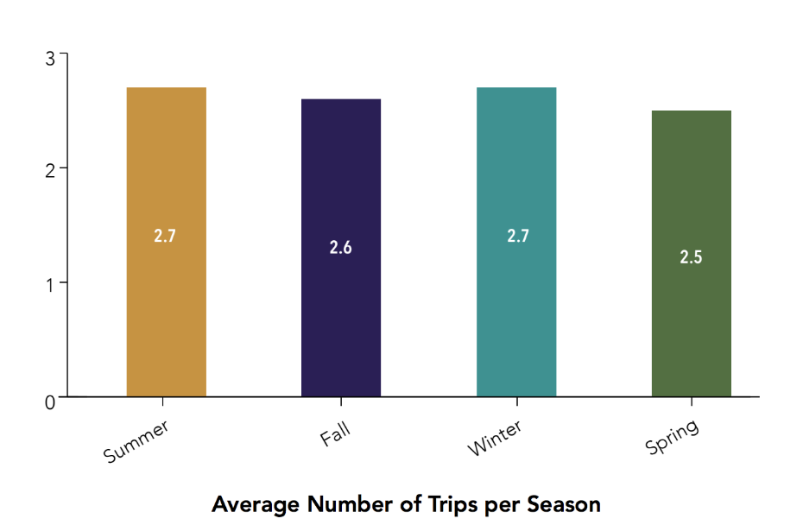
- The tent industry requires innovation to enter comfortably. Otherwise, the ease of entry can be very difficult. The biggest brand competitors to AT are MSR, Big Agnes, The North Face, and Coleman. Between these four brands, nearly every market segment is reached. However, no one of these brands offers a “smart” tent and caters to all market segments on its own. However, the industry is beginning to gravitate toward integrating technology into tents as Big Agnes showed with their mtnGLO® technology.
- Going into the future, the tent industry looks sharp with the growing interest by younger generations. This will end well for incoming brands such as Altitude Tents who will cater to the technologically able young generations. The industry looks to be strong internationally with outdoors camping being a common activity.
  - Any brand mentioned above could compete with Altitude Tents to an extent; however, with our variety of options for each tent and once patents are received, it will be hard for other brands to truly compete with us.

  - The current state of the art in the industry: With young generations driving the camping industry, it is important to cater to their ways of life. Millennials and Gen Xers live in a “smart” world. To succeed, AT plans to integrate technology into the camping experience through comfortable sleeping, device charging, and tent organization. AT plans to beat competitors to this generation market segment and then listens to the consumers’ demands and suggestions to maintain that share of the market and create repeat consumers.

“Camping Is Up in the U.S., Trend Expected to Continue as Millennials Seek the Positive Health Impacts of Time Spent Outdoors.” Camping Is Up in the U.S., Trend Expected to Continue as Millennials Seek the Positive Health Impacts of Time Spent Outdoors | Business Wire, 15 March 2017

III. Description of Product
A. Description of Product
- Altitude Tents’ (AT) main differentiation from tent competitors is our integrated sleeping pad tent floor which eliminates the ability to roll off a pad while sleeping as well as provides comfort no matter what your sleeping position is. AT also provides integrated “smart” technology such as shoe stash pockets, integrated entry mats, outdoor vicinity lighting, and built-in speakers.
- These features will help us meet our target market of Millennials and Gen Xers because of these younger generations’ knack for technology in every facet of their lives. The goal is for consumers to choose our product because of its competitive pricing with other brands and offering of extra features (such as mentioned above).
- Our product life cycle will consist of making the product right the first time around to avoid warranty replacements. The issue arises regarding the ability to create a durable and reliable tent while maintaining the return of customers since a tent is not an annual purchase for most people. Many consumers buy a tent once and use it for 5–10 years before replacing it. The PLC will be managed during the manufacturing process to ensure that the product is made right the first time around, then will go through examination once again before it is boxed for shipment to check for defective product.
- A tent is self-exclamatory, our products will be used for overnight outdoors trips, tailgating events, festival venues, and other locations where someone wants to stay out of the elements. New products may include camping accessories such as replacement parts, campsite lighting and cookware, speakers, and lighting.
- Because this is still a start-up, all of our products are technically “new,” but AT plans to stick with tents only until we gain profit in that market, then continue on from there if we see fit to innovate further products.

B. Competitive Advantages
- Our competitive advantage will come from Altitude Tents’ ability to offer a unique product to a tight market. We plan to work with customers to keep improving our product as well as provide them the best customer service available due to our small business philosophy. AT wants to be an approachable brand that customers feel comfortable to reach out to.
- In the proceeding chart conducted by the University of Colorado-Boulder Economic Outlook from 2018, Colorado’s GDP is expected to increase year after year if the trend continues going into the next 5 years. Colorado has proven to be a stable region for outdoor recreational start-up companies, especially on the western slope.
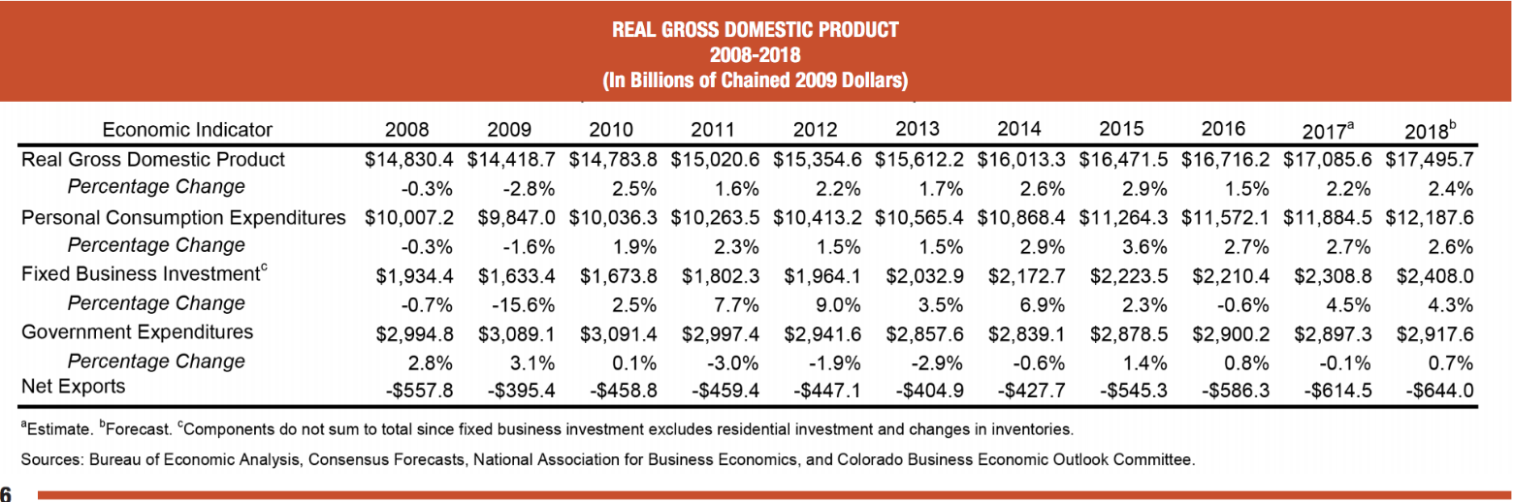

Continuation of the chart above into the next 5 years reveals a steady GDP increase for Colorado, as seen below.

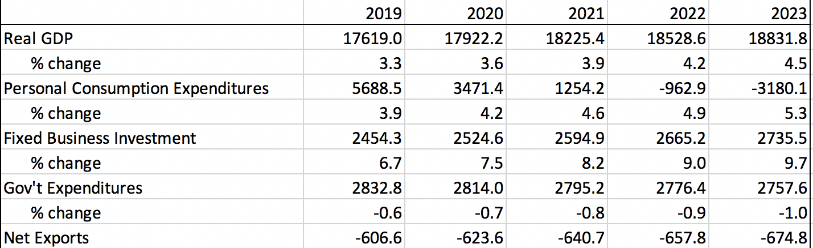

IV. Market Research and Evaluation
A. Markets
- I have not conducted any formal market research other than speaking with like-minded outdoors people whom I personally know. What I have concluded is that, of the 50 or more people I have spoken with, they all have experienced the same discomfort of rolling off their sleeping pad in the night as I do. No one told me that they have never experienced it at least once in all of their camping adventures, and they unanimously agreed that more comfort would be great to have. They also praised the idea of integrated “smart” technology into the tent itself, and many people stated that, for the right price, they would consider trading in their current tent for an Altitude Tent (AT).
- The potential buyers for this product will come from a wide variety of demographic, geographic, and sociological backgrounds. That is what makes the camping industry a great market to tap into. Because AT will make products to reach every economic class, the potential buyer’s market for AT tents is huge. People don’t just camp in the mountains, there are public lands all over the country where people can go to enjoy a night in the outdoors. Rural and urban residents camp and people of all socioeconomical classes camp as well. The activity is open to everyone as the chart by The Coleman Company 2017 American Camper Report displays.
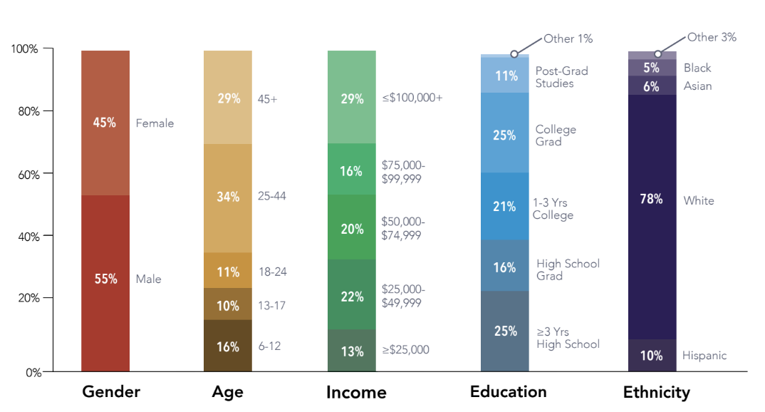

- Because of what is mentioned above regarding the number of participants in the camping industry, it is important that AT narrows down the realistic market segment we can capture. The chart below by The Coleman Company 2017 American Camper Report shows all American campers by camping types. AT plans to target the backpacking market specifically.
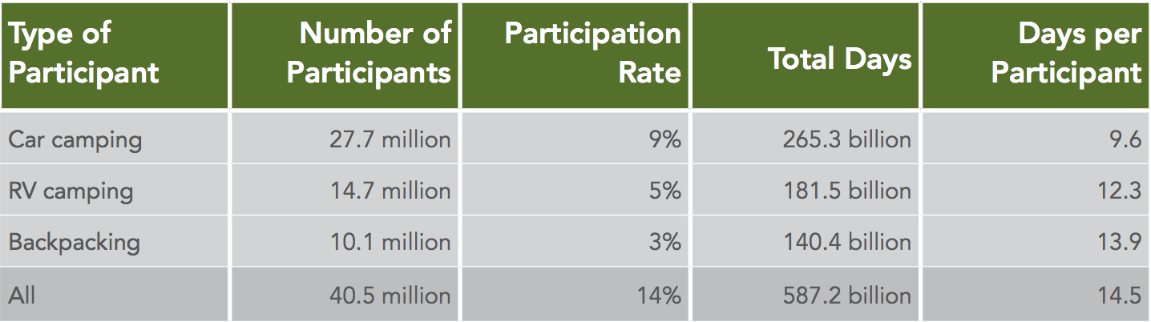

Altitude Tents believes it can realistically capture 4% of the market when we hit our maturity, which equates to 404,000 participants and nearly $121,000,000 in annual revenue at an average tent price of $300. Note that the range of tent prices will go from $125 through $800.
- The primary purpose of purchasing an AT product is the additional options included beyond simply being a tent. Because the camping community has a wide variety of consumers, AT plans to adjust product offering to offer a product for every customer segments criterion. The majority of high-end tent purchasers will buy a tent through an online source, while a mid- to low-end tent purchaser will most often go to a store to purchase a tent.
- Annual purchasers come from all demographics. The goal of AT is not to create annual customers but rather assure that purchasers choose to return to our brand when they are ready for an upgrade. The tent market is not necessarily seasonal because of the variety of tents engineered to withstand all sorts of elements from desert camping to high-altitude mountaineering.
- AT plans to stay competitive with competitors’ pricing. By doing this, we are trying to create a “more for less” mentality in attracting consumers. We want a purchaser to ask themselves why they would purchase a generic tent when they could purchase an equally durable product with additional “smart” features.
- Tents are replaced, on average, every 3 years, according to The Coleman Company 2017 American Camper Report (see chart below)
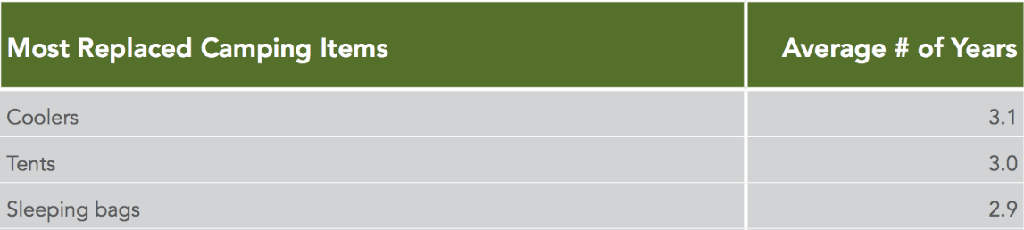
However, even though the replacement of tents is relatively high, there will always be a consumer looking for a new tent at some point. Also, according to The Coleman Company 2017 American Camper Report, a tent is the No. 1 essential item for camping.
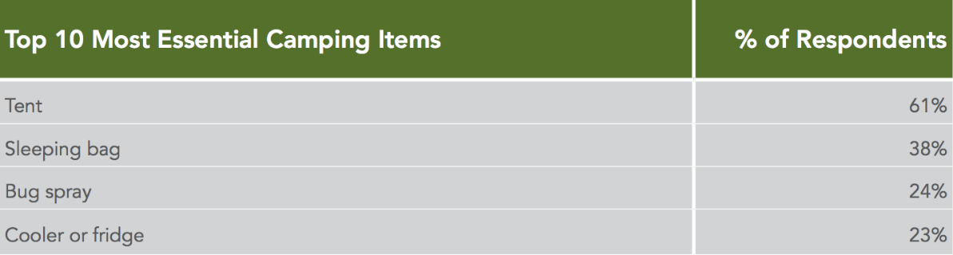

Our company’s growth trend is displayed in the excel sheet below for the first 5 years of cash flow. The overall sales projections are based on attaining 0.1%, 0.4%, 0.6%, 0.6%, and 0.8% of the market share.

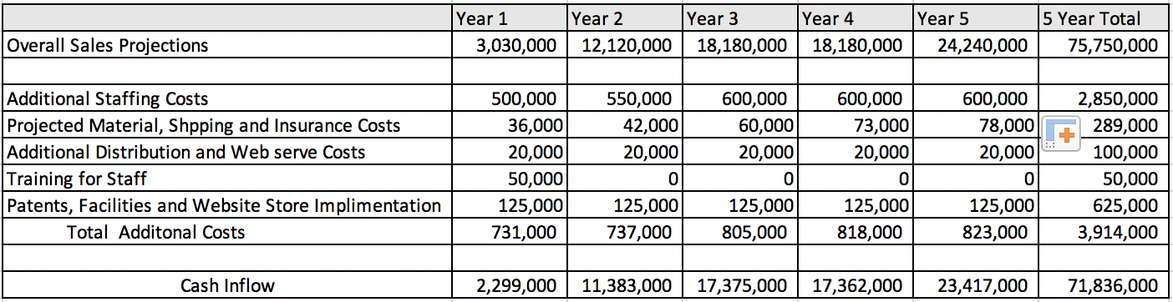

B. Market Trends
- See Section 2 of the “Description of Product” on page 9 for the 5-year Colorado economic forecast. The tent market has shown to stay stable in a fluctuating economy.
- Any addition or subtraction of public lands or national parks by the government could affect the business of Altitude Tents.
- With younger generation coming in to the camping market, a demand for “smarter” camping is eminent to happen sooner than later.
- See the “Market Opportunity” section on page 4 for a comprehensive analysis of the changing market segment of tent campers.
- To track these trends, our company will use semiannual surveys and the number of products sold in various regions and utilize the birthdate of online purchasers to better know the age and demographics of our consumers.

C. Competition
- The biggest brand competitors to AT are MSR, Big Agnes, The North Face, and Coleman. These are all competitors because they offer similar products and meet the demands of nearly every customer segment. However, none of them offer a product like what AT is going to offer. There is no specific way to exploit each of these other brands because none of them are attempting to create a product like AT is, and most of the brands mentioned have other products (clothing, shoes, etc.)
      - Coleman: Cost Leader
      - MSR and Big Agnes: Quality Leaders
      - The North Face: Service Leader
- Our biggest competitor is Big Agnes because of their local, Colorado made, production of their tents as well as their technology implementation with their mtnGLO® interior lighting technology. To combat this, we will implement the ideas mentioned in the “Description of Product” on page 8.
- The essence of what distinguishes their products from ours is that all of the companies mentioned above have an established place in the outdoor tent market unlike AT, since we have not offered a product to the public yet.
- The primary strategy used by all of the abovementioned companies is their environmental initiatives for land preservation and keeping the planet healthy.
- Our biggest comparative weakness is the size we plan to operate at. We don’t desire to expand to the size of these competitors. Our biggest comparative strength will come when we patent the integrated sleeping pad technology.
- Potential competitors may be the abovementioned companies or could also very well be another entering tent manufacturer who sees the opportunity for creating “smart” tents as well.
- --The barriers of entry for the tent market are high if a company desires to match competing brand sales and offers similar products through economy of scale. That is what makes Altitude Tents ahead of the game for success in this market, the key is innovation and not simply trying to make a generic outdoors tent “better.”
- --The upfront capital requirement is another barrier to entry AT will face. Our company needs to purchase a large warehouse in western Colorado for manufacturing, inventory, shipping, and so on. We must find a reliable material source (these are abundant in the outdoor product industry), labor force, and equipment (sewing machines and packaging).
- --Because this is a manufacturing operation, another barrier to entry will be the regulations that must be adhered to. These include compliance on manufacturers directly or indirectly, including product safety, health, safety, environmental impact, data controls, anti-corruption, IT safety and security, fair competition, employment law.

D. Market Share
- Sales Forecast Table:
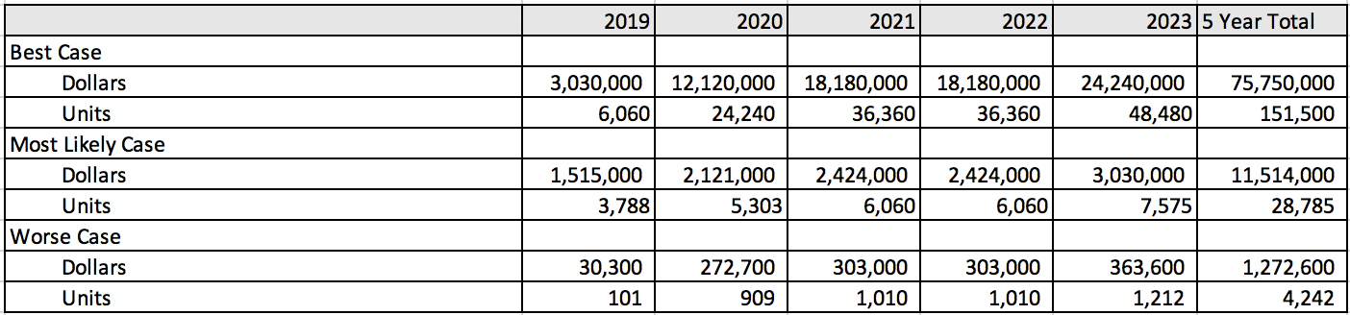
Best case is based off of $500 per unit average, most likely is based on $400 per unit, and the worst case is based on $300 per unit average. Because we have no raw data, the chart above is merely an estimation.
“Camping Is Up in the U.S., Trend Expected to Continue as Millennials Seek the Positive Health Impacts of Time Spent Outdoors.” Camping Is Up in the U.S., Trend Expected to Continue as Millennials Seek the Positive Health Impacts of Time Spent Outdoors | Business Wire, 15 March 2017

V. Marketing Plan
A. Marketing Strategy
- According to Business Wire, “An estimated 13 million U.S. households plan to camp more in 2017 than they did in 2016, and more than 1 million new households have started camping each year since 2014.” Much of this growth is due to millennials’ interest in camping. The same source stated that “Millennials now account for 38 percent of the 75 million active camper households in the U.S., up from 34 percent in 2016, and 51 percent say they plan to increase their camping this year.”
There has also been a growing trend for generation Xers of 6% in the last 2 years. These trends are relevant to investors because the fact that younger generations are more interested in camping than older generations shows that people still resonate with the psychological benefits of getting outdoors to camp. This new influx of young campers allows for a market expansion opportunity, such as AT, to meet the demands of how these younger generations experience the outdoors when they live comfortable lifestyle outside of the outdoors.

- The marketing tactic of Altitude Tents (AT) is to gain a demand for our tent by marketing to all consumer segments. This will create a competitive advantage by not leaving our consumers because of price or accessibility. This marketing strategy will be useful since there are many reasons as to why an individual purchases a tent. We plan to initially keep our marketing in North America and then enter more international segments once we gather enough recognition to feasibly export our product to those marketable countries.

B. Product
- A core mission for AT is to produce a product that matches the durability of any tent on the market for ultimate product satisfaction. AT stands behind our tents and will offer an unlimited 5 years warranty (longer than the average person keeps a tent). The benefit is this will be giving customers an incentive to have brand loyalty with AT.
- Being a start-up, all of our products are new to the market and as stated earlier in this plan, we are taking an innovative approach to the tent market that the world has never seen before. AT is open to criticism and looks forward to hearing customer feedback so that we can make changes where necessary to keep making the steps toward becoming a leading outdoor tent brand.
- Packaging has been factored into our sales projections and forecast charts. Our goals are to create a minimal package that only includes the necessary space to limit cost of packaging and make our product more desirable for our backpacking overnight consumers.

C. Pricing
- Pricing for tents depends heavily on the purpose a consumer has for buying a tent. That is why AT will offer a wide variety of options to cater to all segments’ needs. A backcountry four-season tent typically sells anywhere from $600 to $800, whereas a simple summer family tent may cost $ or less. AT wants to reach the broadest market in the most efficient way while not undercutting competitors’ prices but rather offering out tents around the same prices; we just offer more options the competitors do not.
- Price is determined on the purpose of the tent; these factors include recommended use, seasons, capacity, materials, and weight for the most part. All of these factors are considered when pricing a tent. For example, our three-season: three-person tent will be priced around $339, our four-season: three-person tent will be priced around $779, while our three-season: six-person tent will be priced around $559.
  - At our most likely forecast outcome will be as displayed below:

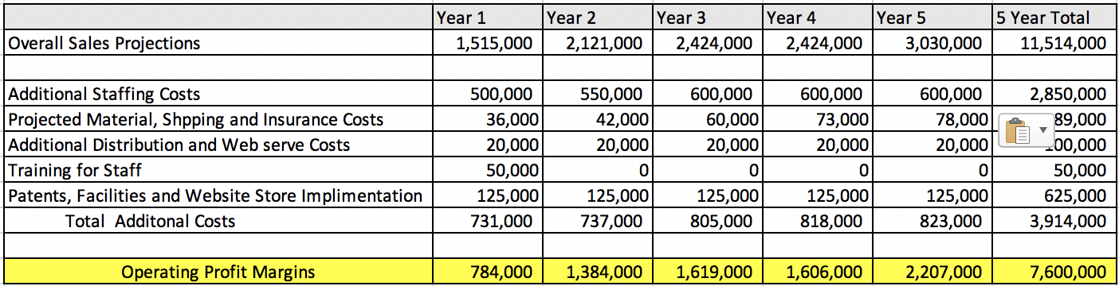

By minimizing our material and shipping costs as well as facility costs, we will be able to maximize our profit margins best.

D. Promotion
- To attract customer, Altitude Tents will launch social media campaigns as well as have booths at gear conventions and shows when possible to help promote our products as well. Because our target market is millennials and Gen Xers, social media will be a large part of our promotional campaign. Eventually, we hope to win awards from magazines such as Outdoors and Backpacker, which will provide extensive promotions when their gear catalogues are released. Regardless of awards or not, we will also try to get our products advertised in both of these magazines.

- As mentioned in (a), AT hopes to advertise our tents on Outdoors and Backpacker magazines. On top of that though, AT plans to offer ambassadorships to a select group of social media consumers. We will provide the ambassadors with discounts and other incentives based on their sales from social media promotion. This ambassadorship has shown to be a successful means of advertising for many start-up companies because rather than an ad, we allow people from our target market to promote our tents through word of mouth and social media posts. Customers trust their friends more than they trust a generic advertisement in today’s world, and although we plan to still utilize some generic advertising, ambassadorships will be a key factor in Altitude Tents product advertising.

  - Our advertising cost:

This percentage is based on our most likely sale forecast numbers, and the 10% annual advertising expense is a tentative number that may be adjusted.

- Because a large part of Altitude Tents advertising and promotional plan will be placed in the hands of people in our target market (ambassadors), we plan to assess the effectiveness of our promotional efforts through consistent communication between AT and ambassadors on company/product updates and promotions as well as keep tabs on each of our ambassador’s monthly, quarterly, and yearly sales. In the end, it is about how much products we are selling and the only way to assess the effectiveness of our promotional efforts will be the number of units being sold each month, quarter, and year. As those figures begin to come in, AT will be better equipped to evaluate the promotional efforts that are most effective.

E. Place
- We will distribute our products through independent sales representatives as well as have our own sales force. Because we plan to stay within North America for the first few years, distribution will stay relatively simple. AT plans to use a database connected to our website so that all orders are neatly organized. We also plan to have our tents in REI and local outdoor gear businesses. We will distribute to these retailers in bulk when product begins to run low.
- The sales compensation is built into the excel document on page 12 under “staffing costs.”
- Our sales force will be divided into groups based on price categories. The category specifics are still being discussed.
- Our sales budget was based on a $33,000 salary per year average for 20 employees. This may change when AT has a more realistic number of employees necessary to operate. Our sales force will approach the customer in a friendly, knowledgeable but not pushy mannerism. We want Altitude Tents products to sell themselves by the uniqueness the product offers; our sales forces are merely a liaison who helps consumers find the product that fits their needs best.
- Refer to the “Projected Material, Shipping and Insurance Costs” and “Additional Distribution and Web Serve Costs” sections of the chart on page 16 for the means of distribution cost. We plan to utilize businesses such as UPS, FedEx, and USPS for shipping our goods.

F. Service and Policies
    - We will offer a 24-hr e-mail response policy and if we do not reply within those 24 hr, we will offer a 10% discount on any product.
    - AT will offer over a 5-year unlimited warranty.
    - We will offer a 90-day satisfaction guarantee program.
    - We will offer free shipping on all orders over $150.

- As important issues arise, we will identify them as new information come to light and address the issues as we get word of them rather than wait to act. This will assure that we stay on top of potential issues and keep production steady.

“Camping Is Up in the U.S., Trend Expected to Continue as Millennials Seek the Positive Health Impacts of Time Spent Outdoors.” Camping Is Up in the U.S., Trend Expected to Continue as Millennials Seek the Positive Health Impacts of Time Spent Outdoors | Business Wire, 15 March 2017

VI. Manufacturing and Operations Plan
A. Production
- Altitude Tents (AT) plans to use 15 employees for the manufacturing’s five processes. Five employees will be assigned to complete over the processes of material cutting, sewing, and packaging. These employees will assure that the equipment is running efficiently.
- The equipment will include industrial sewing machines designed to handle the intricate seams that must be made for the tent’s durability. We will also use a laser cutting system to assure that all of our canvas materials are cut to the correct sizes every time.
- We will run out of one large facility in western Colorado, most likely in the Durango area.
- Our materials will be imported from the canvas distributor out of Europe called ESVO. This material company makes all of the canvas types we need so that we can have a one-stop shop for all of our material needs. Prices are discounted when bought in bulk as well, and the company has a 4.5-star reputation with nearly 7,000 reviews. Because AT plans to make a variety of tents consisting of different weights and prices, we will use a variety of materials such as ripstop nylon, cotton, polyester, and mesh. The best part of using ESVO is that the company provides the exact properties that each material is able to withstand regarding wind and water. ESVO also offers the materials needed for zippers, stake holes, supporting poles, and tent pole location mountain points. We will be able to use ESVO for all aspects of our production and material needs. For example, our mid-range ripstop nylon is:
      - One-sided usable, coating is on the inside
      - Outside of the fabric: rugged side
      - Inside of the fabric: coated/smooth side
      - Sewing machine: household sewing machine or industrial sewing machine
      - Sewing thread: thickness 50, pol./cot., water repellent, and UV resistant
      - Needle thickness: 90 or 100
      - Finishing of the fabric edge: bordering with reinforcement tape or piping with bias tape
and the features include:
- Width: 150 cm
- Material: 100% nylon ripstop
- Weight: 70 g/m²
- Quality: lightweight ripstop nylon
- Coating: PU
- Finish: fluorocarbon
- Water column: >1500 mm
- Color-weather fastness: >4
Our transportation and shipping will be organized from our manufacturing facility to minimize the space needs of having to own a separate facility solely for the purpose of transportation and shipping. AT will organize a daily pickup from either UPS, FedEx, or USPS to pick up our orders and get them to their own distribution centers.
(Flow Chart?)
- Product level will be determined through the number of orders we receive in our preorder period. This will hopefully set the precedence for what consumers demands are and what products will be most popular. This will also help AT in choosing what kind and how much of each raw material to purchase from ESVO. AT plans to use a 6-month preorder period where those who order will receive a discount from the market price (much like what GoFundMe offers) and will make clear a 6-month production time cycle to those who order so that we will make certain to manufacture and fulfill every order made within the following month after the 6-month production cycle (month 13 after the first day of the preorder period). This will hopefully help assure a successful purchasing control process.

B. Geographic Location
- Altitude Tents plans to locate its operations in western Colorado, specifically Ridgeway, Grand Junction, Gunnison, or Durango.
- There are a variety of advantages to operating in this area of Colorado and the United States as a whole. The biggest one being that spaces are not an issue and land is relatively inexpensive when you compare it to the Denver area. Another advantage is the cost of living in western Colorado is inexpensive compared to other areas of the state which allows for employees to live more comfortable lives financially. The Colorado Western Slope also has a large outdoorsy population, and the area offers thousands of BLM land where people can camp, National Forests, desert, and mountain terrain. The areas surrounding most of the towns in western Colorado are full of year-round camping locations, and the milder weather helps prolong the camping season for most. This area of Colorado has a milder winter compared to the rest of the state which helps with distribution, since weather delays are not as prominent. The western slope offers a variety of business development centers, an example of this is the Grand Junction Business Incubator and Telluride Venture Accelerator.
- Taking Colorado as a whole, the state has one of the lowest property taxes in the country at less than 1%. Also, with Colorado being an outdoor hub, the state residents accept innovative outdoor products as well as take a pride in Made in Colorado products. The state also has organized LLC and corporation registrations which allows for a start-up company to quickly gain the tax benefits of being recognized as a business.

C. Facilities
- AT plans to conduct all of its operations in the confines of a 10,000 ft² facility. Five thousand will be used for manufacturing, 3,000 will be used for distribution and inventory, and the remaining 2,000 will be used for office space. Grand Junction offers the best options for a facility of this magnitude and the purchase of 10,000 ft² should cost between $850,000 and $1,000,000 depending on the price per square foot.
The facility below gives an example of the facility we are seeking to purchase, and the specific facility is offered on LoopNet for around $1,000,000 ($100 per square foot) and is located in Grand Junction:
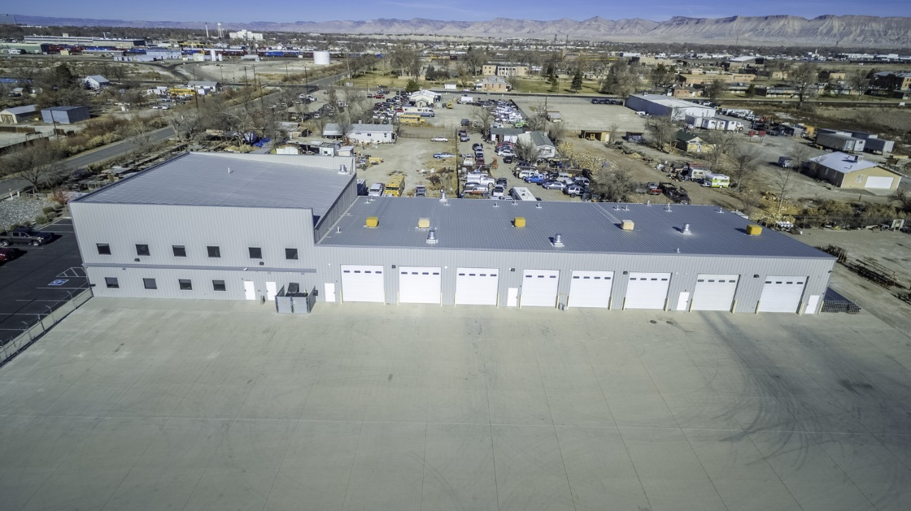
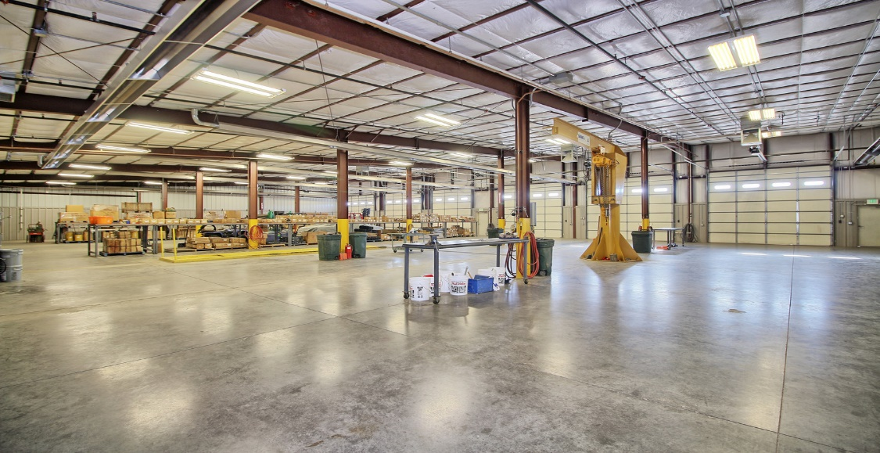

D. Make and Buy Policy
- Our materials will be imported from the canvas distributor out of Europe called ESVO. This material company makes all of the canvas types we need so that we can have a one-stop shop for all of our material needs. Prices are discounted when bought in bulk as well, and the company has a 4.5-star reputation with nearly 7,000 reviews. Because AT plans to make a variety of tents consisting of different weights and prices, we will use a variety of materials such as ripstop nylon, cotton, polyester, and mesh. The best part of using ESVO is that the company provides the exact properties that each material is able to withstand regarding wind and water. ESVO also offers the materials needed for zippers, stake holes, supporting poles, and tent pole location mountain points. We will be able to use ESVO for all aspects of our production and material needs.
  - AT will produce all final products in the Colorado manufacturing facility.

E. Control Systems
- All products will be inspected before they are put into final packaging for delivery. All deliveries will be followed up with 1 week after delivery to ensure our product carriers are satisfied with the units they received.
- Our inventory philosophy is to always deliver high-quality tents the first time. AT wants to make sure suppliers and customers do not have to go through the hassle of needing to return units we deliver. Our ultimate goal is to have a 99% yearly success rate of fulfilling orders to the standards expected. This will save AT money in accepting returns, shipping our new products, as well as maintaining customer/supplier satisfaction and loyalty.
- From order to delivery, AT plans to maintain a 7-day maximum order fulfillment to suppliers (this will depend on the size and location of the order made).
- AT will use QuickBooks for all of our accounting and inventory management. It is affordable and entrepreneurial friendly software. QuickBooks describes its software as “QuickBooks Enterprise is an end-to-end business management software that can grow with your business. It provides all the tools your business needs yet is easy to use. You can organize your books, manage inventory, track sales, and even run payroll, but at the fraction of the cost. With QuickBooks Enterprise, you save thousands of dollars a year vs. comparable solutions. Powerful and flexible, it also comes in editions designed to fit your specific industry.”
- The inventory we carry will vary based on order demand, this could be seasonal. An example would be in the spring and summer where many people buy tents because weather is getting warmer. During this time of the year, AT will carry more product in inventory than during the late fall and winters.

- Our quality control process will run as seen below:

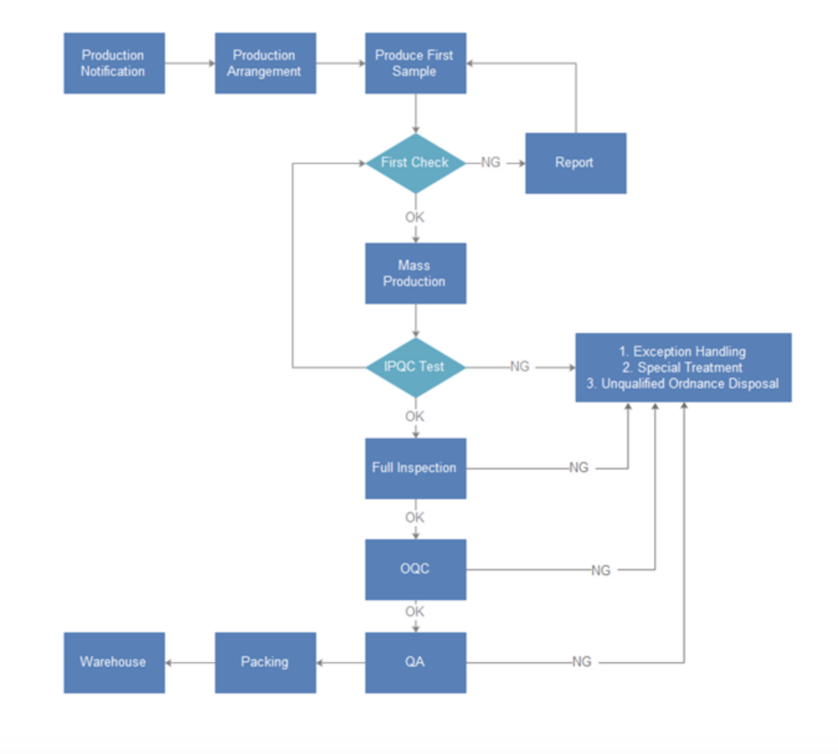

F. Labor Force
- Western Colorado offers a variety of manufacturing opportunities for employees. This means that the labor pool in this area has the employees AT is seeking to hire for manufacturing jobs. Also, with there be a variety of small universities (Colorado Mesa, Western State, WCCC, Fort Lewis, CMC) on the Western Slope, we will be able to draw applicants who could fill management, accounting, and HR positions.

G. Training
- For training, we will use a template like the one below. This will provide an organized template of how to train each employee that AT employs. By organizing our training this way, we will be able to cater the right kind of training to each employee. This will also help us organize the pricing for each aspect of training so that we do not spend too much on one employee.
- Our maximum budget for each employee will be $1,000, and the cost will be organized as shown in the below chart.
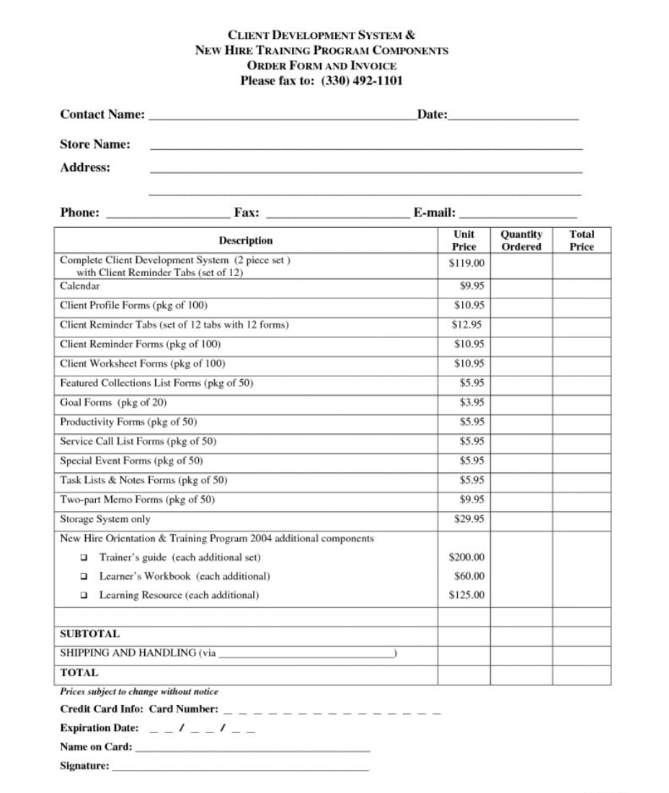

H. Staffing Plan
- We have no current employees

- As soon as we begin to design a prototype and receive funding from investors, Altitude Tents will begin seeking prospective employees and begin the hiring process.
- The order of position priority is as follows:
      - Find investors
      - Hire a patent attorney
      - Establish ESVO as raw material provider
      - Hire manufacturing employees
      - Establish distributors
      - Hire managers and HR employees
- Employees will be found through online sources such as Indeed.com, Monster.com, and LinkedIn. AT will also travel to job fairs around Colorado and the surrounding states to meet potential candidates in person.
- Our training program will run like an orientation to show employees what their job involves, how AT runs, and for social interaction so that new employees can feel like they are included from Day 1. These orientations will be conducted through short meetings over a couple of weeks so that new employees are not overwhelmed with too much information. These orientations will also include a variety of group orientation meetings and individual interactions as well as formal and informal programs. AT plans to hire 20 manufacturing employees and pay them each $33,000 a year before benefits. Benefits will include sales bonuses for ambassadors and quality bonuses for manufacturing without flaws. AT is still working out compensation plans because we are more focused on designing our product and patenting it at this point in time.

- AT will be compliant with all government standards. Staying within regulations and laws is a priority of AT. This includes programs such as EEOC, ADA, and OSHA. Diversity is important to AT; our company does not plan to have an affirmative action policy unless there begins to be a clear lack of diversity. AT will hire employees based on their credentials regardless of race, gender, or sexual orientation to avoid lawsuits and make sure our company is viewed as accepting of all types of employees or all positions.

VII. Altitude Tents Management Team
A. Identification of Key People
- My main partner in this venture will be Marisa Marsh. She currently resides in Lincoln, Nebraska. She is a graduate in Real Estate from the University of San Diego. Her experience in managements is extensive and will bring a strong personality to Altitude Tents. She currently manages an office building of nearly 100 tenets and has various investments in other commercial properties. She also has a keen eye for marketing opportunities.
- My other partners will include other family members who will double as investors in Altitude Tents (AT).
Mike Marsh brings 25 years of experience in commercial development, small business entrepreneurship, and management. His expertise will bring an eye for detail and ability to manage the production process of AT products.
Kim Marsh will help with marketing and financial operations of AT. She has over 30 years of experience in small business accounting and expense management.
- Between the four of us, I will own 55% of Altitude Tents (AT) and Marisa, Mike, and Kim will each own 15% of AT. We all have an ownership in a family-owned real estate company named Realty Trust Group which brings a strong bond to this venture un AT. We already know how to function as a group and run a company effectively.
- Retention of these individuals will be made through ownership and contractual agreements.
- The four of us will function as the board of directors with Marisa, Mike, and Kim having one vote on decisions and Kipper (myself) will have two votes to make the voting a 5-point system to avoid any potential ties.

B. Succession Plan/Exit Strategy
- Succession of each key officer will be discussed at our next company meeting in December 2018.

- Insurance will be funneled through our already existing company (Realty Trust Group)

- As the company grows and more successors are needed, we will keep those successors limited to known friends and family or reputable people whom we know and can rely on to uphold our family’s policies and conduct expectations. Because there are few of us, we will hold each other accountable. I know how each of my key people function in a business setting and am convinced that there will be no lapse in their character working for AT.

- In an ideal situation, I would like to prove AT to be a successful idea and sell the idea off to a larger competitor while still owning the patent and collect royalties. I have discussed this exit plan with my management member and we are all in agreement of this exit strategy. Realty Trust Group is our biggest focus and AT will be another method of income once it is established. The revenue from selling off the company will be split accordingly to each member ownership after all investors are paid off.

C. Management Philosophy
- Our management philosophy is to make sure every employee feels a part of the company’s culture and is proud to be a part of this innovative product. We plan to provide employees with a safe, fun, and productive working environment to maximize their potential and have the opportunity to move up in the company’s hierarchy. AT also plans to give back to the community by helping to sponsor local events and provide our product to schools, the homeless, and local outdoor programs (Colorado Mesa Outdoors Program). We want to be known for bettering the community and not simply using the area for our own business’s benefit. AT will also keep environmental friendliness in our production by using solar and geothermal energy to help power our facilities.
- See section (d) in “Identification of Key People” on page 28 for how decisions will be made using a 5-point system by the Board of Directors. Growth will happen in congruence with consumer demand; AT does not plan to force growth but rather let demand drive our growth.

D. Business Organization and Structure
- See organizational chart in Appendix.
- We plan to run as an LLC until we expand past the credentials for such legal form and ultimately become an S-corporation.
- Our corporate charter will be addressed when the time to become a corporation arrives. Location of this charter will most likely be Colorado.

E. Identification of Firms Assisting the Altitude Tents
    - Accountant: Jimmy Shultz
    - Attorney: Bob Weigel
    - Banker: Jim Fay
    - Insurance Agency: State Farm

VIII. Timeline
A. Key Events
- AT initial product manufacturing is expected to take 1 year and 6 months from engineering to the first-order shipment. Many of the foundations for this company are already able to be tapped into quickly, but tasks such as patents, website launch, material decisions, hiring, and installing manufacturing equipment will take up the bulk of this time.

    - January 1, 2019: Initiate project by applying for patents
    - February 1, 2019: Project kickoff meeting
    - May 1, 2019: Complete website design
    - November 1, 2019: Complete engineering and produce physical models
    - March 1, 2020: Purchase manufacturing facility and install equipment
    - March 30, 2019: Begin hiring manufacturing employees
    - June 30, 2020: Ship the first batch of orders
- Upon appropriate funding of this project, a detailed schedule will be created to include all tasks.

IX. Critical Risk/Assumptions
A. Risk Management Strategies
- To combat unforeseen market responses and unmet sales forecasts, Altitude Tents will hold monthly board meeting in which we will discuss any shortcomings that are experienced and will keep detailed records of all problems to assess if there are any trends that require AT to adjust to maximize our sales potential. We will conduct weekly staff meetings to discuss the demand for the week and will assess these meeting numbers at the monthly board meetings. If there is an under demand, AT will begin to focus on which products are selling best and shift our manufacturing operations accordingly. The same will go for overdemand situations. In an overdemand scenario, AT will provide overtime pay for employees to motivate them to help in meeting the demands for AT products, and in a scenario where overdemand is an issue AT will focus on the products that are being demanded most and put a priority on the production of those units.

- Because a product of our kind has not been introduced to the market and with so many competing tent companies on the market, it is going to be difficult for a competitor to create a combination of products that matches us in innovation and is able to undercut our pricing. However, if this does occur, AT plans to launch aggressive marketing campaigns to make sure consumers see our product before they see our competitors. Being the first product a potential customer sees is an important aspect for AT to combat any true competitors.

- If the industry takes a downturn, AT will slow its production and focus on making sure advertising and marketing is staying consistent. By the time the industry would take a downturn, we hope to have enough cash on hand to not need to worry about bankruptcy or significant layoffs.

- AT is trying to stay a small business, and labor issues should be able to be seen before they happen. We want employees to be comfortable with expressing their concerns and complaints to management before making irrational decisions. If skilled labor is lacking, AT will expand our recruiting pool area as well as invest in more artificial intelligence that can pick up where physical labor lacks. All government regulations will be complied with by AT, and if a regulation is passed that affects the way we run our business, AT will assess those issues as they are presented because we cannot predict government decisions.

- AT will look into alternative suppliers so that our production will not lapse if ESVO falls through for any reason. There are many different canvas suppliers making a loss of our main supplier not a huge issue. We hope that our suppliers will treat us the way we treat our own customers. AT will give warning to ESVO on issues such as aggressively raining prices and erratic deliveries. We would prefer to solve issues at hand rather than abandon the source of the problem and try to start over with another supplier entirely.

- Altitude Tents will use The Hartford insurance for our business, and our coverage will consist of general liability, property insurance, and workers’ compensation insurance. We will not provide personal insurance for employees.

- The biggest risks with our business are employee working with machinery and cutting tools, weather in Colorado can cause delivery delays of both final products and raw materials, and if we are not able to attain a patent, there is a risk of competing companies to copy our ideas and run us out of business.

X. Benefits to the Community
A. Economic Development
- Altitude Tents will bring a variety of benefits to the Western Slope community. Although we will only be producing around 20 new job opportunities, we plan to show our community involvement in other ways. We will bring in revenue through our tax dollars and try to source all of our employees from the local area so that their support can invest back into the community. AT will also keep environmental friendliness in our production by using solar and geothermal energy to help power our facilities and reduce our carbon footprint on the Western Slope. Unfortunately, we will not use any locally sourced materials because the quality of canvas and other various parts are not produced in the area we plan to operate.

- AT plans to give back to the community by helping to sponsor local events and provide our product to schools, the homeless, and local outdoor programs (an example being the Colorado Mesa Outdoors Program and REI rental program). We want to be known for bettering the community and not simply using the area for our own business’s benefit. The Grand Valley especially has a large homeless population, and AT would like to create a program where the homeless can utilize our product to stay out of the elements. Then for the rental programs as mentioned above, AT wants people to have the opportunity to try our products in a really outdoor setting before they purchase one. AT does not want to just be another tent someone buys, we want to be the tent you can’t go camping without. Our goal is to make people want to get outdoors and be comfortable while they enjoy nature, wherever that may be.

- Our pay won’t be the most competitive, but we want to draw in employees through other compensation opportunities. The biggest of these will be a flexible schedule; AT plans to provide a working schedule where employees are required to check in to work a minimum of 3 days a week but will work on an hour-based schedule. The employee is required to work 38 hr a week but can choose when they do those hours between Monday and Saturday, between 7:00 a.m. and 8:30 p.m. This will allow employees to be more flexible in their lives outside of work, as long as they achieve the required hours in a week there will be no questions asked about when they work as long as it’s within the allotted timeslots. This schedule will also allow employees to adjust their schedule to work with their families and avoid other personal life conflicts caused because of a strict work schedule.

XI. Exit Strategy
- The ultimate goal with Altitude Tents is to sell off the company to a larger competitor and collect royalties on each unit sold. As an entrepreneur, I have ambitions beyond AT and see this company as a stepping stone toward more significant opportunities down the road. The key is for AT to grow to a large enough size that competitors recognize us as a viable idea that they want, this will be a time-consuming process, and everyone parts in AT will get compensated for once we sell our product off. I realistically see AT as a 10-year plan from start to finish. That is roughly 8 and a half years of revenue earning operation under my control. With the average employee working 4.6 years at one job, we will be close to the end of our second round of employees by the time we sell off, making it a clean transition. A big part of AT is to establish investors and show that I am a legit entrepreneur who can use their money wisely and make them a profit.

XII. Financial Plan
A. Sources and Uses of Funds
- Altitude Tents (AT) is seeking $660,000 from investors to fund material costs, manufacturing facilities, and marketing.
- AT plans to take out $122,600 in bank loans on top of investor funds. We are seeking five investors to put up $132,000 each.
- Bank Loan: 15 years at 4.88%--Investor Loan: Either a 3-year, $44,000 per year plan at a 1.22% interest rate with a 12-year payback period or all $132,000 at a 2.44% interest rate with a 10-year payback period.
- $4 royalty on every unit sold, then a jump to an $8 royalty on every unit sold for 5 years after positive cash flow is generated, then steady off back at $5 as long as the company is functioning under current ownership.

B. Financial Practices
- Altitude Tents will use a cash accounting method in the beginning and then transition to an accrual method as we grow. The reasoning for starting off with the cash method is because it gives a clearer picture of cash flow and avoids the appearance of being profitable when in reality we have no money.
- Our collection methods will be adjusted to different suppliers’ preferences. For sales, our collection methods will be through money wiring, credit cards, checks, and PayPal.
- Accounts Receivable and Accounts Payable will be managed at the time when cash is received and when expenses are paid. (Cash Method)
- Costs and funds will be controlled through our accountant weekly, and I will personally check them over again at the end of each week.

C. Cash Flow Statement
- Cash flow will be slow the first year but positive. See the below spreadsheets for the projected cash flows Years 1–3.
- (See Statement on page 36)
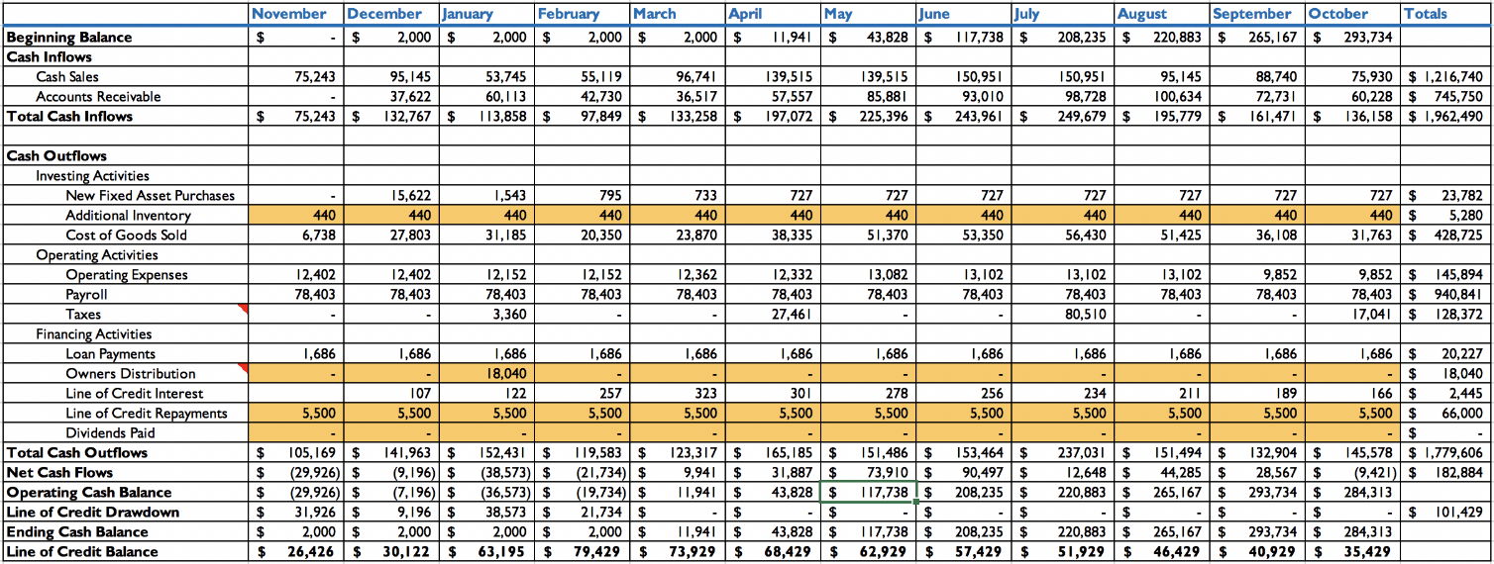
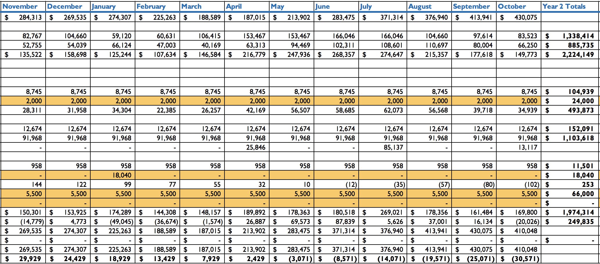
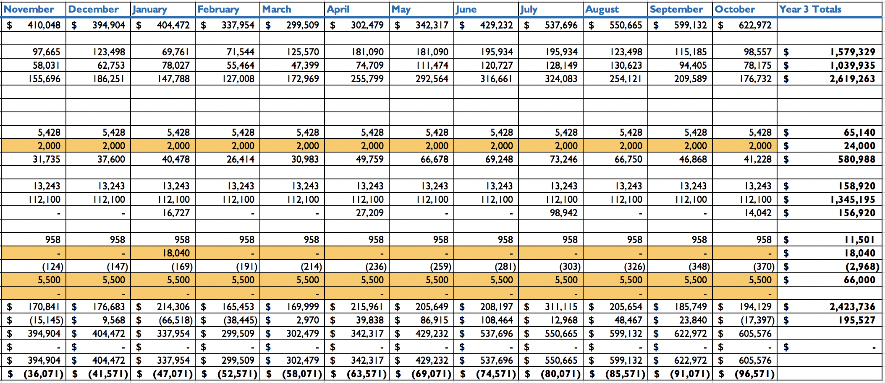
D. Cash Budget
- Our cash budget will be based on our predicted operating expense multiplied by 20% to factor in a 20% over budget situation, and any additional cash will be carried over to the following year’s budget account. Using the sheet below:

    - Year 1 Budget: $213,105.60
    - Year 2 Budget: $225,306.60
    - Year 3 Budget: $241,117.20

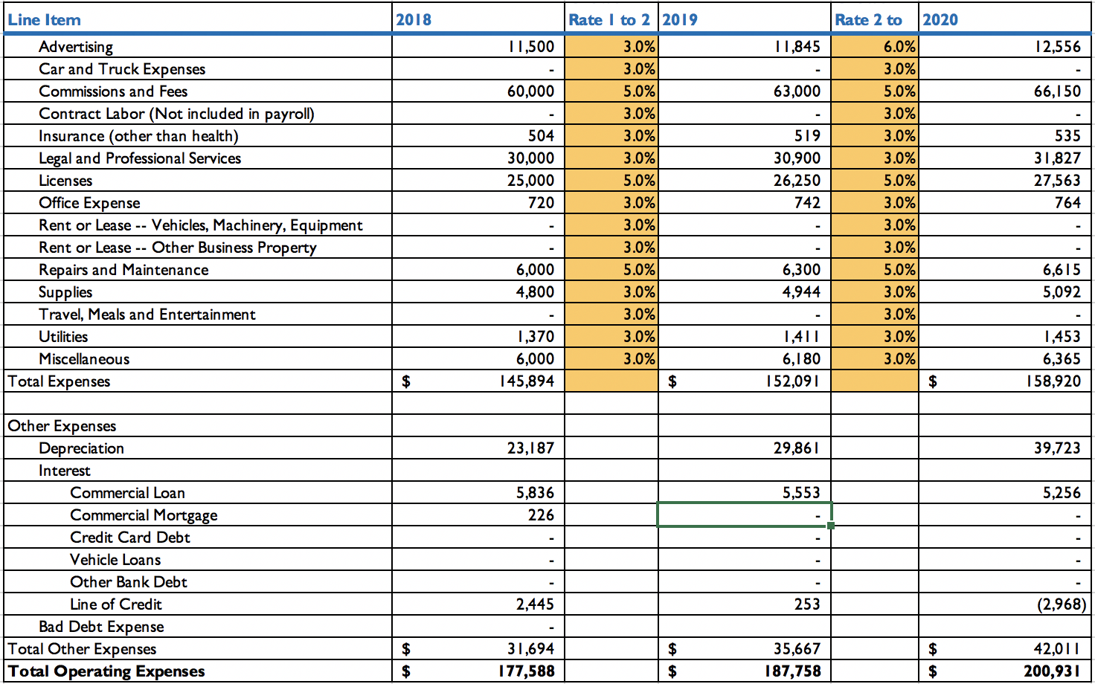
- Balance Sheet

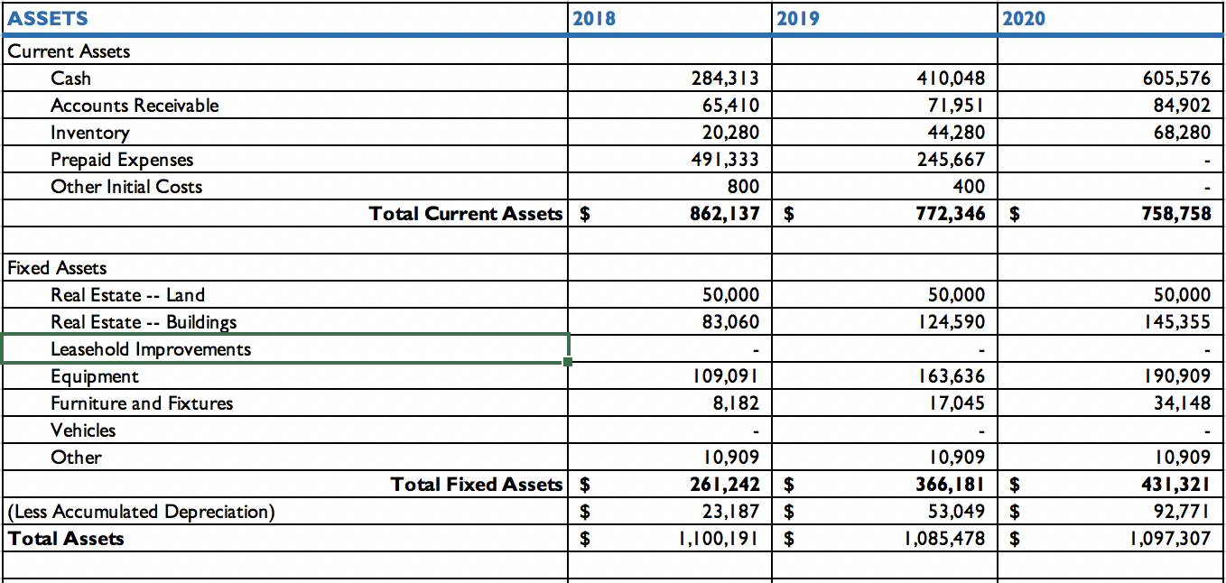
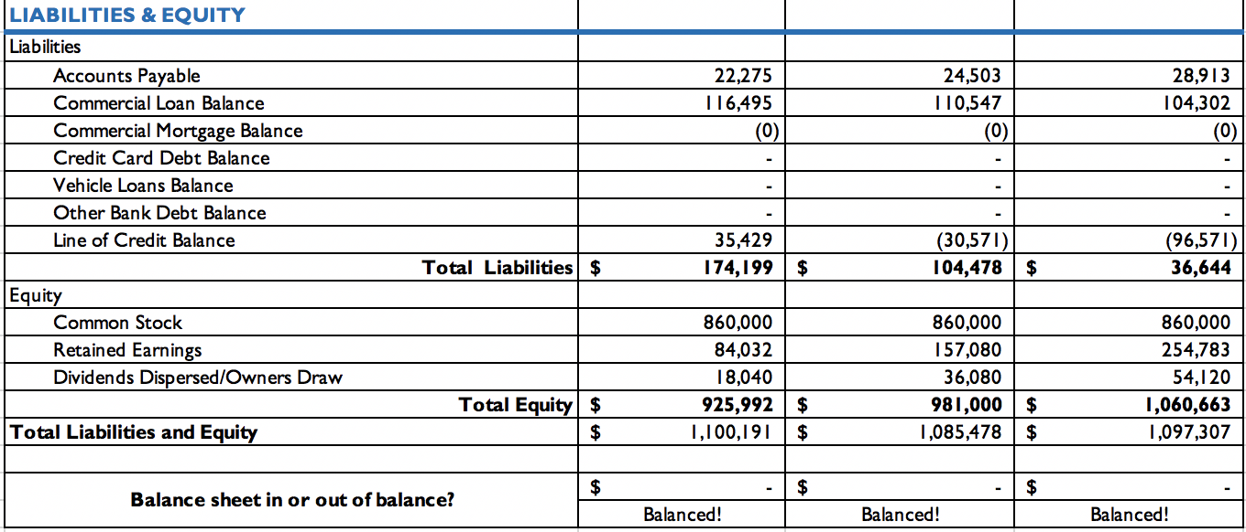

E. Profit/Loss (Income Statement)
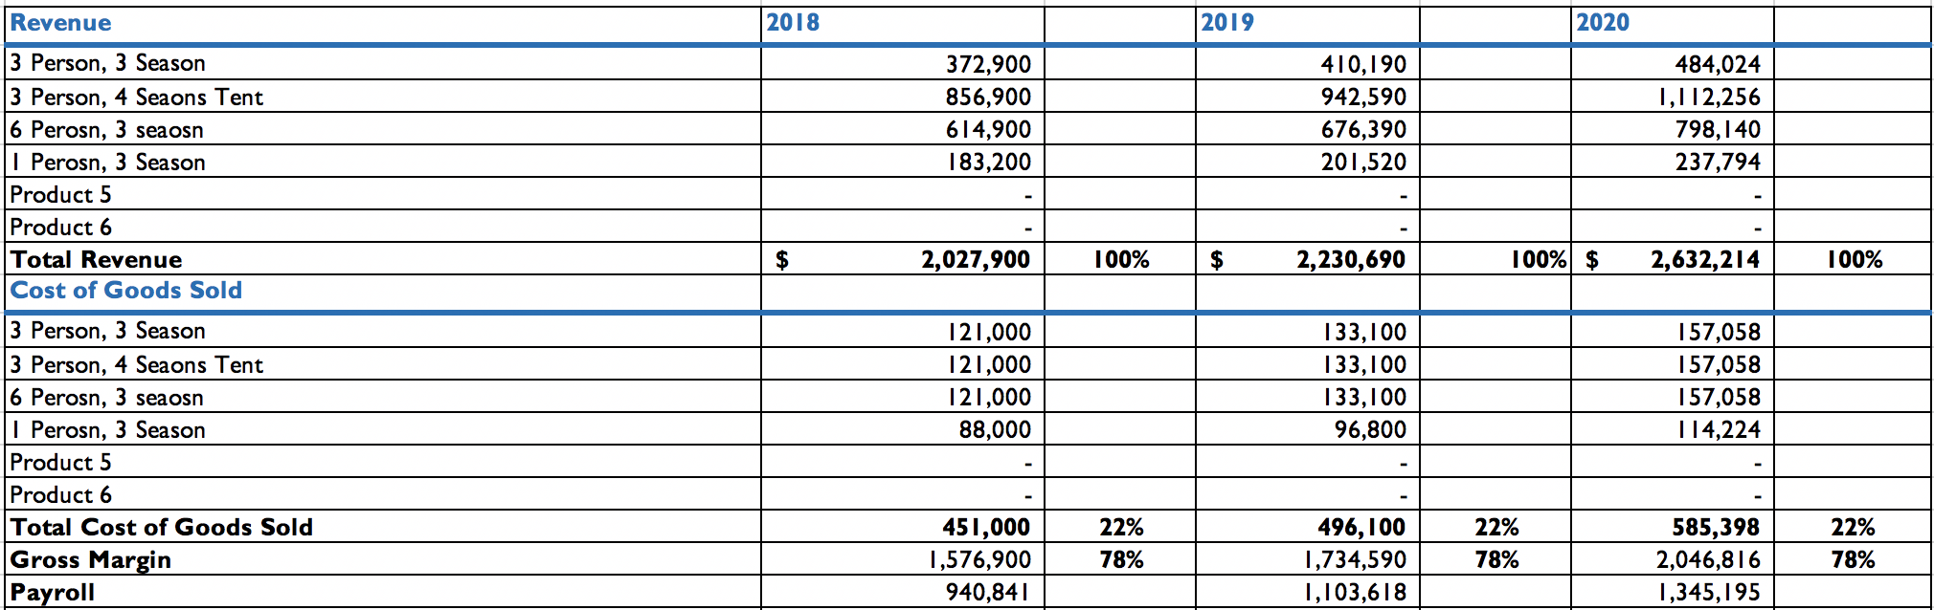
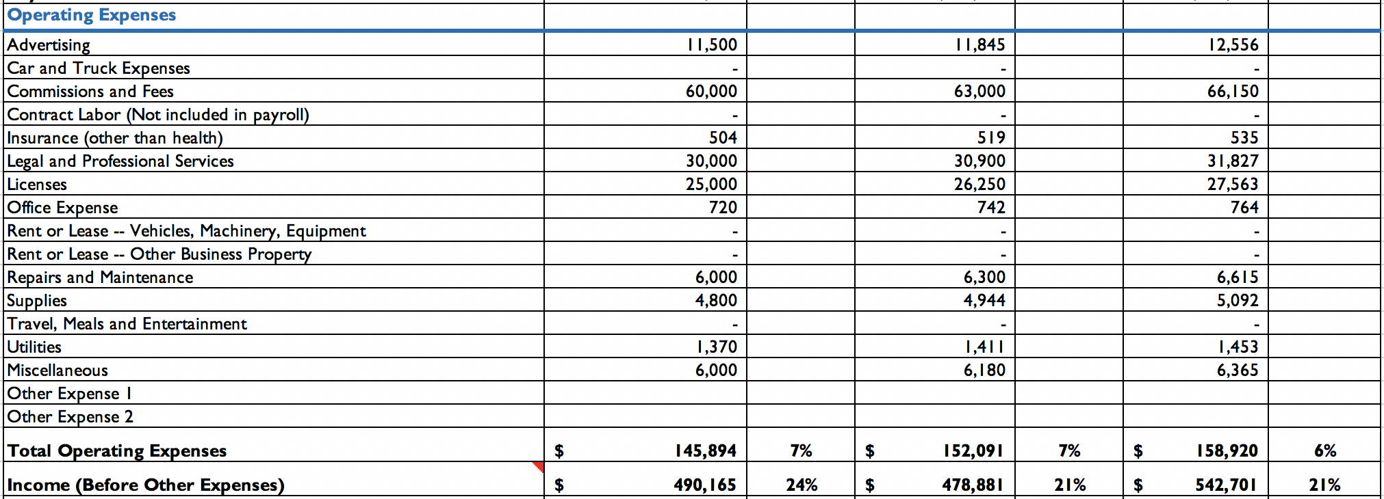
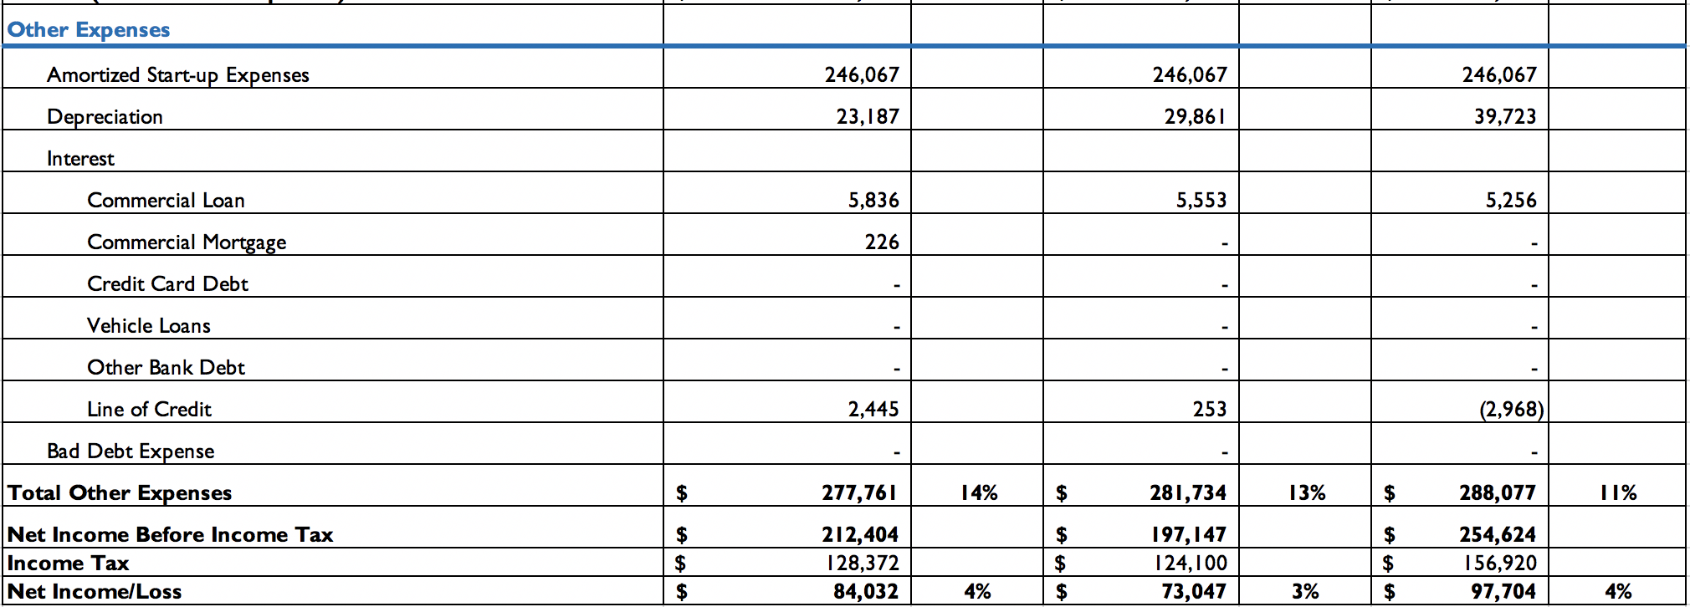

F. Breakeven Analysis
- According to our income statement above, we should break even within the first year making a 4% profit, which means investors will begin to make their money back very quickly and receive the $4–$8 royalty bump after the first year of AT’s operations. According to our Year 1 income statement, AT’s monthly profit/loss figures will vary but maintain a positive cash flow overall.

G. Financial Ratios
  - Liquidity
    - Current: 2018 = 7.22, 2019 = 15.99, 2020 = –30.69
  - Profitability
    - Return on Assets: 2018 = 0.19, 2019 = 0.16, 2020 = 0.19
    - Gross Profit Margin: 0.34
  - Leverage
    - Debt Ratio: 2018 = 0.89, 2019 = 0.95, 2020 = 1.00

Appendix

COGS Statement:

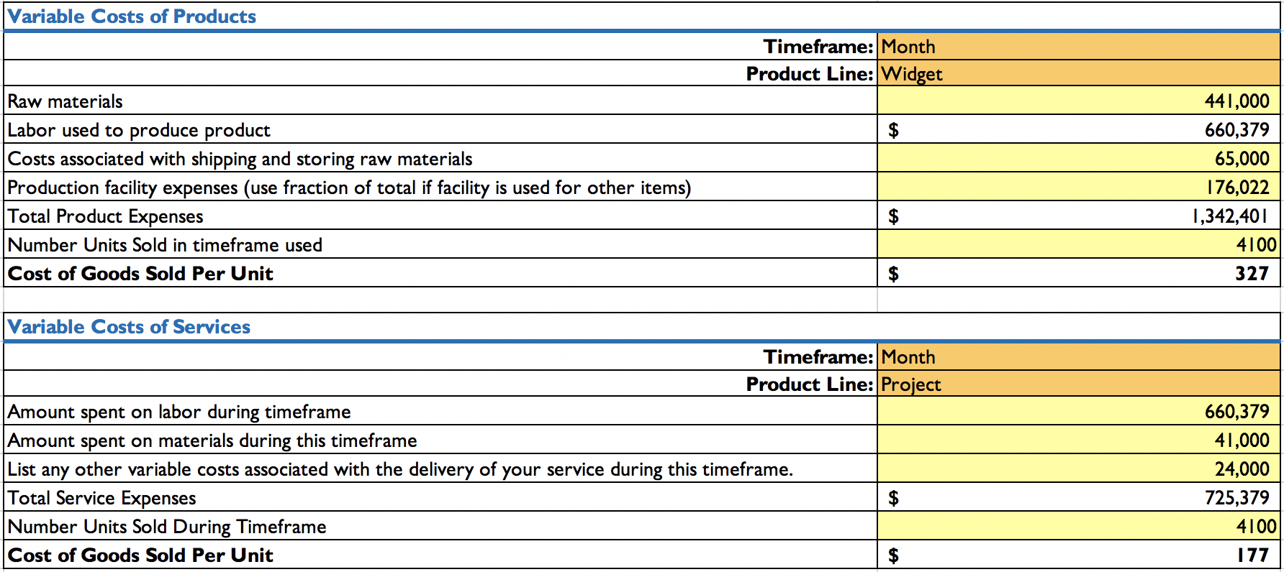

Breakeven Analysis:

