Chapter 16 THE LAW AND MENTAL HEALTH
- This Web Exercise focuses upon the legal perspective and the insanity defense.

Visit the following webpage from Cornell University Law School. Briefly summarize the information and highlight examples of what you found particularly interesting.
https://www.law.cornell.edu/wex/Insanity_defense

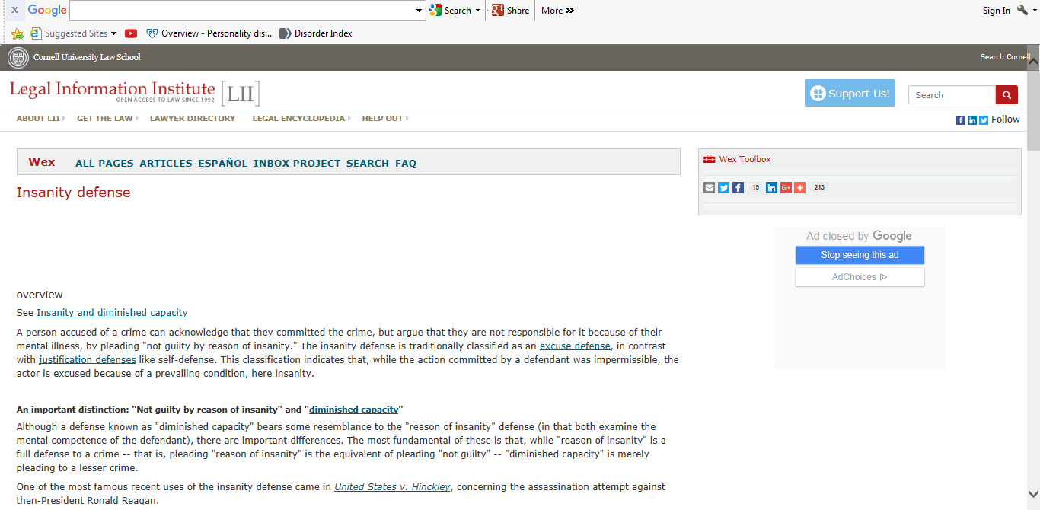

- This Web Exercise focuses upon the legal and community perspective of mental health professionals’ duty to warn.

View the following resource from Imminent Danger – JSONLINE.COM
Milwaukee-Wisconsin Journal Sentinel

http://archive.jsonline.com/news/134341463.html
2013 Polk Award Winner: Chronic Crisis | A system that doesn't heal
Grappling with mental health's most vexing question: Who is dangerous?

Consider what you learned from the Ray text and the stories from the Imminent Danger documentary, what are your views in balancing the rights and safety of people with mental illness and community needs and responsibilities? You may want to discuss issues related to confidentiality, involuntary hospitalization, duty to warn, or community training in providing services.

