Chapter 13 SCHIZOPHRENIA
- This Web Exercise focuses upon early childhood onset of schizophrenia.

View and read the following regarding January Schoefield’s experiences with childhood schizophrenia. What are additional considerations regarding the symptoms associated with Schizophrenia from a developmental framework? What challenges were noted by her parents? And what kind of assistance do you think January and her family need in order to live healthier lives?

http://www.latimes.com/health/la-he-schizophrenia29-2009jun29-story.html
https://www.youtube.com/watch?v=UTUMt05_nCI

Young schizophrenic at her mind's mercy - Los Angeles Times
January Schofield has schizophrenia. Potent psychiatric drugs in doses that would stagger most adults seem to skip off her. She is among the rarest of the rare: a child seemingly born mentally ill.

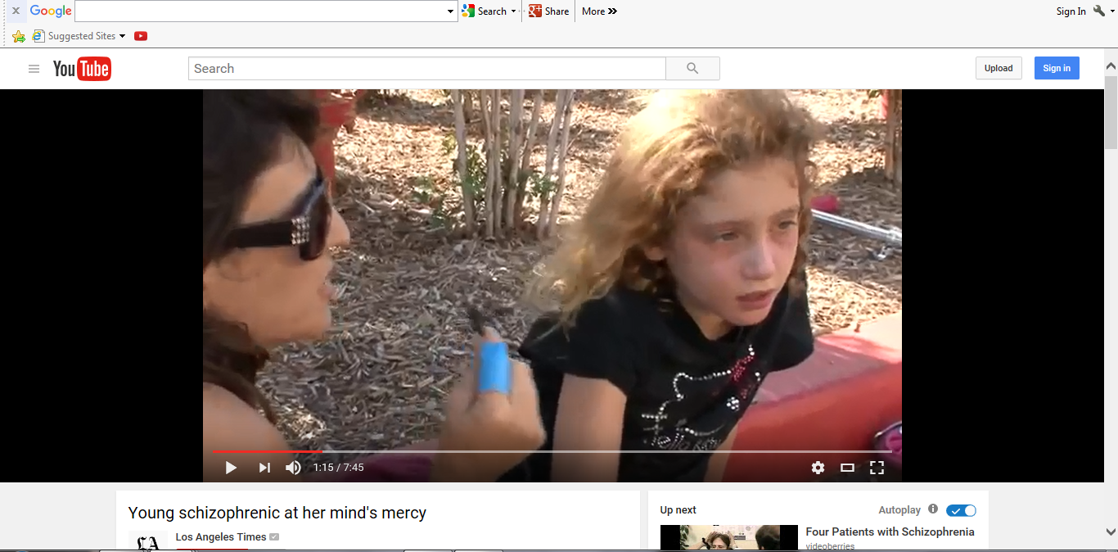
- This Web Exercise focuses upon psychotic symptoms and intervention.
View the following video from NIMH and discuss possible causes of psychosis. What are some of the available treatments for psychosis?
https://www.youtube.com/watch?v=IJuy7E4RC6g
The National Institute of Mental Health (NIMH) hosted a Hangout during National Children’s Mental Health Awareness Week on first-episode psychosis with NIMH expert Amy Goldstein, Ph.D. and NIMH grantee and psychiatrist John Kane, M.D.

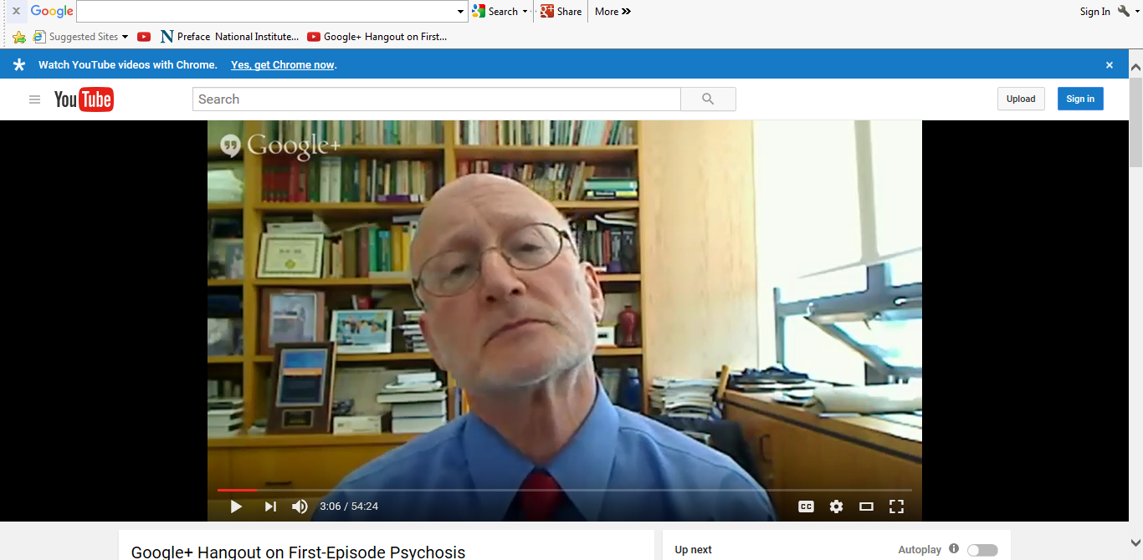

- This Web Exercise focuses upon intervention for people who experience their initial schizophrenia episode.

Explore the National Institute of Mental Health (NIMH) Recovery After an Initial Schizophrenia Episode (RAISE) project by reviewing the information from the following NIMH webpage. Describe 3 important aspects to the program that you think contributes to the health and wellbeing of young adults who experience schizophrenia.

https://www.nimh.nih.gov/health/topics/schizophrenia/raise/index.shtml
