Chapter 12 SUBSTANCE-RELATED AND ADDICTIVE DISORDERS
- This Web Exercise focuses upon identifying research-informed intervention as recommended by National Institutes on Drug Abuse-NIDA.

Visit and navigate the NIDA site, explore its content. Carefully review the contents of the web resource, by firs reading the preface and the sequentially move to the next topic, Principles of Effective Treatment, etc. You may use the next button or use the menu bar on the left side of the webpage.

Describe at least 3 types of treatments and interventions you found to be rather effective based that you found important to highlight upon the description provided by NIDA. Or describe the answer to a frequently asked question

https://www.drugabuse.gov/publications/principles-drug-addiction-treatment-research-based-guide-third-edition/preface

Principles of Drug Addiction Treatment: A Research-Based Guide (Third Edition)

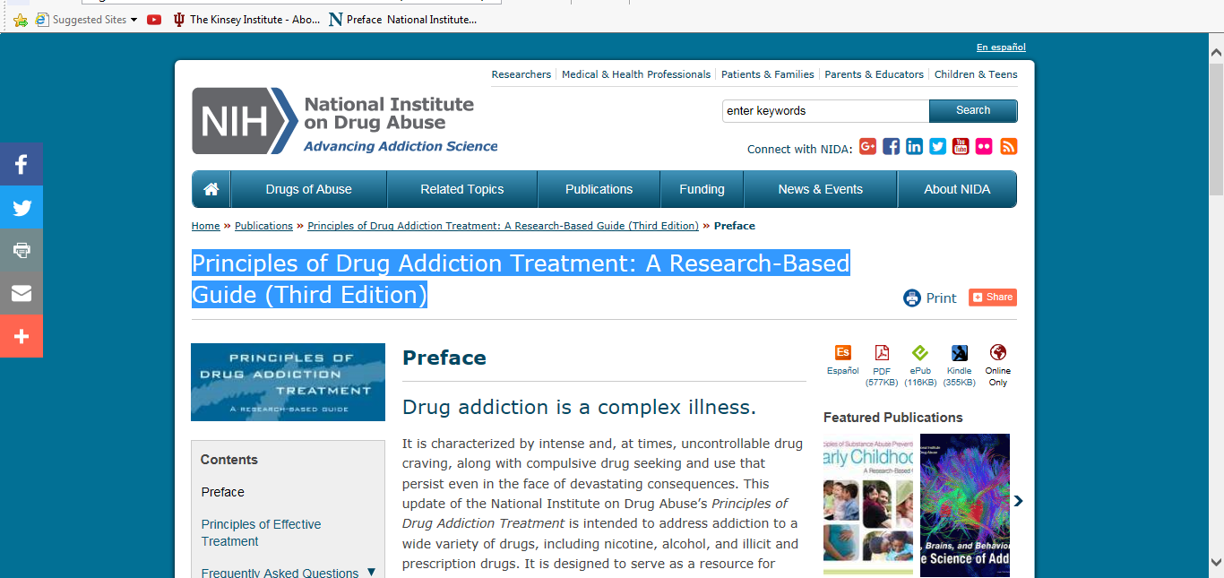

- This Web Exercise focuses upon providing research-informed facts regarding various types of drugs from National Institutes on Drug Abuse-NIDA specific to the teen audience.

https://teens.drugabuse.gov/drug-facts

National Institute on Drug Abuse for Teen

Explore this webpage regarding various drugs how the brain is affected by drug use. Choose 3 of the drugs topics and explore in detail by clicking on the tab. Discuss how user-friendly is this site for teens and their parents? Provide specific information and examples from the site that you found to increase your knowledge. How would you improve this web-resource for teens?

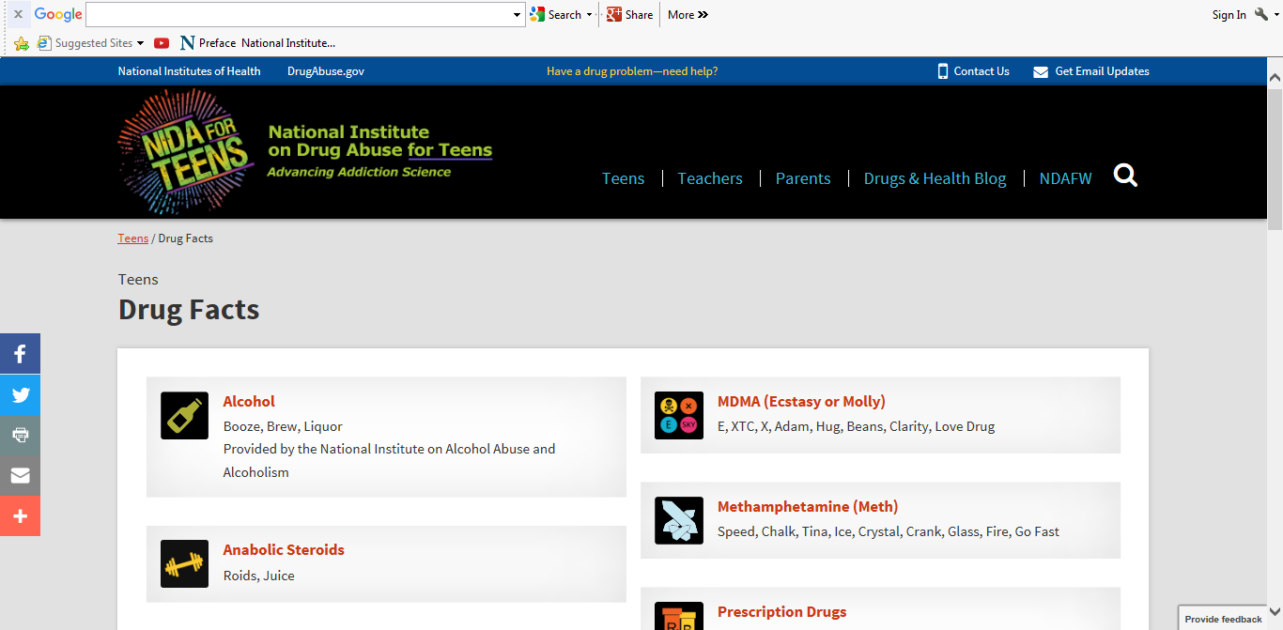

- This Web Exercise focuses upon providing visuals for brain function and changes as a result of drug exposure by National Institutes on Drug Abuse-NIDA.

https://www.youtube.com/playlist?list=PLE4ZNGaomJBk7EQDTcFQyWtKN92tqIUx1
Brain Reward Series- National Institute on Drug Abuse (NIDA/NIH)
•4 videos• Last updated on Feb 12, 2016

View the 4 videos and compare and contrast the different types of drugs used with the changes in brain functioning, specifically the brain location and the change in level of neurotransmitters.

