Chapter 11 SEXUALITY DISORDERS AND GENDER DYSPHORIA
- This Web Exercise focuses upon identifying current research supported regarding sexual health and sexuality.

Visit and navigate The Kinsey Institute site. Explore contemporary research on sexual health and sexuality on the page and click on a research topic (for example, The Neurobiology of Love) and summarize the current research being conducted. What did you find particularly interesting about the research. Be sure to page down to see all the research topics listed.
http://www.indiana.edu/~kinsey/research/index.html

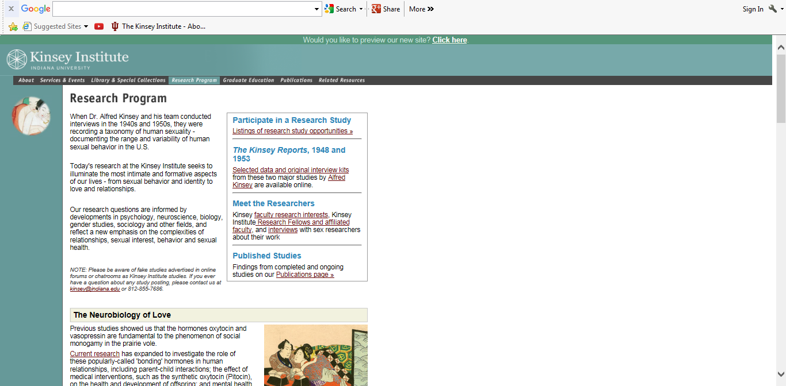

- This Web Exercise focuses upon exploring community resources on sexual health for emerging adults and college students.

Sometimes it can be challenging to find out answers to interesting and/or obscure questions regarding sex, sexual health, and myths associated with sex. Explore the link below and randomly find (or choose) a topic of interest from the page. Discuss how helpful this site is in answering questions or providing information regarding sexual health, etc. Do you think you would recommend this site for college-aged student? Why or why not? What other websites would be helpful for college students and emerging adults in gaining more knowledge about sexual health?

https://kinseyconfidential.org/

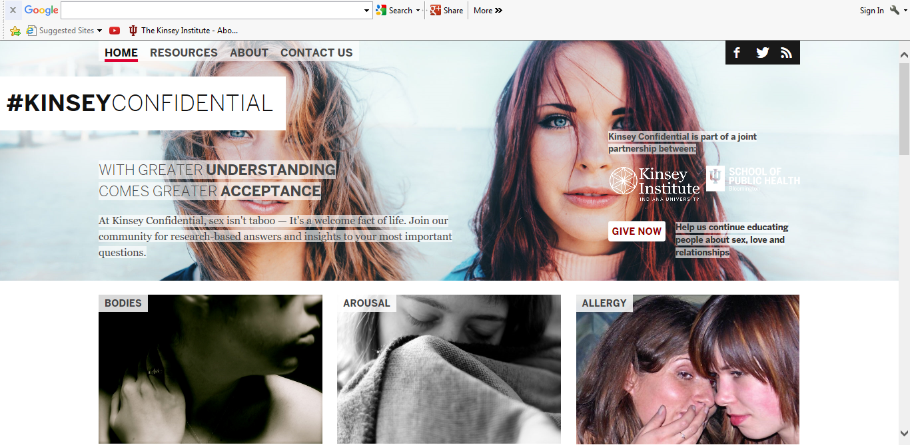

- This Web Exercise focuses upon transgender youth, gender dysphoria and treatment.

View the Ted Talk by Dr. Norma Spack. Discuss what you learned from this Ted Talk and how it helps to inform your knowledge regarding gender dysphoria and the challenges of transgender youth.

https://www.ted.com/talks/norman_spack_how_i_help_transgender_teens_become_who_they_want_to_be?language=en

Ted Talk: Puberty is an awkward time for just about everybody, but for transgender teens it can be a nightmare, as they grow overnight into bodies they aren't comfortable with. In a heartfelt talk, Norman Spack tells a personal story of how he became one of the few doctors in the US to treat minors with hormone replacement therapy. By staving off the effects of puberty, Spack gives trans teens the time they need.

