Chapter 10 EATING DISORDERS
- This Web Exercise focuses upon identifying resources for community members experiencing an eating disorder, concerned family and friends, and for professionals.

Visit and navigate the National Eating Disorders Association site, explore its content. What did you find helpful and user-friendly about NEDA’s resource. Briefly describe a resource that you found as particularly informative about eating disorders.

http://www.nationaleatingdisorders.org/general-information

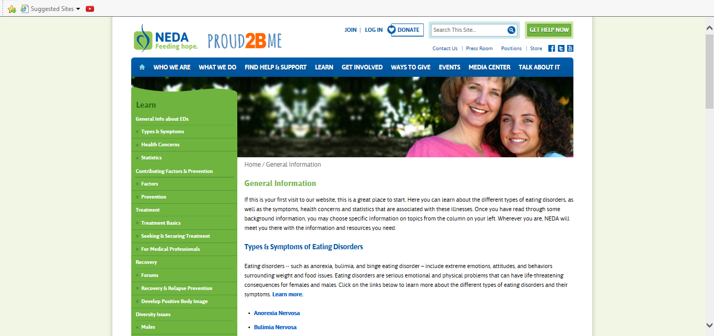

- This Web Exercise focuses upon identifying video resources for community members experiencing an eating disorder, concerned family and friends, and for professionals.
From the link below, choose one of the following videos on eating disorders and provide a brief summary. Also indicate 3 aspects to the video that increased your knowledge regarding eating disorders.

http://www.nationaleatingdisorders.org/videos-eating-disorders

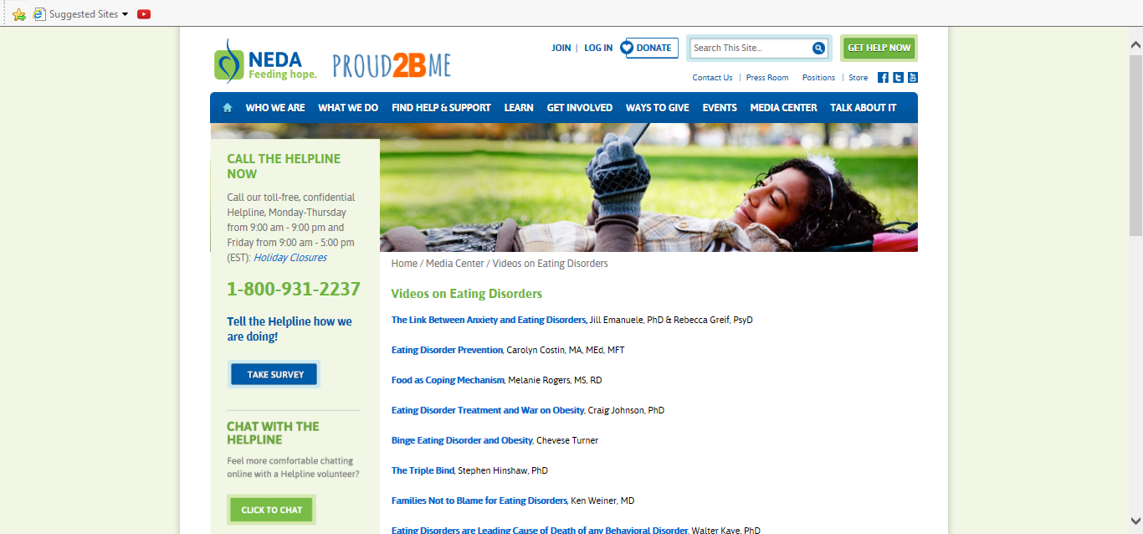

- This Web Exercise focuses upon contemporary research and intervention for athletes who are at risk for eating disorders and the challenges associated with obtaining and receiving therapeutic services.

View the video below by Dr. Riley Nickols and Amanda Schlitzer Tierney on Special Considerations in the Treatment of Athletes with Eating Disorders. Discuss aspects of the video presentation that you found particularly helpful in working with athletes. Identify at least 3 presentation facts, knowledge, and information that you will remember most from viewing this resource.

From Eating Disorder Hope
https://www.youtube.com/watch?v=XXkshkaN-Co

