Chapter 8 ANXIETY DISORDERS AND OBSESSIVE-COMPULSIVE DISORDERS
- This Web Exercise focuses upon identifying current research supported by NIHM and how these research topics relate to the three approaches of psychopathology.

Participate in the learning modules of National Institue of Mental Health Neuroscience & Psychiatry (Module 2-Anxiety). Describe how well you did on your pre-test and post-test score? What was most helpful in your understanding of anxiety and fear response.

https://www.nimh.nih.gov/neuroscience-and-psychiatry-module2/index.html

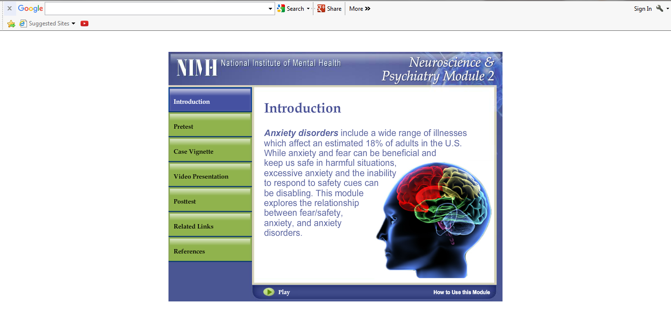

- This Web Exercise is relevant to the topic of anxiety symptoms and therapies.

Explore and review the learning topics on anxiety from the National Institutes of Mental Health from the link below. Discuss why you think there is a range of therapeutic interventions for anxiety disorders and how so treatments work for some people and not others.

https://www.nimh.nih.gov/health/topics/anxiety-disorders/index.shtml

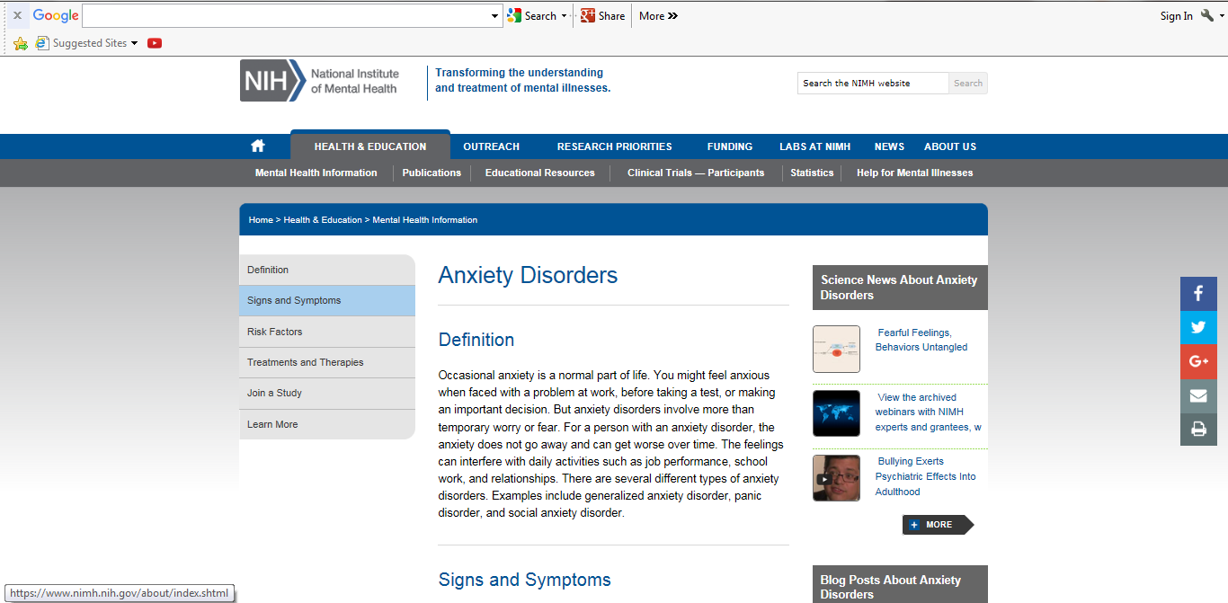

- This Web Exercise is relevant to the topic of anxiety symptoms and therapies.
Visit and explore the webpages below from the National Institutes of Health. Discuss some interesting newly learned information regarding yoga and how it may help to reduce stress and anxiety and facilitate wellbeing.

https://nccih.nih.gov/health/yoga/introduction.htm

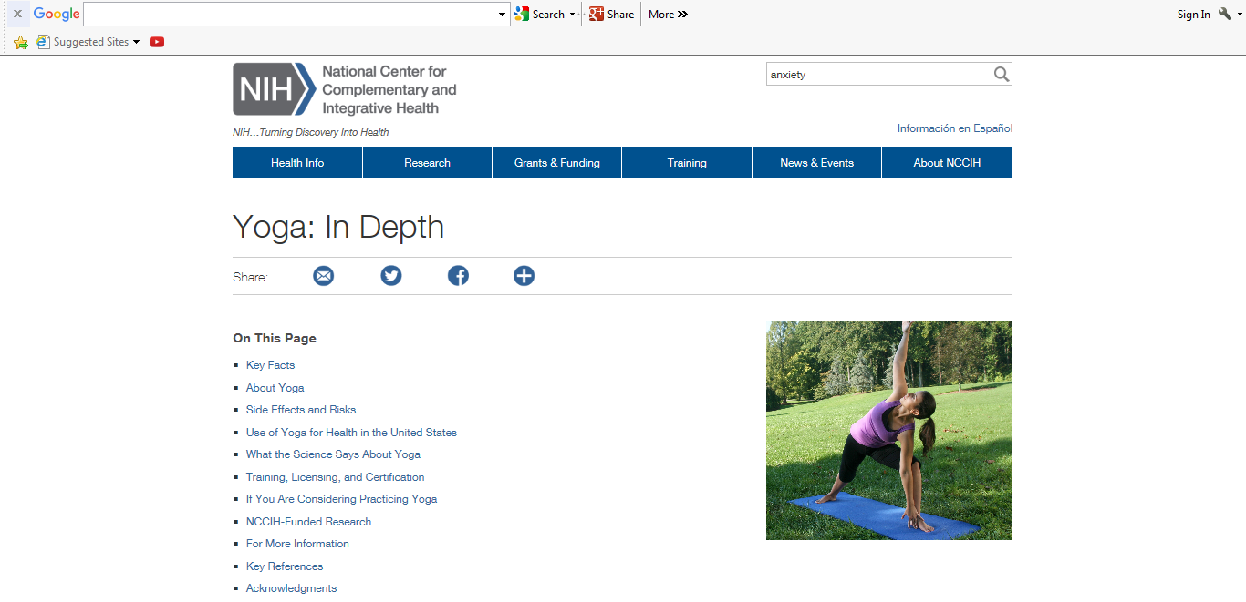

https://www.ncbi.nlm.nih.gov/pubmed/20387774?dopt=Abstract
Am Fam Physician. 2010 Apr 15;81(8):981-6.
Exercise, yoga, and meditation for depressive and anxiety disorders.
Saeed SA1, Antonacci DJ, Bloch RM.

Abstract

Anxiety and depression are among the most common conditions cited by those seeking treatment with complementary and alternative therapies, such as exercise, meditation, tai chi, qigong, and yoga. The use of these therapies is increasing. Several studies of exercise and yoga have demonstrated therapeutic effectiveness superior to no-activity controls and comparable with established depression and anxiety treatments (e.g., cognitive behavior therapy, sertraline, imipramine). High-energy exercise (i.e., weekly expenditure of at least 17.5 kcal per kg) and frequent aerobic exercise (i.e., at least three to five times per week) reduce symptoms of depression more than less frequent or lower-energy exercise. Mindful meditation and exercise have positive effects as adjunctive treatments for depressive disorders, although some studies show multiple methodological weaknesses. For anxiety disorders, exercise and yoga have also shown positive effects, but there are far less data on the effects of exercise on anxiety than for exercise on depression. Tai chi, qigong, and meditation have not shown effectiveness as alternative treatments for depression and anxiety.

PMID: 20387774
[PubMed - indexed for MEDLINE] Free full text
http://www.aafp.org/afp/2010/0415/p981.html

