Chapter 7 STRESS, TRAUMA, AND PSYCHOPATHOLOGY
- This Web Exercise focuses upon identifying current research supported by NIHM and how these research topics relate to the three approaches of psychopathology.

http://www.ted.com/talks/kelly_mcgonigal_how_to_make_stress_your_friend?language=en
Identify at least 3 topics regarding stress and trauma and health that were shared you found particular helpful and relevant.

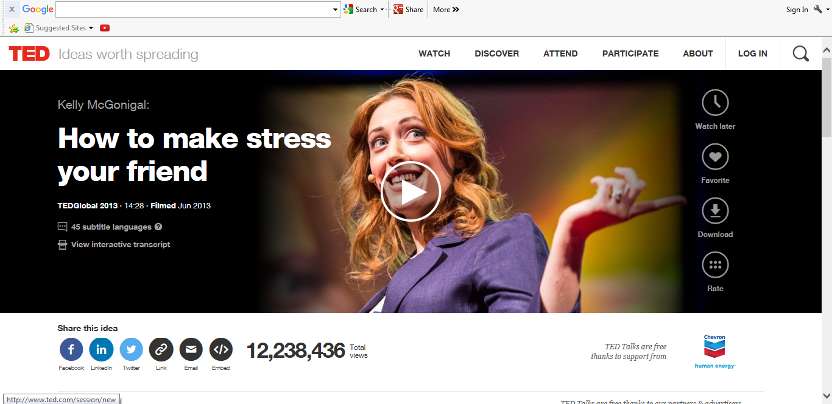

- This Web Exercise is relevant to the topic of trauma and resiliency.

Explore the topics from The National Child Traumatic Stress Network relevant to your future career goals or as a community member. What specific topic area(s) did you find very useful? How might you implement the knowledge gained in your work or the training you will engage in?
http://www.nctsn.org/
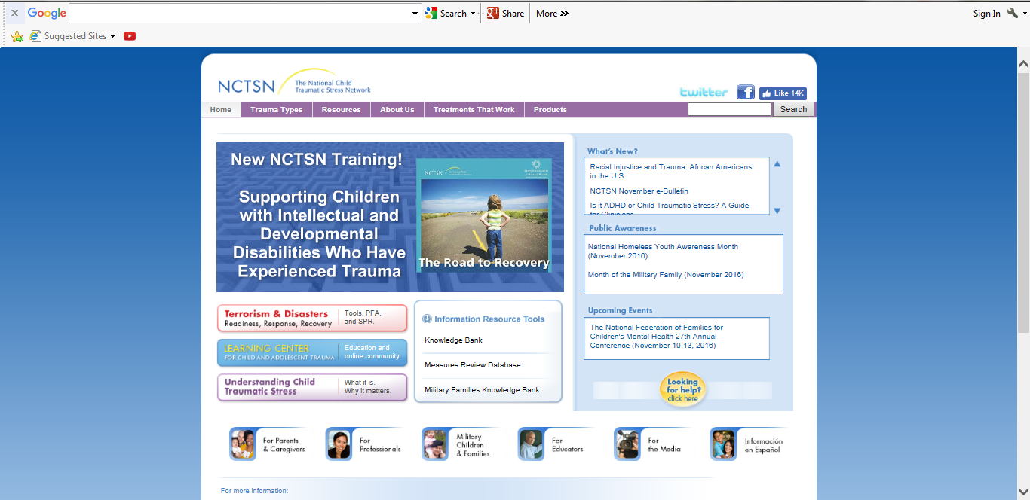

- This Web Exercise is relevant to the chapter section on exposure therapy for Veterans with PTSD.

View the videos below and connect the concepts of exposure therapy for PTSD and trauma with Dr. Rizzo’s work in helping veterans contend with their combat trauma experience through virtual reality. Provide examples when virtual reality exposure therapy may not be helpful for community members who experience trauma. Discuss your response.

Treating PTSD with Virtual Reality Therapy A Way to Heal Trauma
CTN#9NewsGlobal
https://www.youtube.com/watch?v=sHl9fjJBwHw

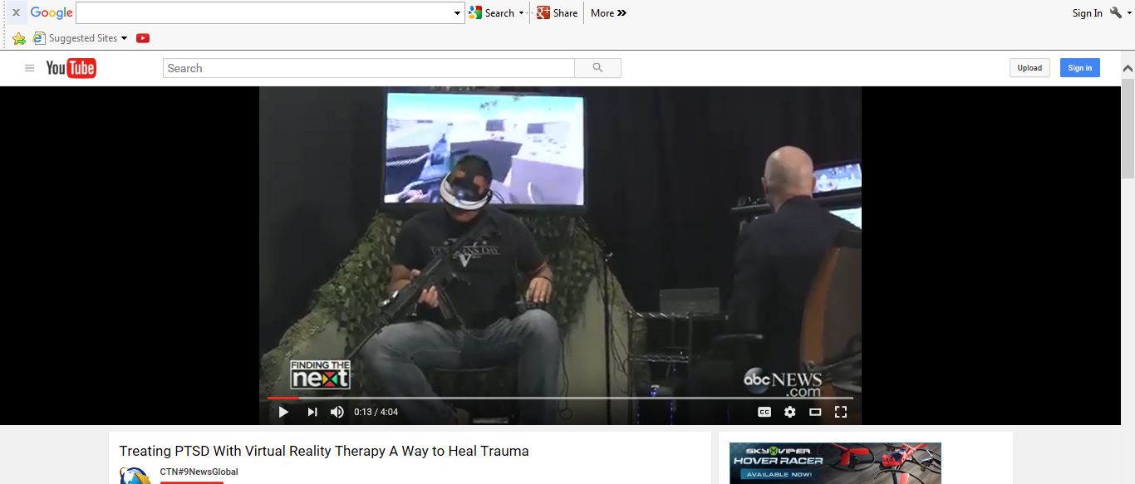

Fighting PTSD with Virtual Reality UCF Patient Interview
Skip Rizzo (http://ict.usc.edu/groups/medical-vr/)
https://www.youtube.com/watch?v=ylaUMmvxAXw

